What is my child learning in Year 6…



School Values  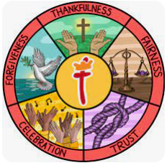 | Here at St Thomas’ we fulfil our mission of ‘Learning for Life with Jesus’ at every opportunity. Underpinning this are our 5 school values of: thankfulness, fairness, trust, celebration and forgiveness. Each half term we focus on a different value through our worship and class lessons.  This half term our value of focus is fairness. In Year 6, we will be exploring how the value of fairness is demonstrated in the world around us and how we can embody fairness in our daily lives. We will learn about the importance of treating others with equality and justice, ensuring that everyone is respected and valued. During our class Worships, we will read Bible verses that highlight fairness and discuss how we can practise fairness in our actions and words every day. We will also look at our key value of Fairness in line with our Rights Respecting Schools to look at our value of fairness on a global scale.
  RE | Why do Christians believe that Jesus was the Messiah?  This half term we will be joined each week in RE by Barry from Walk through the Bible. He will teach children about the Old Testament through hands-on learning and fun activities.
Writing    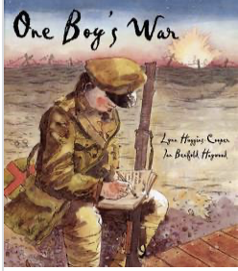 | In writing, the children will be continuing to work on building a range of language devices in order to develop their writing style. We focus particularly on:  - The use of more advanced punctuation (semi-colons, brackets, colons)  - Extending sentences by adding fronted adverbials and relative clauses  - Developing their understanding of the difference between and main clause and a subordinate clause so they can manipulate the order of sentences.  - Exploring language choices and ensuring they are appropriate for the audience of that genre  - Looking at the features of different genres  Continuing with Letters from a lighthouse, children will write their own Historical story.  Later in the half term, using ‘One Boy’s War’ as inspiration, we will be writing a non-chronological report about World War 2.
Reading  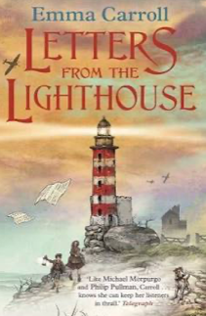 | In Reading, we are continuing with our current book for the next half term, ‘Letters from a Lighthouse’ by Emma Carroll, a fiction text based in World War 2 that the children are already enjoying reading. We will be using this text to practice a range of different comprehension questions types including retrieval, inference and discussions around vocabulary.
Maths   | In maths, we will be covering the following topics:  - The four operations (addition, subtraction, multiplication and division)  - Fractions (including ordering and comparing, finding equivalent fractions and solving problems  - Converting units (including units of time, weight and capacity)  During all of the topics, we will focus on both fluency and problem solving and reasoning questions to ensure the children develop a deep understanding of the concepts
  Science | In science this half term, we will be covering a new topic, electricity.  The children will be exploring signs and symbols used in electrical circuit diagrams, investigating the impact of adding extra bulbs, switches and other components into a circuit and how to stay safe around electrical items.
History  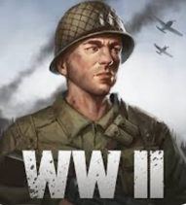 | Next half term we will be continuing with our topic on World War 2  Within this topic, we will be focusing on what life would have been like during this time, key events from the time including the Battle of Britain and their impact on today. We will also be learning about Reginald Mitchell and his impact on the war.
  D&T | Structures- Shelters -To build a model version of an Anderson Shelter  In this unit, we will be focusing on exploring the design of an Anderson Shelter and the advantages and disadvantages of these. We will then be designing and creating a sturdy 3D model of an Anderson Shelter from the knowledge we have gained.
Computing   | Creating media – 3D modelling  Children will develop their knowledge and understanding of using a computer to produce 3D models. Year 6 will initially familiarise themselves with working in a 3D space, moving, resizing, and duplicating objects.
French  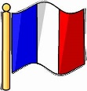 | French Football Champions  Year 6 will be developing their understanding of masculine and feminine, and become familiar with football-related vocabulary around the positions of players and events in the game. They will explore different footballers and where they have come from.
PE   | Handball  Year 6 will also be learning how to play handball and how to transition quickly between attack and defense to help gain or maintain possession.
  Music | Film Music  Year 6 will learn to appraise musical features in a variety of film contexts, identify and understand some composing techniques in film music, use graphic scores to portray different emotions, create and notate musical ideas and relate them to film music and play a sequence of musical ideas to convey emotion
PSHE   | Celebrating differences  This topic with involve exploring and discussing:  - Perceptions of normality and an understanding disability  - Understanding bullying  - Differences as conflict  - Difference as celebration  - Empathy
Key events for the half term | Future dates to be aware of:  Mon 2nd Nov – Swimming begins  Tues 10th Nov – Year 6 INSPIRE at St Thomas Church  Thurs 19th Nov – Flu immunisations Rec – Y6  Mon 23rd Nov – Heights and Weights check – Rec and Y6  Friday 20th November – Non uniform day – bring a bottle for the PSA Christmas Fayre  Fri 27th Nov – Year 6 Coffee morning  Friday 4th December – Non uniform day – bring a chocolate donation for the PSA Christmas Fayre.  Fri 11th Dec – PSA Christmas Fair 5pm  Wed 16th Dec – KS2 Carol service at St Thomas 6pm  Thurs 17th Dec – Christmas Dinner and Jumper day  Fri 18th Dec – PSA Christmas Panto afternoon  Fri 18th Dec – School closes for Christmas Holidays.
Homework | Reading- We ask that all children read a minimum of four times per week at home. Reading records should be signed by an adult to indicate that their child has read at home.  Children in Years 2–6 will also be expected to complete three sessions each week on Times Tables Rock Stars (TT Rock Stars).  Children in Years 2–6 will be expected to complete three sessions each week on the Morphs Spelling Game.  Thank you for your support with completing your child’s homework.

