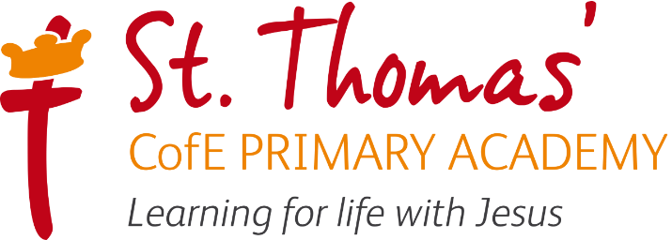



Phonics & Reading
Learning Journey
2026/2027

Intent, Implementation and Impact

Learning for life with Jesus
Inspired by our Christian faith, we guide children on a personalised journey towards achievement. As a learning community, we are committed to ensuring that children are equipped with, skills and aspirations to reach their full potential in mind, body, heart and spirit.

Intent
As a Church of England school, our English curriculum is underpinned by our gospel values. These values are used and applied throughout the English curriculum. Our children are learned and wise in the way that they practise and apply English skills in a variety of different contexts and use these skills to read for a real purpose. They show curiosity, attentiveness and active learning through their independence within lessons, following their own learning journey, taking charge of their own learning by using a variety of resources, including their working wall and continuously acting on their ‘pink pen’ feedback through active marking within each lesson. Our gospel values create a solid moral background for our children and encourage them to become better members of society.
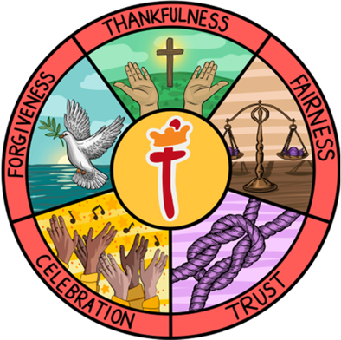
At the heart of our English curriculum is our core skills, evident in our termly learning journeys. These skills are progressive and are built on year after year from EYFS all the way through to Year 6. These learning journeys enable our pupils to be ready to access the next stages in their education, culminating in them being well-equipped in their English education for secondary school. Our children come from a wide range of backgrounds and many are not equipped with the English skills and experiences they need to become the the best readers that they can be. We have worked together to create our main outcomes that we want for our children. In English, we want to instil curiosity and a love of learning through immersion in high quality texts. Real-life experiences provide children with purposeful contexts for their reading. Our class/lesson set-up and marking policy promotes independence, resilience and high aspirations through our learning journeys.
Our Christian values, core skills and key outcomes will raise aspirations and ensure that our children are more than ready for the next stages in their English journey.
Our English Lead is Mrs A Tomkins
Our Early Reading and Phonics lead is Miss E Knobbs

Implementation

St Thomas’ Reading Learning Journey focuses on a spiral curriculum model where previous skills and knowledge are revisited and built upon.

EYFS

Reading and Phonics is taught as part of the Literacy area of the EYFS learning and development. Some aspects of Reading and Phonics also link to the Communication and Language area. Children in Reception are taught the mechanics of reading and have whole class shared reading sessions in addition to reading in groups at their phonic level. The children in Reception are exposed to a class text each fortnight and book talk will typically include discussion of the problem in the story, the characters, joining in with key/repeated phrases, freeze-framing characters feelings, discussing whether characters are nice or not nice and how we know, how the problem is solved, and focus on key vocabulary particularly Tier 2 words. Discussion and questions will link to the ‘Reading Comprehension’ strand of the ‘Literacy’ Area of Learning within the EYFS Statutory Framework.

Children are taught to recognise graphemes, segmenting and blending through phonics sessions as well as being taught to read in group sessions (see below). Phonics and group reading sessions link to the ‘Word Reading’ strand within the ‘Literacy’ Area of Learning.

Children in Reception also have stories read to them each day to promote a passion for reading.

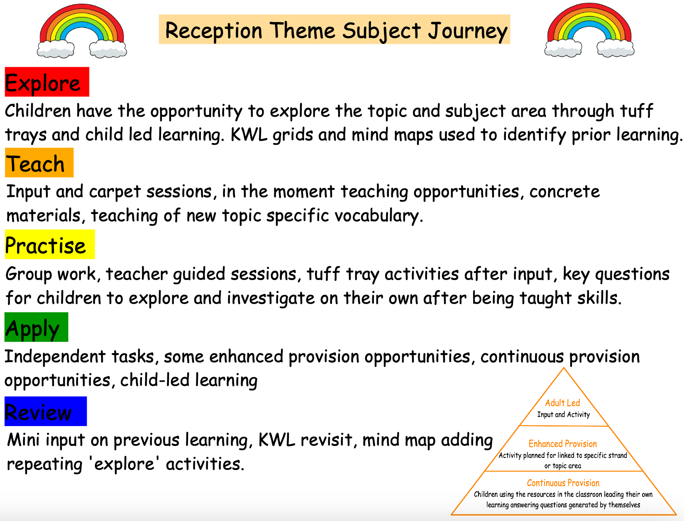

EYFS Early Learning Goals

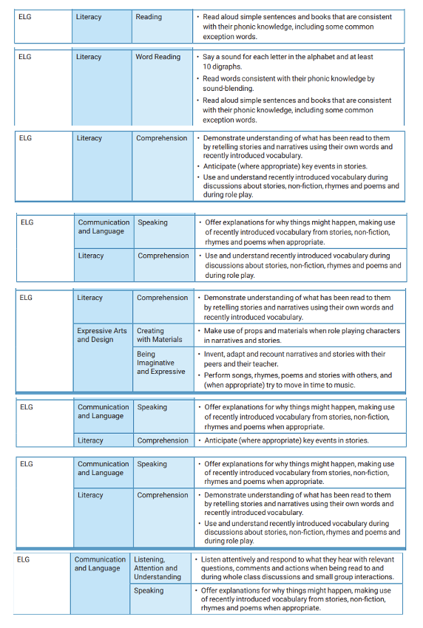
Phonics

We have Supersonic Phonic Friends as our phonic scheme. It has been chosen due to the rhyme and alliteration running through the whole scheme, it’s interactive nature, and consistency in approach to teaching phonics across the school. Staff follow the Supersonic Phonic Friends planning and Powerpoint presentations online. Staff are expected to plan their own revisit and review sessions which will be based on previous informal assessments of learning. Staff have the autonomy to and are expected to make alterations to planning to suit the needs of the children, for instance how long to spend on the learning of a GPC (Grapheme Phoneme Correspondence).
Each new piece of learning should include the following sections:
- Revisit and review (every lesson)
- Listen with Len
- Segment with Seb and blend with Ben
- See it with Sam
- Segment with Seb and build with Bill
- Read with Rex
- Write with Ron

Nursery phonics sessions are typically 10-15 minutes. Reception lessons start at 20 minutes, with daily additional oral blending – increasing to 25-30 minutes when ready, like Key Stage 1. Timely interventions take place for the lowest 20% and children who have been identified as needing more support from lesson assessments. These usually take the form of post-teach of approximately 10-15 minutes. This is also the case for Key Stage 2 children who need extra support with phonics.

Reading

Whilst some reading strategies are used more often to teach emergent reading (such as phonics), the academy recognises that learners may require a blend of different strategies in order for children to progress.

1. Phonics (see previous sections on phonics)

2. Group Reading and Individual Reading in Reception and Key Stage 1
Teachers and support staff will teach children to read in small group sessions, three times per week. Children will be placed in groups which are as closely aligned to their phonic level as possible. They will read the same book three times. Each reading session is made up of three parts:
1. Revisit and Review/Pre-read.
2. Practise and Apply, decoding and developing automaticity,
3. Review - after reading.

Reading teachers will use informal assessment from the previous day to inform the Revisit and Review/Pre-read. The Review after reading follows the same pattern each week:
Day 1 – Decoding specific words.
Day 2 – Prosody and expression.
Day 3 – Comprehension.

Group reading will be used to:
• Ensure each child is listened to read three times a week by a member of teaching staff.
• Provide an opportunity for children to consolidate their early decoding skills.
• Focus on developing fluency and automaticity.
• Monitor the application of reading skills of the child.
• Enable teachers to model the skills and strategies used by effective readers.
• Ensure that children hear a good model of how the text should be read, with expression and intonation.

If a child requires more focused support in applying their phonics and/or developing their fluency, staff may listen to them read individually too.

Home Reading
When the book has been read three times at school, it will be sent home for further reading practise, to enable the child to develop automaticity and fluency with a familiar text. We ask that children are listened to read at home at least three times per week.
Reading books in Reception and Key Stage 1 will be changed once per week.

3. Whole Class Reading
• Shared reading takes place in various forms across all ages:

In Reception, shared reading is a whole-class learning experience based on a shared text. These texts align with the overarching theme for the half term and may provide the theme for adult-led activities and activities within classroom provision. Through these experiences children develop their understanding of vocabulary, language, characters, settings and simple story structures.

In Key Stage 1, reading lessons, in addition to the group reading sessions (above) take place twice a week, for twenty minutes, and are closely linked to the class text for the half term. These sessions focus on developing key reading skills, including retrieval, vocabulary, inference, prediction and sequencing. Lessons are designed to be engaging and varied, combining traditional comprehension activities with active learning opportunities that bring the text to life. Children take part in scavenger hunts, matching tasks, drama and reading games that encourage them to explore the story in fun and meaningful ways. This approach helps pupils build a deep understanding of the text while developing the skills needed to become confident, thoughtful readers.

In Key Stage 2, reading takes place within the Whole Class Reading session, using a range of texts across the half term, including their class text, non-fiction texts and poetry. Children access the text through copies and the use of the interactive whiteboard/visualiser. The children’s reading has a purpose, such as exploring characters, plot, making simple predictions and developing vocabulary further. Reading will take place in a range of ways, such as teacher modelling, paired reading, echo reading, choral reading and independent reading. Teachers will model using and applying the reading skills in conjunction with children as part of the shared reading process and discussion. The whole class reading structure ensures that children will have opportunities to apply their skills to independent activities and build up their stamina to answering a range of comprehension questions on their book.

Reading lessons are taught four times a week, for thirty minutes. Within these WCR lessons, the children will continue to work on building their reading fluency in order that they may become automatic in their reading and will be able to read with appropriate tone and expression (prosody). Each lesson focuses on developing a range of key reading skills, including retrieval, inference, vocabulary, summarising, predicting, author questions, and comparing and commenting on texts. Lessons are carefully structured to deepen pupils’ understanding of language, themes and author intent. A mixture of traditional comprehension tasks and interactive activities, such as discussion-based learning, text comparisons and vocabulary challenges, are used to engage pupils and promote higher-level thinking. This approach supports children in becoming analytical, reflective readers who can confidently discuss and evaluate a wide range of texts while maintaining a passion for reading.

The class texts used in shared reading are linked to writing activities.

WCR across all stages will be used to:
• Demonstrate how to read a wide variety of different genres and text types;
• Demonstrate that reading is a pleasurable experience;
• Give access to challenging texts for all pupils;
• Focus on developing the comprehension skills of the children;
• Focus on language development through oracy.

WCR work is recorded in an exercise book and marked in line with the marking policy

4. Independent Reading (SQUIRT)
We feel it is important for all children to enjoy time with a book, reading or interacting at their own level. For this we hold weekly SQUIRT (Silent, Quiet, Uninterrupted, Reading Time) in our library. This is a timetables session.

Independent reading / SQUIRT sessions will be used to:
- Promote enjoyment of reading;
- Promote the development of independent learning strategies;
- Provide a context for the application of skills and knowledge about reading.

.

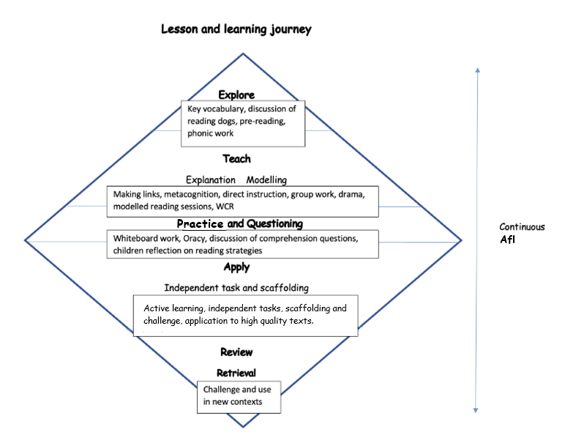

Impact
In addition to the outcomes shown on our curriculum tree the specific impact of the St Thomas’ Reading Learning Journey is that children will (as stated in the national curriculum):

- read easily, fluently and with good understanding
- develop the habit of reading widely and often, for both pleasure and information
- acquire a wide vocabulary, an understanding of grammar and knowledge of linguistic conventions for reading, writing and spoken language
- appreciate our rich and varied literary heritage
- use discussion in order to learn; they should be able to elaborate and explain clearly their understanding and ideas
- are competent in the arts of speaking and listening, making formal presentations, demonstrating to others and participating in debate

Adaptive Teaching Strategies

To ensure all pupils can access our reading curriculum and lessons, we make the following adjustments where necessary:

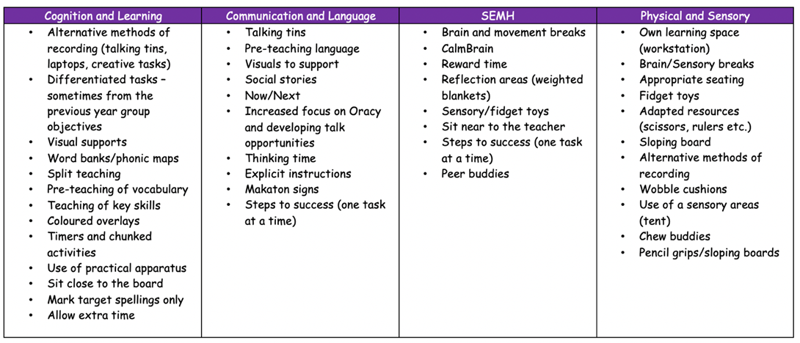

Phonics Road Map

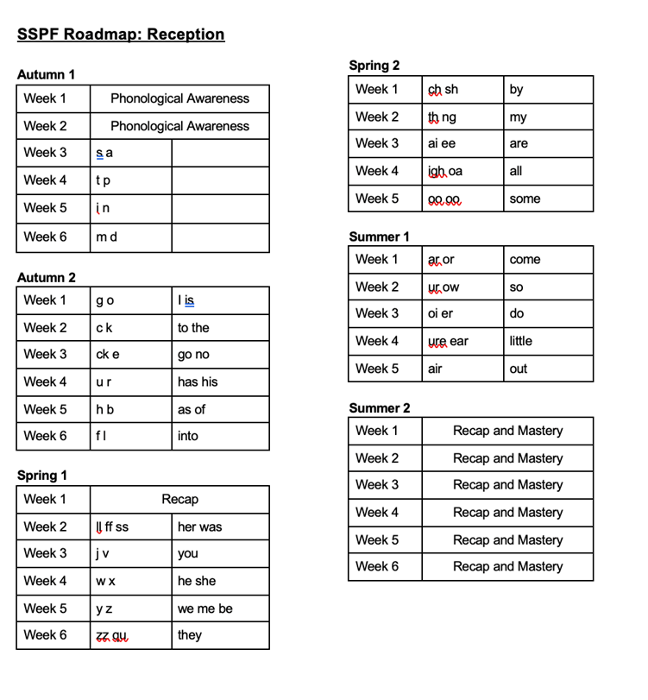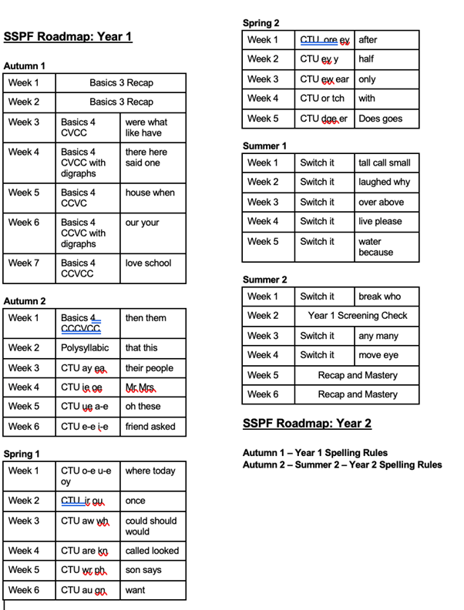
2026/2027 Class focus texts

Year | Autumn 1 | Autumn 2 | Spring 1 | Spring 2 | Summer 1 | Summer 2
Rec | 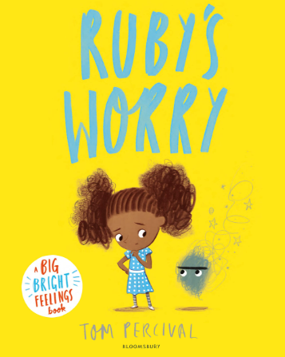  Tom Percival – Ruby’s Worry  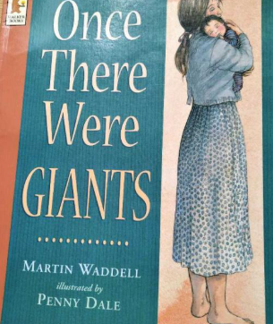 Martin Waddell - Once there were giants  +Space Week – Tim Peake (significant individ  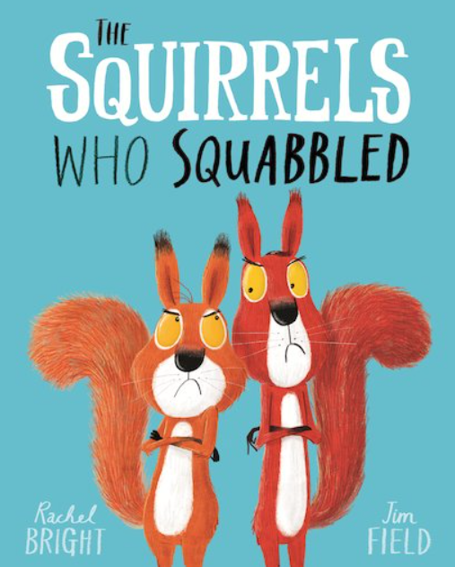 Rachel Bright – The Squirrels Who Squabbled  Black History Month  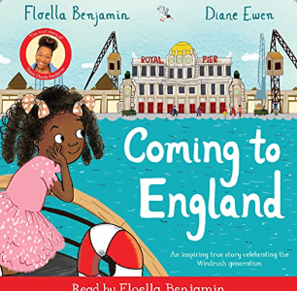  Floella Benjamin – Coming to England | 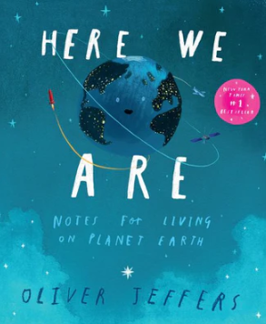  Oliver Jeffers – Here We Are  Nursery Rhyme Week (10-14 Nov):  -Sing a Song of Sixpence  -Humpty Dumpty  -When I was One  -I Hear Thunder  -Two Little Dickie Birds  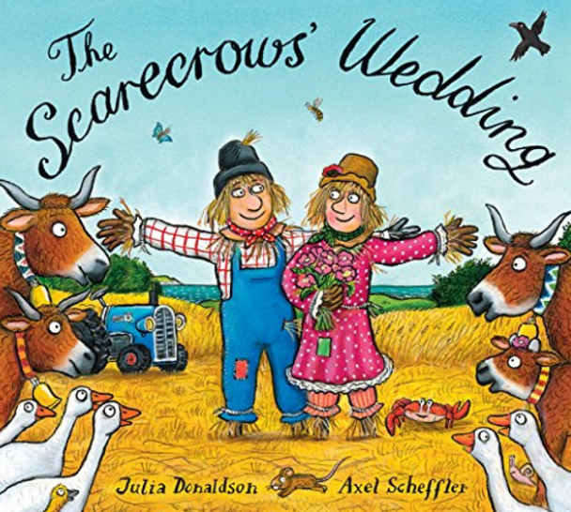  Julia Donaldson – The Scarecrows Wedding  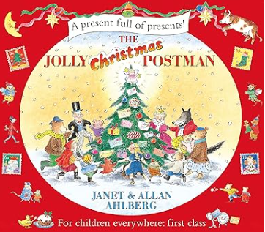  Allan & Janet Ahlberg – The Jolly Christmas Postman | 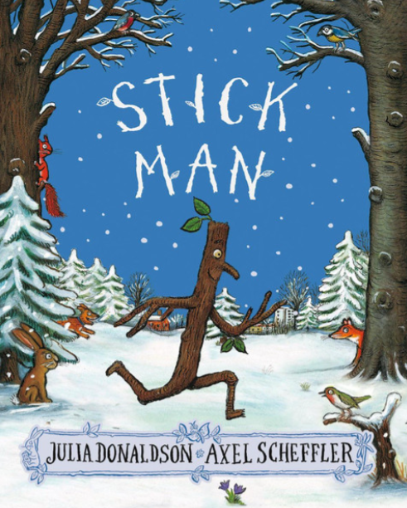  Julia Donaldson – Stick Man  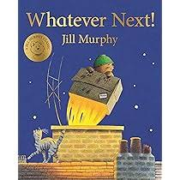  Jill Murphy – Whatever Next  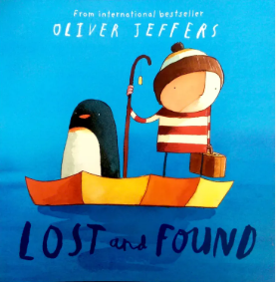  Oliver Jeffers – Lost and Found | 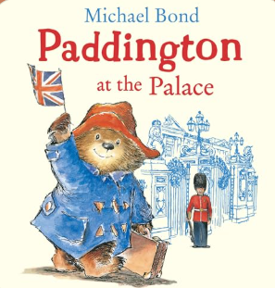  Michael Bond – Paddington at the Palace  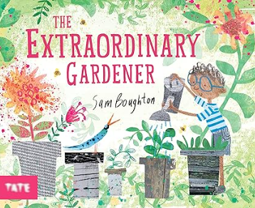  Sam Boughton – The Extraordinary Gardener  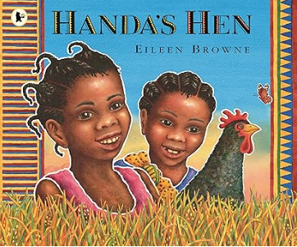  Eileen Browne – Handa’s HeN | Eileen Browne – Handa’s Hen  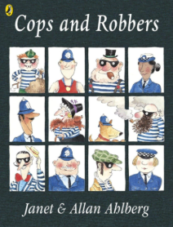  Allan & Janet Ahlberg – Cops and Robbers  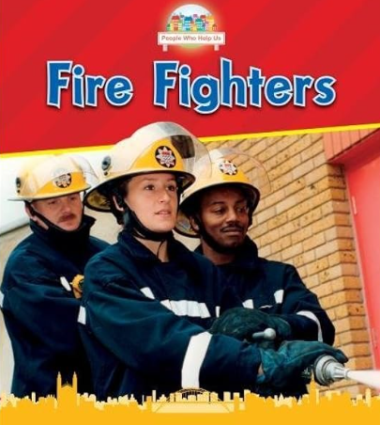  Non-fiction – Fire Fighters / Police Officers | 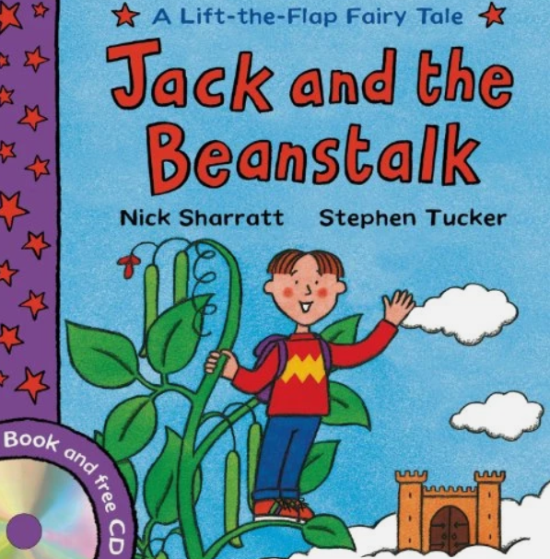  Nick Sharratt - Jack and the Beanstalk  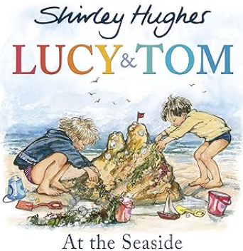  Shirley Hughes - Lucy and Tom at the seaside  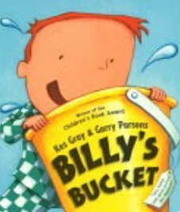  Kes Gray – Billy’s Bucket
Y1 | 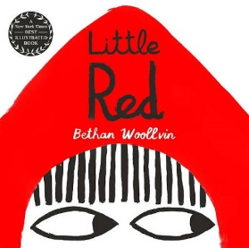  Bethan Woolvin – Little Red  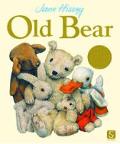  Jane Hissey – Old Bear  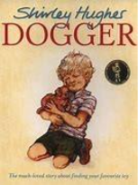  Shirley Hughes – Dogger | 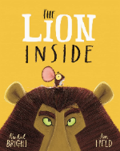  Rachel Bright – The Lion Inside  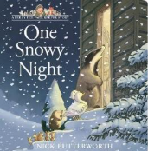  Nick Butterworth – One Snowy Night  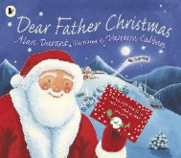  Alan Durant – Dear Father Christmas | 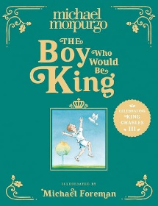  Michael Morpurgo – The Boy Who would be King  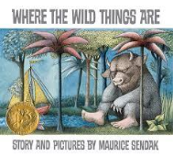  Maurice Bendak– Where the Wild Things are | 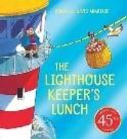  Ronda and David Hermitage – The Lighthouse Keeper’s Lunch  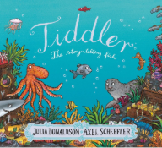  Julia Donaldson – Tiddler  . | 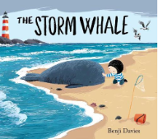  Benji Davies – The Storm Whale  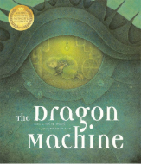  Helen Ward - The Dragon Machine | 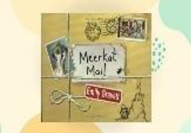  Emily Gravett – Meerkat Mail  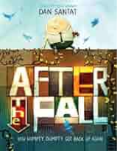  Dan Santat – After The Fall
Y2 |   Rachel Bright – The Way Home for Wolf  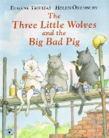  Helen Oxenbury - The Three Little Wolves and the Big Bad Pig |   Kate Cunningham – Vlad and the Great Fire of London  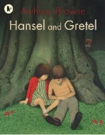  Anthony Browne – Hansel and Gretel |   Simon Bartram – Man on the Moon  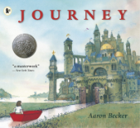  Aaron Becker - Journey | 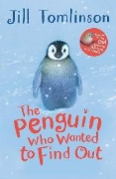  Jill Tomlinson – The Penguin Who Wanted to Find Out | 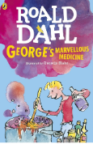  Roald Dahl – George's Marvellous Medicine | 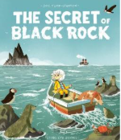  Joe Todd-Stanton – The Secret of Black Rock  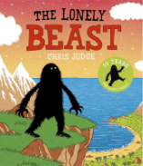.  Chris Judge – The Lonely Beast
Y3 | 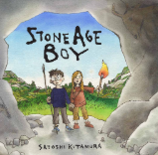  Satoshi Kitamura - Stone Age Boy  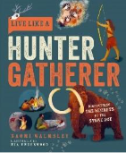  Naomi Walmsley – Live like a Hunter Gatherer | 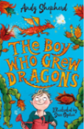  Andy Shepherd – the boy who grew dragons | 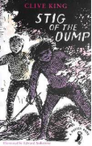  Clive King – Stig of the Dump | 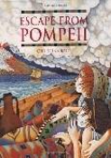  Christina Balit – Escape from Pompeii | 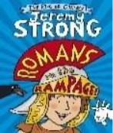  Jeremy Strong – Romans on the Rampage  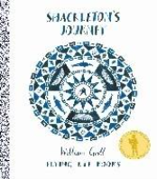#  William Grill – Shackleton’s journey
Y4 | 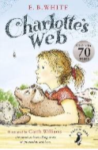  E.B White – Charlotte's Web | 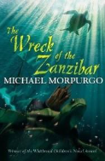  Michael Morpurgo – The Wreck of the Zanzibar  - Mariner. | 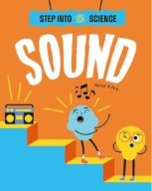  Peter Riley – Step into Science – Sound  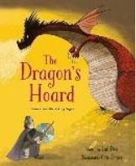  Lari Don – The Dragon’s Hoard | 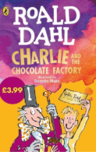  Roald Dahl – Charlie and the Chocolate Factory | 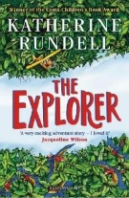  Katherine Rundell – The Explorer | 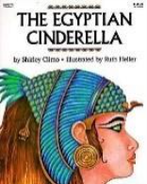  Shirley Climo - The Egyptian Cinderella
Y5 | 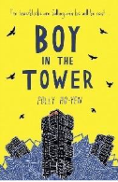  Polly Ho-yen – Boy in the Tower | Polly Ho-yen – Boy in the Tower    Lara Albanese – Space Maps: Your tour of the Universe | 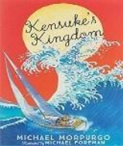  Michael Morpurgo –  Kensuke’s Kingdom |  | 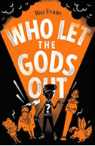  Maz Evans – Who Let the Gods Out? | 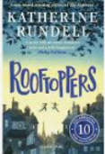  Katherine Rundell – Rooftoppers
Y6 | 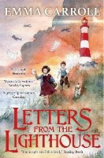  Emma Carroll – Letters from the Lighthouse | 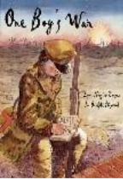  Lynn Huggins-Cooper – One Boy’s War | 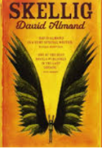  David Almond - Skellig | David Almond – Skellig | 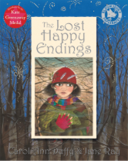  Carol Ann Duffy - The Lost Happy Endings  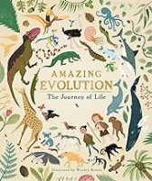  Anna Claybourne – Amazing Evolution | 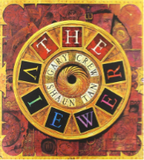  Gary Crew – The Viewer  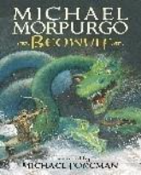  Michael Morpurgo – Beowulf

Whole Schoool Progression of Skills ( adapted from the National Curriculum statements)

 | Year 1 | Year 2 |  | Year 3 | Year 4 |  | Year 5 | Year 6
Word Reading | Read aloud phonically-decodable texts  Speedily read all 40+ letters /groups for 40+ phonemes including alternative sounds for graphemes  Read Year 1 common exception words  Read polysyllabic words containing taught GPCs  Read common suffixes (–s, –es, –ing, –ed, –er and –est)  Read contractions and understand that the apostrophe represents the omitted letter(s) | Apply phonic decoding until automatic and reading is fluent  Read common suffixes (-ed, -ing,-er, -est, -y, -er, -ment, -ful, -ness, -less, -ly  Note punctuation to read with appropriate expression  Read Year 2 common exception words  Read polysyllabic words containing above graphemes  Read most words quickly & accurately without overt sounding and blending |  | Apply their growing knowledge of root words, prefixes and suffixes (morphology and etymology), both to read aloud and to understand the meaning of new words they meet  Read further exception words, noting the unusual correspondences between spelling and sound, and where these occur in the word |  |  | Apply their growing knowledge of root words, prefixes and suffixes (morphology and etymology), both to read aloud and to understand the meaning of new words that they meet
Vocabulary     | Can identify a word that means the same as…. | Can find and copy a word that means the same as... |  | Can match the underlined word in a sentence to the correct definition  Can use a dictionary to look up the meaning of a word |  |  | Can find and copy a group of words that means the same as…. (synonyms and antonyms)  Give the meaning of words in certain sentences (words with more than one meaning)
Retrieval     | Can locate specific information- where, when, who, what  Can identify whether a statement is true or false | Can give more than one answer to the same question  Can tick correct response in a table of different options |  | Can locate information by skimming (for a general impression) and scanning (to locate specific information)  Can quote from the text to answer a retrieval question  Can answer and write true or false statements about the text using evidence |  |  | Can quote from the text to answer a retrieval question with more than one answer (Give 3 things)  Can identify and explain the difference between fact and opinion.  Can use text marking to retrieve information or ideas from texts (e.g. highlighting, notes in the margin).
Inference   | Can discuss an answer to a question where the information is not directly in the text (why) | Can tick the correct statement about a story when the information is implied and not stated  Can find a quote in the text to back up their answer  Can find and copy words that show… (inferring meaning from context) |  | Can explain how and why main characters act in certain ways in a story or why events happen (How do you know, what evidence is there to suggest…)  Can understand and explain different characters’ points of view. (What evidence is there to suggest.)  Can infer meaning, using evidence from the text and wider experiences (uses quotes to back up answer) |  |  | Can refer to the text to support inferences about characters/setting/action (how can you tell that)  Can securely make deductions firmly rooted in the evidence in the text- ‘according to the text questions’ using (PE model point-evidence)
Summarising  /Sequencing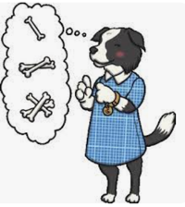   | Can sequence pictures about a story | Can sequence events in a story by numbering statements  Can match sub-headings to paragraphs |  | Can identify the main theme of a paragraph  Can identify and order key events in a text |  |  | Can summarise the text in fewer words whilst keeping the main points  Can suggest alternative sub-headings for paragraphs
Predicting   | Can predict the ending or a story from what they have read so far. | Can predict what might happen to a character from details stated or implied. |  | Can make plausible predictions based on knowledge from text  Can back up their predictions with a quote from the text |  |  | Can refer to the text to support predictions and opinions (What evidence is there to suggest?)  Can make plausible predictions based on knowledge from text or what is implied
Commentating |  |  | Can talk about the purpose of features of the text (such as glossary, contents etc)  Can label different parts of texts studied- sub headings, title, headline, diagram etc.  Can use knowledge of text structure to better understand the information (e.g. use appropriate heading and sub-heading in non-fiction, find relevant paragraph / chapter in fiction)  Can compare the structure of different stories to discover how they differ in pace, build up, sequence, complication and resolution. |  |  | Can identify the intended audience for a text  Can identify the ways in which paragraphs are linked (e.g. use of connecting adverbs, pronouns for character continuity).  Can discuss why headings/chapter names/character names have been chosen for that text  Can give detailed insight into how the structural choices support the writer’s theme or purpose (e.g. decisions about plot structure, mapping character development through a whole text, flash backs)  Can discuss the range of organisational features used and how they contribute to the overall effect of the text (e.g. how a writer changes viewpoints within a text; how a writer organises information)
Author’s use of language |  |  | Can talk about the effects of different words and phrases to create different images and atmosphere (e.g. powerful verbs, descriptive adjectives and adverbs) and in non-fiction texts  Can explore potential meanings of ambitious vocabulary (WOW Words) read in context (using knowledge of etymology (the word origin), morphology (structure- the ‘root’ word plus prefix /suffix), or the context.  Can say what impressions they get from the words used to describe settings/character |  |  | Can discuss how an author builds a character through dialogue, action and description.  Can discuss the difference between literal and figurative language and the effects of imagery- what impressions do you get of  Can evaluate how messages, moods, feelings and attitudes are conveyed in poetry, prose and non-fiction, making reference to the text  Can recognise the use of irony and comment on the writer’s intention (e.g. sarcasm, insincerity, mockery)

St Thomas’ CofE Academy – Progression in reading spine
Key Stage 1
Firm Foundations in Phonics – Big Cat Foundations for Phonics
The Basics 2
Group 1 |  | Group 2 |  |  |  |  | Group 3 |  |  |  | Group 4 |  |  |  | Group 5 |  |  |  |  | Group 6
Big Cat Letters and Sounds Revised
The Basics 3
Group 1 | Group 2 |  |  |  |  | Group 3 |  |  |  | Group 4 |  |  | Group 5 |  |  |  | Group 6 |  |  |  |  | Group 7
Big Cat Letters and Sounds Revised
The Basics 4
Group 1 |  |  |  | Group 2 |  |  |  |  | Group 3 |  |  |  |  | Group 4 |  |  |  |  | Group 5
Big Cat Letters and Sounds Revised
The Higher Levels – Choose to use
Group 1 |  |  | Group 2 |  |  |  |  | Group 3 |  |  |  | Group 4 |  |  |  | Group 5 |  |  |  |  | Group 6
Big Cat Letters and Sounds Revised
The Higher Levels – Switch it spellings
Group 1 |  |  |  |  | Group 2 |  |  |  |  |  |  | Group 3 |  |  |  |  |  | Group 4
Big Cat Letters and Sounds Revised
Year 2 (off the SSPF programme) & Key Stage 2
Green books (In cupboards outside library area)
Turquoise books (In cupboards outside library area)
Purple books (In cupboards outside library area)
Gold books (In cupboards outside library area)
White books (In cupboards outside library area)
Lime books (In cupboards outside library area)
Copper books (In cupboards outside library area)
Free Reader (Choose from within the library)

