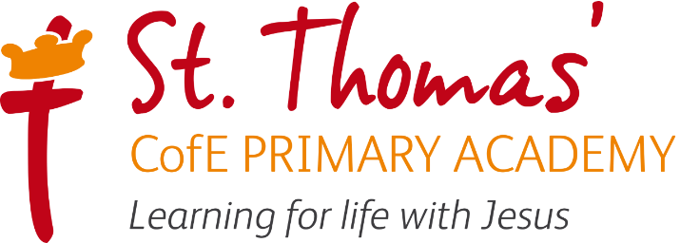

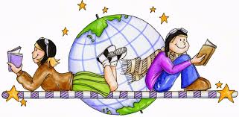

Geography Learning Journey
2026/2027

Intent, Implementation and Impact

Learning for life with Jesus

Intent
All areas of our curriculum are underpinned by our Gospel values and we ensure that our curriculum makes links to these values. At the heart of each subject is a set of core skills which form a subject learning journey, this journey is built from EYFS through to year 6 and the skills progressive as you move through the school. Knowledge is communicated to ensure coverage of National curriculum and it is through this knowledge that children apply their skills. Children at St Thomas’ leave with a secure knowledge of both the academic knowledge and skills needed for the next stage of their education. They will have developed a clear set Christian and moral values which they can apply in all areas of their lives and will have taken part in real-life experiences which will have raised their aspirations and given them a thirst for wisdom and knowledge.
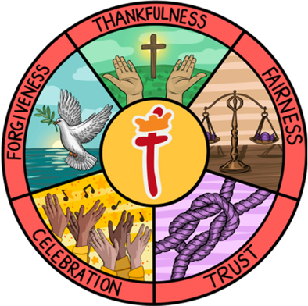
The intention of the St Thomas’ Geography learning journey is to inspire all pupils develop their knowledge of the world, an understanding where they live and their impact on our lives today and as a result understand how they can make a positive impact on the world. We focus on developing the skills, knowledge and understanding that children need in order find out about the world so they have the skills to continually develop their skills and knowledge throughout their lives.

Our Geography lead in school is Miss E Knobbs

Implementation

St Thomas’ Geography Learning Journey focuses on a spiral curriculum model where previous skills and knowledge are revisited and built upon. Over the course of the journey children will focus on both declarative and procedural knowledge. Declarative knowledge in Geography is the factual knowledge surrounding the world we live in. This knowledge is not a list of disconnected facts; it is explicitly linked to the content being taught. Procedural knowledge can be viewed as the know-how to apply declarative facts. This might include applying their Geographical skills in another context.

At the start of each topic the children explore the key question using the knowledge they already have of the topic. During lessons, the children will practice and apply the skills and knowledge through activities that are scaffolded where needed. Throughout their Geography journey, the children will be taught key sills that are developed and practiced throughout their time in school, such as map work. Assessment and feedback will address misconceptions and identify next steps for learning.

Geography Lesson Journey

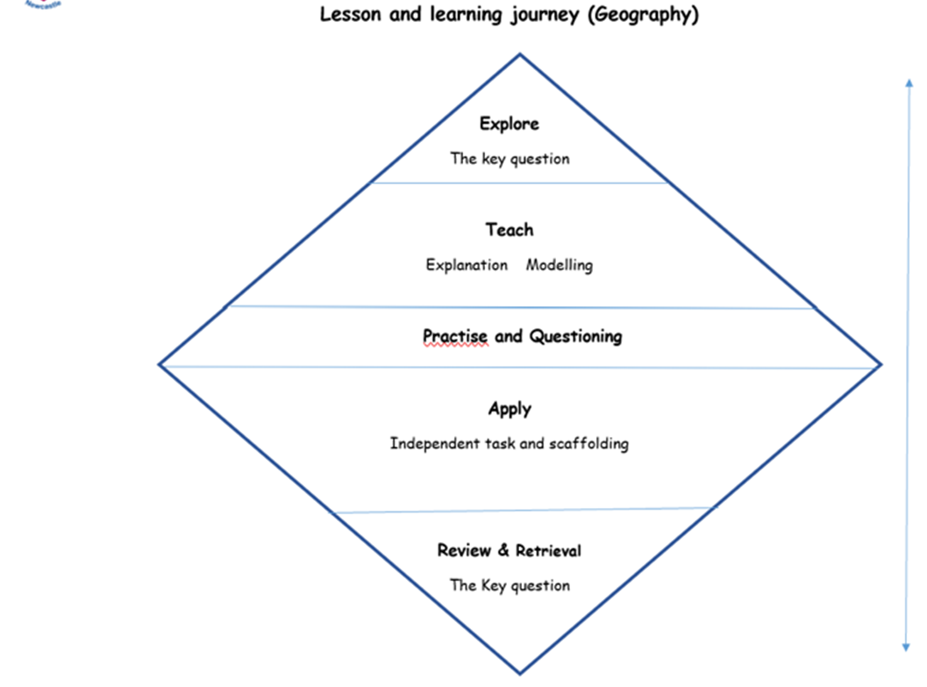

In Geography, work is recorded in an exercise book and marked in line with the marking policy

EYFS
The Area of Learning that builds the foundations for Geography, within the Early Years Foundation Stage Statutory Framework, is ‘Understanding the world’, through which the children learn about the natural world, people, culture and communities, and the past and present. Children will explore key questions within a wider topic/theme. Learning takes the form of adult-led inputs and child-initiated learning within the continuous provision. Reception have an investigation station and a curiosity cuboid. Humanities based enhanced provision will be planned for each half term.
Humanities based enhanced and child-initiated provision may also be found in the Construction area, for instance building a farm or a city. Humanities may also be found in the outside provision, either enhanced or child-initiated, such as treasure hunts, map drawing.

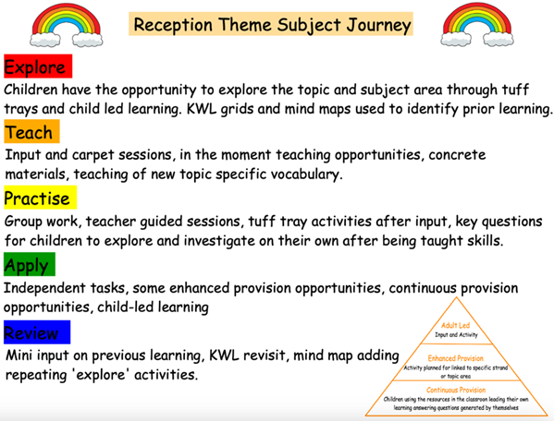

Impact

The impact of the St Thomas’ Geography Learning Journey is that children will (as stated in the national curriculum):

- develop contextual knowledge of the location of globally significant places – both terrestrial and marine – including their defining physical and human characteristics and how these provide a geographical context for understanding the actions of processes
- understand the processes that give rise to key physical and human geographical features of the world, how these are interdependent and how they bring about spatial variation and change over time
- collect, analyse and communicate with a range of data gathered through experiences of fieldwork that deepen their understanding of geographical processes
- interpret a range of sources of geographical information, including maps, diagrams, globes, aerial photographs and Geographical Information Systems (GIS)
- communicate geographical information in a variety of ways, including through maps, numerical and quantitative skills and writing at length.

Formative assessment takes part in each lesson, and misconceptions are addressed straightaway. Adaptations and scaffolds are used to support learning where needed.

Adaptive Teaching Strategies

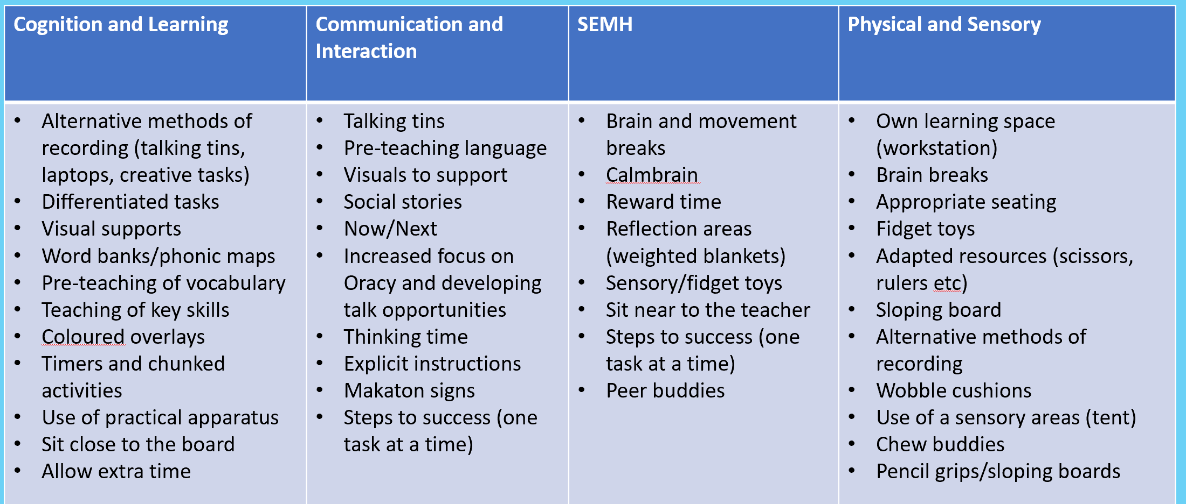

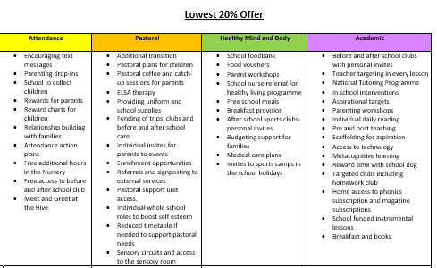
Lowest 20% offer

2026/2027 Geography Overview

 | Autumn 1 | Autumn 2 |  | Spring 1 | Spring 2 | Summer 1 | Summer 2
Nursery | What makes me Amazing? | What do we celebrate? |  | What is it like in Winter? | What is it like in the countryside? | What is our community like? | What is it like at the seaside?
Reception | What makes me marvellous? |  | Why do we celebrate?  Where is my school? | What happens in Winter?  What is it like where I live? | What is it like the in the big city? London | Who helps in our community? | What were seaside holidays like in the past?
Year 1 |  | What is it like here?  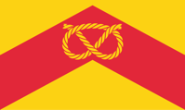 |  |  | What is the weather like in the UK?   |  | What is it like to live in Shanghai?  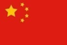
Year 2 | Why is our natural world wonderful?   |  |  |  | Would you prefer to live in a hot or a cold place?   |  | What is it like to live by the coast?  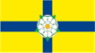
Year 3 |  | Are all settlements the same?   |  |  | Why do people love near volcanoes?   |  | Who lives in Antarctica?  
Year 4 |  | What are rivers and how are they used?   |  |  | Where does our food come form?  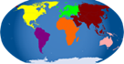 | Why are rainforests important to us?  
Year 5 |  | What is life like in the Alp’s?  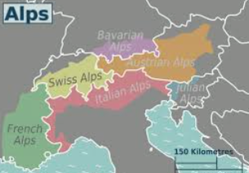 |  |  | Why do Oceans matter?   |  | Would you live in a desert?  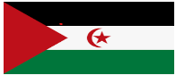
Year 6 |  |  |  | Why does population change?   | Where does our energy come from?   |  | Can I carry out an independent fieldwork inquiry?

Geographical Skills Progression
EYFS – Year 6.

 | EYFS | Year 1 | Year 2 | Year 3 | Year 4 | Year 5 | Year 6
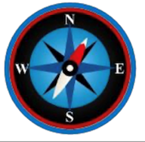 | To know how to read a map of the school.  To know how to travel from their house to school. | Using an atlas to locate the UK.  Using directional language to describe the location of objects in the classroom and playground.  Using directional language to describe features on a map in relation to other features (real or imaginary)  Using simple picture maps and plans to move around the school.  Showing on a map which continent they live in.  Locating the four countries of the United Kingdom (UK) on a map of this area.  Beginning to locate the capital cities of the four countries of the UK on a map of this area. Showing on a map which country they live in and locating its capital city.  Using an atlas to locate the UK.  Using simple picture maps and plans to move around the school.  Locating two of the world’s seven continents on a world map.  Using a world map and globe to locate four of the world’s seven continents (Europe and Asia).  Using a world map and globe to locate the Atlantic Ocean and Pacific Ocean. | Showing on a map the oceans nearest the continent they live in.  Locating the surrounding seas of the UK on a map of this area.  Using an atlas to locate the four capital cities of the UK.  Using locational language and the compass points (N, S, E, W) to describe the location of features on a map.  Using locational language and the compass points (N, S, E, W) to describe the route on a map.  Locating all the world’s seven continents on a world map.  Locating some hot and cold areas of the world on a world map.  Locating the Equator and North and South Poles on a world map.  Locating hot and cold areas of the world in relation to the Equator and the North and South poles.  Using a world map, globe and atlas to locate all the world’s seven continents on a world map.  Confidently locating the capital cities of the four countries of the UK on a map of this area.  Using an atlas to locate the four capital cities of the UK. Using a world map, globe and atlas to locate all the world’s seven continents on a world map.  Using a world map, globe and atlas to locate the world’s five oceans. | Locating some major cities of the countries studied.  Locating key physical features in countries studied including significant environmental regions.  Locating some key human features in countries studied.  Locating some counties in the UK (local to your school).  Locating some cities in the UK (local to your school).  Beginning to locate the twelve geographical regions of the UK.  Locating some countries in Europe and North and South America using maps.  Locating the world’s most significant mountain ranges on a map and identifying any patterns.  Locating where the world’s volcanoes are on a map and identifying the ‘Ring of Fire’.  Finding countries and features of countries in an atlas using contents and index.  Beginning to use maps at more than one scale.  Locating some countries in Europe and North and South America using maps.  Locating some major cities of the countries studied.  Locating some of the world’s most significant rivers and identifying any patterns.  Beginning to use maps at more than one scale.  Using atlases, maps, globes, satellite images and beginning to use digital mapping to locate countries studied.  Using atlases, maps, globes and beginning to use digital mapping to recognise and describe physical and human features in countries studied.  Zooming in and out of a digital map.  Beginning to use the key on an OS map to name and recognise key physical and human features in regions studied.  Accurately using 4-figure grid references to locate features on a map in regions studied. Beginning to locate features using the 8 points of a compass.  Using a simple key on their own map to show an example of both physical and human features. | Locating some countries in Europe and North and South America using maps.  Locating key physical features in countries studied including significant environmental regions.  Locating some key human features in countries studied.  Finding the position of the Equator and describing how this impacts our environmental regions.  Finding lines of latitude and longitude on a globe and explaining why these are important.  Identifying the position of the Tropics of Cancer and Capricorn and their significance.  Using atlases, maps, globes, satellite images and beginning to use digital mapping to locate countries studied. Finding countries and features of countries in an atlas using contents and index.  Mapping land use in a small local area using maps and plans.  Locating some countries in Europe and North and South America using maps.  Identifying the position and significance of both the Arctic and Antarctic Circle.  Accurately using 4-figure grid references to locate features on a map in regions studied.  Beginning to locate features using the 8 points of a compass.  Using atlases, maps, globes, satellite images and beginning to use digital mapping to locate countries studied.  Finding countries and features of countries in an atlas using contents and index | Locating more countries in Europe and North and South America using maps.  Locating key human features in countries studied.  Locating many counties in the UK.  Confidently locating the twelve geographical regions of the UK.  Confidently using and understanding maps at more than one scale.  Using atlases, maps, globes and digital mapping to locate countries studied.  Using atlases, maps, globes and digital mapping to describe and explain physical and human features in countries studied.  Recognising an increasing range of Ordnance Survey symbols on maps and locating features using six-figure grid references.  Beginning to use thematic maps to recognise and describe human and physical features studied. Confidently using the key on an OS map to name and recognise key physical and human features in regions studied.  Following a short pre-prepared route on an OS map.  Accurately using four and six-figure grid references to locate features on a map in regions studied.  Locating major cities of the countries studied.  Locating some key physical and human features in countries studied on a map.  Identifying significant environmental regions on a map.  Using maps to explore wider global trading routes.  Beginning to use thematic maps to recognise and describe human and physical features studied.  Beginning to use standard field sampling techniques appropriately.  Deciding how to present data using plans, freehand sketch maps, annotated drawings, graphs, presentations, writing at length and digital technologies (photos with labels/captions) when communicating geographical information. | Locating major cities of the countries studied.  Locating some key physical features in countries studied on a map.  Locating key human and physical features in countries studied.  Locating many cities in the UK.  Confidently locating the twelve geographical regions of the UK.  Confidently using and understanding maps at more than one scale.  Using atlases, maps, globes and digital mapping to locate countries studied. Using atlases, maps, globes and digital mapping to describe and explain physical and human features in countries studied.  Recognising an increasing range of Ordnance Survey symbols on maps and locating features using six-figure grid references.  Recognising the difference between Ordnance Survey and other maps and when it is most appropriate to use each. Selecting a map for a specific purpose.  Confidently using the key on an OS map to name and recognise key physical and human features in regions studied.  Confidently locating features using the 8 points of a compass.  Identifying the eight compass points on an OS map.  Making sketch maps of areas studied including labels and keys where necessary.  Locating more countries in Europe and North and South America using maps.  Using longitude and latitude when referencing location in an atlas or on a globe.  Using maps to explore wider global trading routes.  Recognising an increasing range of Ordnance Survey symbols on maps and locating features using six-figure grid references.  Using models and maps to talk about contours and slopes.  Selecting a map for a specific purpose.  Accurately using four and six-figure grid references to locate features on a map in regions studied.
 | Asking questions about the different environments they see and visit.  Being curious about the world around them | Asking questions about the world around them.  Asking and answering simple questions about the features of their school and school grounds. | Asking and answering simple questions about human and physical features of the area surrounding their school grounds. | Asking and answering one-step and two-step geographical questions. Observing, recording, and naming geographical features in their local environments.  Finding answers to geographical questions through data collection. | Beginning to choose the best approach to answer an enquiry question.  Asking and answering one-step and two-step geographical questions.  Suggesting different ways that a locality could be changed and improved.  Finding answers to geographical questions through data collection. | Choosing the best approach to answering an enquiry question.  Making an independent or collaborative plan of how they wish to collect data to answer an enquiry-based question. | Identifying, analysing and asking questions about distributions and relationships between features using maps (e.g settlement distribution).  Developing their own enquiry questions.  Choosing the best approach to answering an enquiry question.  Making an independent or collaborative plan of how they wish to collect data to answer an enquiry-based question.  Designing interviews/questionnaires to collect qualitative data.  Conducting interviews/questionnaires to collect qualitative data.
 | Draw freehand pictures of their surroundings.  Draw information from a simple map. | Drawing freehand maps (of real or imaginary places) using simple pictures or symbols.  Drawing a simple sketch map of the school and local area using simple pictures, colours, or symbols to represent features.  Using a simple recording technique to express their feelings about a specific place and explaining why they like/dislike some of its features. | Collecting quantitative data through a small survey of the local area/school to answer an enquiry question.  Drawing a simple sketch map of the playground or school grounds using symbols to represent human and physical features. | Taking digital photos and labelling or captioning them.  Presenting data using plans, freehand sketch maps, annotated drawings, graphs, presentations, writing and digital technologies (photos with labels/captions) when communicating geographical information  Observing, recording, and naming geographical features in their local environments.  Beginning to use a simplified Likert Scale to record their judgements of environmental quality. | Observing, recording, and naming geographical features in their local environments.  Making annotated sketches, field drawings and freehand maps to record observations during fieldwork. Collecting quantitative data in charts and graphs. | Beginning to use standard field sampling techniques appropriately. Using GIS (Geographical Information Systems) to plot data sets.  Using a simplified Likert Scale to record their judgements of environmental quality.  Selecting appropriate methods for data collection.  Using GIS (Geographical Information Systems) to plot data sets. | Selecting appropriate methods for data collection.  Beginning to use standard field sampling techniques appropriately.  Using GIS (Geographical Information Systems) to plot data sets.  Using a simplified Likert Scale to record their judgements of environmental quality.  Making an independent or collaborative plan of how they wish to collect data to answer an enquiry-based question.
Observe | Talk about what they see using a wide range of vocabulary. | Recognising some physical features in their locality.  Recognising some human features in the locality. Recognising local landmarks on aerial photographs.  Recognising basic human features on aerial photographs.  Recognising basic physical features on aerial photographs.  Recognising some physical features in their locality.  Commenting on the features they see in their school and school grounds on a walk around the respective places.  Recognising local landmarks on aerial photographs.  Naming some key similarities between their local area and a small area of a contrasting non-European country.  Naming some key differences between their local area and a small area of a contrasting non-European country.  Recognising local landmarks on aerial photographs.  Recognising basic human features on aerial photographs.  Recognising basic physical features on aerial photographs. | Describing and understand the differences between a city, town and village.  Recognising human features on aerial photographs and plan perspectives.  Recognising physical features on aerial photographs and plan perspectives.  Describing and beginning to explain some key similarities between their local area and a small area of a contrasting non-European country.  Describing and beginning to explain some key differences between their local area and a small area of a contrasting non-European country.  Describing what physical features may occur in a hot place in comparison to a cold place.  Recognising physical features on aerial photographs and plan perspective Identifying characteristics (both human and physical) of the four capital cities of the UK.  Describing the key physical features in a local river area using basic geographical vocabulary.  Recognising landmarks of a city studied on aerial photographs and plan perspectives. | Identifying key physical and human characteristics of counties, cities and/or geographical regions in the UK.  Describing how a locality has changed over time, giving examples of both physical and human features.  Describing and beginning to explain similarities between two regions studied.  Describing how and why humans have responded in different ways to their local environments.  Describing and explaining how people who live in a contrasting physical area may have different lives to people in the UK.  Describing and explaining how physical features such as rivers, mountains, volcanoes and earthquakes have had an impact upon the surrounding landscape and communities.  Describing and understanding types of settlement and land use.  Explaining why a settlement and community has grown in a particular location.  Identifying how topographical features studied have changed over time using examples.  Describing how physical features, such as mountains and rivers are formed, and why volcanoes and earthquakes occur.  Describing where volcanoes, earthquakes and mountains are located globally. Identifying key physical and human characteristics of counties, cities and/or geographical regions in the UK. | Identifying how topographical features studied have changed over time using examples.  Describing how a locality has changed over time, giving examples of both physical and human features.  Describing and beginning to explain similarities between two regions studied.  Describing how and why humans have responded in different ways to their local environments.  Discussing climates and their impact on trade, land use and settlement. Describing and explaining how people who live in a contrasting physical area may have different lives to people in the UK.  Describing how humans use water in a variety of ways.  Describing and understanding types of settlement and land use.  Identifying the position of the Tropics of Cancer and Capricorn and their significance.  Identifying the position of the Northern and Southern hemispheres and explaining how they shape our seasons.  Describing and beginning to explain similarities between two regions studied.  Describing how and why humans have responded in different ways to their local environments. Discussing climates and their impact on trade, land use and settlement. | Identifying key physical and human characteristics of the geographical regions in the UK. | Identifying key physical and human characteristics of the geographical regions in the UK.  Recognising geographical issues affecting people in different places and environments
Geographical Knowledge Progression
EYFS – Year 6.

 | EYFS | Year 1 | Year 2 | Year 3 | Year 4 | Year 5 | Year 6
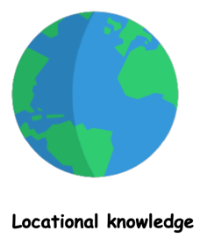 | To know their address the name of the town they live in and their school | To know that the UK is short for ‘United Kingdom’.  To know that a country is a land or nation with its own government.  To know that an aerial photograph is a photograph taken from the air above.  To know the name of two continents (Europe and Asia).  To know that a continent is a group of countries.  To know that they live in the continent of Europe. | To know that a sea is a body of water that is smaller than an ocean.  To know that a sea is a body of water that is smaller than an ocean.  To know that there are four bodies of water surrounding the UK and to be able to name them.  To know that the Equator is an imaginary line around the middle of the Earth.  To know that, because it is the widest part of the Earth, the Equator is much closer to the sun than the North and South poles.  To know that the North Pole is the northernmost point of the Earth and the South Pole is the southernmost point of the Earth.  To be able to name the seven continents of the world.  To know that the Equator is an imaginary line around the middle of the Earth.  To know that the North Pole is the northernmost point of the Earth and the South Pole is the southernmost point of the Earth.  To be able to name the five oceans of the world.  To know the four capital cities of the UK. | To know the names of some of the world’s most significant rivers.  To know the name of some counties in the UK (local to your school)  To know the name of some cities in the UK (local to your school).  To know the name of the county that they live in and their closest city.  To begin to name the twelve geographical regions of the UK.  To know the names of some countries and major cities in Europe and North and South America.  To know the names of some of the world’s most significant mountain ranges.  To know that mountains, volcanoes and earthquakes largely occur at plate boundaries.  To know where North and South America are on a world map. | To know where North and South America are on a world map.  To know the names of some countries and major cities in Europe and North and South America.  To know that climate zones are areas of the world with similar climates.  To know that countries near the Equator have less seasonal change than those near the poles.  To know that the Equator is a line of latitude indicating the hottest places on Earth and splitting our globe into the Northern and Southern Hemispheres.  To know lines of latitude are invisible lines on the globe that determine how far north or south a location is from the Equator.  To know the Tropics of Cancer and Capricorn are lines of latitude and mark the equatorial region; the countries with the hottest climates.  To know the world’s different climate zones.  To know where North and South America are on a world map.  To know the world’s different climate zones (equatorial, tropical, hot desert, temperate and polar).  To know the world’s biomes.  To know the Northern and Southern hemisphere are ‘halves’ of the Earth, above and below our Equator and have alternate seasons to each other.  To know the boundaries of the polar regions are marked by the invisible lines the Arctic and Antarctic circle. To know the patterns of daylight in the Arctic and Antarctic circle and the Equatorial regions. | To know the name of many countries and major cities in Europe and North and South America.  To know the name of many counties in the UK.  To know the name of many cities in the UK.  To confidently name the twelve geographical regions of the UK.  To know the location of key physical features in countries studied. | To know the name of many countries and major cities in Europe and North and South America.  To know the name of many cities in the UK.  To know the Prime/Greenwich Meridian is a line of longitude which goes through 0°and determines the start of the world’s time zones.  To confidently name the twelve geographical regions of the UK.
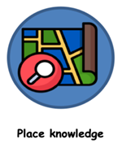 | Understand that some places are special to members of their community. | To know that life elsewhere in the world is often different to ours.  To know that life elsewhere in the world often has similarities to ours. | To know some similarities and differences between their local area and a contrasting non-European country.  To know that different parts of the world experience different weather conditions and that these are often caused by the location of the place.  To name some characteristics of the four capital cities of the UK.  To know that a capital city is the city where a country’s government is located. | To know the negative and positive effects of living near a volcano.  To know the negative effects an earthquake can have on a community.  To know ways in which communities respond to earthquakes.  To know the main types of land use.  To know some types of settlement. | To know that climates can influence the foods able to grow.  To know the main types of land use. | To know that the global population has grown significantly since the 1950s.  To know that London and the South East regions have the largest population in the UK.  To know some positive and negative impacts of humans on the environment.  To be aware of some issues in the local area. | To be aware of some issues in the local area.
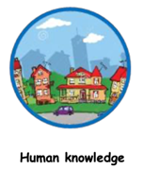 | Recognise some similarities and differences between life in this country and life in other countries.  Begin to understand the need to respect and care for the natural environment and all living things. | To know the key human features in the local area (VUE Cinema, marketplace, library, our school)  To know that human features mean any feature of an area that was made or built by humans. | To know some key human features of the UK.  To know some key human features of the UK. | To know the main types of land use.  To know some types of settlements.  To know an urban place is somewhere near a town or city.  To know a rural place is somewhere near the countryside.  To know an urban place is somewhere near a town or city.  To know a rural place is somewhere near the countryside.  To know that a natural resource is something that people can use which comes from the natural environment.  To know the main types of land use (agricultural, residential, recreational, commercial, industrial and transportation). |  | To know which factors are considered before people build settlements.  To be aware of some issues in the local area.  To know some negative impacts of humans on the environment. | To know some positive and negative impacts of humans on the environment.
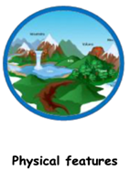 | Recognise some similarities and differences between life in this country and life in other countries. | To know the key physical features in the local area (Lyme valley park, fields around Newcastle under Lyme and the river Trent)  To know that physical features mean any feature of an area that is on the Earth naturally. | To know that coasts (and other physical features) change over time.  To know some key physical features of the UK  To know some key physical features of the UK. | To know that a natural resource is something that people can use which comes.  To know the different types of mountains and volcanoes and how they are formed.  To know that an earthquake is the intense shaking of the ground.  To know the names of some of the world’s most significant rivers.  To know the courses and key features of a river. | To know the main types of land use.  To know that a natural resource is something that people can use which comes from the natural environment.  To know the threats to the rainforest both on a local and global scale. | To know some negative impacts of humans on the environment.  To know which factors are considered before people build settlements.  To know why the ocean is important. | To know that natural resources can be used to make energy.  To know some positive and negative impacts of humans on the environment.

National Curriculum Links:

Year group | Topic Name/place | Geography enquiry question | Main national curriculum focus
Nursery | What makes me Amazing? | Who am I? Who is in my family? Have I changed since I was a baby? | Begin to make sense of their own life- story and family’s history. Develop positive attitudes about the differences between people.  Begin to understand that people are different and special.
Nursery | What do we celebrate? | What do we celebrate? | Talk about different celebrations, including different communities / faiths.
Nursery | What is it like in Winter? | What is it like in Winter? | Explore seasonal changes.
Nursery | What is it like in the countryside? | What is it like in the countryside. | Learn about farms/farming. Explore where some foods come from.
Nursery | What is our community like? | Who are the people who help us in our community? | Begin to take an interest in different occupations.
Nursery | What is it like at the seaside? | How do people spend their time at the seaside? | Know that there are different places and talk about the differences they have experienced or seen in photos.
Reception | What makes me marvellous? | What is it like to be me? Who is in my family? How have I changed since I was a baby? | Talk about members of their immediate family and community.  Name and describe people who are familiar to them.  Talk about how they have changed since they were a baby/what they can do now.
Reception | Why do we celebrate? | Where do I live? Where is my school? | Explore celebrations they have taken part in and ones they haven’t, e.g. birthdays, weddings, Christmas, Bonfire night, Diwali.
Reception | What happens in Winter? | What happens in Winter? | Explore seasonal changes.  Explore the natural world around them.  Describe what they see, hear and feel whilst outside.  Life cycle of a penguin.
Reception | What is it like in the big city? London | What is it like where I live?  What is it like in London? | Draw information from a simple map.  Recognise some environments that are different from the one in which they live.
Reception | Who helps in our community? | Who helps in our community? What does a farmer do? | Explore seasonal changes. Learn about farming, where some foods come from.  Plant and grow flowers/vegetables. Life cycle of a seed.
Reception | What were seaside holidays like in the past? | What is it like at the seaside? How has the seaside changed? | Explore seasonal changes.  Draw information from a simple map.  Recognise some environments that are different from the one in which they live.
Year 1 | Kidsgrove  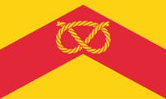 | What is it like to live here? | - Use basic geographical vocabulary to refer to: key physical features, including: beach, cliff, coast, forest, hill, mountain, sea, ocean, river, soil, valley, vegetation, season and weather  - Use basic geographical vocabulary to refer to key human features, including: city, town, village, factory, farm, house, office, port, harbour and shop  - name and locate the world’s seven continents and five oceans.  - understand geographical similarities and differences through studying the human and physical geography of a small area of the United Kingdom, and of a small area in a contrasting non-European country.  - use basic geographical vocabulary to refer to: key physical features, including: beach, cliff, coast, forest, hill, mountain, sea, ocean, river, soil, valley, vegetation, season and weather  - use basic geographical vocabulary to refer to key human features, including: city, town, village, factory, farm, house, office, port, harbour and shop
Year 1 | United Kingdom   | What is the weather like in the UK? | - Name, locate and identify characteristics of the four countries and capital cities of the United Kingdom and its surrounding seas.  - Identify seasonal and daily weather patterns in the United Kingdom and the location of hot and cold areas of the world in relation to the Equator and the North and South Poles  - name and locate the world’s seven continents and five oceans.  - name, locate and identify characteristics of the four countries and capital cities of the United Kingdom and its surrounding seas.  - use basic geographical vocabulary to refer to: key physical features, including: beach, cliff, coast, forest, hill, mountain, sea, ocean, river, soil, valley, vegetation, season and weather  - use basic geographical vocabulary to refer to key human features, including: city, town, village, factory, farm, house, office, port, harbour and shop
Year 1 | Shanghau  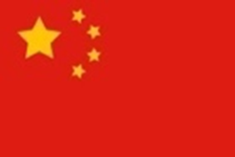 | What is it like to live in Shanghai? | - Name and locate the world’s seven continents and five oceans.  - Understand geographical similarities and differences through studying the human and physical geography of a small area of the United Kingdom, and of a small area in a contrasting non-European country.  - Use basic geographical vocabulary to refer to: key physical features, including: beach, cliff, coast, forest, hill, mountain, sea, ocean, river, soil, valley, vegetation, season and weather  - Use basic geographical vocabulary to refer to key human features, including: city, town, village, factory, farm, house, office, port, harbour and shop.
Year 2 | United Kingdom | Why is our natural world wonderful? | - use world maps, atlases and globes to identify the United Kingdom and its countries, as well as the countries, continents and oceans studied at this key stage.  - use simple compass directions (North, South, East and West) and locational and directional language [for example, near and far; left and right], to describe the location of features and routes on a map.  - use aerial photographs and plan perspectives to recognise landmarks and basic human and physical features; devise a simple map; and use and construct basic symbols in a key.  - Use simple fieldwork and observational skills to study the geography of their school and its grounds and the key human and physical features of its surrounding environment.
Year 2 | Kenya and Finland  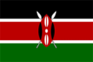   | Would you preferer to live in a hot or cold place? | - Use world maps, atlases and globes to identify the United Kingdom and its countries, as well as the countries, continents and oceans studied at this key stage.  - use simple compass directions (North, South, East and West) and locational and directional language [for example, near and far; left and right], to describe the location of features and routes on a map.  - use aerial photographs and plan perspectives to recognise landmarks and basic human and physical features; devise a simple map; and use and construct basic symbols in a key.  - Use simple fieldwork and observational skills to study the geography of their school and its grounds and the key human and physical features of its surrounding environment.
Year 2 | 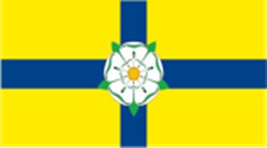 | What is it like to live at the coast? | - use world maps, atlases and globes to identify the United Kingdom and its countries, as well as the countries, continents and oceans studied at this key stage.  - use simple compass directions (North, South, East, and West) and locational and directional language [for example, near and far; left and right], to describe the location of features and routes on a map.  - use aerial photographs and plan perspectives to recognise landmarks and basic human and physical features; devise a simple map; and use and construct basic symbols in a key.  - Use simple fieldwork and observational skills to study the geography of their school and its grounds and the key human and physical features of its surrounding environment.
Year 3 | Staffordshire | Are all settlements the same? | - locate the world’s countries, using maps to focus on Europe (including the location of Russia) and North and South America, concentrating on their environmental regions, key physical and human characteristics, countries, and major cities.  - name and locate counties and cities of the United Kingdom, geographical regions and their identifying human and physical characteristics, key topographical features (including hills, mountains, coasts and rivers), and land-use patterns; and understand how some of these aspects have changed over time.  - understand geographical similarities and differences through the study of human and physical geography of a region of the United Kingdom, a region in a European country, and a region within North or South America  - describe and understand key aspects of human geography, including types of settlement and land use, economic activity including trade links, and the distribution of natural resources including energy, food, minerals and water.  - use maps, atlases, globes and digital/computer mapping to locate countries and describe features studied.  - use the eight points of a compass, four and six-figure grid references, symbols and key (including the use of Ordnance Survey maps) to build their knowledge of the United Kingdom and the wider world.  - use fieldwork to observe, measure, record and present the human and physical features in the local area using a range of methods, including sketch maps, plans and graphs, and digital technologies
Year 3 | Japan   | Why do people live near volcanoes? | - locate the world’s countries, using maps to focus on Europe (including the location of Russia) and North and South America, concentrating on their environmental regions, key physical and human characteristics, countries, and major cities.  - understand geographical similarities and differences through the study of human and physical geography of a region of the United Kingdom, a region in a European country, and a region within North or South America  - describe and understand key aspects of physical geography, including climate zones, biomes and vegetation belts, rivers, mountains, volcanoes and earthquakes, and the water cycle.  - describe and understand key aspects of human geography, including types of settlement and land use, economic activity including trade links, and the distribution of natural resources including energy, food, minerals, and water.  - use maps, atlases, globes, and digital/computer mapping to locate countries and describe features studied.  - use fieldwork to observe, measure, record and present the human and physical features in the local area using a range of methods, including sketch maps, plans and graphs, and digital technologies.
Year 3 | Antatica   | Who lives in Antarctica? | - locate the world’s countries, using maps to focus on Europe (including the location of Russia) and North and South America, concentrating on their environmental regions, key physical and human characteristics, countries, and major cities.  - identify the position and significance of latitude, longitude, Equator, Northern Hemisphere, Southern Hemisphere, the Tropics of Cancer and Capricorn, Arctic and Antarctic Circle, the Prime/Greenwich Meridian and time zones (including day and night)  - describe and understand key aspects of physical geography, including: climate zones, biomes and vegetation belts, rivers, mountains, volcanoes and earthquakes, and the water cycle  - describe and understand key aspects of human geography, including: types of settlement and land use, economic activity including trade links, and the distribution of natural resources including energy, food, minerals and water  - use maps, atlases, globes and digital/computer mapping to locate countries and describe features studied.  - use the eight points of a compass, four and six-figure grid references, symbols and key (including the use of Ordnance Survey maps) to build their knowledge of the United Kingdom and the wider world.  - use fieldwork to observe, measure, record and present the human and physical features in the local area using a range of methods, including sketch maps, plans and graphs, and digital technologies.
Year 4 | Egypt  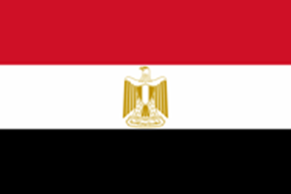 | What are rivers and why are they useful? | - locate the world’s countries, using maps to focus on Europe (including the location of Russia) and North and South America, concentrating on their environmental regions, key physical and human characteristics, countries, and major cities.  - name and locate counties and cities of the United Kingdom, geographical regions and their identifying human and physical characteristics, key topographical features (including hills, mountains, coasts and rivers), and land-use patterns; and understand how some of these aspects have changed over time.  - describe and understand key aspects of physical geography, including climate zones, biomes and vegetation belts, rivers, mountains, volcanoes and earthquakes, and the water cycle.  - describe and understand key aspects of human geography, including types of settlement and land use, economic activity including trade links, and the distribution of natural resources including energy, food, minerals and water.  - use maps, atlases, globes and digital/computer mapping to locate countries and describe features studied.  - use the eight points of a compass, four and six-figure grid references, symbols and key (including the use of Ordnance Survey maps) to build their knowledge of the United Kingdom and the wider world.  - use fieldwork to observe, measure, record and present the human and physical features in the local area using a range of methods, including sketch maps, plans and graphs, and digital technologies.
Year 4 | The World  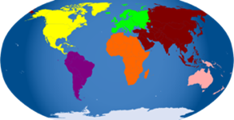 | Where does our food come from? | - locate the world’s countries, using maps to focus on Europe (including the location of Russia) and North and South America, concentrating on their environmental regions, key physical and human characteristics, countries, and major cities  - understand geographical similarities and differences through the study of human and physical geography of a region of the United Kingdom, a region in a European country, and a region within North or South America  - describe and understand key aspects of: physical geography, including: climate zones, biomes and vegetation belts, rivers, mountains, volcanoes and earthquakes, and the water cycle  - describe and understand key aspects of: human geography, including: types of settlement and land use, economic activity including trade links, and the distribution of natural resources including energy, food, minerals and water  - use maps, atlases, globes and digital/computer mapping to locate countries and describe features studied  - use fieldwork to observe, measure, record and present the human and physical features in the local area using a range of methods, including sketch maps, plans and graphs, and digital technologies.
Year 4 | Brazil  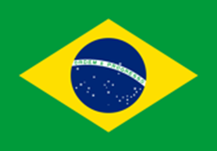 | Why are rainforests important to us? | - locate the world’s countries, using maps to focus on Europe (including the location of Russia) and North and South America, concentrating on their environmental regions, key physical and human characteristics, countries, and major cities.  - identify the position and significance of latitude, longitude, Equator, Northern Hemisphere, Southern Hemisphere, the Tropics of Cancer and Capricorn, Arctic and Antarctic Circle, the Prime/Greenwich Meridian and time zones (including day and night)  - describe and understand key aspects of physical geography, including: climate zones, biomes and vegetation belts, rivers, mountains, volcanoes and earthquakes, and the water cycle  - describe and understand key aspects of human geography, including: types of settlement and land use, economic activity including trade links, and the distribution of natural resources including energy, food, minerals and water  - use maps, atlases, globes and digital/computer mapping to locate countries and describe features studied.  - use fieldwork to observe, measure, record and present the human and physical features in the local area using a range of methods, including sketch maps, plans and graphs, and digital technologies.
Year 5 | Alps – spanning several countries  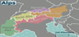 | What is life like in the Alp’s? | locate the world’s countries, using maps to focus on Europe (including the location of Russia) and North and South America, concentrating on their environmental regions, key physical and human characteristics, countries, and major cities  name and locate counties and cities of the United Kingdom, geographical regions and their identifying human and physical characteristics, key topographical features (including hills, mountains, coasts and rivers), and land-use patterns; and understand how some of these aspects have changed over time  identify the position and significance of latitude, longitude, Equator, Northern Hemisphere, Southern Hemisphere, the Tropics of Cancer and Capricorn, Arctic and Antarctic Circle, the Prime/Greenwich Meridian and time zones (including day and night)  understand geographical similarities and differences through the study of human and physical geography of a region of the United Kingdom, a region in a European country, and a region within North or South America  describe and understand key aspects of: physical geography, including: climate zones, biomes and vegetation belts, rivers, mountains, volcanoes and earthquakes, and the water cycle  describe and understand key aspects of: human geography, including: types of settlement and land use, economic activity including trade links, and the distribution of natural resources including energy, food, minerals and water  use maps, atlases, globes and digital/computer mapping to locate countries and describe features studied  use the eight points of a compass, four and six-figure grid references, symbols and key (including the use of Ordnance Survey maps) to build their knowledge of the United Kingdom and the wider world  use fieldwork to observe, measure, record and present the human and physical features in the local area using a range of methods, including sketch maps, plans and graphs, and digital technologies.
Year 5 | Australia   | Why do oceans matter? | - locate the world’s countries, using maps to focus on Europe (including the location of Russia) and North and South America, concentrating on their environmental regions, key physical and human characteristics, countries, and major cities.  - name and locate counties and cities of the United Kingdom, geographical regions and their identifying human and physical characteristics, key topographical features (including hills, mountains, coasts and rivers), and land-use patterns; and understand how some of these aspects have changed over time.  - describe and understand key aspects of physical geography, including: climate zones, biomes and vegetation belts, rivers, mountains, volcanoes and earthquakes, and the water cycle  - describe and understand key aspects of human geography, including: types of settlement and land use, economic activity including trade links, and the distribution of natural resources including energy, food, minerals and water  - use maps, atlases, globes and digital/computer mapping to locate countries and describe features studied.  - use fieldwork to observe, measure, record and present the human and physical features in the local area using a range of methods, including sketch maps, plans and graphs, and digital technologies.
Year 5 | Sahara – spanning several countries   | Would you like to live in a desert? | - world’s countries, using maps to focus on Europe (including the location of Russia) and North and South America, concentrating on their environmental regions, key physical and human characteristics, countries, and major cities  - identify the position and significance of latitude, longitude, Equator, Northern Hemisphere, Southern Hemisphere, the Tropics of Cancer and Capricorn, Arctic and Antarctic Circle, the Prime/Greenwich Meridian and time zones (including day and night)  - understand geographical similarities and differences through the study of human and physical geography of a region of the United Kingdom, a region in a European country, and a region within North or South America  - describe and understand key aspects of: physical geography, including: climate zones, biomes and vegetation belts, rivers, mountains, volcanoes and earthquakes, and the water cycle  - describe and understand key aspects of: human geography, including: types of settlement and land use, economic activity including trade links, and the distribution of natural resources including energy, food, minerals and water  - use maps, atlases, globes and digital/computer mapping to locate countries and describe features studied  - use the eight points of a compass, four and six-figure grid references, symbols and key (including the use of Ordnance Survey maps) to build their knowledge of the United Kingdom and the wider world
Year 6 |  | Why do population change? | - locate the world’s countries, using maps to focus on Europe (including the location of Russia) and North and South America, concentrating on their environmental regions, key physical and human characteristics, countries, and major cities  - name and locate counties and cities of the United Kingdom, geographical regions and their identifying human and physical characteristics, key topographical features (including hills, mountains, coasts and rivers), and land-use patterns; and understand how some of these aspects have changed over time  - understand geographical similarities and differences through the study of human and physical geography of a region of the United Kingdom, a region in a European country, and a region within North or South America  - describe and understand key aspects of: human geography, including: types of settlement and land use, economic activity including trade links, and the distribution of natural resources including energy, food, minerals and water  - use maps, atlases, globes and digital/computer mapping to locate countries and describe features studied  - use fieldwork to observe, measure, record and present the human and physical features in the local area using a range of methods, including sketch maps, plans and graphs, and digital technologies.
Year 6 | USA   | Where does energy come from? | - locate the world’s countries, using maps to focus on Europe (including the location of Russia) and North and South America, concentrating on their environmental regions, key physical and human characteristics, countries, and major cities.  - name and locate counties and cities of the United Kingdom, geographical regions and their identifying human and physical characteristics, key topographical features (including hills, mountains, coasts and rivers), and land-use patterns; and understand how some of these aspects have changed over Tim  - identify the position and significance of latitude, longitude, Equator, Northern Hemisphere, Southern Hemisphere, the Tropics of Cancer and Capricorn, Arctic and Antarctic Circle, the Prime/Greenwich Meridian and time zones (including day and night)  - understand geographical similarities and differences through the study of human and physical geography of a region of the United Kingdom, a region in a European country, and a region within North or South America  - describe and understand key aspects of human geography, including: types of settlement and land use, economic activity including trade links, and the distribution of natural resources including energy, food, minerals and water  - use maps, atlases, globes and digital/computer mapping to locate countries and describe features studied.  - use the eight points of a compass, four and six-figure grid references, symbols and key (including the use of Ordnance Survey maps) to build their knowledge of the United Kingdom and the wider world.  use fieldwork to observe, measure, record and present the human and physical features in the local area using a range of methods, including sketch maps, plans and graphs, and digital technologies.
Year 6 | The World  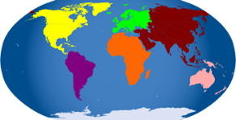 | Can I carry out an independent fieldwork inquiry? | - name and locate counties and cities of the United Kingdom, geographical regions and their identifying human and physical characteristics, key topographical features (including hills, mountains, coasts and rivers), and land-use patterns; and understand how some of these aspects have changed over time.  - describe and understand key aspects of: human geography, including: types of settlement and land use, economic activity including trade links, and the distribution of natural resources including energy, food, minerals and water  - use maps, atlases, globes and digital/computer mapping to locate countries and describe features studied.  - use the eight points of a compass, four and six-figure grid references, symbols and key (including the use of Ordnance Survey maps) to build their knowledge of the United Kingdom and the wider world.  - use fieldwork to observe, measure, record and present the human and physical features in the local area using a range of methods, including sketch maps, plans and graphs, and digital technologies.

Assessment in Geography

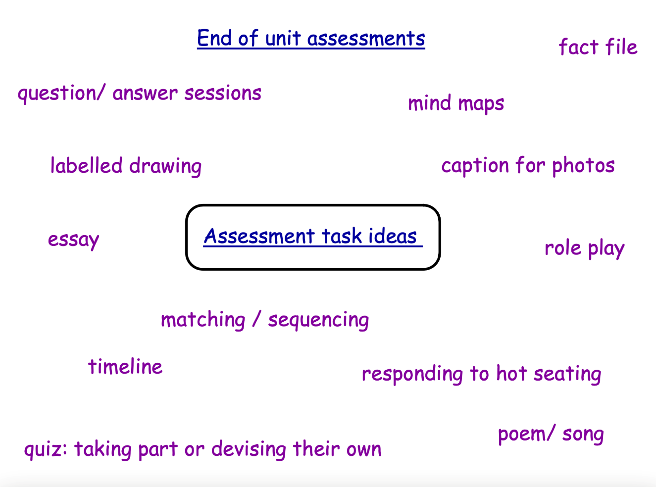
At the end of each Geography unit, we use a different method of assessment to assess the children’s knowledge and skills from that unit of work.

