Meet Our Local Academy Committee

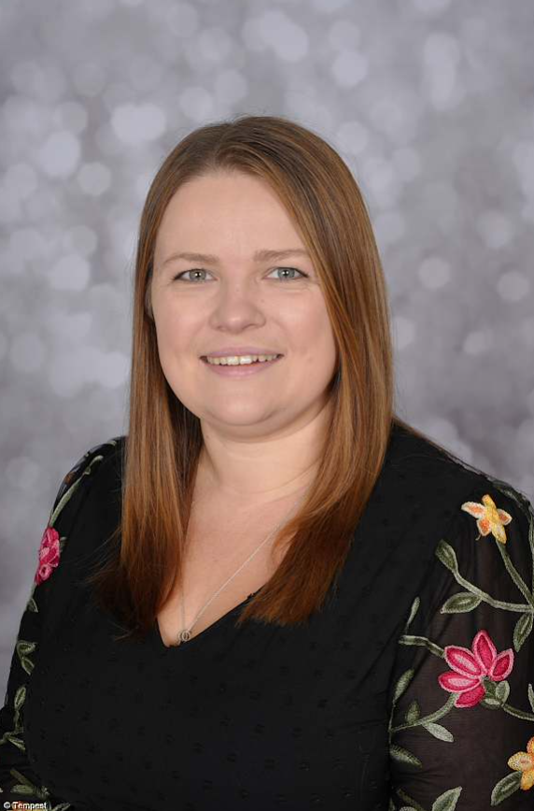

Link Roles | None
Why I became a member of the Local Academy Committee? | The Principal (headteacher)is always a member of the Governing Board as senior leaders and governors constitute a school’s leadership team.
My day job! | My role encompasses every aspect of leading a primary academy, it is both challenging and rewarding. I am very passionate about the academy, the children, their families and the community we serve. I thoroughly enjoy my role and being here at St Thomas’.
What do I contribute to St Thomas’ Local Academy Committee? | During my time at St Thomas’ the emphasis has been on developing the vision and culture, maximising pupil progress, improving quality of teaching and learning, developing the curriculum, fostering children’s learning power and life skills, and developing leadership at all levels. Since I joined in January 2024, we have collectively strengthened parental engagement and trust in the school, we have also developed the Rights Respecting Schools award, achieving Silver in November 2024 and currently on our path to gold! I am also a foundation governor at another primary school.
Do I have children at this school? | No, but I do have primary aged children at a school closer to my home.

Donna Pierpoint Principal

