Meet Our Local Academy Committee

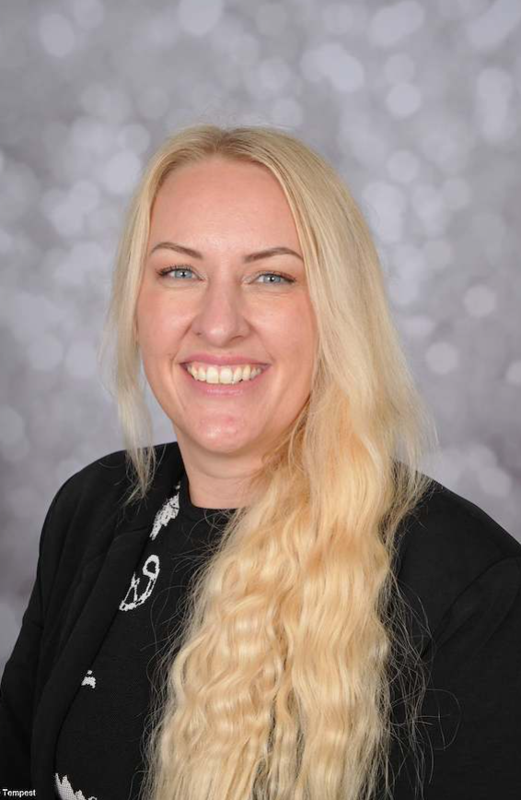

Link Roles | Personal Development
Why I became a member of the Local Academy Committee? | I became a parent governor to support our school and contribute to shaping the best possible educational experience for all children as well as make a positive impact on our local community.
My day job! | A leader in higher education supporting first line support within student services and across the wider university, including disability and inclusion, attendance & engagement, health & well-being, scholarship and bursaries and other initial advice and guidance.
What do I contribute to St Thomas’ Local Academy Committee? | With first-hand experience as a parent, including supporting my own daughters’ learning, and working in education, I’m committed to helping the school thrive and every child succeed.
Do I have children at this school? | Yes

Kirstie Brookes Parent Member

