Meet Our Local Academy Committee

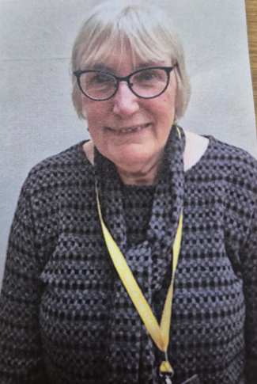

Link Roles | Early Years Foundation Stage (EYFS)
Why I became a member of the Local Academy Committee? | To put back into school, after my sons were educated at The Wade Memorial CE Infant School and then Kinnersey CofE Junior School many years ago. The two schools later merged when the present St. Thomas CofE Academy was formed in the new building.
My day job! | I worked for several accountancy firms as a Secretary and later for 14 years in a Manchester City Council residential school for boys with emotional, behavioural and learning difficulties. I was an Administrator, first assisting the Business Manager and later on, at the same school, working for the Head of Care and Care Team who supported the boys during lessons and after school, in residential units of six boys. I worked there until my retirement in 2017.
What do I contribute to St Thomas’ Local Academy Committee? | I hope my 50+ years in the community, as a Church member and my years as a parent of two boys (one Dyslexic) will mean that I am familiar with the problems faced by parents. My experience helping to run the administration of a school means that I understand the needs of the school. As a Governor, I have so far (since my appointment late in 2024) been into school to do Walk-Thru visits to EYFS, to learn more about the needs of the children and problems faced by staff and parents in meeting those needs. I hope to continue this learning curve and am attending all Governors' meetings and the training sessions offered, which include Safeguarding, Prevent training, awareness of the needs of disadvantaged and SEND pupils.
Do I have children at this school? | No (My children previously attended the school)

Janice Joynson Foundation Member

