Meet Our Local Academy Committee

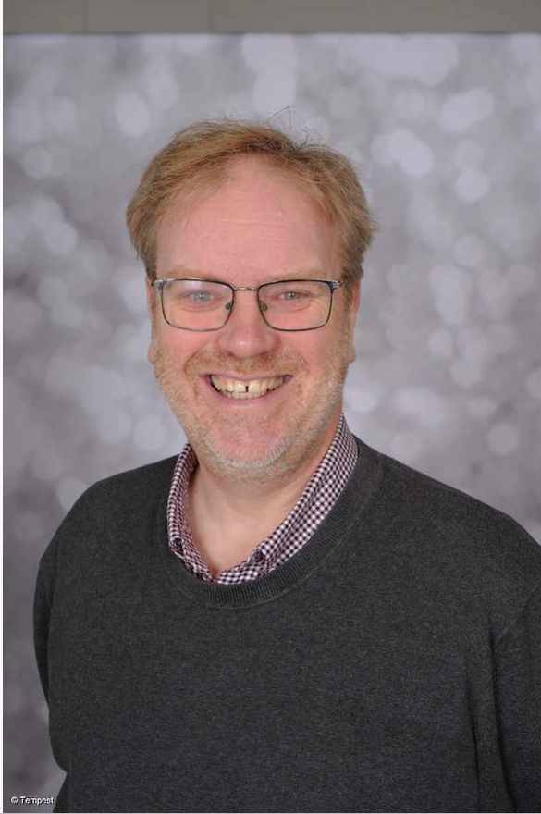

Link Roles | Christian Distinctiveness
Why I became a member of the Local Academy Committee? | As Vicar of St Thomas Church, I am an automatic member of the governing body. But I am thrilled to have been able to serve in this role for many years, seeing the school grow and develop.
My day job! | I am the vicar of St Thomas Church in Kidsgrove. I love being part of the church family - its a loving and friendly community.
What do I contribute to St Thomas’ Local Academy Committee? | I contribute by asking questions! I ask questions to ensure the school is working as well as it can to help your children flourish and thrive during their years at St Thomas.
Do I have children at this school? | No (My children previously attended the school)

Iain Baker Foundation Member

