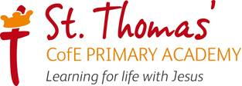


RE Learning Journey
2026/ 2027
RE Over RE Overview
view
RE Intent, Implementation and Impact

‘Learning for Life with Jesus’
Intent
All areas of our curriculum are underpinned by our Gospel values and we ensure that our curriculum makes links to these values. At the heart of each subject is a set of core skills which form a subject learning journey, this journey is built from EYFS through to year 6 and the skills are progressive as you move through the school. Knowledge is communicated to ensure coverage of the National curriculum and it is through this knowledge that children apply their skills.
Children at St Thomas’ leave with a secure knowledge of both the academic knowledge and skills needed for the next stage of their education. They will have developed a clear set Christian and moral values which they can apply in all areas of their lives and will have taken part in real-life experiences, which will have raised their aspirations and given them a thirst for wisdom and knowledge.
The intention of the St Thomas’ Religious Education (RE) learning journey is to ensure that Religious Education is rich, varied and inspiring to enable children to explore big questions, reflect critically and develop the skills to analyse, interpret and apply biblical text. As a school, we strive to provide our children with many opportunities for them to learn about a range of Religions but also to promote Christian values and a curriculum that is inspired by the life and example of Jesus Christ.
As a result of an excellent RE curriculum we want our children to:

· Understand Christianity as a Global living faith
· Become Courageous Advocates, making reasoned and well-informed judgments about religious and moral issues, enabling them to problem solve ways to combat prejudice and social injustice (bringing light to the darkness)
· Understand the Big Story (God’s salvation plan) and the big ideas in Christianity (the concepts)
· Positively engage with their religion and use this to make a positive impact on their friends, families and the local and wider communities
· Have an understanding, respect and tolerance for other people’s faiths and beliefs and the difference it makes to their lives, deepening their understanding of the world and their own experience within it
· Leave primary school as well rounded individuals with a respect and appreciation for their own religion, beliefs, morals as well as those of others using our school vision.

Our RE lead in school is Mrs K Buggy
Our Christian Distinctiveness and SIAMS lead in school is Mrs D Pierpoint

Jesus said ‘I have come that they may have life, and have it to the full.’ John 10:10
Implementation
At St Thomas’ RE learning journey is guided by the Stoke-on-Trent agreed syllabus. Christianity units continue to be taught using Understanding Christianity so that pupils develop secure knowledge of the Bible’s big story, core Christian concepts and the impact of Christian belief on daily life. Non-Christian religion and worldview units now follow NATRE planning and resources, ensuring that pupils encounter high-quality, carefully sequenced learning about a range of faiths and beliefs.
Throughout the journey from nursery to Year 6, we follow a spiral curriculum to ensure progression of knowledge, vocabulary and disciplinary skills. NATRE materials will support teachers to plan enquiry-led lessons which help children learn about religion and worldviews, learn from different perspectives, ask thoughtful questions, compare beliefs and practices, and reflect on how faith and belief can shape people’s lives.
Children will experience an RE based educational visit, visitor or workshop each year to support their learning. Our curriculum also supports children to become Courageous Advocates and life-long ‘agents of change’. Children will learn about different Christian charities and wider community projects and will engage in community outreach. These links are identified on the RE curriculum overview.
RE is taught weekly. For KS1 this is for 1.25 hours per week, and for KS2 this is for 1.5 hours each week. Each new unit of learning is introduced through a key question or enquiry question. To check current knowledge and understanding, children answer what they already know about the key question through a mind-map, discussion or written response. Responses are used to support planning and adaptation for the unit. Children are then introduced to key knowledge and vocabulary through a knowledge organiser or unit knowledge sheet. Knowledge organisers and unit materials will be reviewed and updated so that non-Christian religion and worldview content reflects NATRE planning.
From this point, children are taught a sequence of RE lessons within each unit. Lessons include opportunities to explore key knowledge, encounter sacred texts, stories, artefacts and lived examples, make connections, discuss respectfully, reflect through Pause and Ponder questions, and express their own ideas with reasons.
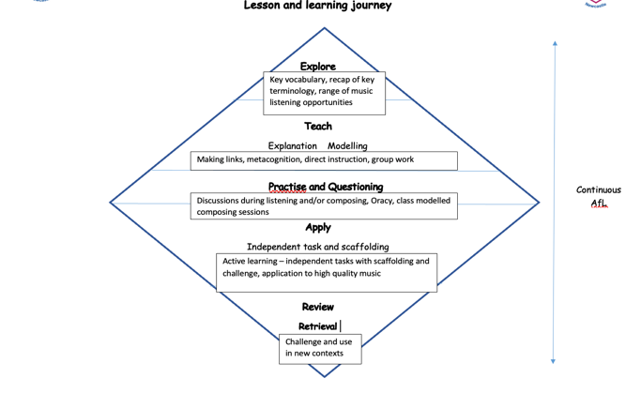

During each lesson, activities are varied for all learning styles and are differentiated where appropriate. Assessment and feedback will focus on misconceptions and next steps for learning using on-the-spot pink pen and pre-planned ‘Next Steps’ to support and challenge learning. At the end of each unit of learning, children will be asked the unit’s Key Question again and, using the ‘windows, mirrors and doors’ approach, they will answer the question in a written response that should reflect what they have learnt, how it has impacted them personally and what they will take on board for the future. In EYFS and KS1, groups of children or the whole class may do this together, whereas in KS2, children will complete this independently using prompts.
In RE, work is recorded through the use of exercise books. Children should record a pre-assessment (key question answer). Work for each lesson should then be included before the end of unit assessment (key question answer) and the assessment framework for the lesson, which is highlighted by the teacher. This should make a ‘sandwich’ of learning that children will be able to use to talk about their learning journey.
Impact
In addition to the outcomes shown on our curriculum tree, the impact of the St Thomas’ RE Learning Journey is that children will have the ability to:
- Develop an understanding, respect and tolerance for a range of World Religions
- Develop an appreciation of their faith and fulfil their God-given talents
- Achieve well in RE, this will be reflected in good or outstanding progress that reveals a clear learning journey. Children will be able to talk enthusiastically about their learning in RE and are eager to further their learning in the next stages of their education
- Be confident, resilient and actively engaged in the wider society, taking on their role as Courageous Advocates
- Show compassion, justice, love and forgiveness in their relationships with others
- Confidently use skills such as retelling, describing, comparing, giving reasons, explaining the meaning of biblical stories and considering the impact of beliefs
- Reflect and consider important questions about RE
Formative assessment takes part in each lesson and misconception and next steps of the focus for feedback. Summative assessment is completed for each child at the end of each unit using the assessment framework. A best fit approach to statements achieved results in an end of year summative grade using each child’s work and the teacher’s half-termly assessment to support this. The impact of the RE curriculum is monitored through pupil/staff/parent voice, work scrutiny and teaching and learning observations.

RE Overview 2026/2027

Two complementary resources are used: Understanding Christianity for Christianity units and NATRE for non-Christian religion and worldview units.

NATRE will be used to support planning, subject knowledge, vocabulary, enquiry questions and assessment opportunities for all other faith and worldview units. Existing knowledge organisers for these units should be reviewed and updated to align with NATRE content.
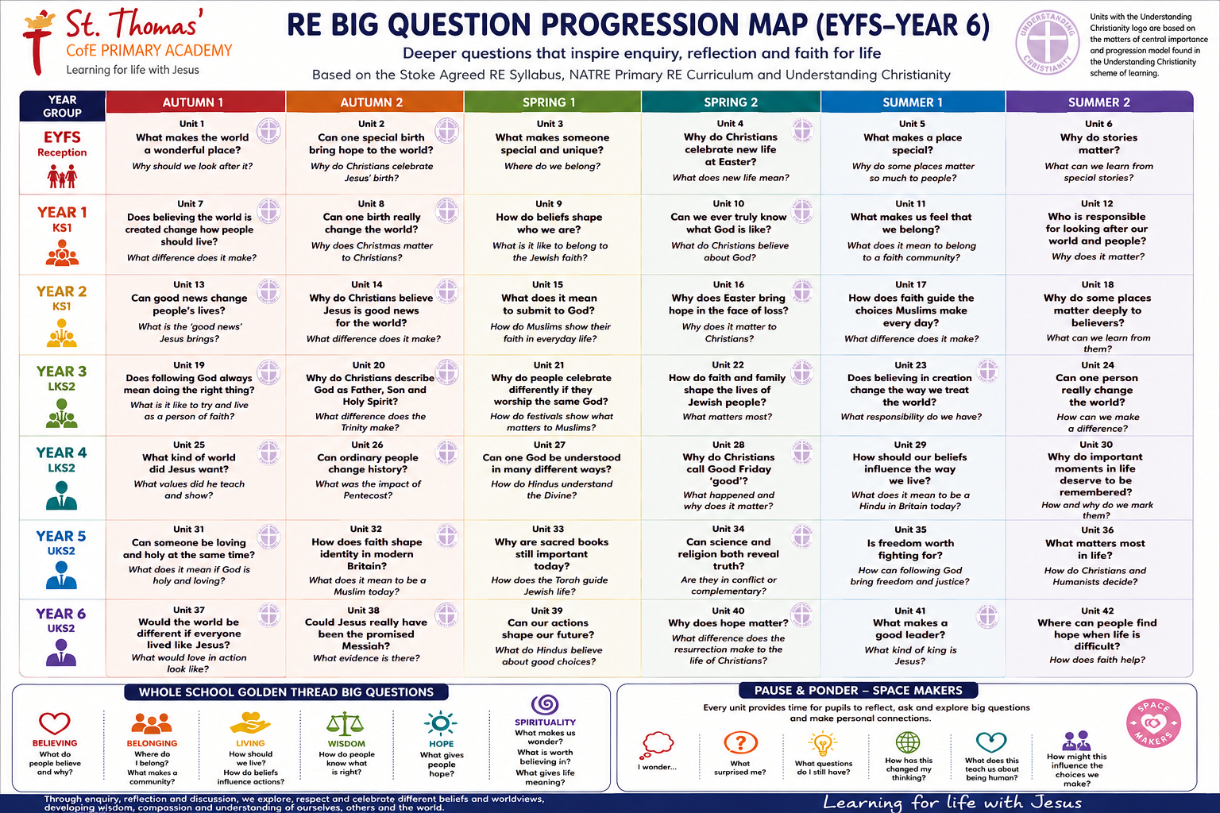

RE Skills Progression
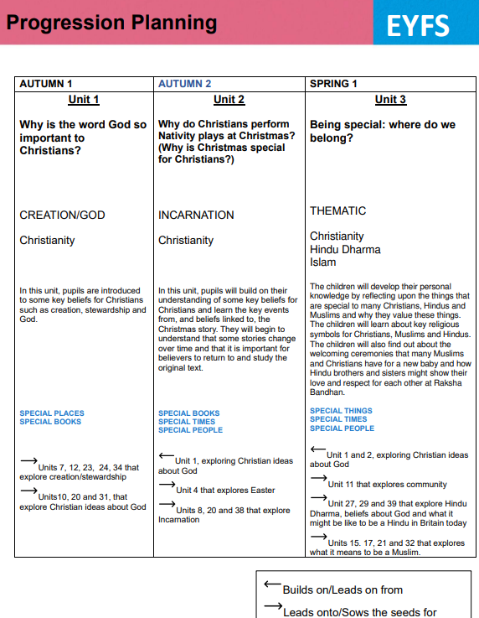
Progression 2026/2027

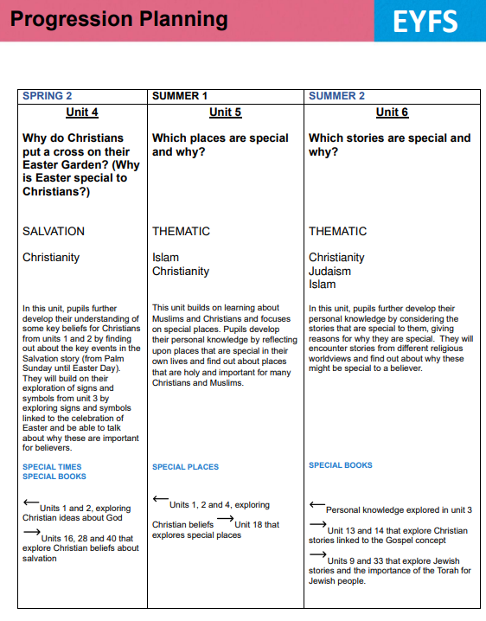

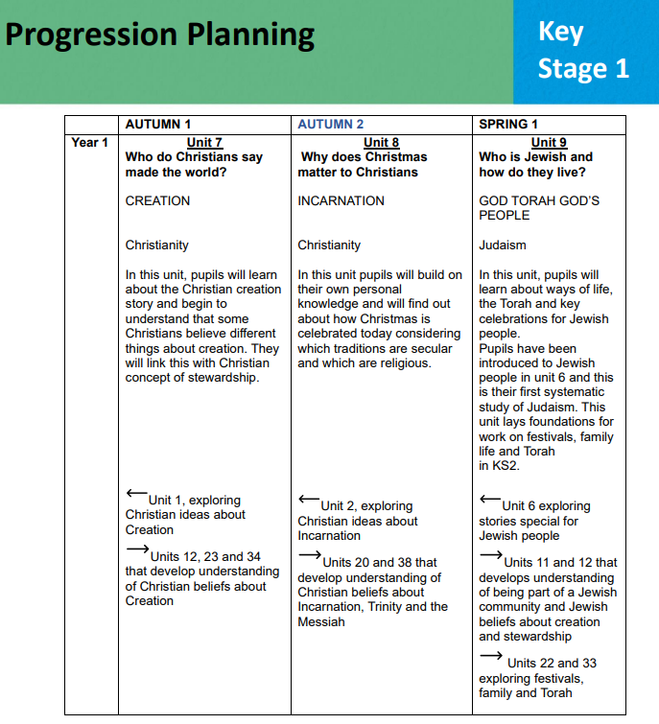

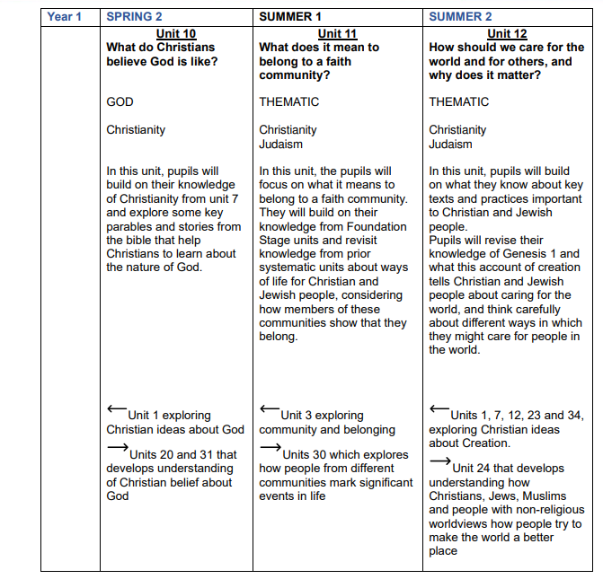

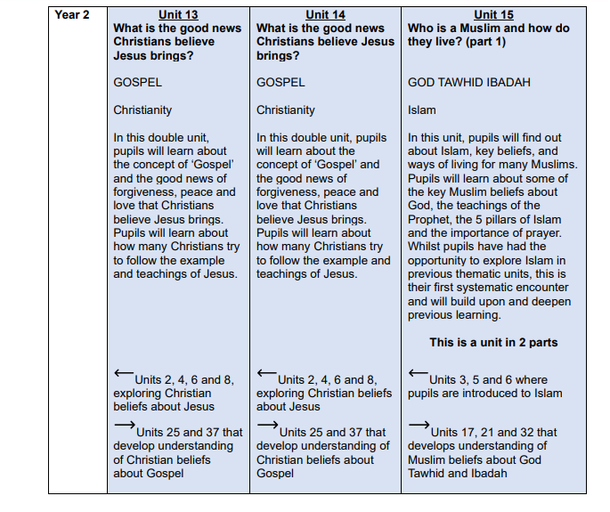

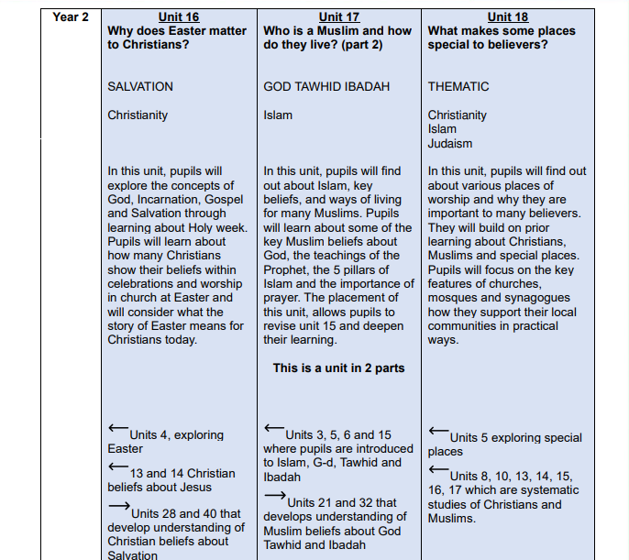

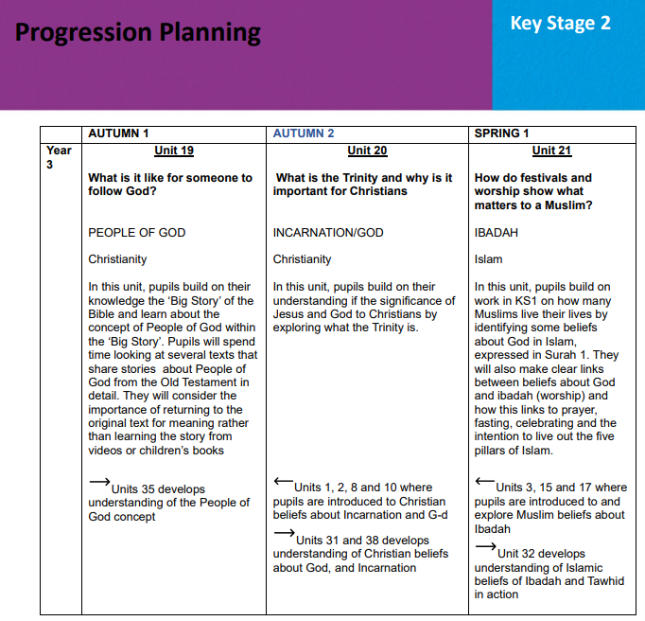

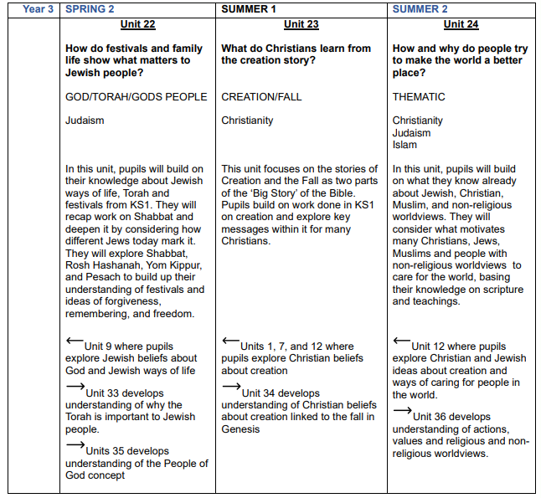

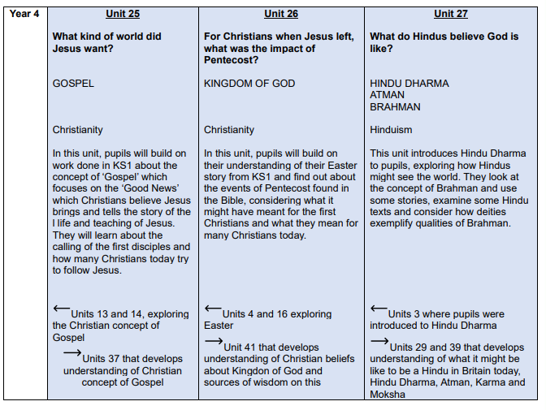

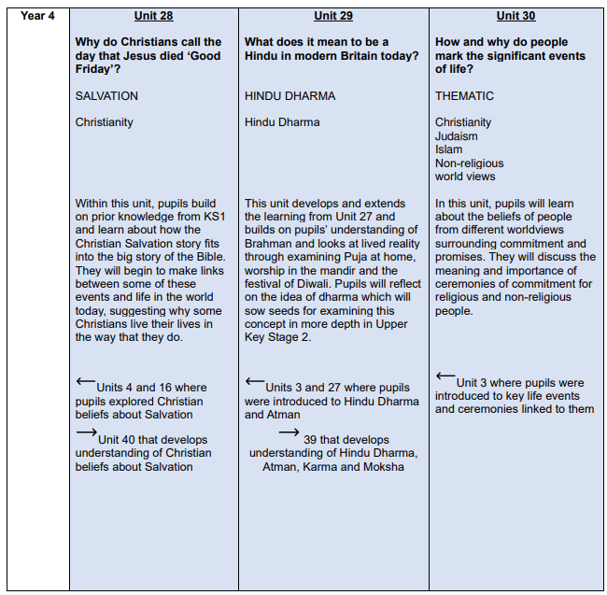

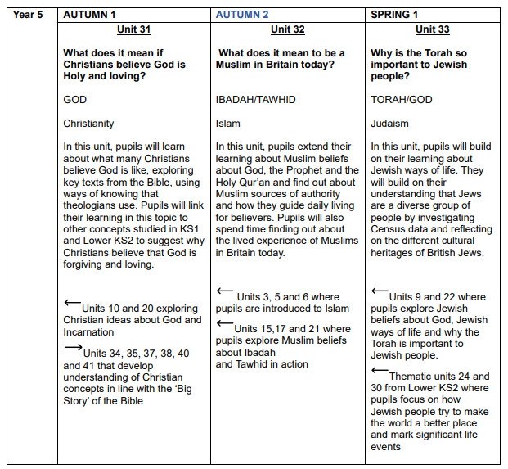

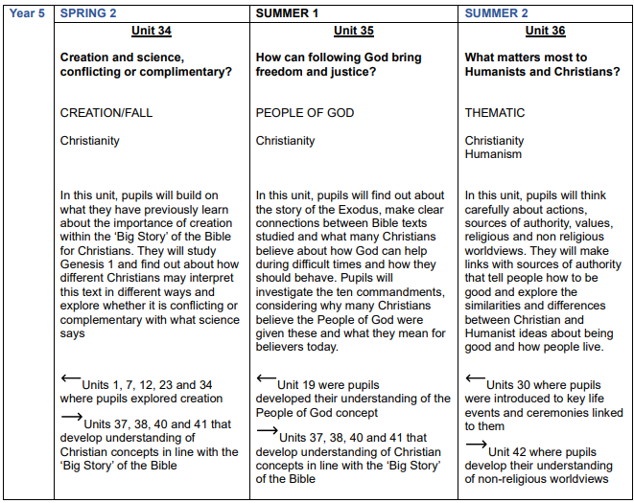

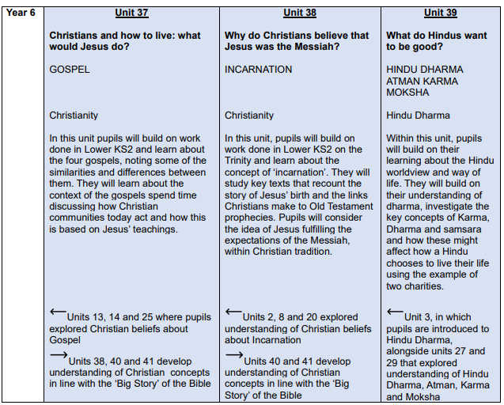

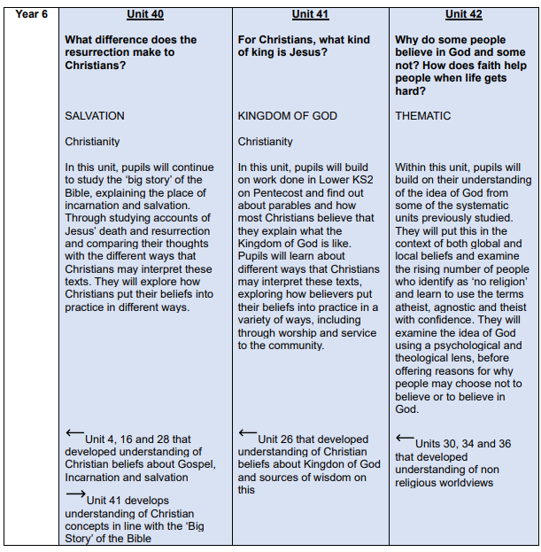

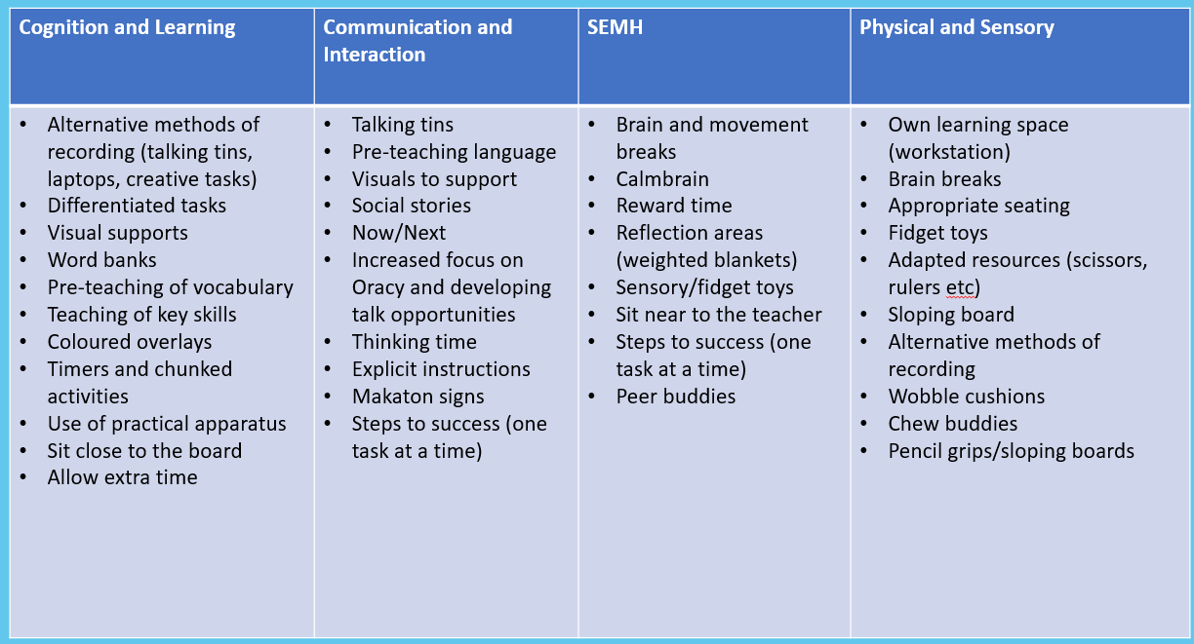
Adaptive Teaching Strategies
RE Knowledge Organiser Year 1– Autumn 1

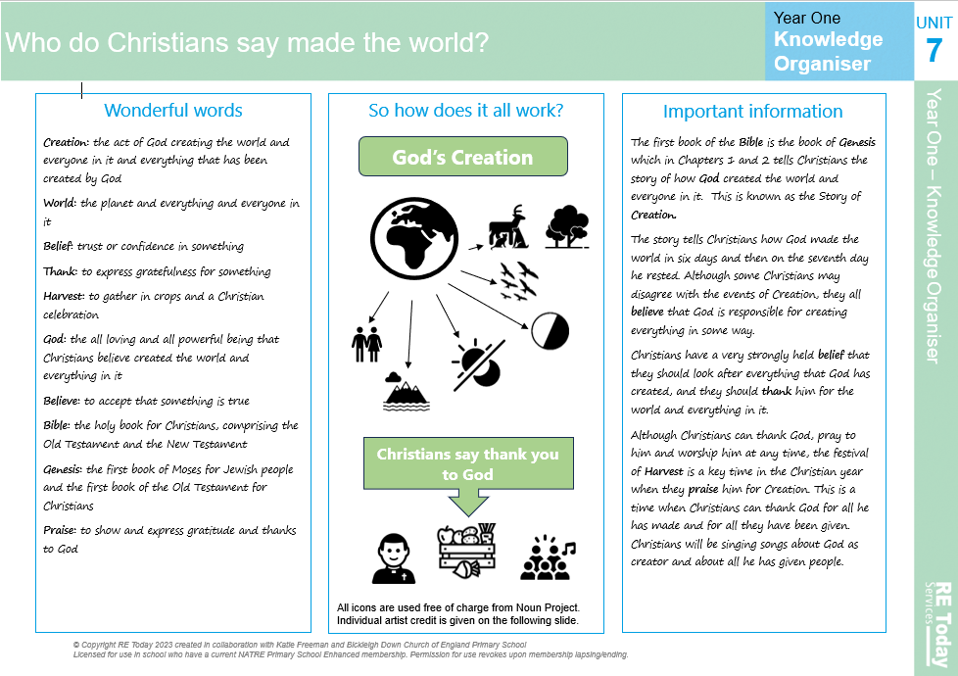

Gospel Value:
Grateful and Generous- To be grateful for our special places like school and home

RE Knowledge Organiser Year 1– Autumn 2

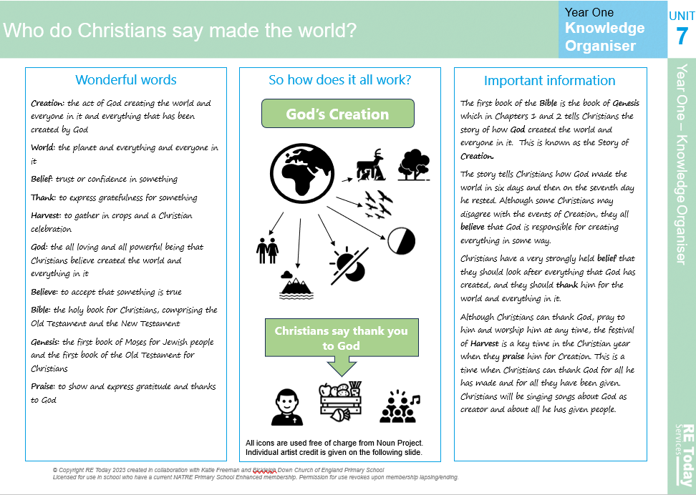

Gospel Value:
Curious and Active- To be curious about who made the world and where we live

RE Knowledge Organiser Year 1– Spring 1

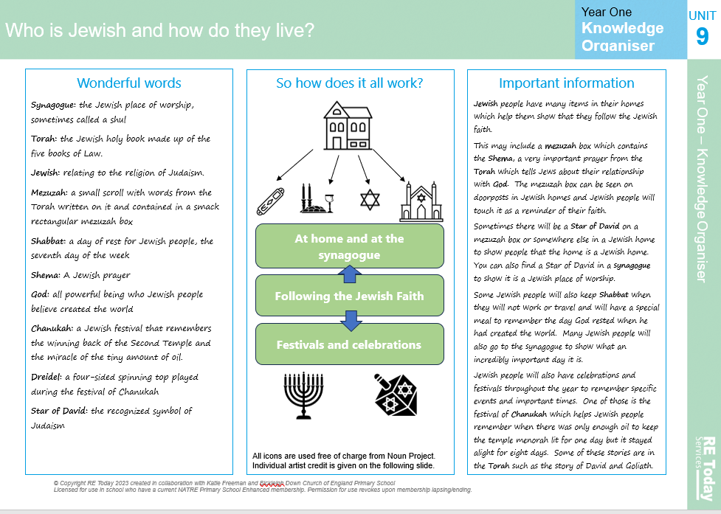

Gospel Value:
Grateful and Generous- To be grateful for the gift of Jesus at Christmas time

RE Knowledge Organiser Year 1– Spring 2

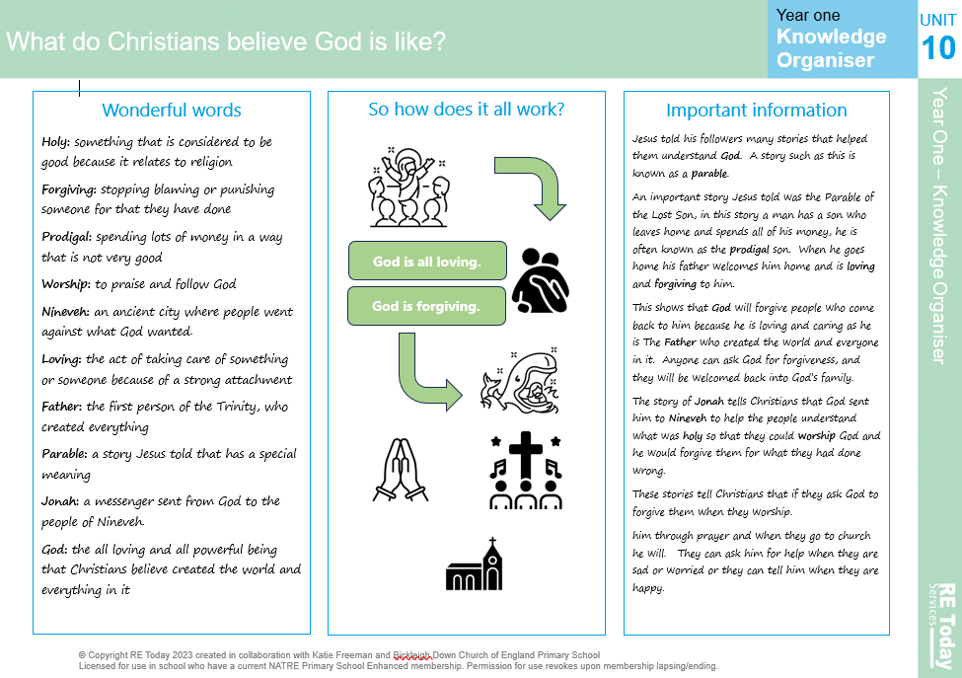

Gospel Value:
Compassionate and Loving- To be a good friend and forgive others

RE Knowledge Organiser Year 1– Summer 1

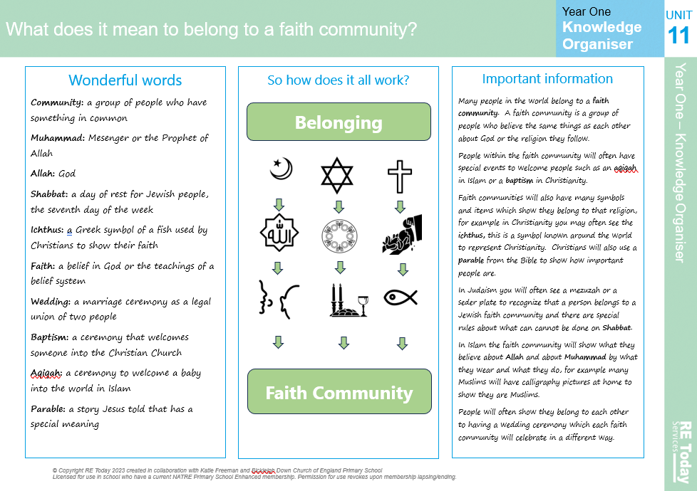

Gospel Value:
Compassionate and Loving- To be understanding and show love towards Jesus for the ultimate sacrifice to save us

RE Knowledge Organiser Year 1– Summer 2

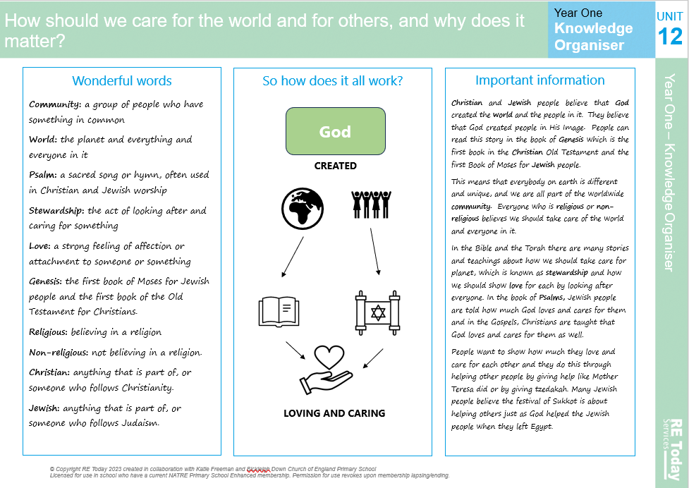

Gospel Value:
Compassionate and loving- To be compassionate towards others and respect their beliefs

RE Knowledge Organiser Year 2– Autumn 1

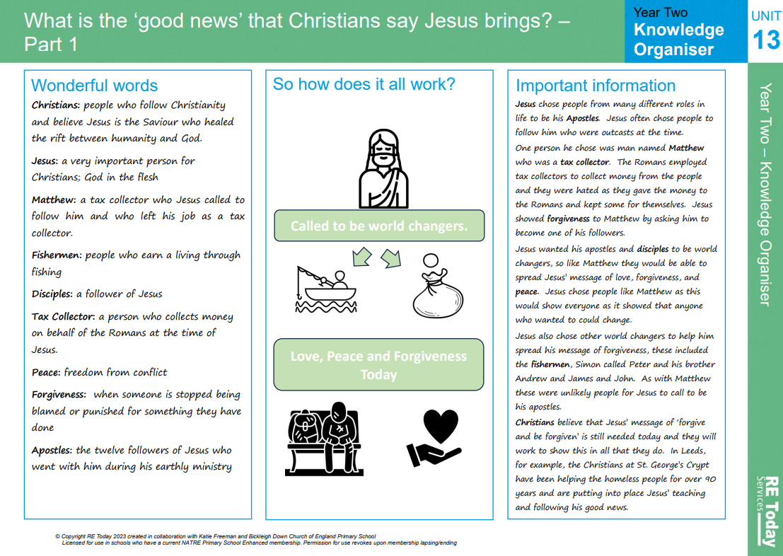

Gospel Value:
Grateful and Generous- To be grateful for the religious festivals that we enjoy

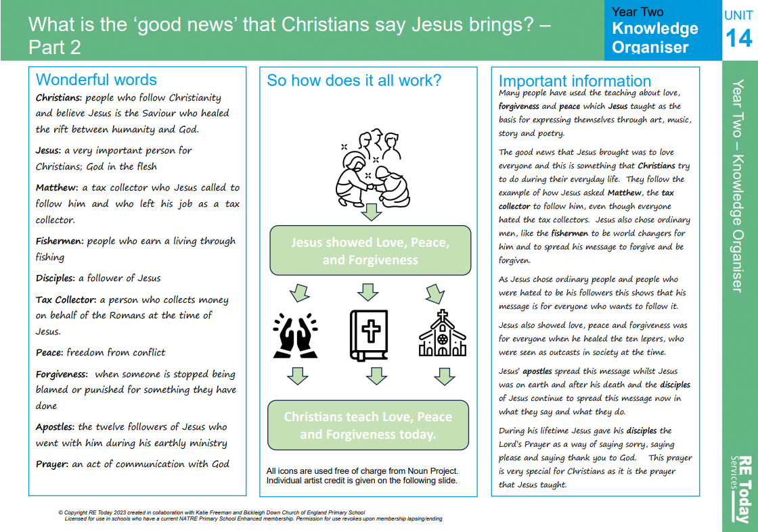
RE Knowledge Organiser Year 2– Autumn 2

Gospel Value:
Compassionate and Loving- To be kind and show love to all using actions and words

RE Knowledge Organiser Year 2– Spring 1

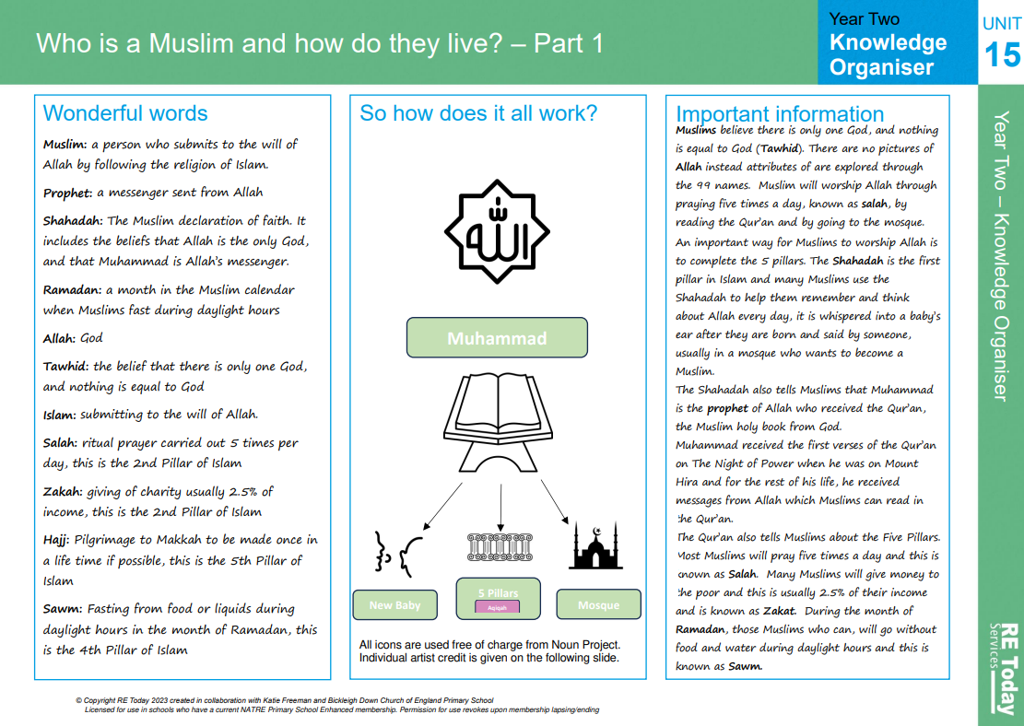

Gospel Value:
Intentional and Prophetic- To share the good news that Jesus brings with others

RE Knowledge Organiser Year 2– Spring 2

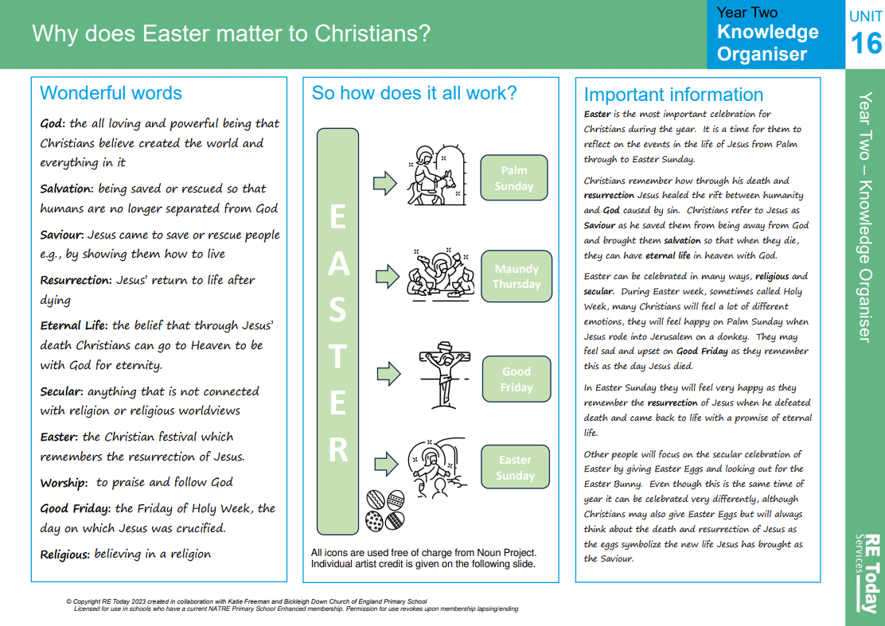

Gospel Value:
Attentive and Discerning- To consider the choices that we have and the effect they may have on others

RE Knowledge Organiser Year 2– Summer 1

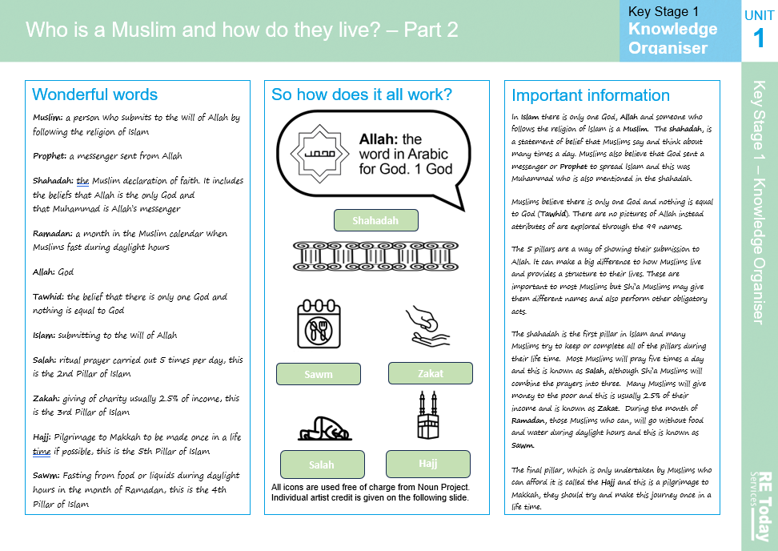

Gospel Value:
Learned and Wise- To take all opportunities and share with others the good things that God does

RE Knowledge Organiser Year 2– Summer 2

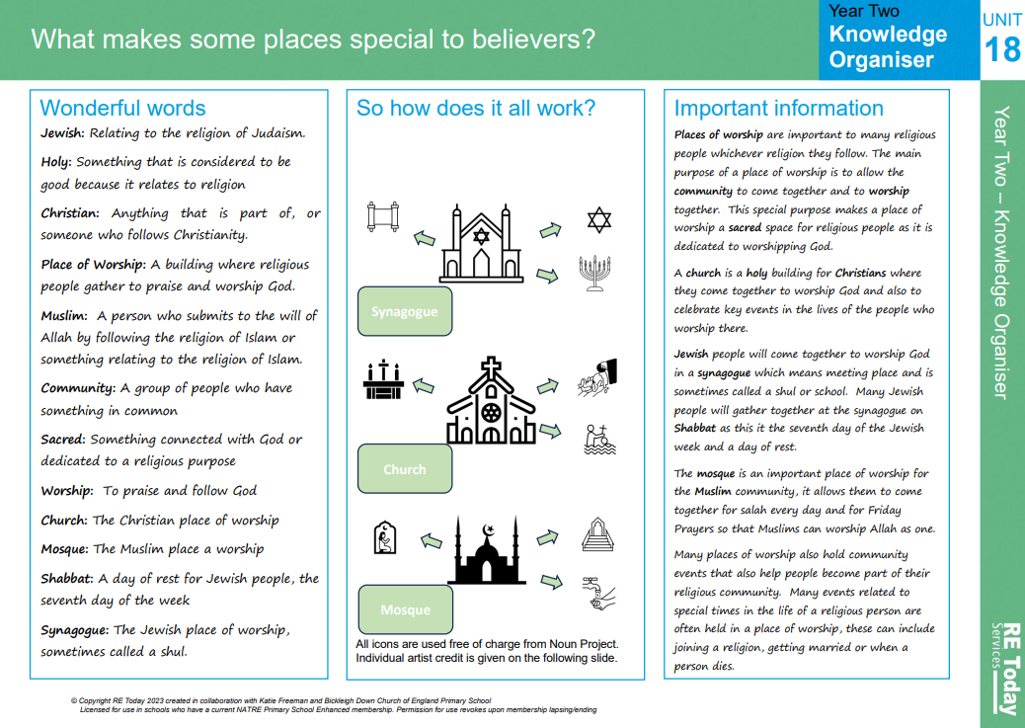

Gospel Value:
Intentional and Prophetic- To learn from the example set by others in their relationship with God and set a good example yourself

RE Knowledge Organiser Year 3– Autumn 1

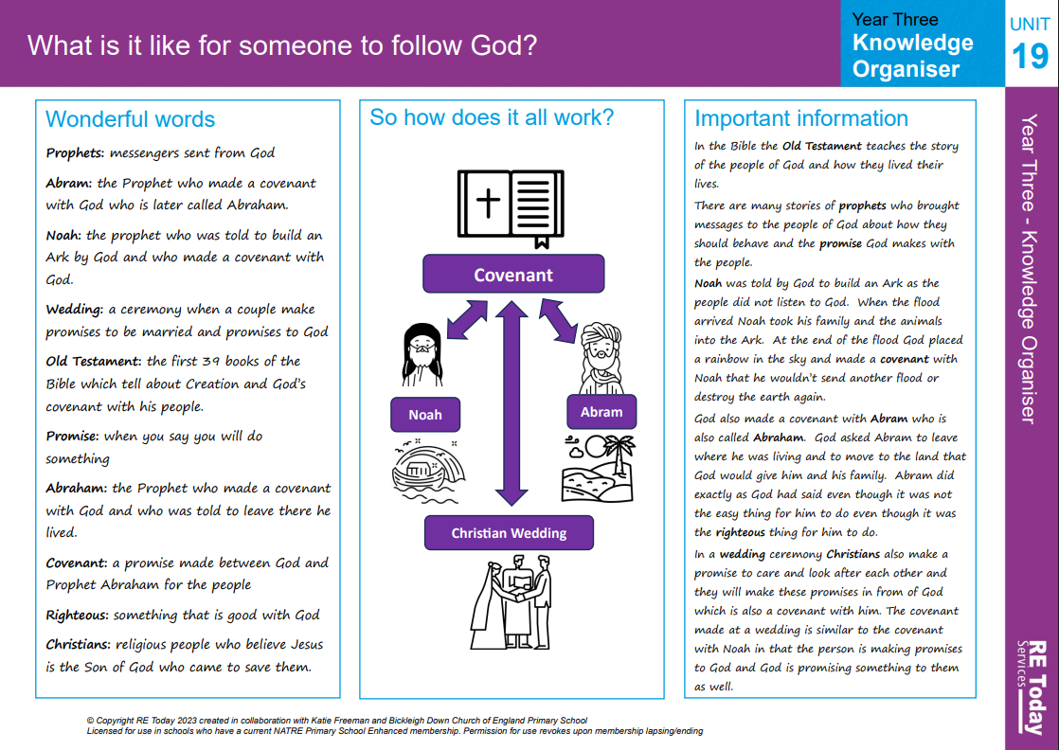

Gospel Value:
Compassionate and Loving- To show compassion for how Jews show their commitment and love for God

RE Knowledge Organiser Year 3– Autumn 2

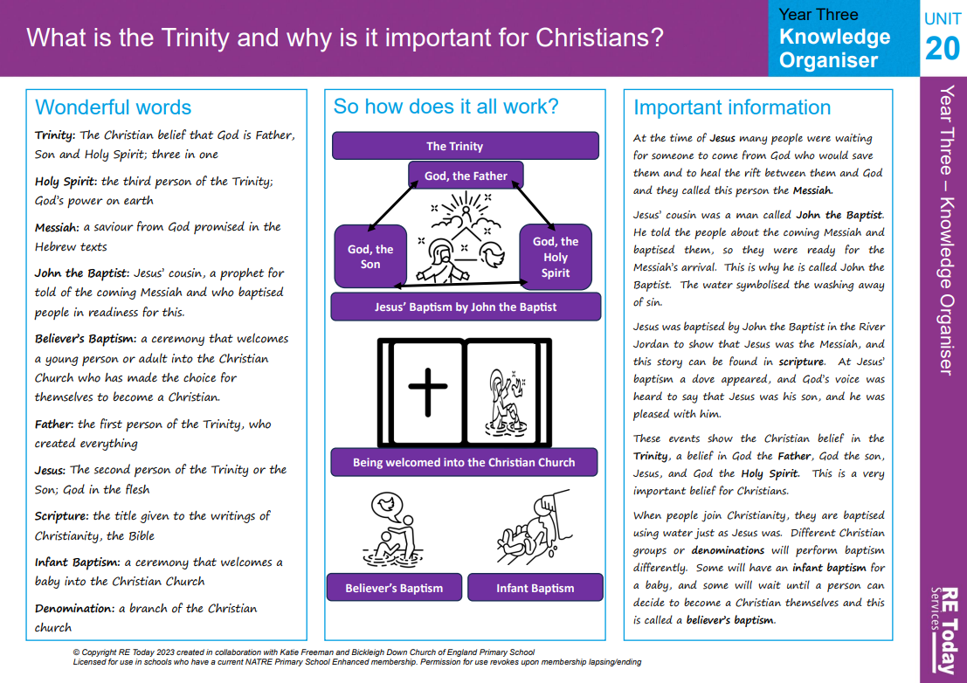

Gospel Value:
Attentive and Discerning- To be attentive about the experiences that others have and the sense of belonging they gain from them.

RE Knowledge Organiser Year 3– Spring 1

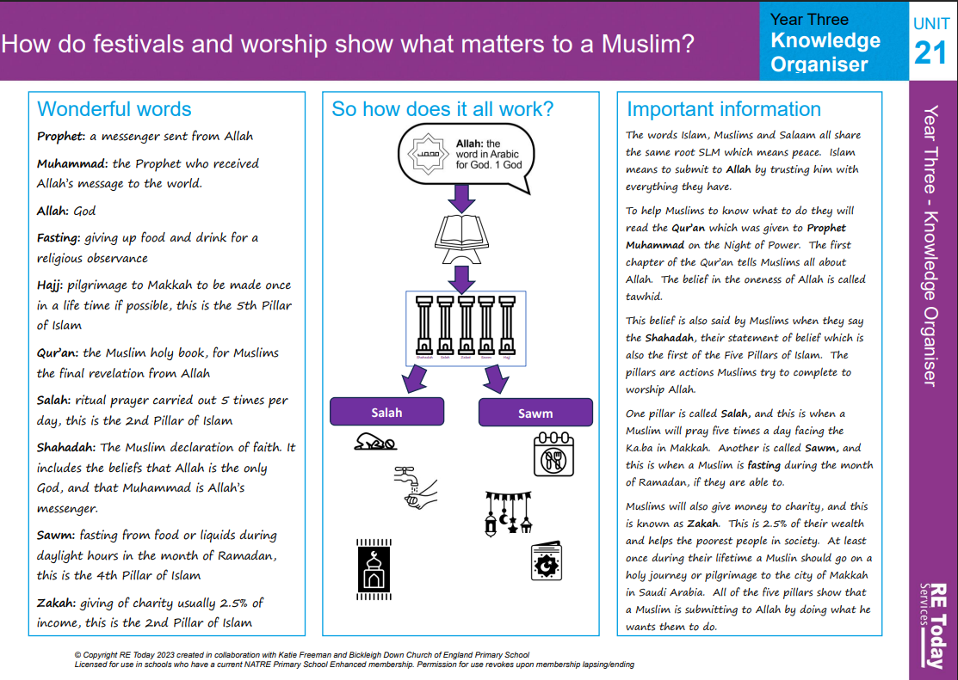

Gospel Value:
Curious and Active- To be curious about the way God represents himself to us

RE Knowledge Organiser Year 3 – Spring 2

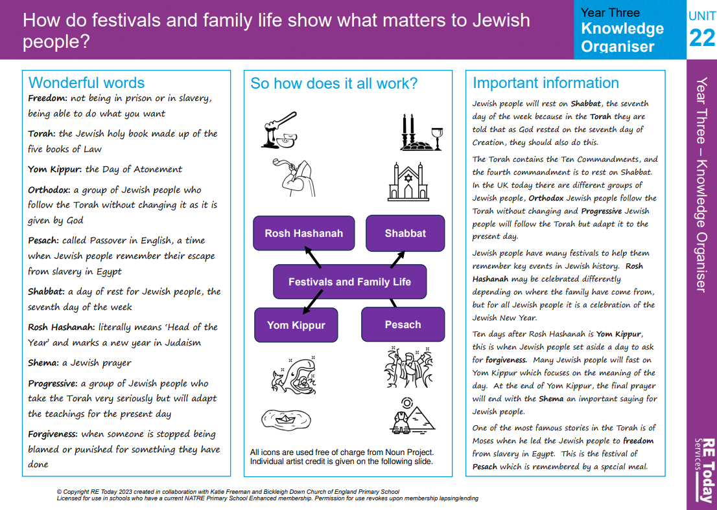

Gospel Value:
Grateful and Generous- To be grateful for the gift of the world

RE Knowledge Organiser Year 3 – Summer 1

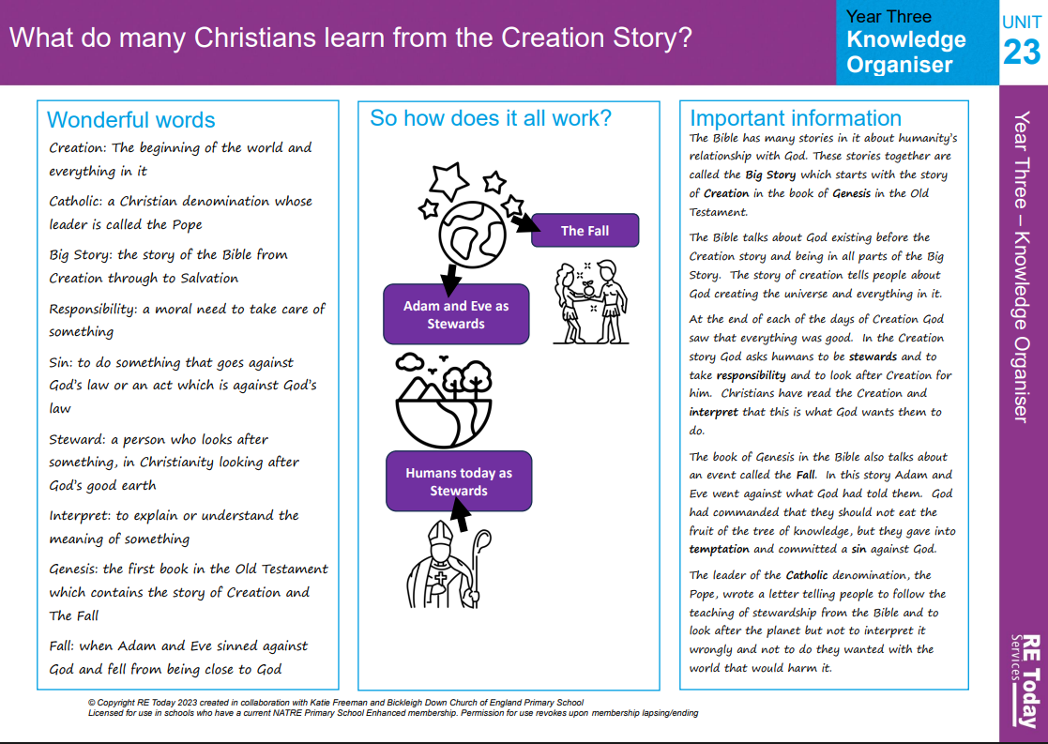

Gospel Value:
Learned and-Wise To learn and share the reasons why Jesus died and saved us

RE Knowledge Organiser Year 3 – Summer 2

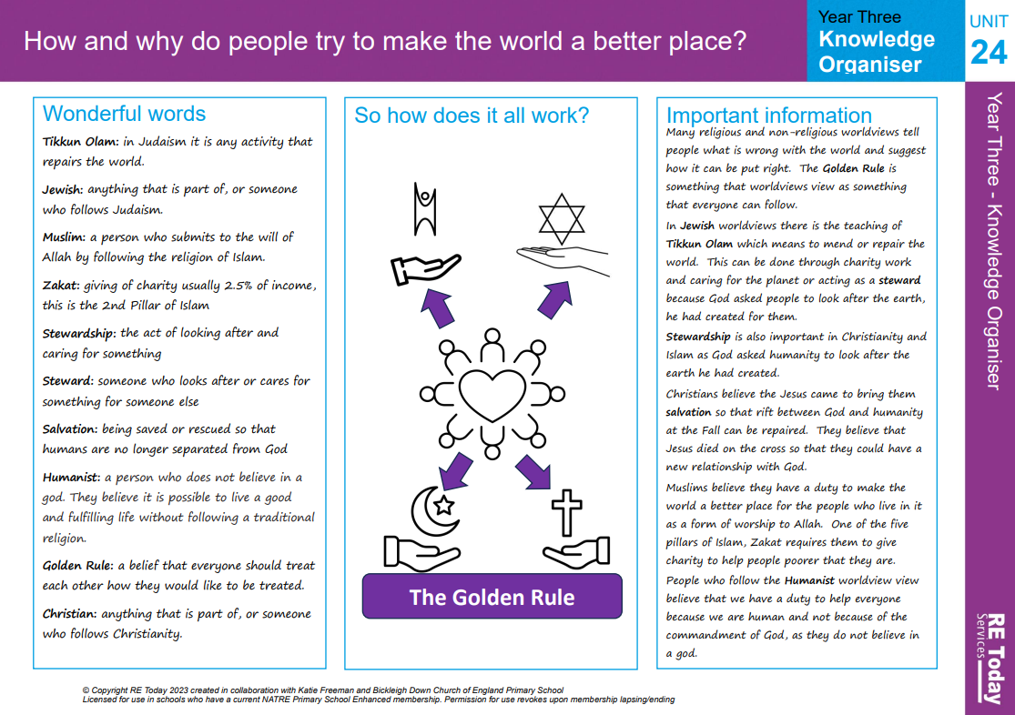

Gospel Value:
Curious and Active- To be curious about how a soul can be all around and support Hindus in their life

RE Knowledge Organiser Year 4 – Autumn 1

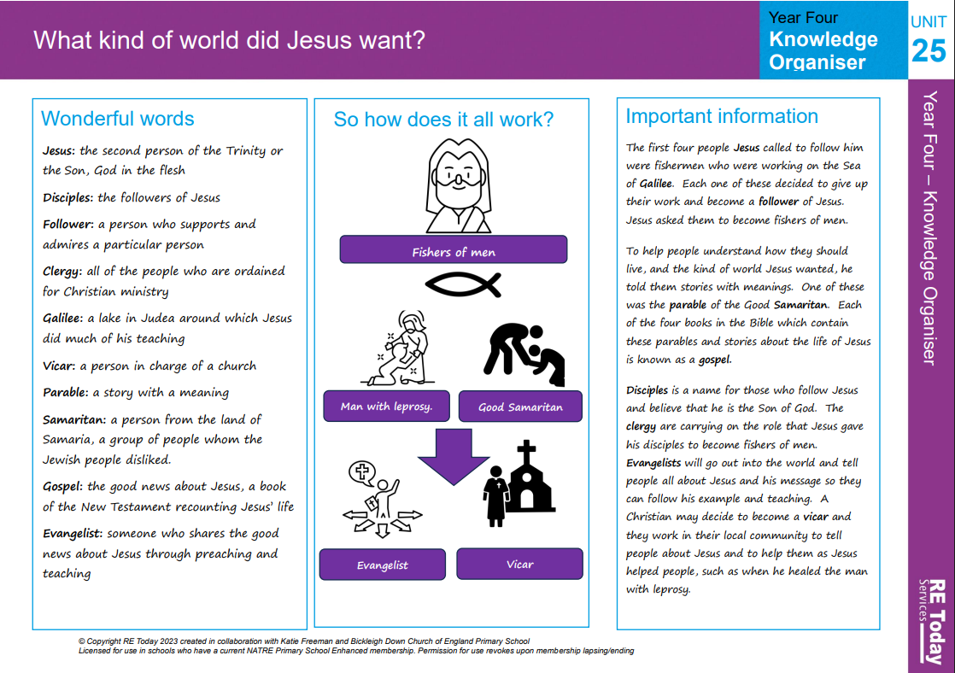

Gospel Value:
Curious and Active- To be curious about the pilgrimage Hindus and Muslims make

RE Knowledge Organiser Year 4 – Autumn 2

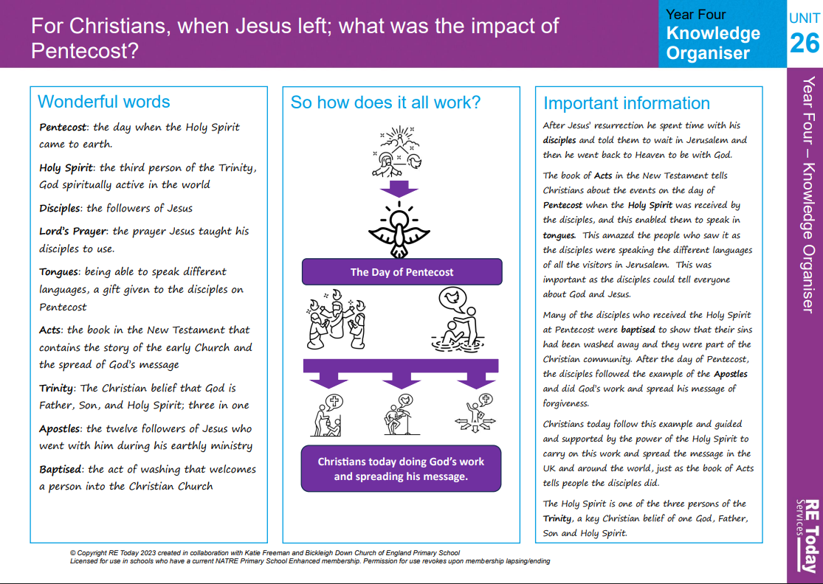

Gospel Value:
Grateful and Generous- To be grateful for our own lives and happiness, and generous in how we treat others

RE Knowledge Organiser Year 4 – Spring 1

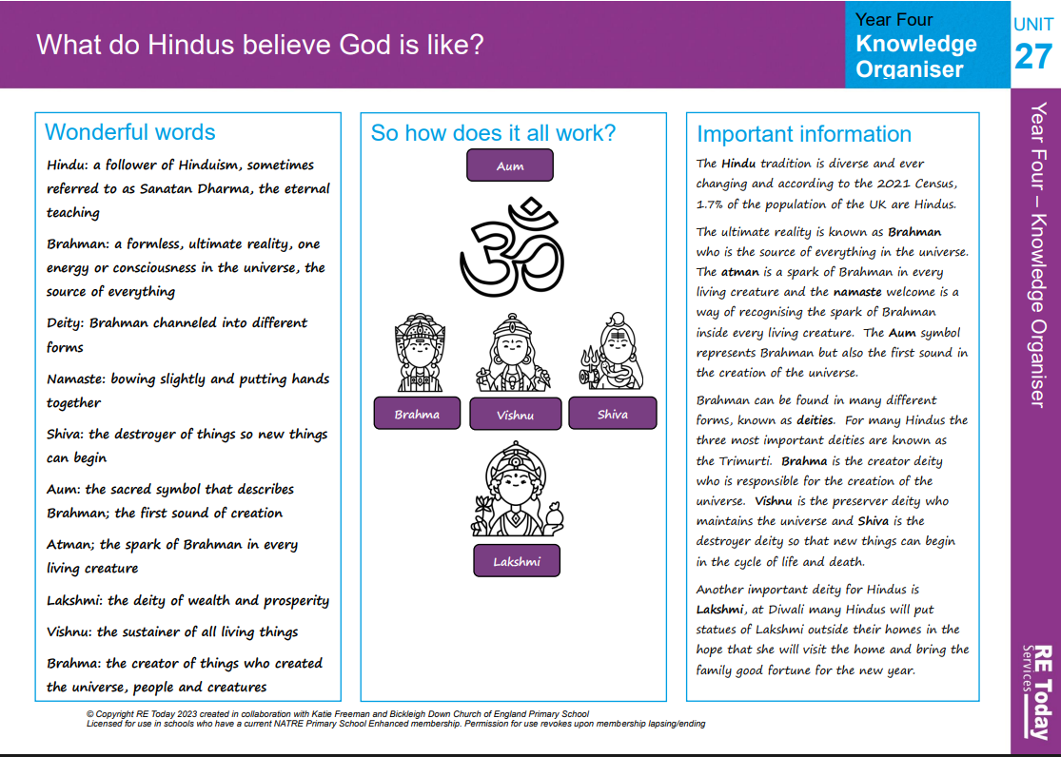

Gospel Value:
Curious and Active- To be active in the way in which we follow God

RE Knowledge Organiser Year 4 – Spring 2

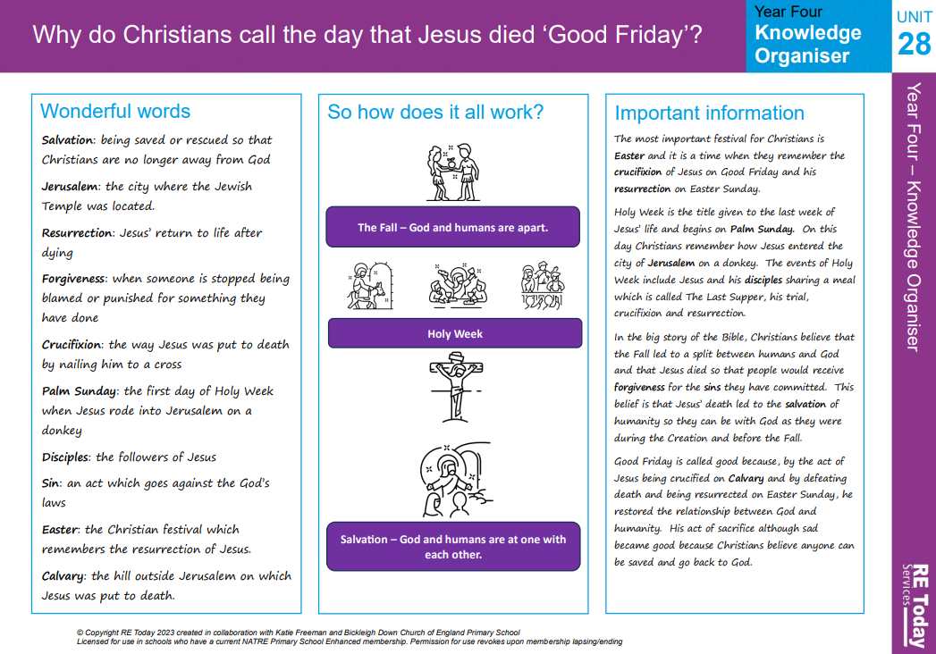

Gospel Value:
Learned and Wise- To learn about the way in which others live and wise to use this knowledge to improve our own

RE Knowledge Organiser Year 4 – Summer 1

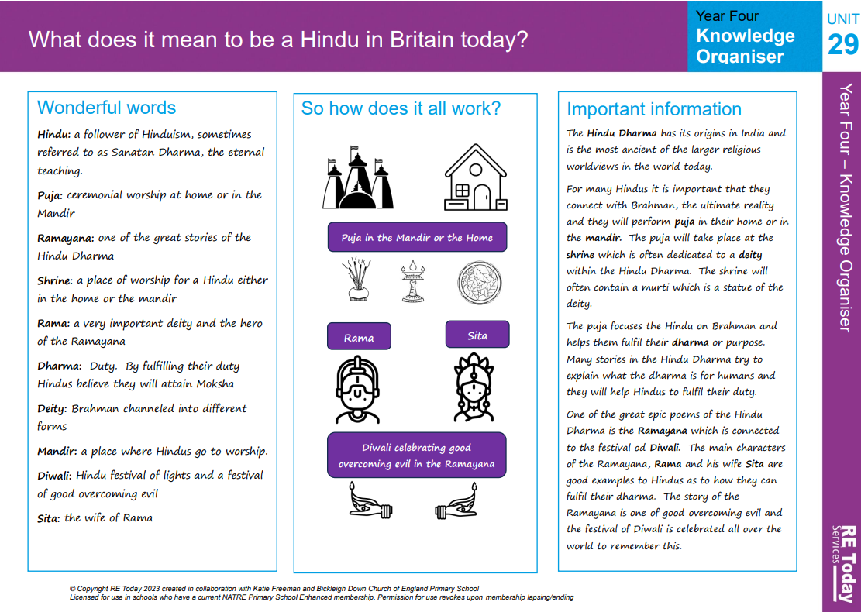

Gospel Value:
Compassionate and Loving- To empathise with others and show compassion by forgiving

RE Knowledge Organiser Year 4 – Summer 2

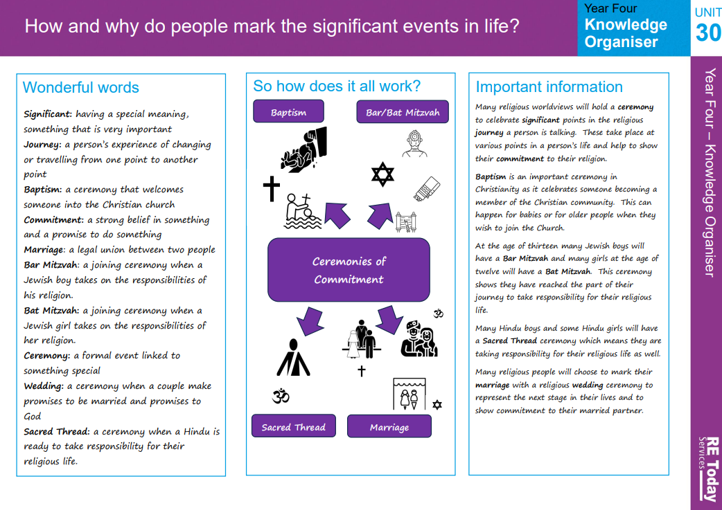

Gospel Value:
Intentional and Prophetic- To be intentional and conscientious in the way in which we live

RE Knowledge Organiser Year 5 – Autumn 1

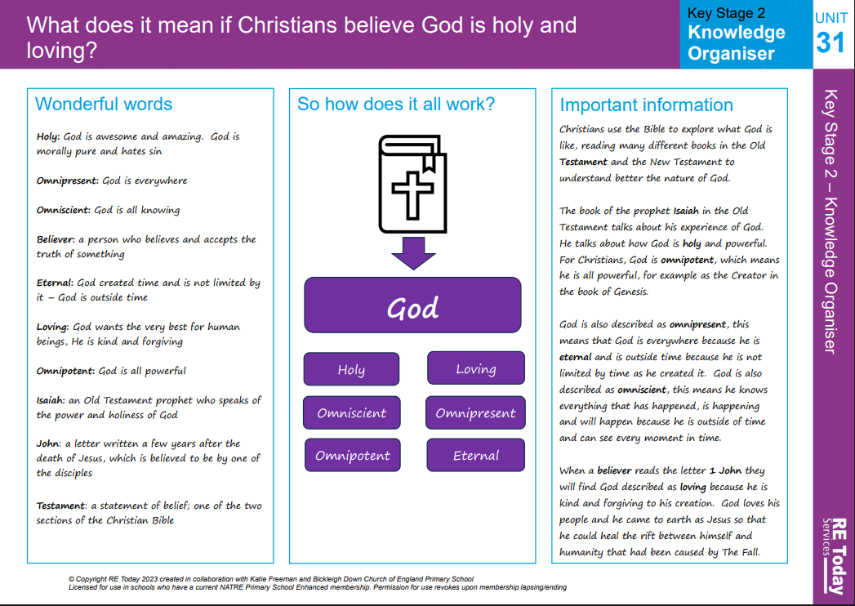

Gospel Value:
Faith-filled and Hopeful- To be consumed by the belief of the Holy Spirit and the hope this brought to Jesus’ disciples

RE Knowledge Organiser Year 5 – Autumn 2

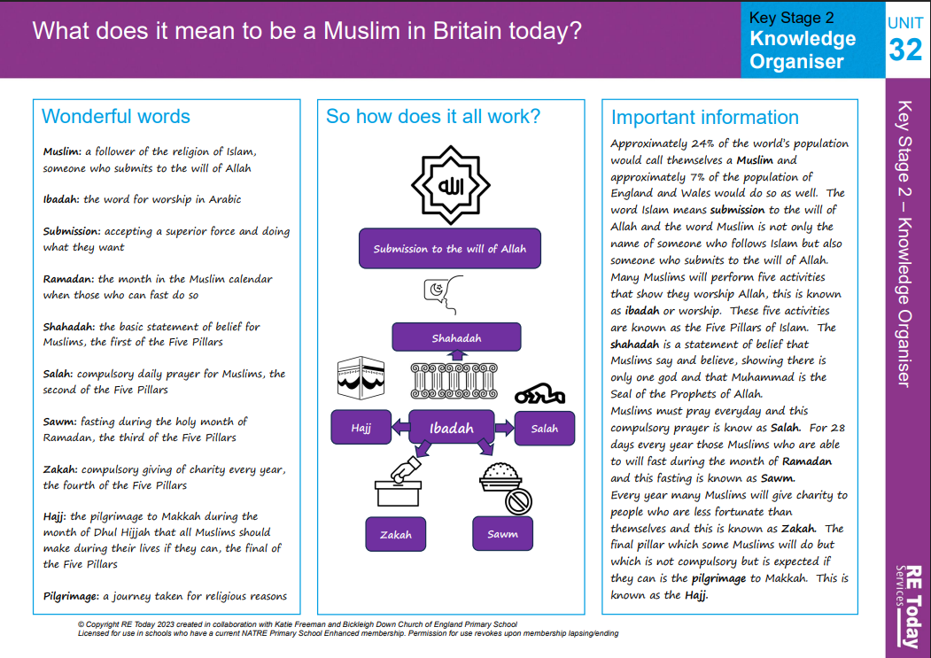

Gospel Value:
Attentive and Discerning- To consider your own experiences and be discerning in the choices you make because of them

RE Knowledge Organiser Year 5 – Spring 1

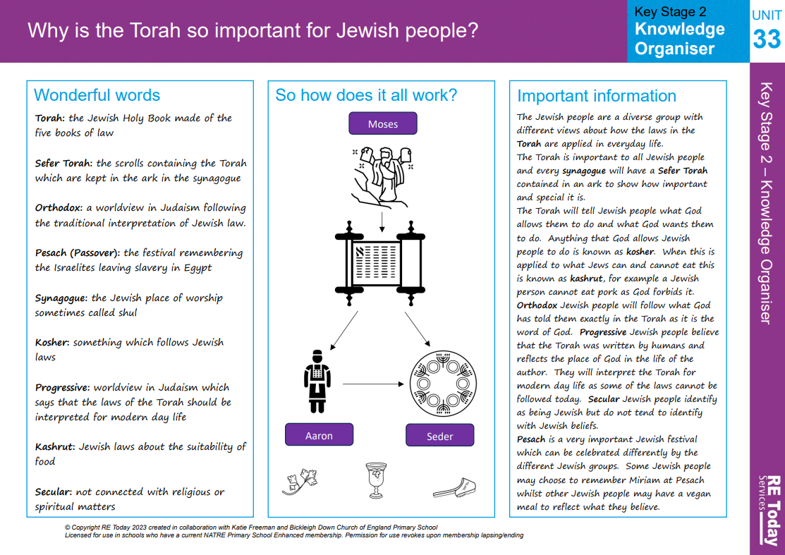

Gospel Value:
Intentional and Prophetic- To learn from the Bible about people’s view of Jesus and share this knowledge with others

RE Knowledge Organiser Year 5 – Spring 2

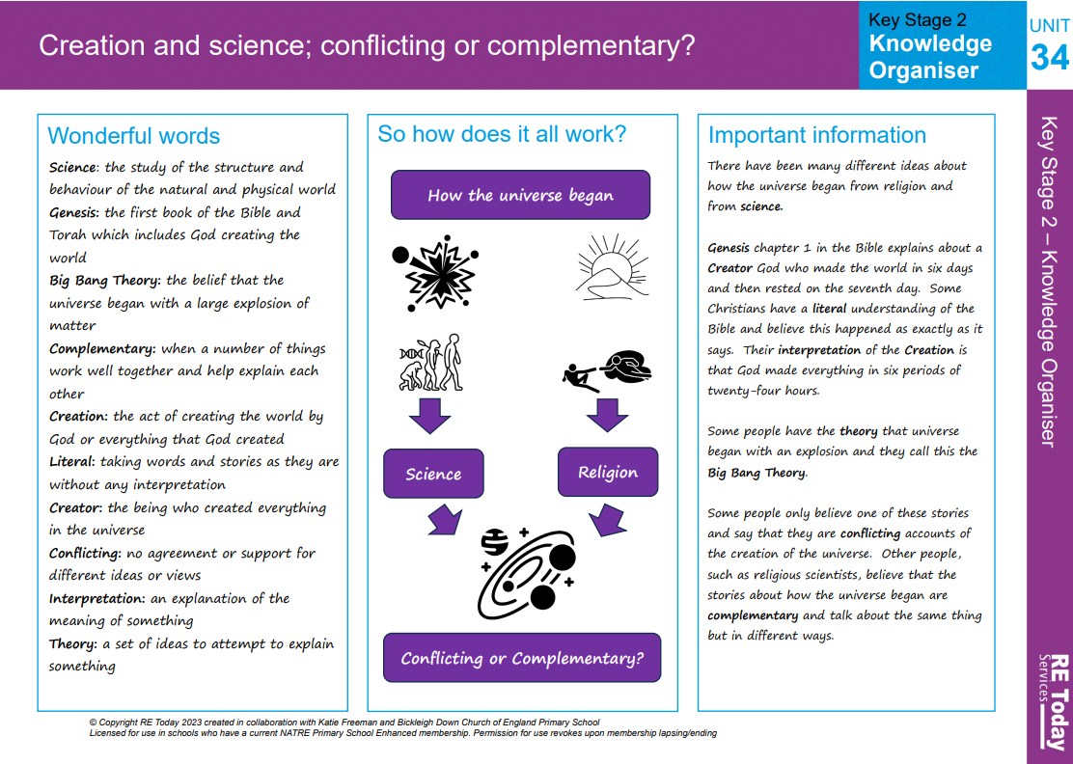

Gospel Value:
Learned and Wise- To immerse ourselves in the stories from the Guru Granth Sahib and wise in the links we can make to the Bible

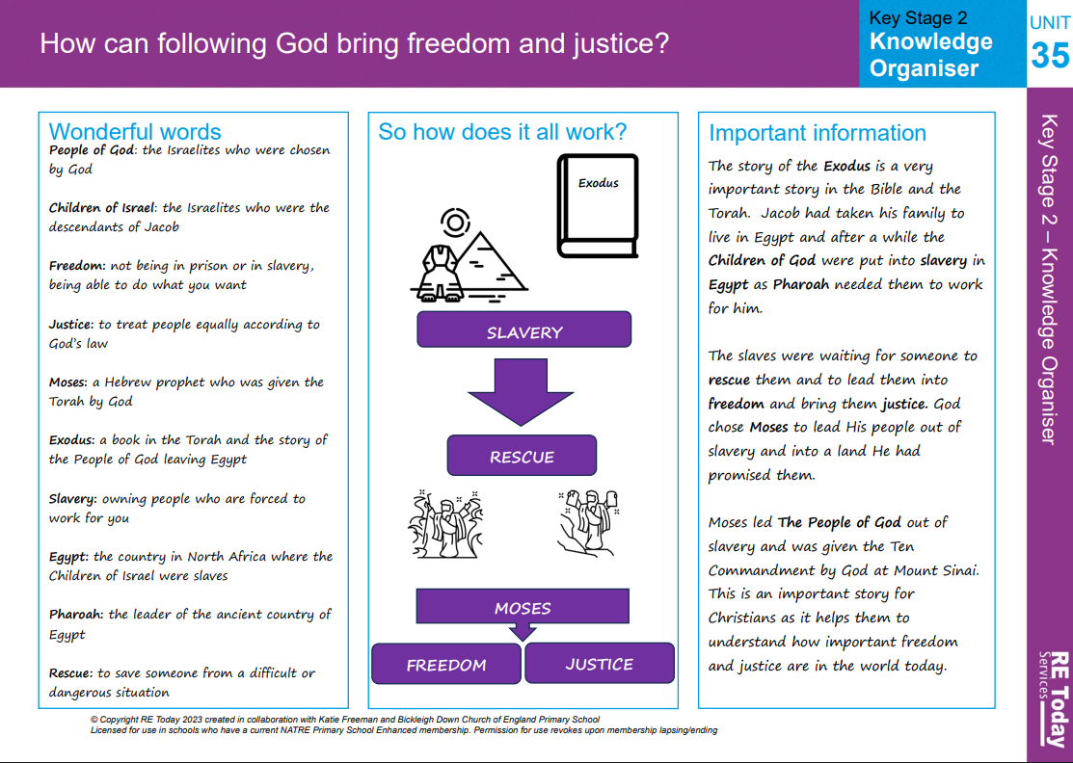
RE Knowledge Organiser Year 5 – Summer 1

Gospel Value:
Grateful and Generous- To be grateful for the sacrifice made by Jesus to save us all

RE Knowledge Organiser Year 5 – Summer 2

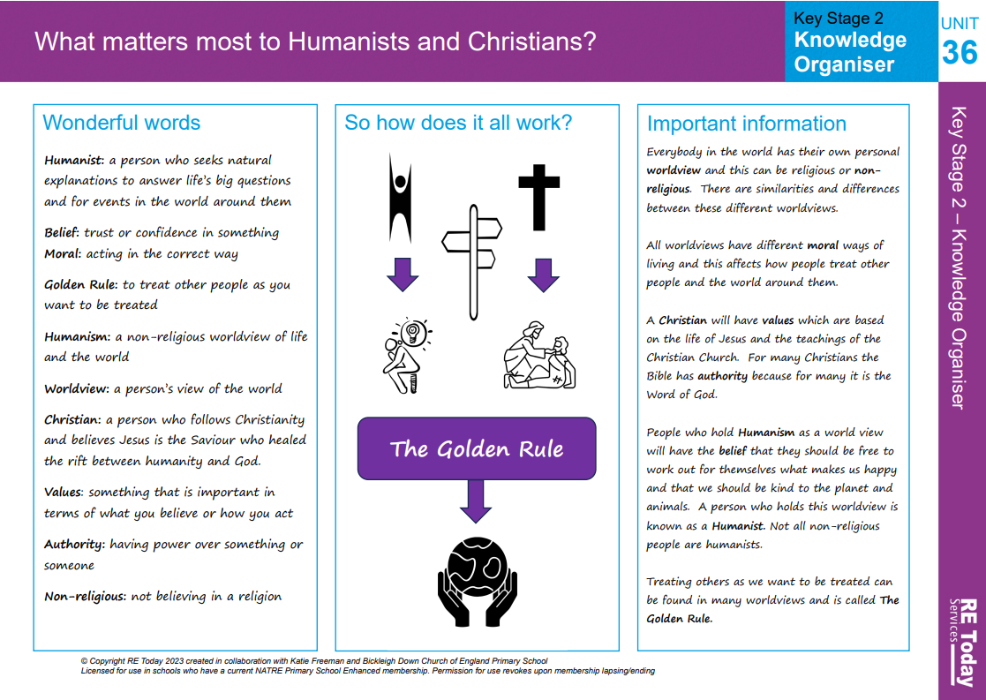

Gospel Value:
Curious and Active- To be curious about a Sikh’s commitment to God and active in our own commitment to God

RE Knowledge Organiser Year 6 – Autumn 1

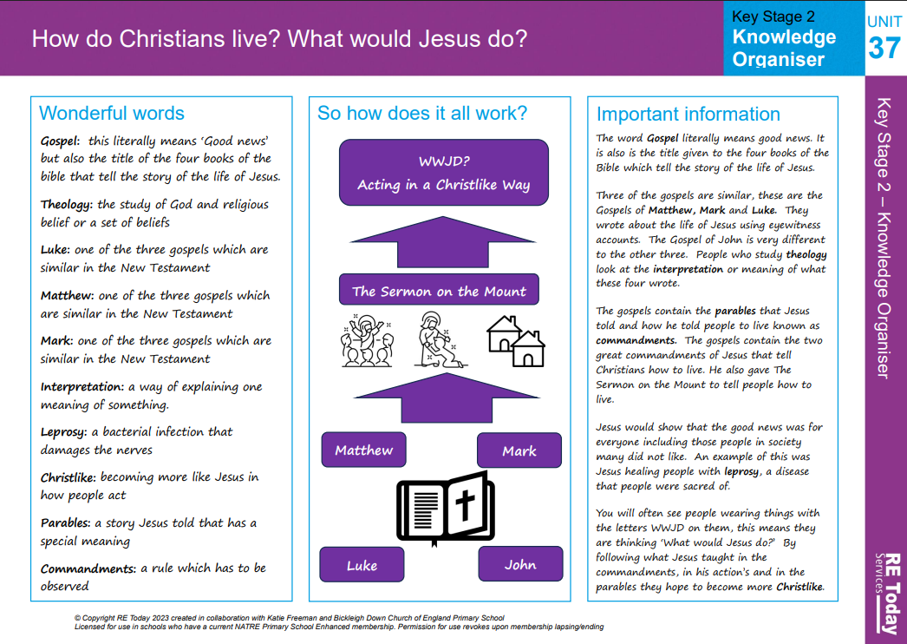

Gospel Value:
Compassionate and Loving- To learn from God’s example of being loving and recreate this within our own relationships.
RE Knowledge Organiser Year 6 – Autumn 2

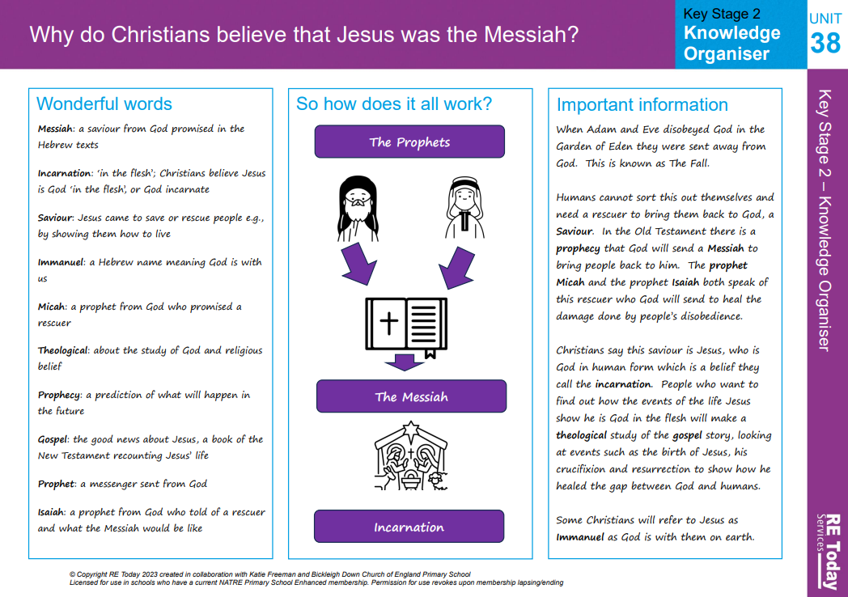

Gospel Value:
Curious and Active- To be curious about a Muslim’s commitment to Allah and active in our own commitment to God
RE Knowledge Organiser Year 6 - Spring 1

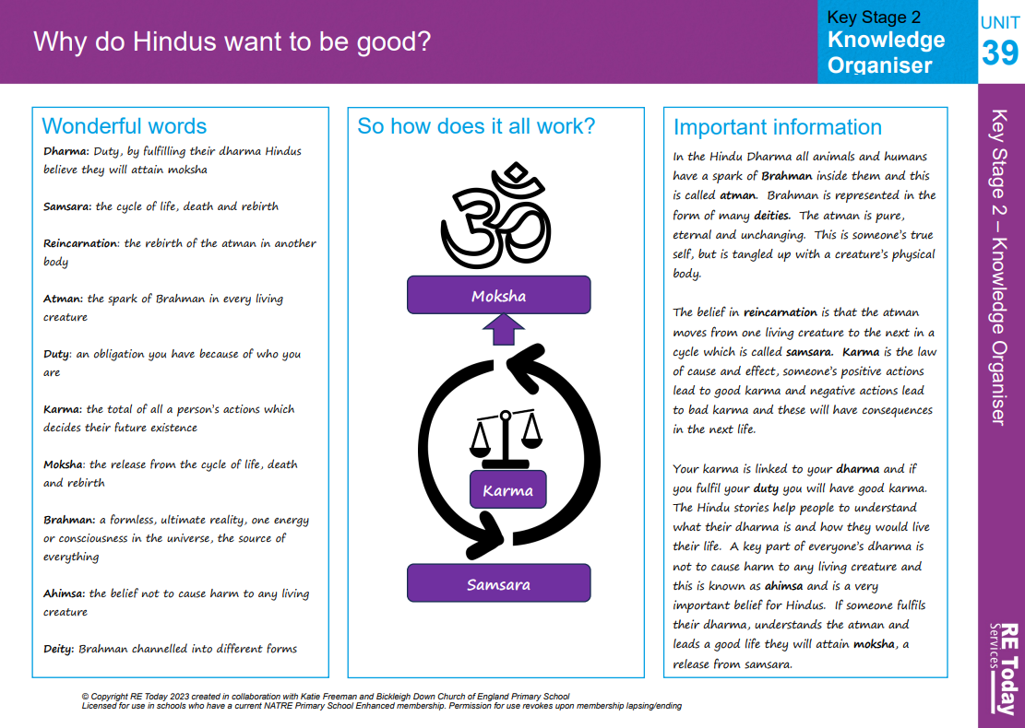

Gospel Value:
Intentional and Prophetic- To learn from Jesus and to consider and be prophetic in the examples we set to others.
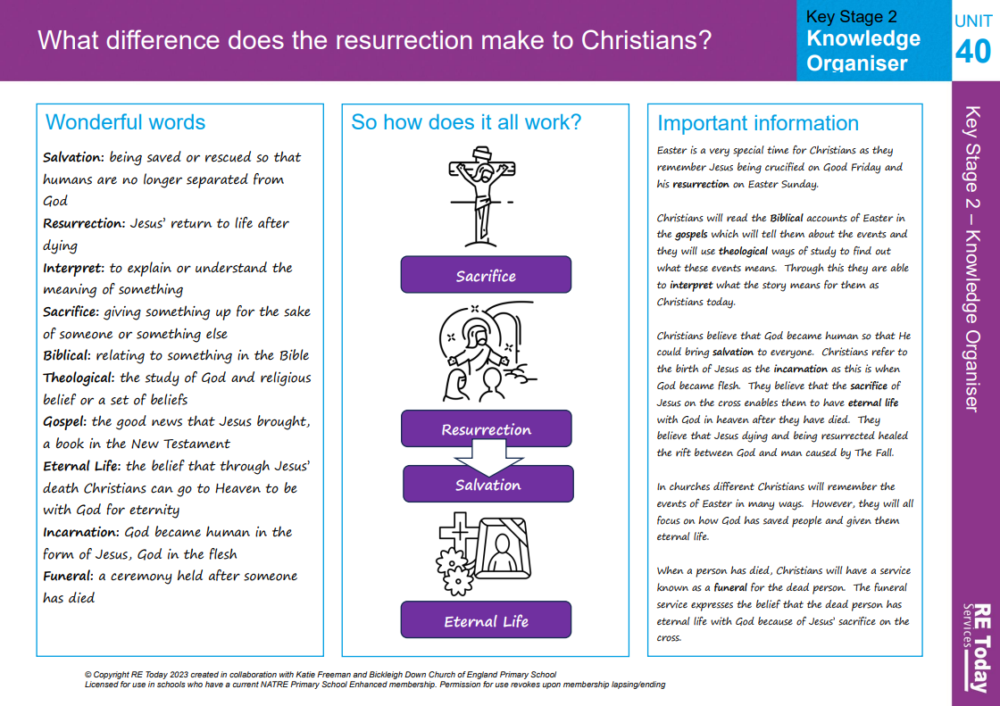
RE Knowledge Organiser Year 6 - Spring 2

Gospel Value:
Learned and Wise- To be open to learning about topics from different perspectives and wise in the way we articulate our own views.
RE Knowledge Organiser Year 6 - Summer 1

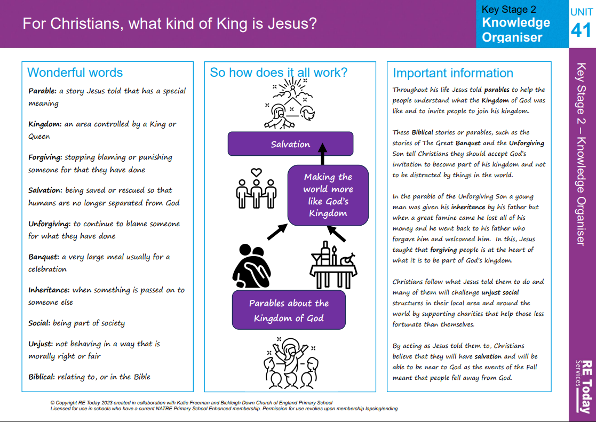

Gospel Value:
Grateful and Generous- To be grateful for the sacrifice made by Jesus and the blessings of each day.
RE Knowledge Organiser Year 6 - Summer 2

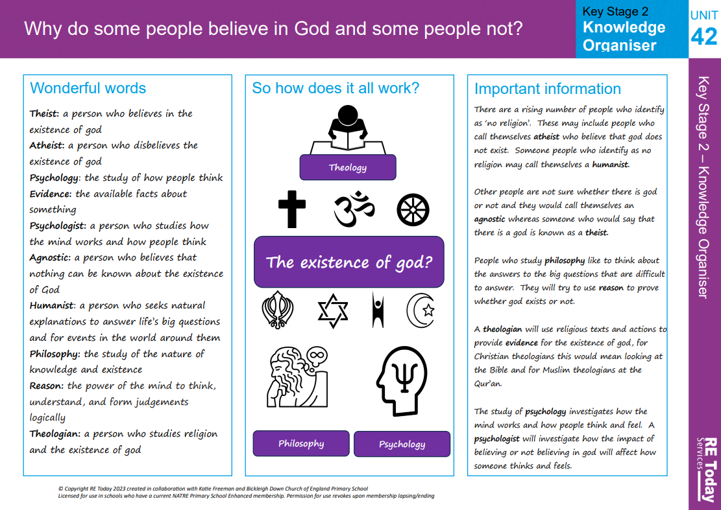

Gospel Value:
Faith-filled and Hopeful- To be hopeful for the future according to our own beliefs.

Gospel Value:
Attentive and Discerning- To be perceptive of the world around us and respectful of the choices we each make.

