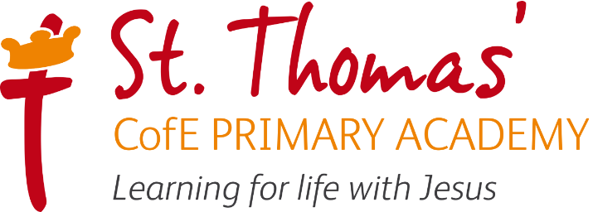

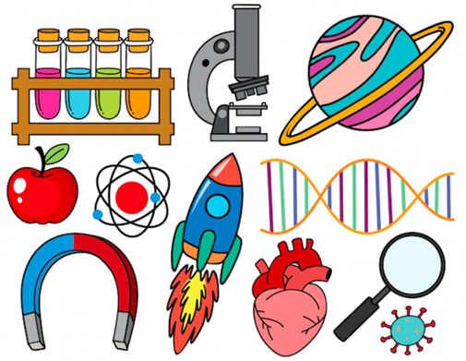

Science Learning Journey
2025/2026

Intent, Implementation and Impact

Learning for life with Jesus

Intent
As a Church of England school, our Science curriculum is underpinned by our Christian values. These values are used and applied throughout the Science curriculum.
The children show curiosity about the world around them by asking and raising questions which they are then encouraged to seek the answers to, thus developing their scientific knowledge and understanding. They show attentiveness and active learning by taking on the role of a scientist by working scientifically whether it be through pattern seeking, carrying out research, identifying and classifying, observing overtime or through comparative and fair testing. Our children are learned and wise in the way that they apply scientific skills and knowledge in investigations and experiments and use these to raise follow up questions. They show gratefulness through the opportunities to go on trips and visits related to their science topics which paves way for experiencing science beyond the classroom walls, thus enhancing their learning and offering real life experiences. We are very lucky to have school dogs, chickens, a pond and a wide outdoor learning space including the woodland area and the fields. With animals all around, our children are able to develop and show their compassionate and loving side. At the heart of our Science curriculum is our knowledge and scientific enquiry, both evident in our curriculum learning journey. These knowledge and scientific skills are progressive and are built on year after year from EYFS all the way through to Year 6.
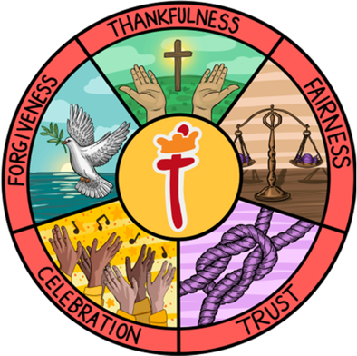
In Science, we want to instil a curiosity and a love of learning by getting the children to learn about the world around them through a combination of building up conceptual scientific knowledge, engaging in hands on activities and providing opportunities for learning to take place beyond the classroom walls. We believe that linking science to real-life experiences provide children with purposeful contexts and a deeper connection to their learning. Our curriculum aims to show the relevance of science to their everyday life; this allows them to learn more about the world around them. Our science curriculum promotes independence as well as working as a team, inquisitiveness by working scientifically and high aspirations by increasing children’s science capital.
Through our sustainability links, we want children to:
- Understand the current issues around sustainability and climate change.
- Identify that they have a role to play in creating a more sustainable future for themselves and others.
- Think of ways to make a positive impact on their local and wider environments.
- Have a positive and proactive mindset when it comes to making sustainable changes.
Our Christian values, core skills and key outcomes will raise aspirations and ensure that our children are more than ready for the next stages in their science journey.
Our Science lead in school is Mrs K Buggy

Implementation

St Thomas’ Science Learning Journey focuses on a spiral curriculum model where previous skills and knowledge are revisited and built upon. Over the course of the journey children will focus on both declarative and procedural knowledge. Declarative knowledge in science is the factual knowledge; this knowledge is not a list of disconnected facts; it is explicitly linked to the content being taught. Procedural knowledge can be viewed as the know-how to apply declarative facts – these are outlined in the working scientifically skills.

At St Thomas’, we use the White Rose Science scheme as a basis for our structure. Each year group has a series of ‘blocks’. These blocks are them broken down into small steps. Each block has an enquiry question that it leads up to and each year group will cover the five types of enquiry over a year. Each ‘small step’ has a working scientifically skill focus. These skills are developed across year groups. Each year group has two blocks dedicated to sustainability.

In Science, work is recorded in an exercise book where appropriate, this may be in the form of writing, drawing or photographs, and marked in line with the marking policy.

Science is taught for an hour a week or two hours every two weeks depending on the topic and year group being taught. At the start of each unit of work, children explore what they already know about their topic and have an opportunity to recap previously learnt knowledge and skills. They have chance to raise any questions and think about what they want to learn during the unit. The learning intention is shared with the children at the start of the lesson and how they are working scientifically if appropriate. New knowledge and skills are specifically taught and modelled by the teacher and children have the opportunity to practise this knowledge. During the lesson activities are as active and hands on as possible, providing purposeful and engaging tasks that enable the children to Apply their new found knowledge and skills. These tasks are differentiated where appropriate and assessment and feedback will focus on misconceptions and next steps for learning. At the end of each lesson, and then at the end of the topic, the children complete a review to show what they have learnt.

Science Lesson Journey

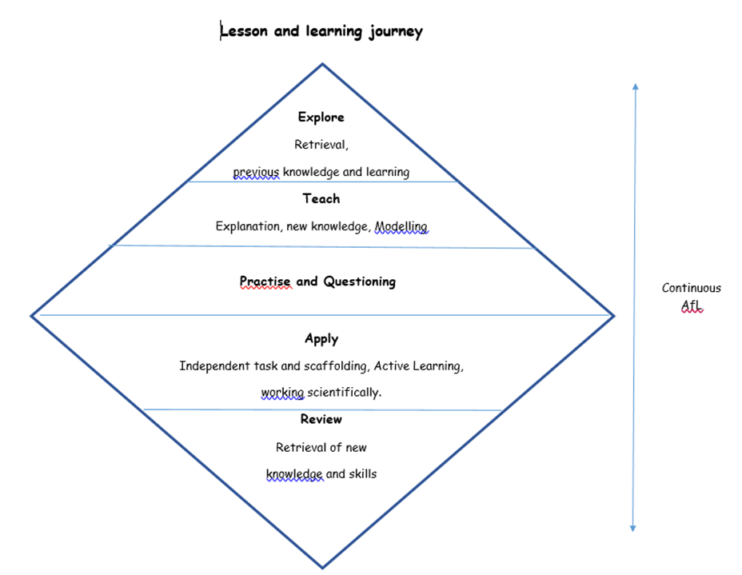

In Science, work is recorded in an exercise book and marked in line with the marking policy

EYFS
As part of Development Matters (2021), Science is taught in relation to the strand Understanding the World. Children in EYFS have a science unit each half term linked to a key question, focusing on a different strand of science. Lessons take the same form as the rest of the school where children take part in the Explore – Teach – Practise – Apply – Review cycle illustrated below. There will then be an independent activity relating to the input. All classrooms have an investigation station. As part of this, science based enhanced provision will be planned for weekly. Children also have access to science-based resources which they are free to use as part of the child-initiated provision.
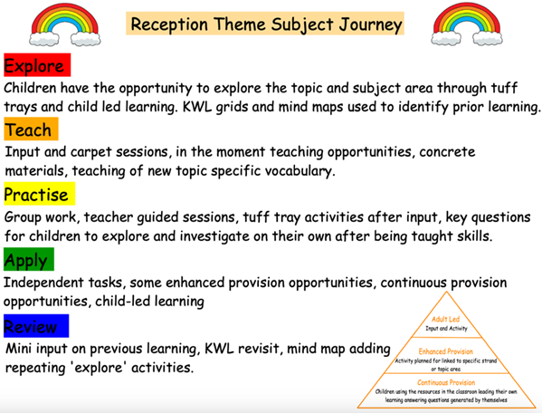

Impact

The specific impact of the St Thomas’ Science Learning Journey is that children will (as stated in the national curriculum:

- develop scientific knowledge and conceptual understanding through the specific disciplines of biology, chemistry and physics
- develop understanding of the nature, processes and methods of science through different types of science enquiries that help them to answer scientific questions about the world around them
- are equipped with the scientific knowledge required to understand the uses and implications of science, today and for the future

Formative assessment takes part in each lesson and misconception and next steps of the focus for feedback. Summative assessment is completed for each child at the end of each unit of teaching using the assessment framework at the end of this document. A best fit approach to statements achieved results in an end of year summative grade.

Adaptive Teaching Strategies

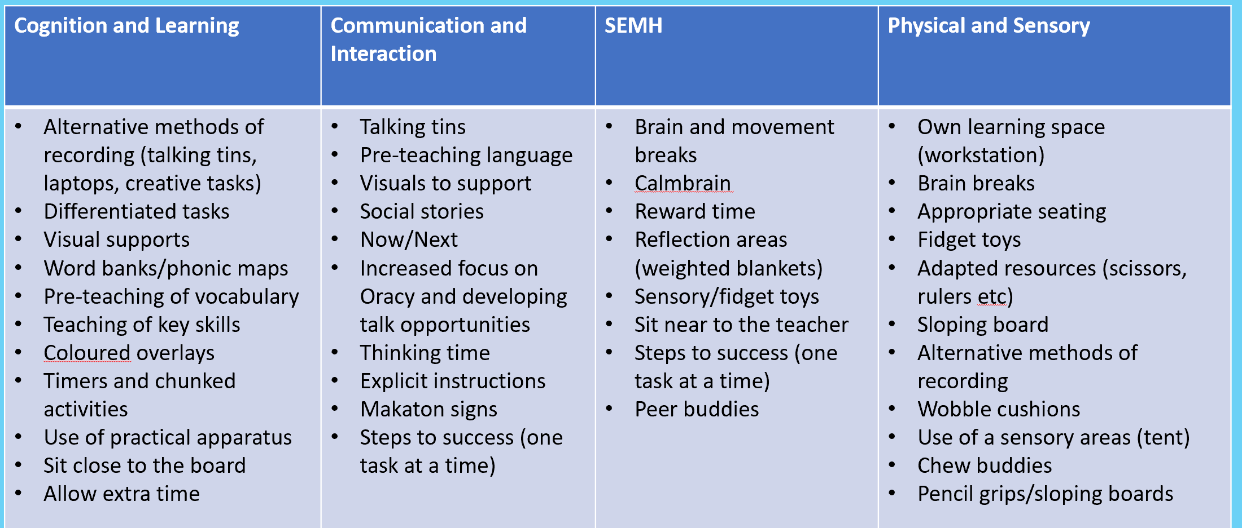

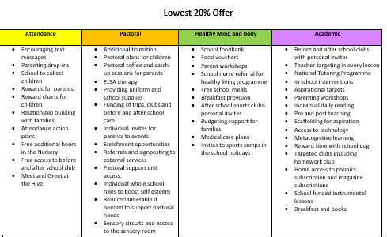
Lowest 20% offer

2026/2027 Science Overviews

RECEPTION
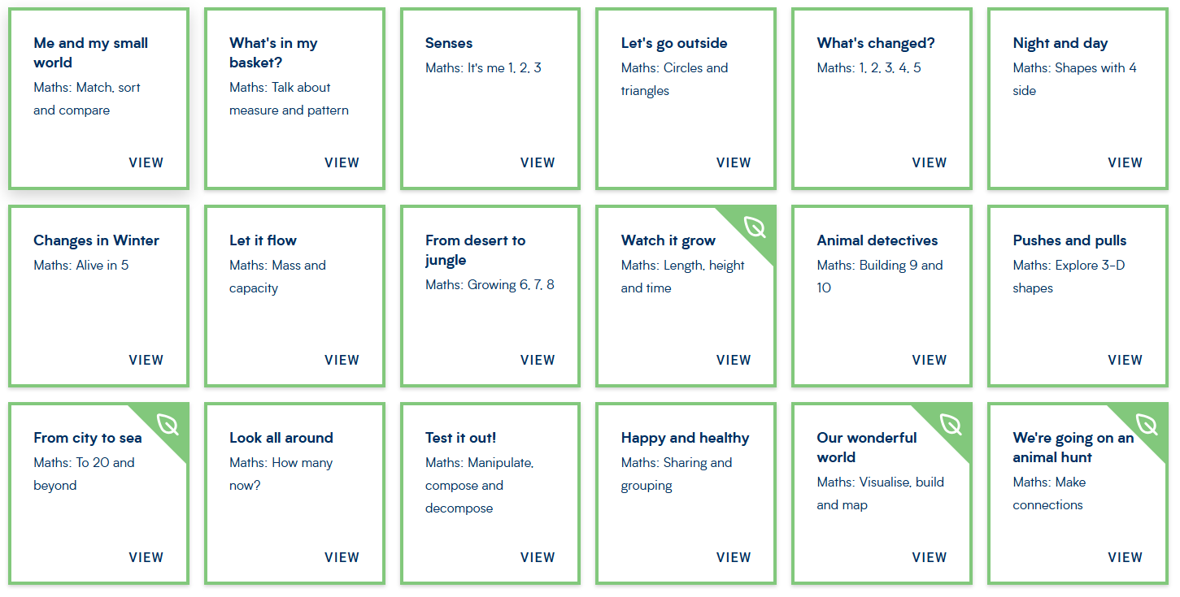

YEAR ONE
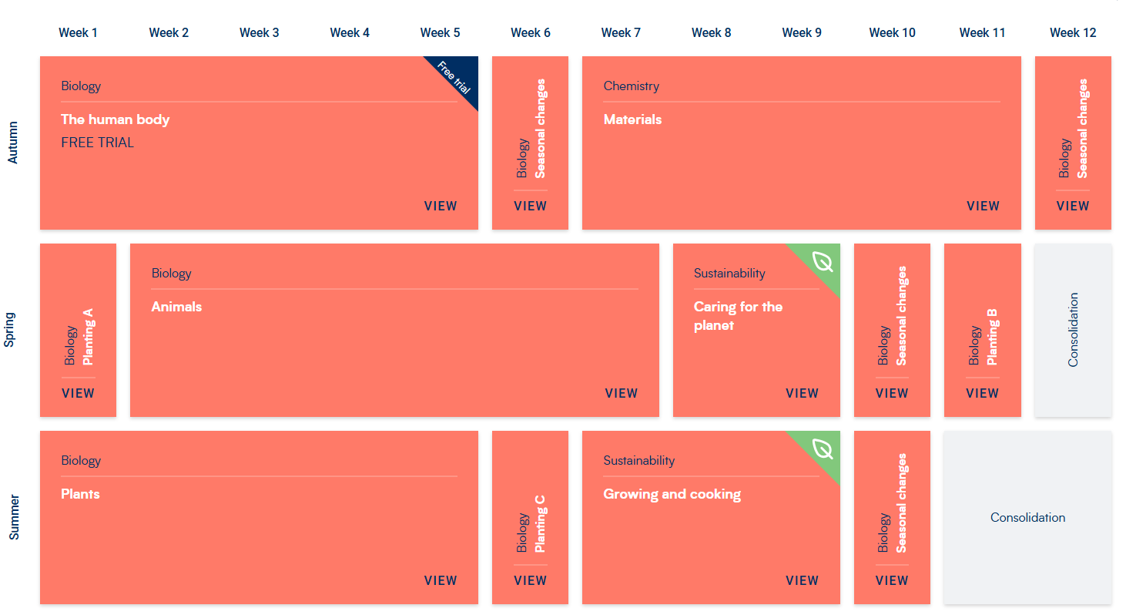

YEAR TWO

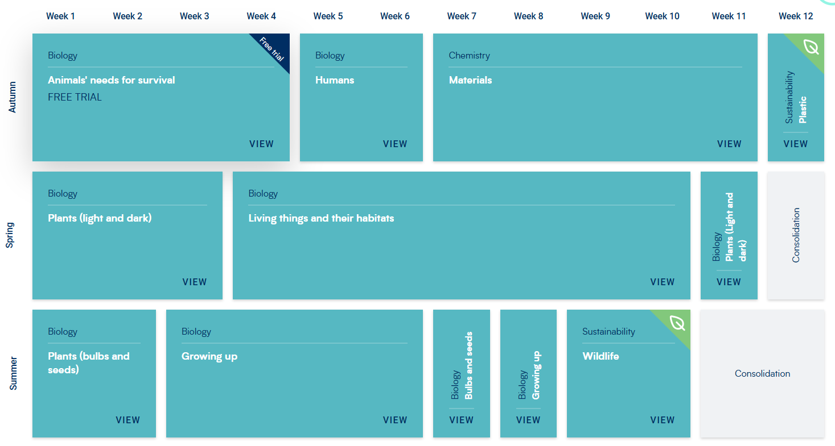

YEAR THREE

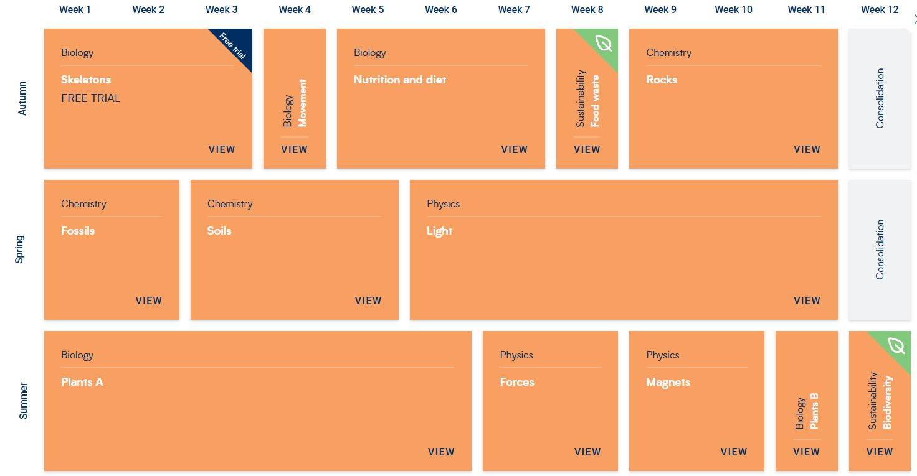

YEAR FOUR

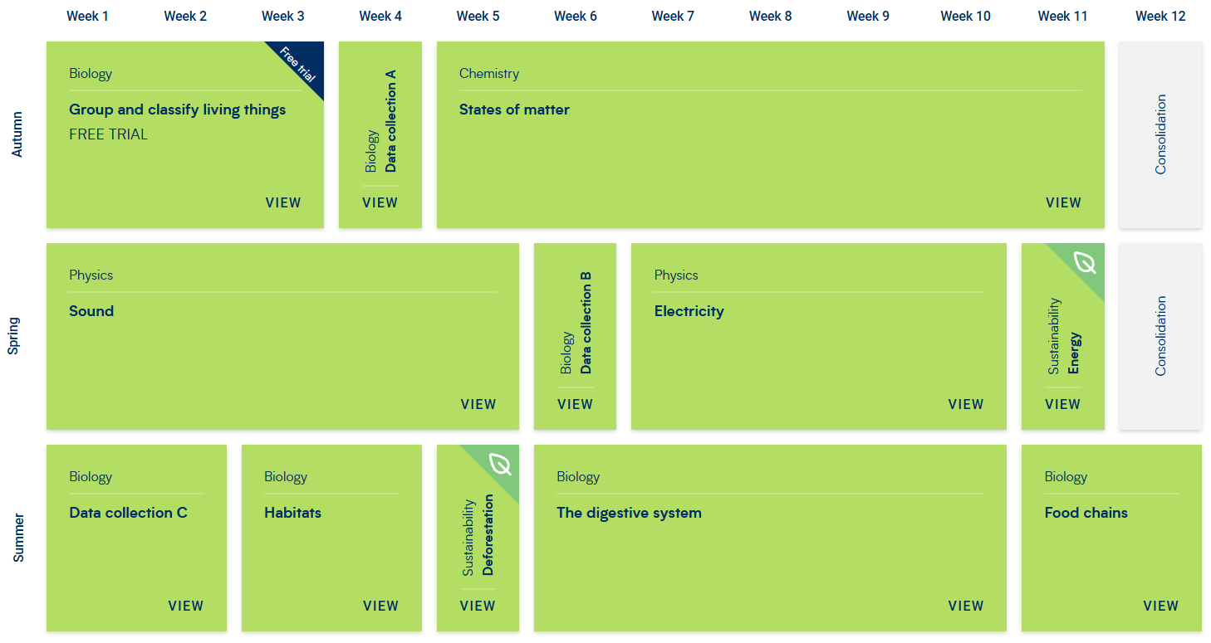

YEAR FIVE

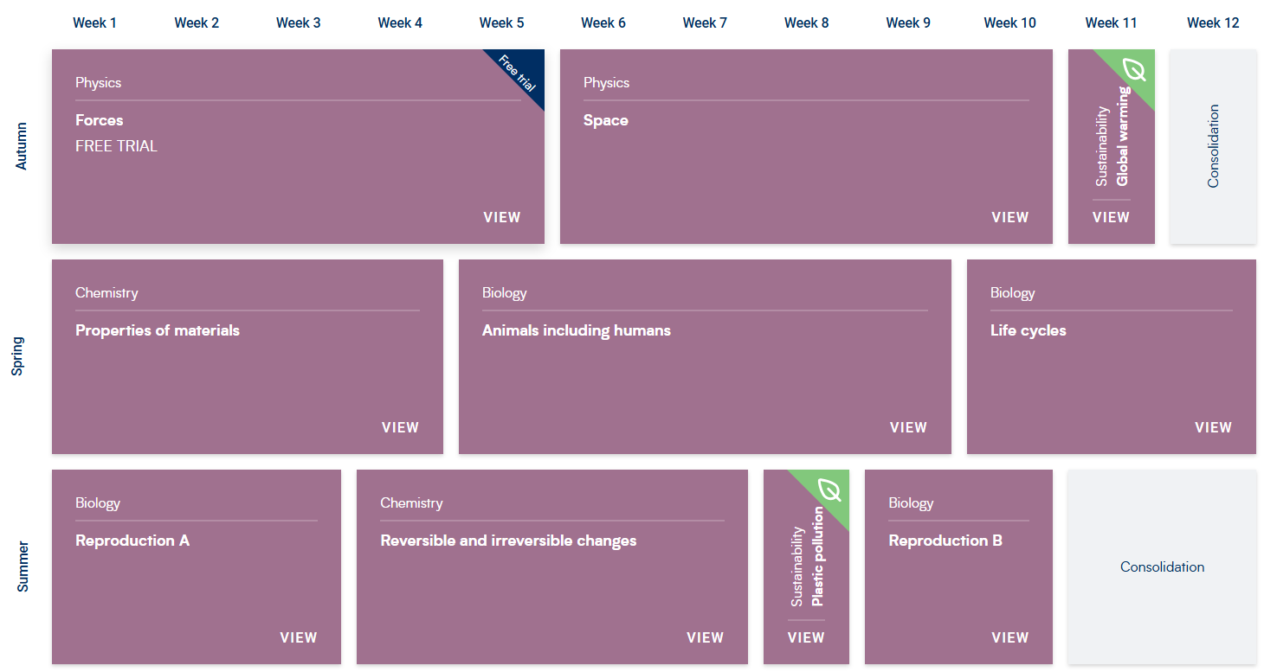

YEAR SIX

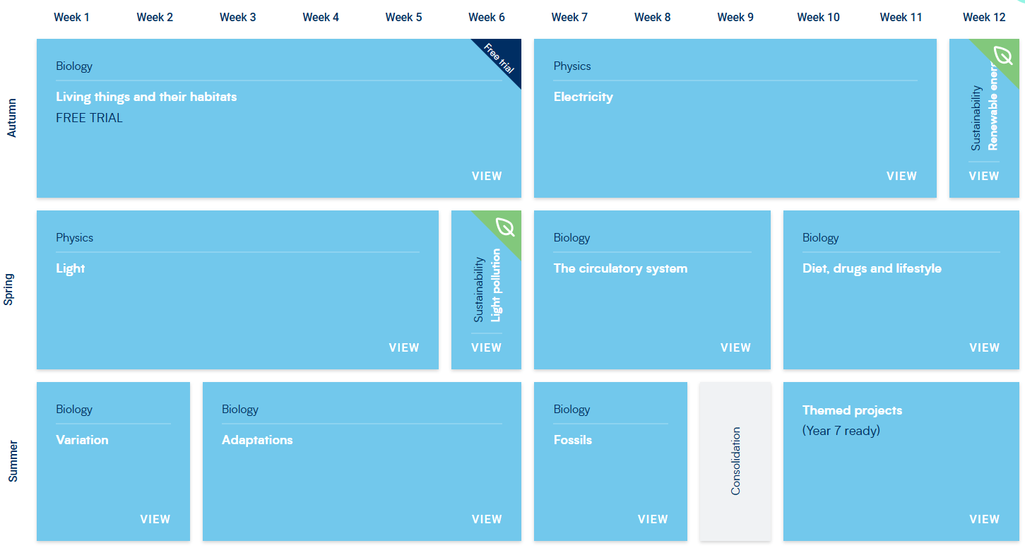

EYFS Development Matters Coverage

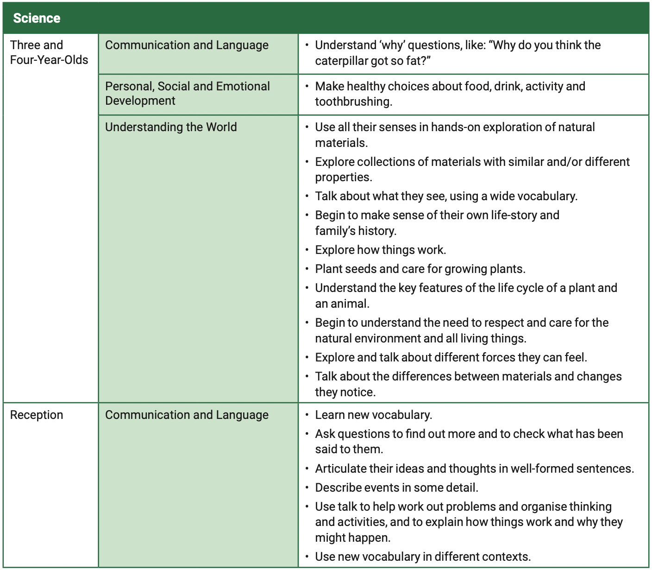

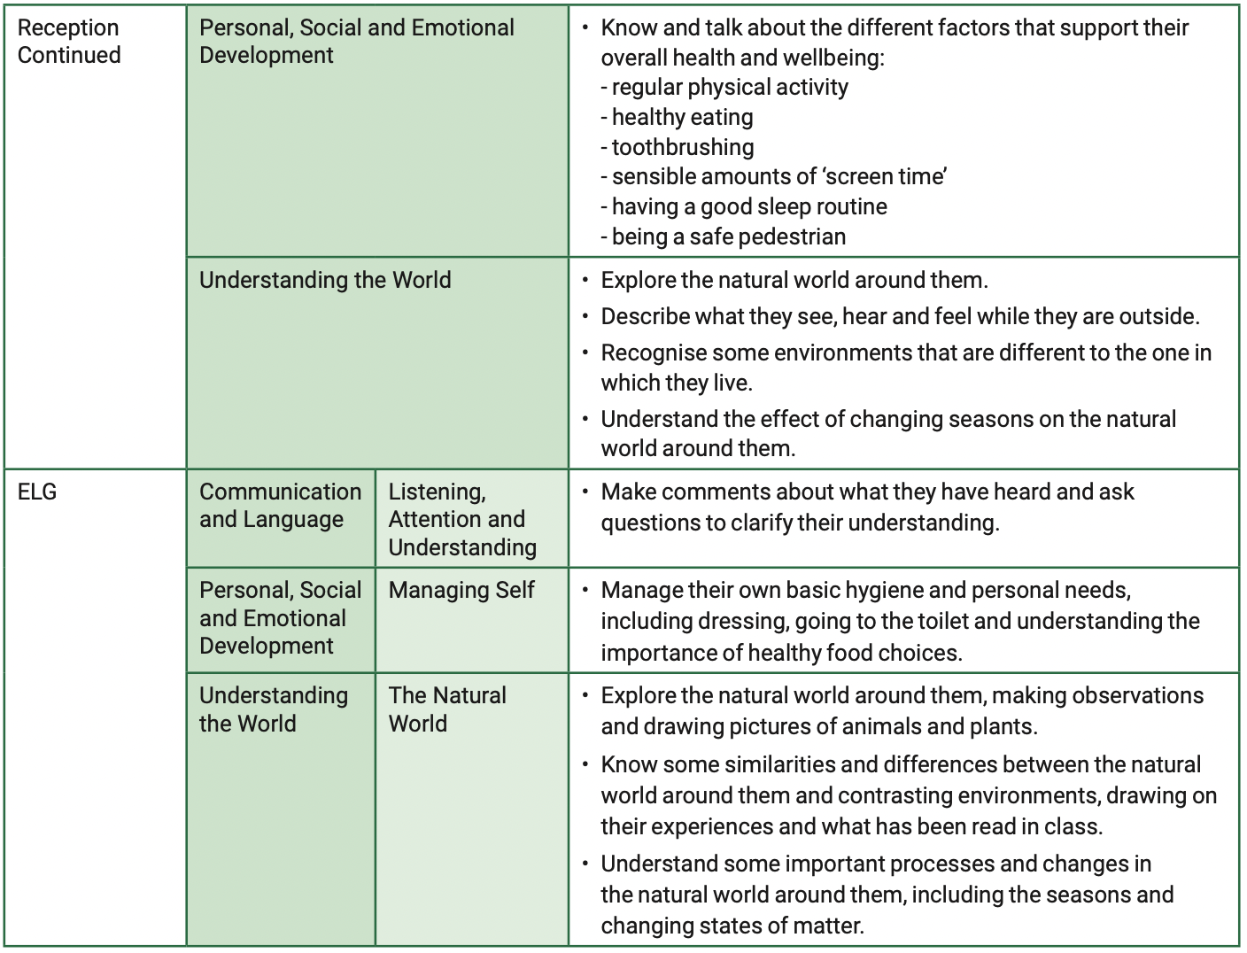

National Curriculum Coverage and Progression
Year 1 – Year 6

Animals, including humans
Year 1 | Year 2 | Year 3 | Year 4 | Year 5 | Year 6
Identify and name a  variety of common  animals including fish,  amphibians, reptiles,  birds and mammals  • Identify and name a  variety of common  animals that are  carnivores, herbivores  and omnivores  • Describe and compare  the structure of a  variety of common  animals (fish,  amphibians, reptiles,  birds and mammals  including pets)  • Identify, name, draw  and label the basic parts  of the human body and  say which part of the  body is associated with  each sense | • Notice that animals, including humans, have offspring which grow into adults  • Find out about and describe the basic needs of animals, including humans, for survival (water, food and air)  • Describe the importance for humans of exercise, eating the right amounts of different types of food, and hygiene. | Identify that animals, including humans, need the right types and amount of nutrition, and that they cannot make their own food; they get nutrition from what they eat  • Identify that humans and some other animals have skeletons and muscles for support, protection and movement | • Describe the simple functions of the basic parts of the digestive system in humans  • Identify the different types of teeth in humans and their simple functions  • Construct and interpret a variety of food chains, identifying producers, predators and prey | Describe the changes as humans develop to old age | Identify and name the main parts of the human circulatory system, and describe the functions of the heart, blood vessels and blood  • Recognise the impact of diet, exercise, drugs and lifestyle on the way their bodies function  • Describe the ways in which nutrients and water are transported within animals including humans.
Living things and their habitats
Year 1 | Year 2 | Year 3 | Year 4 | Year 5 | Year 6
 | • Explore and compare the differences between things that are living, dead, and things that have never been alive  • Identify that most living things live in habitats to which they are suited and describe how different habitats provide for the basic needs of different kinds of animals and plants, and how they depend on each other  • Identify and name a variety of plants and animals in their habitats, including microhabitats  • Describe how animals obtain their food from plants and other animals, using the idea of a simple food chain, and identify and name different sources of food. |  | Recognise that living things can be grouped in a variety of ways  • explore and use classification keys to help group, identify and name a variety of living things in their local and wider environment  • Recognise that environments can change and that this can sometimes pose dangers to living things | Describe the differences in the life cycles of a mammal, an amphibian, an insect and a bird  • Describe the life process of reproduction in some plants and animals | Describe how living things are classified into broad groups according to common observable characteristics and based on similarities and differences, including micro-organisms, plants and animals  • Give reasons for classifying plants and animals based on specific characteristic
Plants
Year 1 | Year 2 | Year 3 | Year 4 | Year 5 | Year 6
• Identify and name a variety of common wild and garden plants, including deciduous and evergreen trees  • Identify and describe the basic structure of a variety of common flowering plants, including trees | Observe and describe how seeds and bulbs grow into mature plants • Find out and describe how plants need water, light and a suitable temperature to grow and stay healthy | Identify and describe the functions of different parts of flowering plants: roots, stem/trunk, leaves and flowers  • Explore the requirements of plants for life and growth (air, light, water, nutrients from soil, and room to grow) and how they vary from plant to plant  • Investigate the way in which water is transported within plants  • Explore the part that flowers play in the life cycle of flowering plants, including pollination, seed formation and seed disperse
Materials
Year 1 | Year 2 | Year 3 | Year 4 | Year 5 | Year 6
• Distinguish between an object and the material from which it is made  • Identify and name a variety of everyday materials, including wood, plastic, glass, metal, water, and rock  • Describe the simple physical properties of a variety of everyday materials  • Compare and group together a variety of everyday materials on the basis of their simple physical property | • Identify and compare the suitability of a variety of everyday materials, including wood, metal, plastic, glass, brick, rock, paper and cardboard for particular uses  • Find out how the shapes of solid objects made from some materials can be changed by squashing, bending, twisting and stretching |  |  | Compare and group together everyday materials on the basis of their properties, including their hardness, solubility, transparency, conductivity (electrical and thermal), and response to magnets  • know that some materials will dissolve in liquid to form a solution, and describe how to recover a substance from a solution  • use knowledge of solids, liquids and gases to decide how mixtures might be separated, including through filtering, sieving and evaporating • Give reasons, based on evidence from comparative and fair tests, for the particular uses of everyday materials, including metals, wood and plastic • Demonstrate that dissolving, mixing and changes of state are reversible changes  • Explain that some changes result in the formation of new materials, and that this kind of change is not usually reversible, including changes associated with burning and the action of acid on bicarbonate of soda.
Electricity
Year 1 | Year 2 | Year 3 | Year 4 | Year 5 | Year 6
 |  |  | Identify common appliances that run on electricity  • Construct a simple series electrical circuit, identifying and naming its basic parts, including cells, wires, bulbs, switches and buzzers  • Identify whether or not a lamp will light in a simple series circuit, based on whether or not the lamp is part of a complete loop with a battery  • Recognise that a switch opens and closes a circuit and associate this with whether or not a lamp lights in a simple series circuit  • Recognise some common conductors and insulators, and associate metals with being good conductors |  | Associate the brightness of a lamp or the volume of a buzzer with the number and voltage of cells used in the circuit  • Compare and give reasons for variations in how components function, including the brightness of bulbs, the loudness of buzzers and the on/off position of switches  • Use recognised symbols when representing a simple circuit in a diagram
Rocks
Year 1 | Year 2 | Year 3 | Year 4 | Year 5 | Year 6
• Compare and group together different kinds of rocks on the basis of their appearance and simple physical properties
• Describe in simple terms how fossils are formed when things that have lived are trapped within rock
• Recognise that soils are made from rocks and organic matter
States of Matter
Year 1 | Year 2 | Year 3 | Year 4 | Year 5 | Year 6
Compare and group materials together, according to whether they are solids, liquids or gases
• Observe that some materials change state when they are heated or cooled, and measure or research the temperature at which this happens in degrees Celsius (°C)
• Identify the part played by evaporation and condensation in the water cycle and associate the rate of evaporation with temperature
Earth and Space
Year 1 | Year 2 | Year 3 | Year 4 | Year 5 | Year 6
Describe the movement of the Earth and other planets relative to the sun in the solar system
• Describe the movement of the moon relative to the Earth
• Describe the sun, Earth and moon as approximately spherical bodies
• Use the idea of the Earth’s rotation to explain day and night and the apparent movement of the sun across the sky
Seasonal change
Year 1 | Year 2 | Year 3 | Year 4 | Year 5 | Year 6
• Observe changes across the 4 seasons
• Observe and describe weather associated with the seasons and how day length varies
Sound
Year 1 | Year 2 | Year 3 | Year 4 | Year 5 | Year 6
• Identify how sounds are made, associating some of them with something vibrating
• Recognise that vibrations from sounds travel through a medium to the ear
• Find patterns between the pitch of a sound and features of the object that produced it
• Find patterns between the volume of a sound and the strength of the vibrations that produced it
• Recognise that sounds get fainter as the distance from the sound source increases
Light
Year 1 | Year 2 | Year 3 | Year 4 | Year 5 | Year 6
 |  | Recognise that they need light in order to see things and that dark is the absence of light  • Notice that light is reflected from surfaces • Recognise that light from the sun can be dangerous and that there are ways to protect their eyes  • Recognise that shadows are formed when the light from a light source is blocked by an opaque object  • Find patterns in the way that the size of shadows change |  |  | • Recognise that light travels in straight lines  • Use the idea that light travels in straight lines to explain that objects are seen because they give out or reflect light into the eye  • Explain that we see things because light travels from light sources to our eyes or from light sources to objects and then to our eyes  • Use the idea that light travels in straight lines to explain why shadows have the same shape as the objects that cast them
Forces and Magnets
Year 1 | Year 2 | Year 3 | Year 4 | Year 5 | Year 6
 |  | Compare how things move on different surfaces  • Notice that some forces need contact between 2 objects, but magnetic forces can act at a distance  • Observe how magnets attract or repel each other and attract some materials and not others • Compare and group together a variety of everyday materials on the basis of whether they are attracted to a magnet, and identify some magnetic materials • Describe magnets as having 2 poles  • Predict whether 2 magnets will attract or repel each other, depending on which poles are facing |  | Explain that unsupported objects fall towards the Earth because of the force of gravity acting between the Earth and the falling object  • Identify the effects of air resistance, water resistance and friction, that act between moving surface  • Recognise that some mechanisms including levers, pulleys and gears allow a smaller force to have a greater effect
Evolution and Inheritance
Year 1 | Year 2 | Year 3 | Year 4 | Year 5 | Year 6
• Recognise that living things have changed over time and that fossils provide information about living things that inhabited the Earth millions of years ago
• Recognise that living things produce offspring of the same kind, but normally offspring vary and are not identical to their parents
• Identify how animals and plants are adapted to suit their environment in different ways and that adaptation may lead to evolution

Working scientifically skills progression
Year 1 – Year 6

Ask questions
Year 1 | Year 2 | Year 3 | Year 4 | Year 5 | Year 6
Ask simple questions. | Ask simple questions and recognise that they can be answered in different ways. | Ask questions and understand there are different enquiry types they could use to answer them. | Ask relevant questions and use different types of scientific enquiry to | Ask scientific questions and begin to understand which questions would be best suited to each enquiry type. | • Ask relevant scientific questions and choose which enquiry type would be best suited to answer them
Plan
Year 1 | Year 2 | Year 3 | Year 4 | Year 5 | Year 6
Planning is not explicitly mentioned in the KS1 curriculum however, if appropriate, children can verbally state what they will investigate, what they will change and what they will keep the same. |  | • Make relevant predictions.  • Identify what they will change, observe and keep the same.  • With support, set up simple practical enquiries | Make predictions based on simple scientific knowledge.  • Identify what they will change, observe or measure and keep the same.  • Set up simple practical enquiries, comparative and fair tests. | • Make predictions based on scientific knowledge.  • With support, plan different types of scientific enquiry. Where appropriate, identify the dependent, independent and controlled variables. | Make predictions based on scientific knowledge.  • Plan different types of scientific enquiries to answer questions, including recognising and controlling variables where necessary.
Make observations
Year 1 | Year 2 | Year 3 | Year 4 | Year 5 | Year 6
Observe closely. | • Observe closely, using simple equipment. | Make careful observations using scientific equipment. | • Make systematic and careful observations using scientific equipment. | • Use a range of scientific equipment to make systematic and careful observations. | Use a range of scientific equipment to make systematic and careful observations with increased complexity.
Take measurements
Year 1 | Year 2 | Year 3 | Year 4 | Year 5 | Year 6
• Carry out simple tests using non-standard measurements when appropriate. | • Perform simple tests using standard units when appropriate. | Perform tests and simple experiments and take measurements using standard units. | Take accurate measurements using standard units, using a range of equipment, including thermometers and data loggers. | • Take accurate measurements using a range of scientific equipment. Start to take repeat readings when appropriate. | • Take measurements, using a range of scientific equipment, with increasing accuracy and precision, taking repeat readings when appropriate.
Gather, record and classify data
Year 1 | Year 2 | Year 3 | Year 4 | Year 5 | Year 6
• Gather and record simple data  . • Sort objects and living things into groups based on simple properties. | Gather and record data to help in answering questions.  • Identifying and classifying. | • Recording findings using simple scientific language, drawings, labelled diagrams, bar charts, and tables | • Gather, record and classify data in a variety of ways to help in answering questions  . • Record findings using simple scientific language, drawings, labelled diagrams, keys, bar charts, and tables. | • Record data using scientific diagrams and labels, classification keys, tables, bar and line graphs. | Record data and results of increasing complexity using scientific diagrams and labels, classification keys, tables, scatter graphs, bar and line graphs.
Present findings
Year 1 | Year 2 | Year 3 | Year 4 | Year 5 | Year 6
• Explain what they found out to an adult or a partner | • Talk about what they have found out and how they found it out. (non-statutory) | • Report on findings from enquiries, including oral and written explanations. | • Report on findings from enquiries, including oral and written explanations, displays or presentations of results and conclusions. | Report and present findings from enquiries, including conclusions and begin to identify causal relationships in oral and written forms such as displays and other presentations. | Report and present findings from enquiries, including conclusions, causal relationships and explanations of and a degree of trust in results, in oral and written forms such as displays and other presentations.
Answer questions and make conclusions
Year 1 | Year 2 | Year 3 | Year 4 | Year 5 | Year 6
• Answer simple questions | • Use their observations and ideas to suggest answers to questions. | • Make simple conclusions. • Use results, findings or observations to answer questions. | • Use straight-forward scientific evidence to answer questions or to support their findings. • Use results to draw simple conclusions. • Begin to identify differences, similarities or changes related to simple ideas or processes. | Make conclusions based on scientific evidence and from their own testing and findings. • Identify scientific evidence and use it to answer questions. | • Make conclusions based on scientific evidence and from their own testing and findings. • Identify scientific evidence that has been used to support or refute ideas or arguments
Evaluate
Year 1 | Year 2 | Year 3 | Year 4 | Year 5 | Year 6
Evaluating is not explicitly mentioned in the KS1 curriculum. |  | • Suggest questions for further investigation. | • Use results to draw simple conclusions, make predictions for new values, suggest improvements and raise further questions. | • Continue to use results to draw simple conclusions, suggest improvements and raise further questions for possible testing | • Use test results to make predictions to set up further comparative and fair tests.  • Provide some simple examples of how to extend the investigation.

Enquiry Type Coverage

Enquiry questions are highlighted when children are undertaking the scientific enquiry process. Each block has one enquiry question and there is coverage of the five enquiry types across a year. This allows children to develop answers to a range of relevant scientific questions.

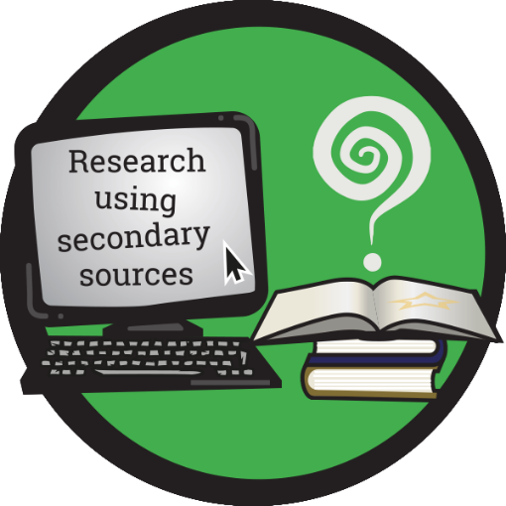

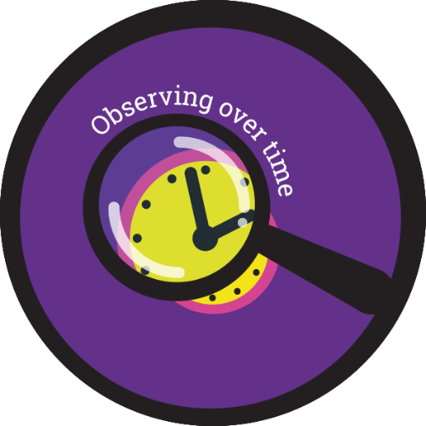
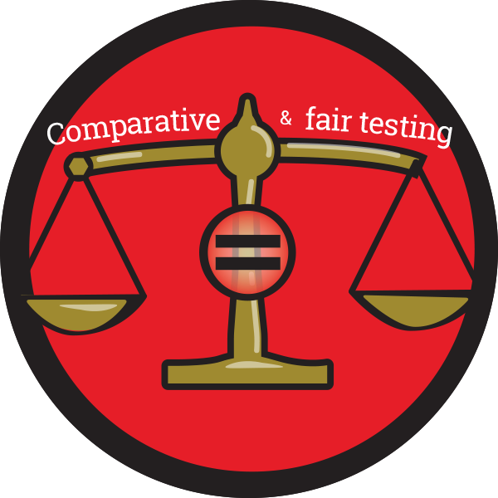
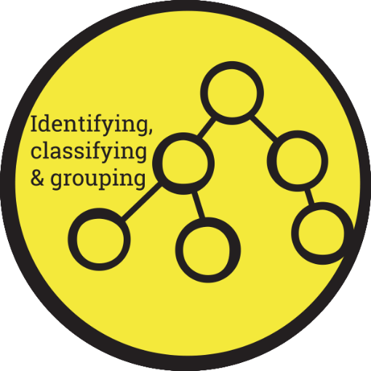
Enquiry Type | EYFS | Y1 | Y2 | Y3 | Y4 | Y5 | Y6
Research | Are all animals that live in the sea, fish? |  |  |  |  | How have our ideas about the Solar System changed over time?
Comparative  /Fair Testing | Which material is the strongest for Little Red’s basket?  Which material will keep me warmest in winter? |  |  |  | What living things do we have in our local area and how does this change over the year? | Does the surface area of a parachute affect how long it takes for it to fall to the ground? | How does the voltage in a circuit affect the brightness of a bulb and the loudness of a buzzer?
Observing over time | How have I changed over time?  What changes occur to ginger bread men over time in different liquids? | What are the main changes in each season?
Pattern Seeking | Do bigger boats float better? | Does the oldest child have the longest feet? | Do the oldest children have the most teeth?
Identifying, classifying and grouping | How can we organise ourselves?  How can we sort farm animals? |  | How can we group these animals based on their needs for survival? | How can we sort and group animals based on their skeletons? | How can we group and classify living things? |  | How can we identify, group and classify plants, animals and microorganisms?

‘Talk like a Scientist’



