Overall theme: Marvellous Me

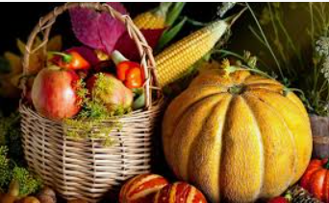

School Values  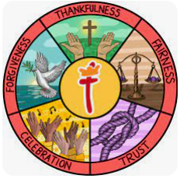 | Everything we do at St Thomas' CofE Primary Academy is built upon our values of thankfulness, fairness, forgiveness, trust and celebration.  Our core Christian values underpin the British values and are closely linked. Core British Values of democracy, the rule of law, tolerance, respect and individual liberty are taught in the context of our strong Christian ethos.  Each half term we focus on one of our values through our class teaching and worship. This half term our key focus is thankfulness. We will be thinking about the people and things we are thankful for.  In the foundation stage, beginning to understand the British value of democracy is learning about turn-taking, sharing and collaboration, understanding that we can all have a say, that we might not agree with someone else, but we respect what others think.
Rights Respecting Schools Award  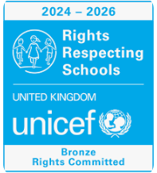 | From Silver to Gold Award  Our journey towards achieving the Gold Rights Respecting School Award is going well!  This is a UNICEF award which recognises schools where the whole school community is actively engaged with the rights of all children. Working towards Gold will support the St Thomas’ school community in continuing to develop as agents for change, strengthening our understanding of children’s rights, justice and responsibility.
RE     | Why is the Word of God so important to Christians?  The children will explore:  - The Bible – What is the Bible? Have you ever seen or read a Bible? Why do you think Christians have a special book?  - God’s Word – Christians believe that the Bible is the Word of God. What might this mean? Why is God’s Word important to Christians?  - Bible Stories – We will listen to and explore stories from the Bible. What can these stories teach us about God, people and how we should live?  - Jesus – We will hear stories about Jesus and explore what Christians believe about him. What can we learn from the things Jesus said and did?  - Living by God’s Word – Christians use the Bible to help them understand how God wants them to live. How can stories and teachings from the Bible help Christians to be kind, loving and caring towards others?  Religions: Christianity,
Prime Areas of Learning:  Personal, Social and Emotional Development  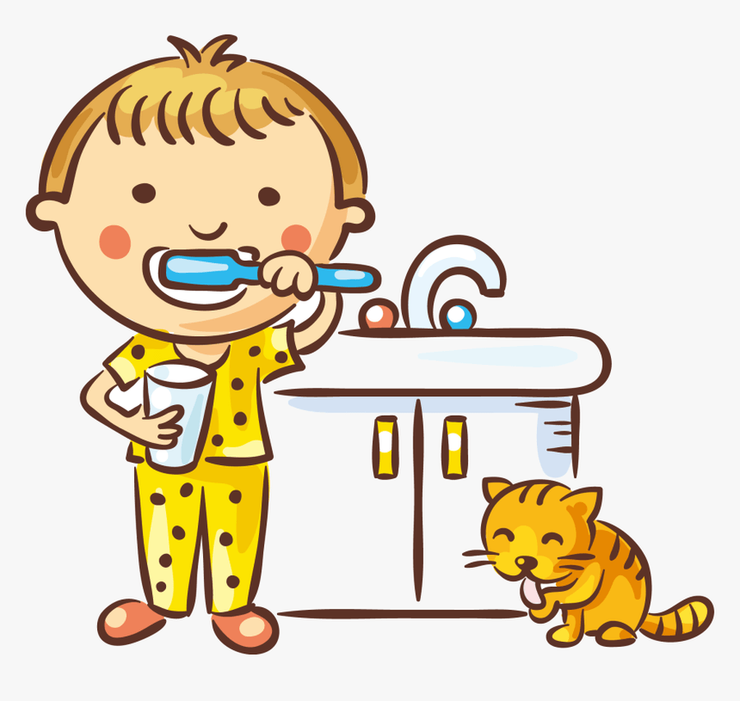 | We will be supporting the children to:  - Settle in to Reception class.  - Learn class and school routines and rules.  - Participate in Circle Time activities.  - Begin to recognise and name feelings.  - Learn that we are all different and special.  - Build constructive and respectful relationships.  - Manage their own needs - personal hygiene.  - Begin to talk about some of the things that support their overall health and wellbeing:  • handwashing  • regular physical activity  • healthy eating – fruit and vegetables
Prime Area of Learning:  Communication and Language  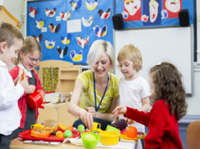 | Listening, Attention & Understanding:  - Begin to learn the skills of being a good listener.  - Begin to listen attentively, e.g. to a story, rhyme, instructions.  Speaking - Develop vocabulary and speaking in full sentences by:  - Taking part in quality back-and-forth conversations.  - Joining in group and class discussions.  - Repeating words and simple sentences using ‘My Turn, Our Turn, Your Turn’.  - Repeat, learn and begin to use Tier 2 vocabulary.  - Engage in book talk, discussing stories and books shared in class.
Prime Area of Learning:  Physical Development  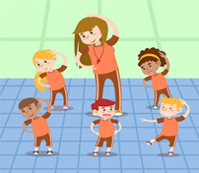 | PE Days: Tuesday and Thursdays  Gross motor skills:  - Introduction to PE: to move around safely in space, follow instructions and stop safely, stop safely and develop control when using equipment, follow instructions and play safely as a group, follow a path and take turns, work co-operatively with a partner.  Fine Motor skills:  - Manipulating dough in different ways.  - Threading and lacing.  - Picking up small items with (children’s) tweezers.  - Holding a pencil, working towards the correct tripod grip.  - Beginning to use tools such as a scissors and hole punches.  Please ensure that your child comes to school in their PE kit on Tuesdays and Thursdays.  PE kit: Plain white t-shirt/polo shirt, plain black shorts or jogging bottoms, red hoodie, trainers or pumps (only allowed for PE days)
Specific Area of Learning:  Literacy  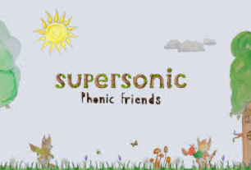     | Focus Texts:  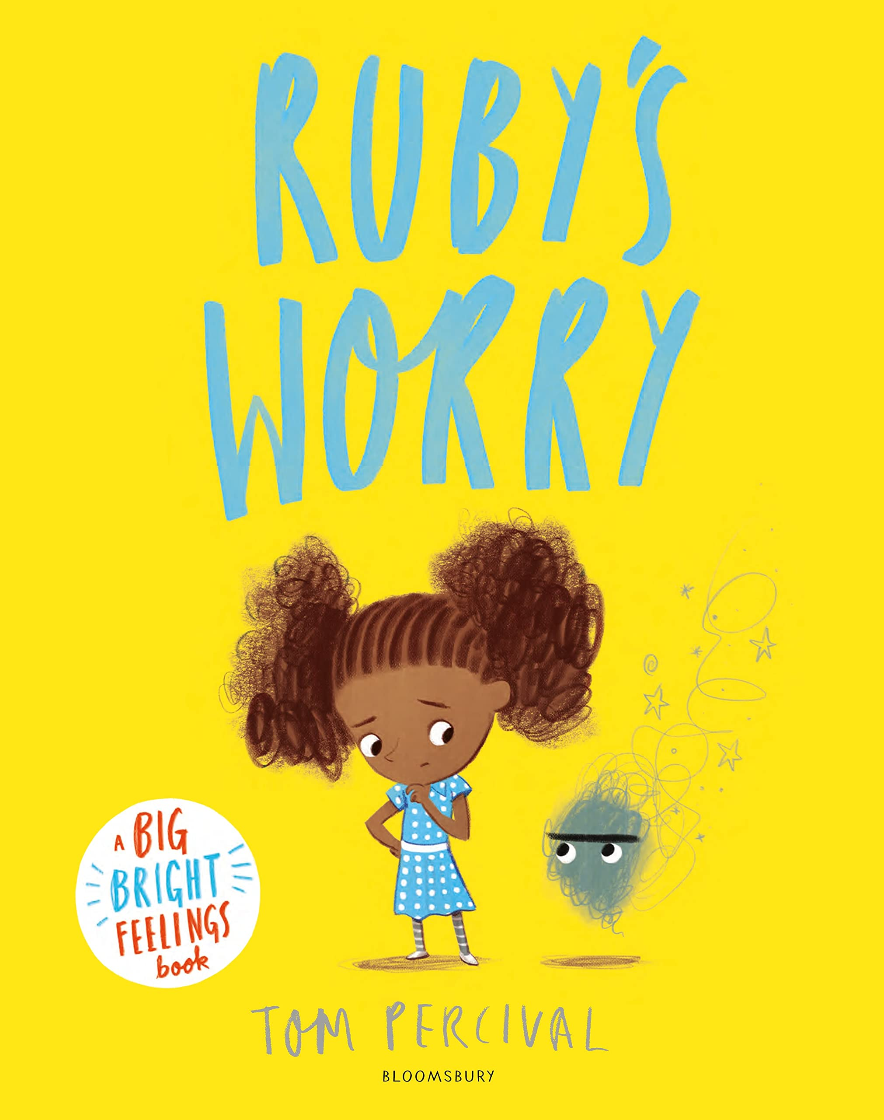  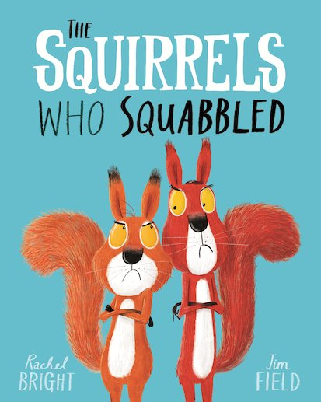  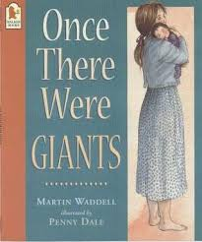  - Ruby’s Worry  - Once There were Giants  - The Squirrels Who Squabbled  - Coming to England  Phonics:  The children will start/continue their journey through Supersonic Phonic Friends, learning the sounds (phonemes) that each individual letter (grapheme) makes, recognising the letters and making the link between the letters and sounds. They will begin to use their phonic knowledge to blend to read, and segment to spell simple consonant-vowel-consonant (CVC) words, e.g. cat.  Reading:  - Listen to a range of stories and rhymes, related to our themes, joining in with repeated phrases.  - Talk about the books we share, talking about the characters.  - Learn how to handle books carefully by holding them the correct way up.  - Use their phonic knowledge to recognise and correctly sound letters/ decode and blend simple 2-sound and 3-sound words to read in a book.  - Recognise and read their (first) name.  Writing:  - Engage in a variety of fine motor and mark-making activities.  - Talk about the meaning of their marks and have their mark-making valued and celebrated.  - Hold a pencil, working towards the correct tripod grip. (‘Pick, Flip and Grip’)  - Begin to learn the correct formation of lower-case letters.  - Begin to write their own name with letters correctly formed.
Specific Area of Learning:  Mathematics  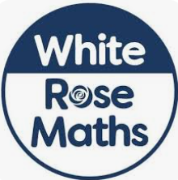  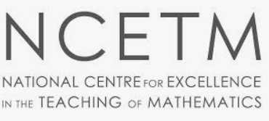 | White Rose:  - Recognise and talk about ‘What’s the same?’ and ‘What’s different?’  - Matching, Sorting and Comparing familiar objects.  - Measure and Pattern.  - It’s Me 1, 2, 3  NCETM Mastering Number:  - Subitising to 5 (knowing how many, without counting)  - Counting with 1:1 correspondence to 5,  - Composing and de-composing numbers to 5  - Comparing two sets of objects.
Specific Area of Learning:  Understanding the world   | Marvellous Me – Who am I? Who is in my family?  - Past and Present  - Name and talk about who is in their family.  - Talk about how they have changed since they were a baby.  - Talk about and represent some of their favourite things, e.g. colour, toys, stories, food.  - People, Culture and Communities  - Harvest  - Judaism  - The Natural World  - Explore and find their way around school and school grounds.  - Begin to learn about seasonal changes Summer-Autumn.
Specific Area of Learning:    Expressive Arts and Design | Creating with Materials:  - Name colours correctly and choose colours for a purpose.  - Mark-making with wax crayons, felt tips, chalk,  - Begin to use tools such as a scissors and hole punches, safely.  - Observational pencil drawing  - Drawing faces, and drawing faces in colour  - Create self-portraits.  Being Imaginative and Expressive:  - Sing a range of well-known nursery rhymes and number songs.  - Try to move in time with music.  - Develop imaginary play, creating and building stories around objects and props of their choosing.
Key events for the half term | Macmillan coffee morning: 25th September  SHINE: Monday 28th September  Coffee morning: Friday 13th November  INSPIRE: Tuesday 29th June
Home Reading  &  Homework | Reading and sharing stories and rhymes to your child helps them to develop a love for reading. Research has shown that children who are able to recite eight nursery rhymes by the age of four, are amongst the best readers by the time they are eight. Please read to and share stories and rhymes with your child as often as possible, talking about story characters and events.  The children will choose a book from the school library every week, to bring home to share for pleasure. This book is for an adult to read to them and discuss with them.  When the children have secured the first sets of phonic sounds, they will be given a reading book. Their reading book will be sent home each night for them to practise reading words which contain sounds they have learned in their phonics lessons. Please encourage your child to say each sound in a word aloud, sounding out simple words, and then blend the sounds together to read the word, and then re-read the word with speed.  School expectation is that children read their reading book at least three times a week. Parents are asked to sign their child’s reading diary each time they have read, and make any relevant comments.

