What is my child learning in Year 3?
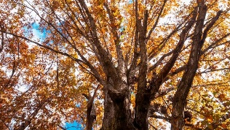


School Values  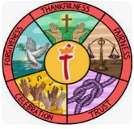 | Thankfulness  Our school Value this term is ‘Thankfulness’. Expressing gratitude is a form of worship and acknowledgment of God's provision in our lives. When we offer thanks for the blessings we've received, we acknowledge that all good things come from God. In Psalm 136:26, the psalmist writes, “Give thanks to the God of heaven. His love endures forever”.
RE  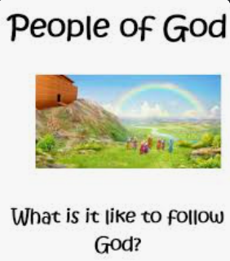 | Christianity – What is it like to follow God?  This half term, Children will explore what it means to follow and trust God, using stories from the Old Testament about Noah, Abraham and Moses. They will consider the challenges these figures faced and how their faith helped them to make difficult choices. Alongside learning about religious beliefs and stories, children will reflect on themes such as courage, trust, making difficult choices and staying true to what they believe is right.
English  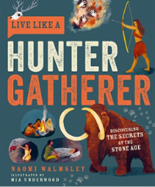  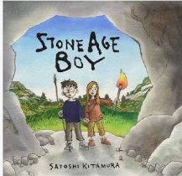 | Book focus: Stone Age Boy  Our class novel follows a boy who accidentally travels 20,000 years back to the Stone Age. There, he meets a girl called Om and discovers what life was really like before finding his way home.  Book focus: Live Like a Hunter Gatherer  Alongside our story, we'll be using this fantastic non-fiction book to explore the realities of Stone Age life and challenge some common myths about prehistoric people.  Using both texts as inspiration, children will write diary entries, narrative retells and non-chronological reports, building on the writing skills they developed in Year 2.  Throughout the term we'll also be focusing on spelling, punctuation and handwriting. Instead of traditional homework, children in Years 2–6 are expected to complete three Morphs Spelling Game sessions each week. Regular practice makes a real difference to their confidence and accuracy in writing.
Reading     | This term, we will be developing our key reading skills, including vocabulary, inference, prediction, retrieval, sequencing, summarising and comparing and contrasting. We will be practising how to find information, read between the lines, make predictions and really think about what we are reading.  At St Thomas’, we are also continuing with SQUIRT (Silent/Quiet Uninterrupted Independent Reading Time). Each year group will have a 20-minute session in our school library, as well as another session where children can share books with their friends and choose a book to bring home.  Instead of traditional homework, we ask that parents read with their child at least four times a week. This is one of the most valuable things you can do to support your child’s education, helping to build their vocabulary, comprehension and confidence, while also creating a lovely opportunity to spend time together and build a love of reading. Even ten minutes at bed time or in the car ride home makes the world of difference!
Maths   | Over the whole Autumn term, the children will be building on their prior knowledge on these subjects  - Place value  - Addition and subtraction  - Multiplication and division  Children in Years 2–6 will be expected to complete three sessions each week on Times Tables Rock Stars (TT Rock Stars). It is a fun and engaging way for children to practise their times tables regularly, helping them develop quick recall and build confidence across the maths curriculum. Teachers can also see which times tables children are confident with and where they need a little more support, allowing us to target our teaching more effectively in school.
Science  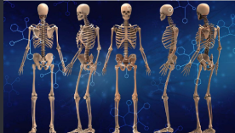 | Animals including humans  This term, we will be learning all about our bodies and how they work, focusing on skeletons, nutrition, diet and movement. Children will explore the important jobs our skeletons do, what our bodies need to stay healthy and how our muscles and bones work together to help us move. We’ll also look at different animals and how their bodies are similar to and different from our own, helping children to understand how animals are adapted to move and survive.
History  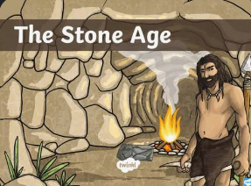 | Would you prefer to live in the Stone Age, Bronze Age or Iron Age?  This term, we’ll be travelling back in time to explore the story of Britain, starting with the Stone Age and moving through the Bronze and Iron Ages. Children will use archaeological evidence and their own research to find out what life was like during these periods, before using what they’ve discovered to answer our big question.
  Art | Painting and mixed media- prehistoric painting.  In this exciting topic, children will discover how and why our ancient ancestors created art. They’ll get hands-on by experimenting with natural materials to make their own paints and playing with scale as they create artwork on a range of different surfaces.
Computing   | Computing systems and networks.  This term, we’ll be exploring what technology is and how we use it in our everyday lives. We’ll look at different types of technology, how they work and the ways they can help us, as well as discussing the pros and cons of AI and thinking about how we can use it safely and responsibly.
French  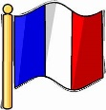 | French language and culture.  This term, we’ll be building our French vocabulary and confidence, learning to listen, speak, read and write in French. Children will practise using simple phrases and sentences, develop their pronunciation and begin to understand some of the differences between French and English. We’ll also explore French culture through songs, games and stories, making language learning fun and practical.
PE  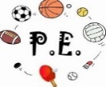 | Year 3’s PE lessons will take place on a Monday and Friday. Please ensure your child comes into school in their PE kit, hair tied back and jewelry removed on these days.  We will be covering the following lessons over the whole Autumn term  - Tennis  - Ball skills  - Swimming (details to follow soon)
Music   | Traditional instruments and improvisation  This term, we’ll be exploring music inspired by the Vikings and Anglo-Saxons, linking our music learning to our History topic. Children will learn to read and perform simple musical notation, sing and play together, and experiment with improvisation. We’ll also explore different musical styles and talk about our own likes, dislikes and feelings about music.
PSHE   | Being Me in My World  This term, we’ll be thinking about who we are and our place within our school community. Children will explore their strengths and achievements, set personal goals and learn how their feelings can affect their behaviour. We’ll also focus on working together, taking responsibility and understanding how our actions can affect those around us.
Key events for the half term | Future dates to be aware of:  Friday 11th September – Everyone welcome coffee morning  Friday 25th September – Macmillan coffee morning  Monday 12th October - Year 3 SHINE  Thursday 22nd October – INSET Day  Friday 23rd October - INSET Day  Friday 20th November – Year 3 coffee morning
Homework/ Meet the Team | A separate letter has gone out detailing the changes to our approach to homework this year.  If you have any questions about your child’s homework, or anything else in the curriculum, please let me or Mrs McNicholas know.  Meet the Year 3 Team  As you know, Year 3 will be shared this year by Miss Brownhill and Mrs McNicholas. Miss Brownhill spent time with the children last year as a student teacher and is now class teacher following her graduation. She will teach from Monday to Wednesday morning, with Mrs McNicholas teaching for the remainder of the week.  We are both very excited to work closely and collaboratively throughout the year, ensuring the children have a happy, settled, and successful year in Year 3. We’ll work together to provide the best possible support and learning opportunities for every child and are always happy to chat with you about your child, whether you have a celebration to share or there is something you feel we need to know about or support with.

