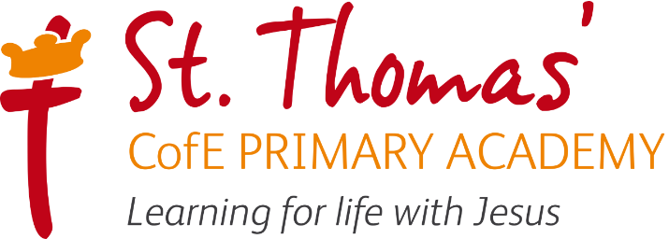

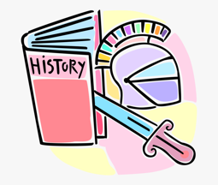

History Learning Journey
2026/27

Intent, Implementation and Impact

Learning for life with Jesus

Intent
All areas of our curriculum are underpinned by our Gospel values and we ensure that our curriculum makes links to these values. At the heart of each subject is a set of core skills which form a subject learning journey, this journey is built from EYFS through to year 6 and the skills progressive as you move through the school. Knowledge is communicated to ensure coverage of National curriculum and it is through this knowledge that children apply their skills. Children at St Thomas’ leave with a secure knowledge of both the academic knowledge and skills needed for the next stage of their education. They will have developed a clear set Christian and moral values which they can apply in all areas of their lives and will have taken part in real-life experiences which will have raised their aspirations and given them a thirst for wisdom and knowledge.

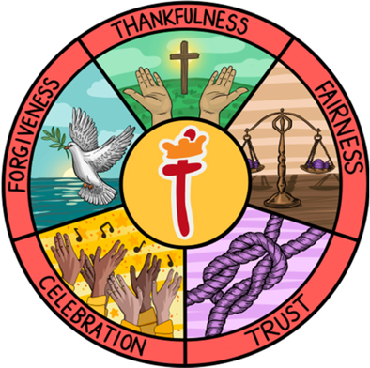
The intention of the St Thomas’ History learning journey is to inspire all pupils develop their knowledge of the world, an understanding of historical events and their impact on our lives today and as a result understand how they can make a positive impact on the world and learn from the past. We focus on developing the skills, knowledge and understanding that children need in order find out about the world and the past so they have the skills to continually develop their skills and knowledge throughout their lives.

Our History lead in school is Mrs A Tomkins

Implementation

St Thomas’ History Learning Journey focuses on a spiral curriculum model where previous skills and knowledge are revisited and built upon. Over the course of the journey children will focus on both declarative and procedural knowledge. Declarative knowledge in History is the factual knowledge surrounding the world we live in and historical events. This knowledge is not a list of disconnected facts; it is explicitly linked to the content being taught. Procedural knowledge can be viewed as the know-how to apply declarative facts. This might include applying their historical research skills in another context.

History Lesson Journey

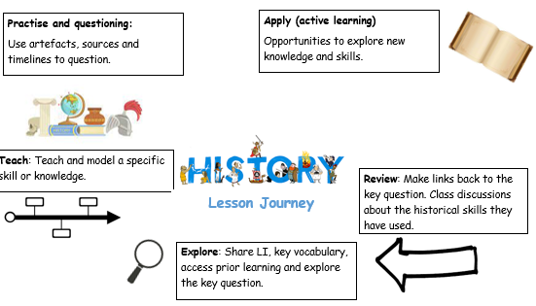

In History, work is recorded in an exercise book and marked in line with the marking policy.

EYFS
As part of Development Matters (2021), History is taught in relation to the strand ‘Understanding the world’. Children have a key question which is planned for each half term. Lessons take the form of adult-led inputs. The amount varies dependent on the theme. There will then be an independent activity relating to the input.
All classrooms have an investigation station. As part of this, Humanities based enhanced provision will be planned for each half term. Humanities based enhanced and child-initiated provision may also be found in the construction area, for instance building a farm or a city. Humanities may also be found in the outside provision, either enhanced or child-initiated, such as treasure hunts, map drawing.

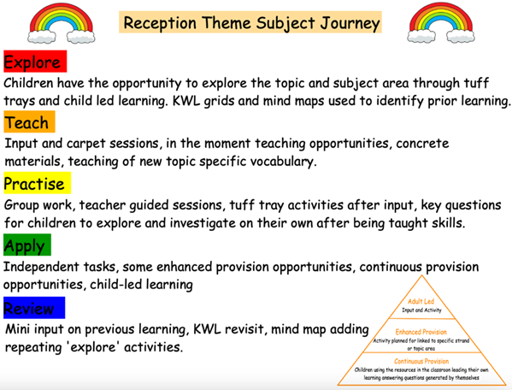
Impact

The specific impact of the St Thomas’ History Learning Journey is that children will (as stated in the national curriculum):
- know and understand the history of these islands as a coherent, chronological narrative, from the earliest times to the present day: how people’s lives have shaped this nation and how Britain has influenced and been influenced by the wider world
- know and understand significant aspects of the history of the wider world: the nature of ancient civilisations; the expansion and dissolution of empires; characteristic features of past non-European societies; achievements and follies of mankind
- gain and deploy a historically grounded understanding of abstract terms such as ‘empire’, ‘civilisation’, ‘parliament’ and ‘peasantry’
- understand historical concepts such as continuity and change, cause and consequence, similarity, difference and significance, and use them to make connections, draw contrasts, analyse trends, frame historically-valid questions and create their own structured accounts, including written narratives and analyses
- understand the methods of historical enquiry, including how evidence is used rigorously to make historical claims, and discern how and why contrasting arguments and interpretations of the past have been constructed
- gain historical perspective by placing their growing knowledge into different contexts, understanding the connections between local, regional, national and international history; between cultural, economic, military, political, religious and social history; and between short- and long-term timescales.

Formative assessment takes part in each lesson and misconception and next steps of the focus for feedback. Summative assessment is completed for each child at the end of each unit of teaching using the assessment framework at the end of this document. A best fit approach to statements achieved results in an end of year summative grade.

Adaptive Teaching Strategies

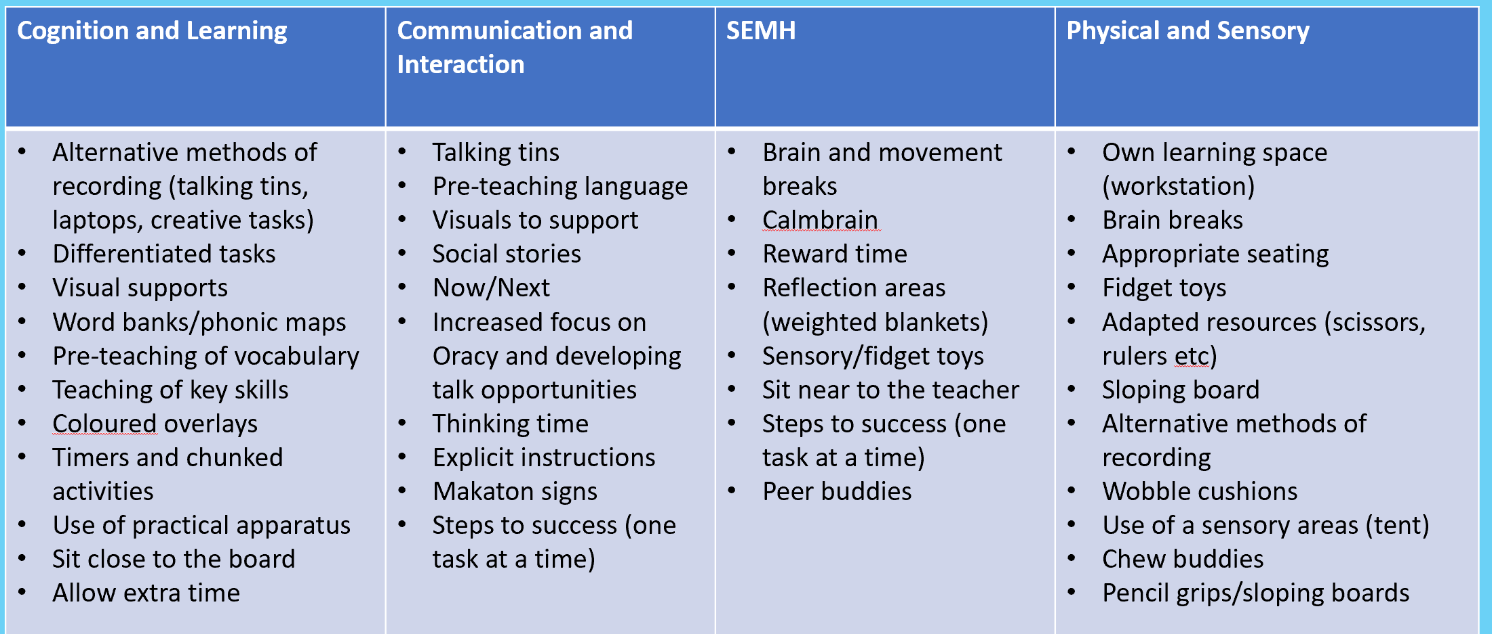

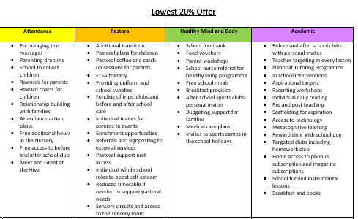
Lowest 20% offer

2025/2026 History Overview

 | Autumn 1 | Autumn 2 | Spring 1 | Spring 2 | Summer 1 | Summer 2
Reception | Who am I? Who is in my family? |  |  | Who is our King? |  | What were seaside holidays like in the past? How have I changed?
Year 1 | What was it like here?  What were toys like in the past? |  | What is a monarch? |  | Who are they and where did they go?
Year 2 |  | What happened in London in September 1666? | How have explorers changed the world? |  | Why were the lives of Florence Nightingale and Mary Seacole significant?
Year 3 | Would you prefer to live in the Stone Age, Bronze Age or Iron Age? |  | Would you prefer to live in the Stone Age, Bronze Age or Iron Age? |  | Why were the Romans so powerful?
Year 4 | What was life like for the Anglo-Saxons? |  | How did life change when the Vikings arrived? |  |  | What were the significant achievements of the Ancient Egyptians?
Year 5 | What did the Victorians leave for us? |  | How did the Maya Civilisation compare to the Anglo-Saxons? |  | What influence did the Ancient Greeks have on the world?
Year 6 | What was the impact of World War 2 on the people of Britain? |  |  |  | What was life like in the Kingdom of Benin?

Historical Skills and Enquiry Progression
EYFS – Year 6.

 | EYFS | Year 1 | Year 2 | Year 3 | Year 4 | Year 5 | Year 6
  Sources of evidence | Discuss photos of their families.  Discuss images of familiar situations in the past. | Use artefacts, photos and visits to answer simple questions about the past.  Find answers to simple questions using sources.  Sorting artefacts from then and now. | Use artefacts, photos and visits to answer and ask simple questions about the past.  Make simple observations about a source or artefact.  Using sources to show an understanding of historical concepts.  Identify a primary source. | Use a range of sources to find out about a period.  Use evidence to build up a picture of a past event. | Observe the small details when using artefacts and pictures.  Identify sources which are influenced by the personal beliefs of the author. | Recognise primary and secondary sources.  Use a range of sources to find out about the past. | Identify bias in a source and identify the value of a source.  Describe how secondary sources are influenced by the author.
Historical interpr-  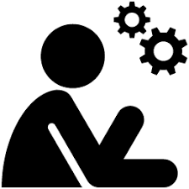  etations | Present children with pictures, artefacts and accounts from the past and explore similarities and differences. | Begin to identify different ways to present the past.  Develop their own interpretations from historical artefacts. | Recognise different ways in which the past is represented.  Compare photos of people or events in the past.  Develop their own interpretation from photos and written sources. | Explore different representations from the period.  Evaluate the usefulness of different sources. | Use text books to gain knowledge.  Identify and give reasons for different ways in which the past is represent  ted.  Identify the differences between different sources. | Compare accounts of events from different sources.  Suggest explanations for different versions of events.  Evaluate the usefulness of sources.  Develop strategies for evaluating the accuracy of sources.  Address and devise historically valid questions. | Identify how conclusions have been arrived at by linking sources.  Understand that different evidence creates different conclusions.  Evaluate the interpretations made by historians.
  Vocabulary | Today  Yesterday  Now  Then  Before I was born  A long time ago  Old  New  Picture  Story  Object  Time | Last week  When I was younger  Past  Present  After  Before  Event  Photograph  Timeline  Sequence  Similar  Difference  (And previous years) | Century  Decade  During  Historical  Modern  Recently  Account  Artefact  Chronological  Evidence  Historian  Source  Museum  Sequence  Similarities  Differences  (And previous years) | Ancient  BC/ AD  kingdom  Date  Era  Time period  Archaeology  Architecture  Chronology  Discoveries  Eye witness  Reliable  Civilisation  Invade  Settle/ settlement  Impact  Timeline  Source  (And previous years) | Primary source  Secondary source  Enquiry  Evaluate  Conclusion  Evidence  Legacy  (And previous years) | Change  Continuity  Citizen  Cultural  Empire  Social  Democracy  Government  Political  Excavate  Interpretation  Reliability  Bias  Conquest  (And previous years) | Critically  Empathy  Perspective  Analyse  Hypotheses  (And previous years)
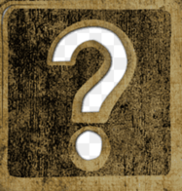  Posing historical questions | Ask simple questions about the past. | Asking how and why questions based on stories, events and people.  Asking questions about sources of evidence. | Asking a range of questions about stories, events and people.  Understanding the importance of historically- valid questions. | Understand how to structure historical questions and ask their own.  Ask questions about the main features of everyday life. | Create questions for different types of historical enquiry.  Ask questions about the bias of historical evidence. | Ask complex historical questions.  Ask questions about the interpretations, viewpoints and perspectives held by others. | Plan a historical enquiry and suggest the evidence and methods needed.  Create a hypothesis to base an enquiry on.

Historical skills

Across Years 1–6, pupils will develop and apply six key historical skills through each topic: chronology, evidence and interpretation, cause and consequence, change and continuity, similarity and difference, and historical significance. These skills will be revisited and progressively developed throughout each year group, enabling pupils to build a secure understanding of how historians investigate and interpret the past. In EYFS, children will begin to develop the foundations of these skills through exploring the past, sequencing events, noticing similarities and differences, and discussing significant people and events, providing a strong basis for their future learning in history.

Prior learning from previous year groups will be regularly revisited through Memory Minutes, providing pupils with opportunities to retrieve, consolidate and build upon their existing historical knowledge and understanding. The specific prior learning to be revisited is identified within the skills overviews for each topic, ensuring that knowledge and historical skills are progressively developed across the curriculum. Below is an example of a skills overview for the Year Two topic, ‘What Happened in London in 1066?’

Medium Term plan | Subject: | History
Medium Term plan | Year group: | 2
Medium Term plan | Term: | Aut 2 – What happened in London in 1066?

Progress of knowledge and skills
Past learning  (Y1) What is a monarch? | NC - the lives of significant individuals in the past who have contributed to national and international achievements.  Skills -  Chronology – Putting events in order  Evidence and Interpretation – Studying images of monarchs and royal residences.  Cause and Consequence – Exploring the reasons for building castles.  Change and Continuity – Considering change and continuity of monarchs and where they live over time.  Similarity and Difference – Comparing and contrasting monarchs.  Historical Significance – Considering the impact of the Norman conquest and the reign of William I.
Planned learning  (Y2) | NC – Events beyond living memory that are significant nationally or globally.  Skills -  Chronology – Putting the events of the GFoL into order using a timeline.  Evidence and Interpretation -Studying and analysing images and historical sources from the GFoL  Cause and Consequence -identifying reasons why the GFoL spread so quickly/ why it took so long to put out.  Change and Continuity – Thinking about how GFoL changed the future e.g. fire service  Similarity and Difference – How has London changed? How have the houses changed?  Historical Significance – Considering the impact of the GFoL and changes to future.
Future learning  (Y3) Would you prefer to live in the Stone Age, Bronze Age or Iron Age? | NC - a study of an aspect or theme in British history that extends pupils’ chronological knowledge beyond 1066  Skills -  Chronology - To place events, artefacts and historical figures on a timeline using dates.  To use BCE and CE  Evidence and Interpretation - Understanding how artefacts can help us to discover about everyday life in the past.  Cause and Consequence - To understand the causes and consequences of the introduction of bronze to society.  Change and Continuity - To understand how everyday life changed from the Stone Age to the Iron Age  Similarity and Difference To compare bronze and iron and the impact these metals had on people at the time.  Historical Significance - understand how Skara Brae is historically significant

Historical Knowledge and Key Concepts
EYFS – Y6

Long Term History Plan 2025-2026
 | Nursery | Reception | Year 1 | Year 2 | Year 3 | Year 4 | Year 5 | Year 6 | Year 7
Autumn | Begin to make sense of their own life story and family’s history  Name themselves and their immediate family members; to know that they belong to a family; photos from home; self-portraits and family portrait | -Compare and contrast characters from stories, including figures from the past.  -Comment on images of familiar situations in the past  -How I have changed  -Remembrance  -Memories-parents and grandparents | Local History & toys- then and now.  Changes within living memory. Where appropriate, these should be used to reveal aspects of change in national life  Significant historical events, people and places in their own locality. | The Great Fire of London  Events beyond living memory that are significant nationally or globally. | Autumn/Spring  Stone Age to Iron Age Britain  changes in Britain from the Stone Age to the Iron Age | Anglo Saxons  Britain’s settlement by Anglo Saxons and Scots. | Victorians (local study)  A study of an aspect or theme in British history that extends pupils’ chronological knowledge beyond 1066 | Conflict - WWII  A study of an aspect or theme in British history that extends pupils’ chronological knowledge beyond 1066  (Roles of women, rebuild, post war rationing)
  1066 and William the Conqueror
  Magna Carta
  The Black Death
  The Peasant Revolt
  Medieval Life
Spring | Begin to make sense of their own life story and family’s history  Talking about and describing significant events in their family; Christmas; Birthdays; Baptism; family outings; visit to Santa; | -Compare and contrast characters from stories, including figures from the past. -Comment on images of familiar situations in the past  -Handle and investigate artefacts  -create timelines of images | Monarchs and Rulers –  Significant individuals in the past who have contributed to national and international achievements. (some should compare different periods)  (Queen Elizabeth I/ Victoria/ Elizabeth II) | Ibn Battuta and Scott of the Antarctic  Christopher Columbus and Neil Armstrong  The Lives of Significant Individuals – Explorers |  | Vikings  Viking and Anglo Saxon struggle for the Kingdom of England at the time of Edward the Confessor. | Mayan civilization c. AD 900;  A non-European society that provides contrasts with British history -
  Tudors
  English civil war
  Cromwell
Summer | Begin to make sense of their own life story and family’s history  Retell what their parents have told them about them about their family history; describing families and relationships; baby photos; find out about what they were like as a baby; remember before they had siblings; new babies/cousins | -Compare and contrast characters from stories, including figures from the past. -Comment on images of familiar situations in the past  -seaside holidays in the past  -when I was little like you | Journeys  -The Wright Brothers  -Amy Johnson  -The Titanic  International  Events beyond living memory that are significant nationally or globally | A study of the lives of Florence Nightingale and Mary Seacole  The Lives of Significant Individuals  Significant historical events, people and places in our local area | Spring/Summer  The Romans  the Roman Empire and its impact on Britain | Ancient Egypt  The achievements of the earliest civilizations – an overview of where and when the first civilizations appeared and a depth study | Ancient Greece  a study of Greek life and achievements and their influence on the western world | Spring/Summer  Benin  Benin (West Africa) c. AD 900-1300 | Suffragettes  Slavery  The Victorian Age  Football and the growth of sport and leisure.

Assessment in History

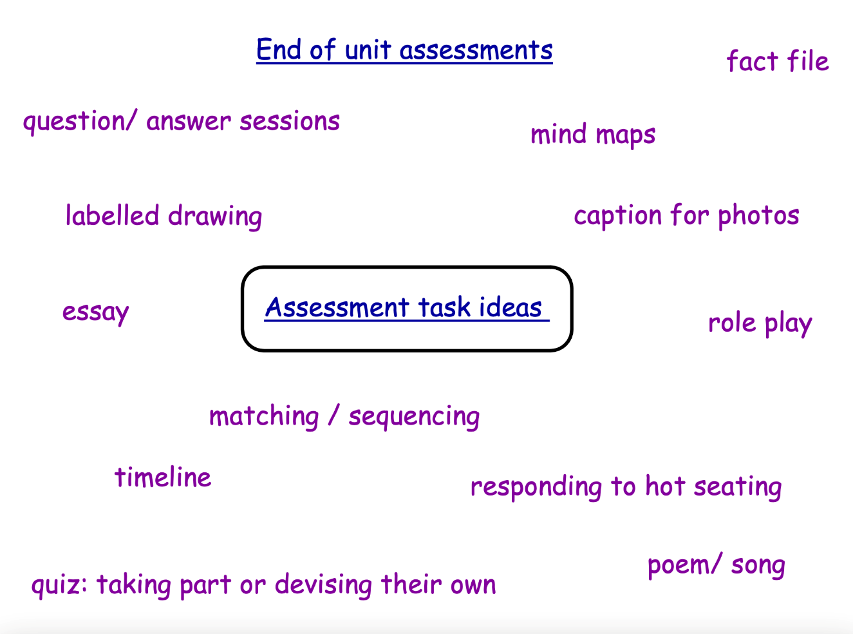
At the end of each History unit, we use a different method of assessment to assess the children’s knowledge and skills from that unit of work.

A small assessment sheet is also completed by the teacher to show whether the child was working below, at expected or working above for that unit of History work.

