Year group | Autumn 1 | Autumn 2 | Spring 1 | Spring 2 | Summer 1 | Summer 2
Rec | UW/P&P  Who am I? Who is in my family? | UW/PC&C  How do we celebrate?  Where is my school? | UW/PC&C  What happens in Winter? What is it like where I live? | UW/P&P – Who is our King? UW/PC&C -  What is it like in London? | UW/PC&C Who helps in our community? UW/P&P How have emergency vehicles changed? | UW/P&P What were seaside holidays like in the past? How have I changed?
Rec | 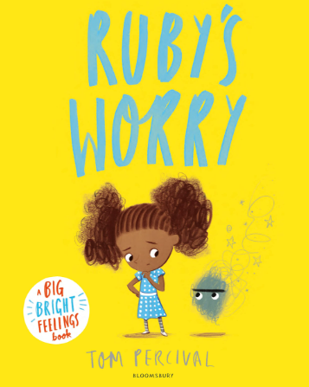  Tom Percival – Ruby’s Worry  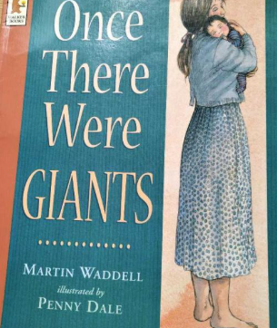 Martin Waddell - Once there were giants  +Space Week – Tim Peake (significant individ  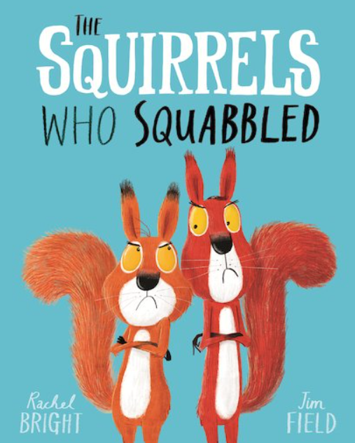 Rachel Bright – The Squirrels Who Squabbled  Black History Month  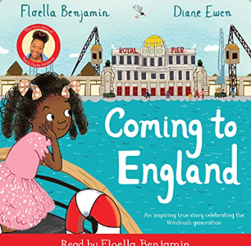  Floella Benjamin – Coming to England | 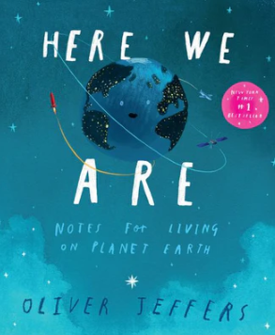  Oliver Jeffers – Here We Are  Nursery Rhyme Week (10-14 Nov):  -Sing a Song of Sixpence  -Humpty Dumpty  -When I was One  -I Hear Thunder  -Two Little Dickie Birds  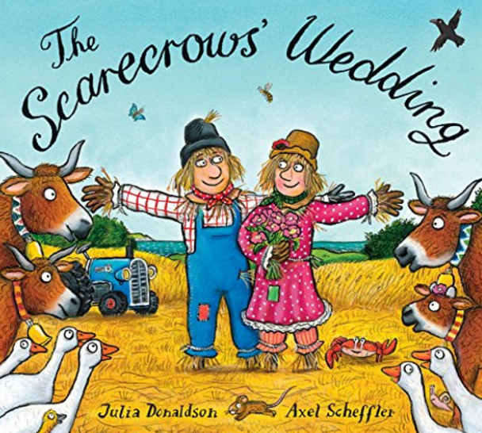  Julia Donaldson – The Scarecrows Wedding  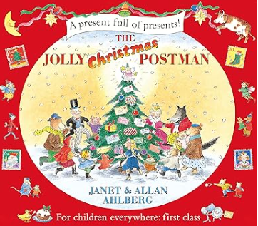  Allan & Janet Ahlberg – The Jolly Christmas Postman | 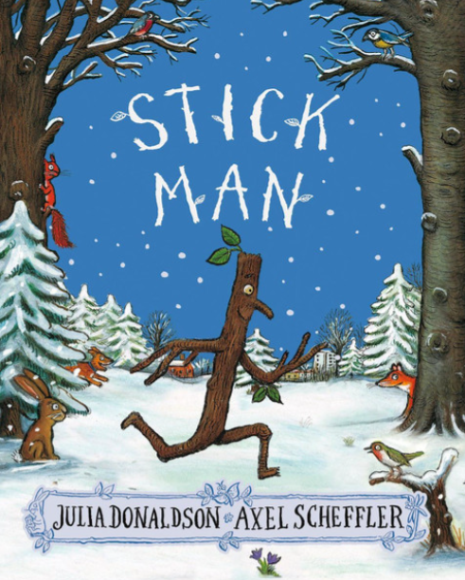  Julia Donaldson – Stick Man  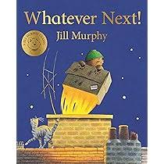  Jill Murphy – Whatever next!  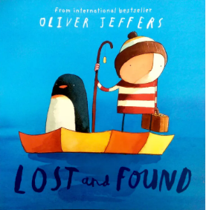  Oliver Jeffers – Lost and Found | 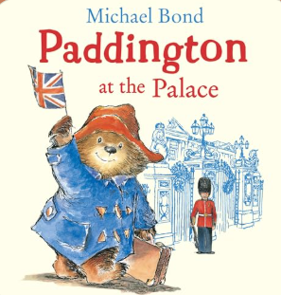  Michael Bond – Paddington at the Palace  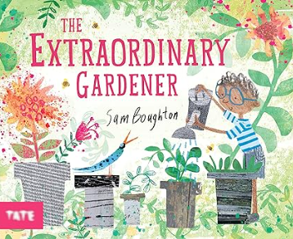  Sam Boughton – The Extraordinary Gardener  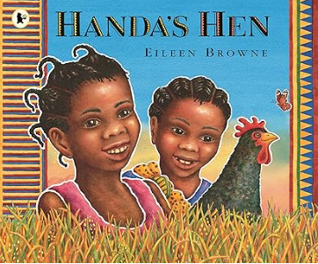  Eileen Browne – Handa’s Hen | Eileen Browne – Handa’s Hen  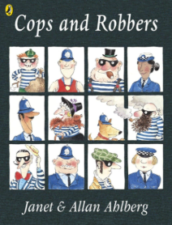  Allan & Janet Ahlberg – Cops and Robbers  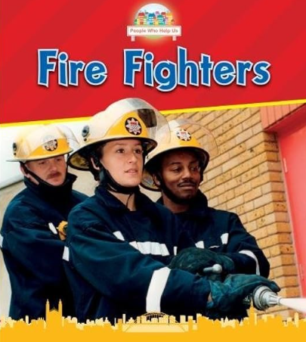  Non-fiction – Fire Fighters / Police Officers | 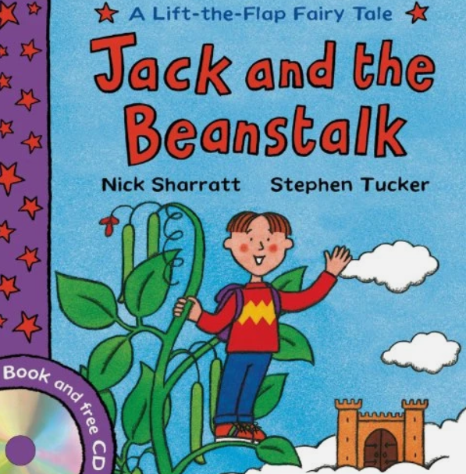  Nick Sharratt - Jack and the Beanstalk  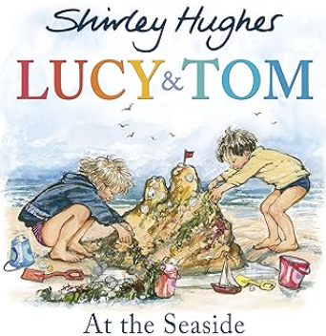  Shirley Hughes - Lucy and Tom at the seaside    Kes Gray – Billy’s Bucket
1 | History  What was it like here?  What were toys like in the past? | Geography  What is it like here? | History  What is a monarch? | Geography  What is the weather like in the UK? | History  Who are they and where did they go? | Geography  What is it like to live in Shanghai?
1 | 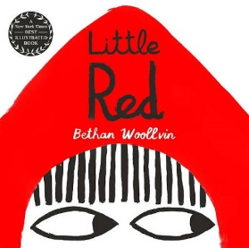  Bethan Woolvin – Little Red  Rehearsal of basic skills (Capital letters, full stops, finger spaces)  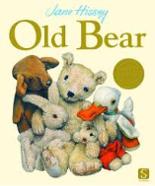  Jane Hissey – Old Bear  Rehearsal of basic skills (Capital letters, full stops, finger spaces)  Captions  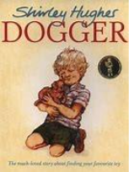  Shirley Hughes – Dogger  - Simple sentences based on character (Dogger) |   Rachel Bright – The Lion Inside  Simple retell (Lion inside)  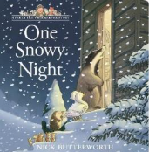  Nick Butterworth – One Snowy Night Simple sentences – setting (One Snowy Night)  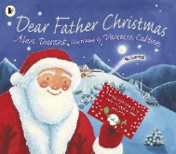  Alan Durant – Dear Father Christmas  Letter to Santa – simple sentences to Santa | 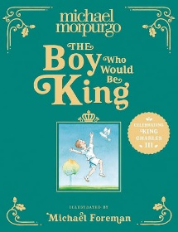  Michael Morpurgo – The Boy who would be King  Fact file about the King – simple sentences using ‘and’ about the King  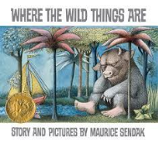  Maurice Bendak– Where the Wild Things are  Character description (wild thing) | 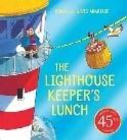  Ronda and David Hermitage – The Lighthouse Keeper’s Lunch  Setting descriptions – seaside setting  Instructions – How to make a sandwich.  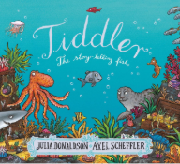  Julia Donaldson – Tiddler  Narrative writing - retell of the story.  . | 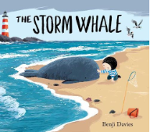  Benji Davies – The Storm Whale  Fact file about a whale (simple sentences).  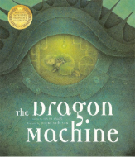  Helen Ward - The Dragon Machine  Narrative writing - adventure story inside the dragon machine. | 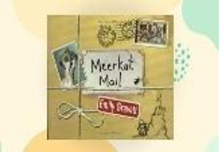  Emily Gravett – Meerkat Mail  Postcards  Letter writing – return response to one of the letters  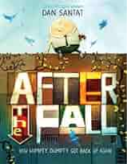  Dan Santat – After The Fall  Twisted tale retell
1 | Punctuation and Grammar
1 | Rehearsal of basic skills from reception  - Capital letters  - Full stops  - Finger spaces  - Application of phonic knowledge | Continued focus on basic skills from Reception  - Capital letters  - Full stops  - Finger spaces  - Application of phonic knowledge  - Begin sequencing sentences to form short texts  National Poetry Week unit – rhyming poems | Fact file  - Headings and subheadings  - Bullet points  - Technical vocabulary  - Pictures and captions  - Coordinating conjunctions (and, but)  - Expanded noun phrases  - Capital letters for proper nouns  - Commas for lists  Character description  - Introduction  - Third person  - Rhetorical question  - Expanded noun phrases  - Coordinating conjunctions  - Capital letters for proper nouns  - Exclamation marks  - Commas for lists | Setting description  - Introduction  - Conclusion  - Third person  - Expanded noun phrases  - Coordinating conjunctions  - Prepositions/adverbials of place  - Capital letters for proper nouns  - Exclamation marks  - Commas for lists  Instructions  - Title statement  - List of equipment or materials  - Sequence, chronological steps  - Diagrams or illustrations  - Present tense  - Commands  - Co-ordinating conjunctions  - Expanded noun phrases  - Adverbs/adverbials of time  - Question marks  Narrative retell  - Third person  - Past tense  - Irregular verbs  - Capital letters for proper nouns  - Adverbs/adverbials of time  - Adverbs/adverbials of place  - Co-ordinating conjunctions (and to join clauses)  - Expanded noun phrases | Fact file  - Headings and subheadings  - Bullet points  - Technical vocabulary  - Pictures and captions  - Coordinating conjunctions (and, but)  - Expanded noun phrases  - Capital letters for proper nouns  - Commas for lists  - Statements and questions  Narrative  - Third person  - Past tense  - Irregular verbs  - Capital letters for proper nouns  - Adverbs/adverbials of time  - Adverbs/adverbials of place  - Co-ordinating conjunctions (and to join clauses)  - Expanded noun phrases  - Exclamation marks and question marks | Postcards/letters  - Features of a letter - address, date, salutation, brief introduction, sign off  - Chronological order  - First person  - Past tense  - Coordinating conjunctions  - Expanded noun phrases  - Commas in a list  - Exclamation marks and question marks  - Capital letter for personal pronoun, I.  - Adverbs/ adverbials of time  - Adverbs/ adverbials of place  Narrative  - Third person  - Past tense  - Irregular verbs  - Capital letters for proper nouns  - Adverbs/adverbials of time  - Adverbs/adverbials of place  - Co-ordinating conjunctions (and to join clauses)  - Expanded noun phrases  - Exclamation marks and question marks
2 | Geography  Why is our natural world wonderful? | History  What happened in London in September 1666? | History  How have explorers changed the world? | Geography  Would you prefer to live in a hot or cold place? | History  Why were the lives of Florence Nightingale and Mary Seacole significant? | Geography  What is it like to live at the coast?
2 | 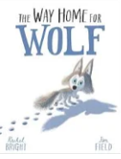  Rachel Bright – The Way Home for Wolf  Diary entry as Wilf when he realises that he is alone.  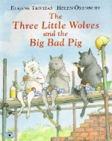  Helen Oxenbury - The Three Little Wolves and the Big Bad Pig  Narrative retell. | 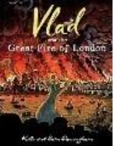  Kate Cunningham – Vlad and the Great Fire of London  Non-chronological report (The Great Fire of London)  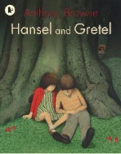  Anthony Browne – Hansel and Gretel  Twisted tale/alternative ending  National Poetry Week unit – list poems | 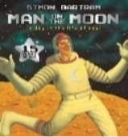  Simon Bartram – Man on the Moon  Character description (Man on the Moon)  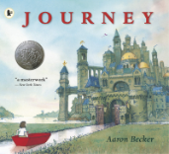  Aaron Becker - Journey  Setting description portal writing – describe a new setting from going through the portal |   Jill Tomlinson – The Penguin Who Wanted to Find Out  Information text – Facts about real penguins.  Informal letter (recount) to Claudius telling him about one of his adventures. | 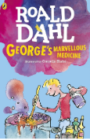  Roald Dahl – George's Marvellous Medicine  Instructional Writing – how to make George’s Marvellous Medicine (also make practical)  Create a new animal reaction story – imagine what happens when a different animal drinks Georges Marvellous Medicine (narrative) | 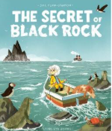  Joe Todd-Stanton – The Secret of Black Rock  Persuasive letter – What Erin might say to convince them not to destroy Black Rock.  .  Chris Judge – The Lonely Beast  Narrative – Create a new adventure for the Beast.
2 | Punctuation and grammar
2 | Diary entry  - Date  - Salutation  - Chronological order  - Past tense  - First person – informal  - Facts and opinions  - Rhetorical questions  - Sign off  - Co-ordinating conjunctions  - Subordinating conjunctions  - Adverbs/adverbials of time  - Adverbs/adverbials of place  - Expanded noun phrases  - Exclamation marks  - Commas for lists  - Apostrophes for omission  - Apostrophes for possession (GDS)  Narrative retell  - Repetitive story path  - Third person  - Past tense  - Pronouns  - Statements, commands and  - exclamation sentences  - Expanded noun phrases  - Adverbials of time  - Adverbials of place  - Adverbials of manner  - Co-ordinating conjunctions  - Subordinating conjunctions  - Exclamation marks  - Commas in a list | Non-chronological report  - Heading and subheadings  - Brief introduction  - Technical vocabulary  - Pictures and captions  - Third person – formal  - Statements giving factual information  - Co-ordinating conjunctions  - Subordinating conjunctions  - Expanded noun phrases  - Present progressive  - Statements  - Questions  - Commands/imperative  - Capital letters for proper nouns  - Commas for lists  - Apostrophes for possession (GDS)  Narrative – twisted tale  - Repetitive story path  - Third person  - Past tense  - Pronouns  - Statements, commands and  exclamation sentences  - Expanded noun phrases  - Adverbials of time  - Adverbials of place  - Adverbials of manner  - Co-ordinating conjunctions  - Sub-ordinating conjunctions  - Exclamation marks  - Commas in a list | Character description  - Introduction  - Third person  - Rhetorical questions  - Expanded noun phrases  - Adverbials of manner including similes  - Adverbials of place  - Commas in a list  - Apostrophes for possession  - Apostrophes for omission  - Capital letters for proper nouns  - Question marks  Setting description  - Introduction  - Paragraphs pan the setting  - Third person  - Rhetorical questions  - Conclusion including a clihanger  - Expanded noun phrases sights, sounds  and smells  - Adverbials of manner including similes  - Adverbials of place  - Commas in a list  - Apostrophes for possession  - Apostrophes for omission  - Capital letters for proper nouns  - Question marks | Information text  - Heading and subheadings  - Brief introduction  - Technical vocabulary  - Pictures and captions  - Third person – formal  - Statements giving factual information  - Co-ordinating conjunctions  - Subordinating conjunctions  - Expanded noun phrases  - Present progressive  - Statements  - Questions  - Commands/imperative  - Capital letters for proper nouns  - Commas for lists  - Apostrophes for possession (GDS)  Letter  - Address  - Date  - Salutation  - Brief introduction  - Chronological order  - First person  - Past tense  - Facts and opinions  - Rhetorical questions  - Sign off  - Co-ordinating conjunctions  - Subordinating conjunctions  - Expanded noun phrases  - Adverbs/adverbials of time  - Adverbs/adverbials of place  - Apostrophes for omission  - Apostrophes for possession (GDS)  - Commas in a list  - Exclamation marks | Instructions  - Title statement  - List of equipment or materials  - Sequence, chronological steps  - Diagrams or illustrations  - Present tense  - Commands  - Detailed information  - Co-ordinating conjunctions  - Subordinating conjunctions  - Expanded noun phrases  - Direct address using ‘you’  - Adverbials of place  - Adverbs/adverbials of time  - Adverbs/adverbials of manner  - Question marks  - Commas for lists  - Apostrophes for possession (GDS)  - Apostrophes for omission  Narrative  - Introduction  - Paragraphs pan the setting  - Third person  - Rhetorical questions  - Conclusion including a clihanger  - Expanded noun phrases sights, sounds  - and smells  - Adverbials of manner including similes  - Adverbials of place  - Commas in a list  - Apostrophes for possession  - Apostrophes for omission  - Capital letters for proper nouns  - Question marks | Persuasive writing  - Deals and bargains  - Direct address (can include flattery)  - Alliteration and assonance  - Facts and statistics  - Opinion (can be expert opinion)  - Repetition  - Rhetorical questions  - Emotive/exaggerated language  - Triples/the rule of three  - Co-ordinating conjunctions  - Subordinating conjunctions  - Expanded noun phrases  - Commands  - Question marks  - Exclamation marks  - Apostrophes for possession (GDS)  Narrative  - Introduction  - Paragraphs pan the setting  - Third person  - Rhetorical questions  - Conclusion including a clihanger  - Expanded noun phrases sights, sounds  - and smells  - Adverbials of manner including similes  - Adverbials of place  - Commas in a list  - Apostrophes for possession  - Apostrophes for omission  - Capital letters for proper nouns  - Question marks
2 | Morphology morphemes, prefixes and suffixes
2 | Baseline assessments GPCs  Vowels and consonants  1Compound words  -s -es  -y | -ed  -ing  un-  re-  -ly | -er  -est  -er/-or  -ly | -less  -ful  Super-/sur-  Under-/over- | -ness  -ed  -ing | -ment  Recap all affixes
3 | History  Would you prefer to live in the Stone Age, Bronze Age or Iron Age? | Geography  Are all the settlements the same? | History  Would you prefer to live in the Stone Age, Bronze Age or Iron Age? | Geography  Why do people live near volcanoes? | History  Why were the Romans so powerful? | Geography  Who lives in Antarctica??
3 | 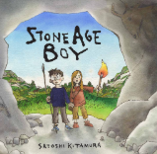  Satoshi Kitamura - Stone Age Boy  Diary entry (1st person)  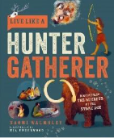  Naomi Walmsley – Live like a Hunter Gatherer  Non-chronological report - How to be a Hunter Gatherer | 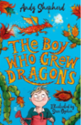  Andy Shepherd – the boy who grew dragons  Instructions – How to grow a dragon  Write a short story as a sequel. Using the three next book titles, children to choose one and write story based on title  National Poetry Week unit – cinquains | 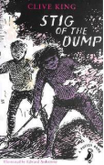  Clive King – Stig of the Dump  Narrative – character description  Biography - Clive King | 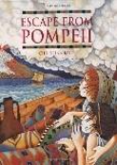  Christina Balit – Escape from Pompeii  Informal letter to family – escaping Pompeii  Persuasive leaflet – ‘come to live near a volcano!’ | 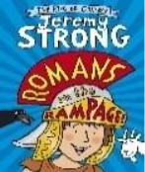  Jeremy Strong – Romans on the Rampage  Historical narrative – write their own short story set in Roman Times.  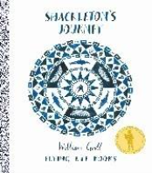  William Grill – Shackleton’s journey  Job advert – persuasive writing – looking for a new explorer to join the team. | William Grill – Shackleton’s journey  Narrative writing – adventure/ mystery story during an artic exploration.  Write own story – application of skills.
3 | Punctuation and grammar
3 | Diary entry  - Address  - Date  - Brief introduction  - Chronological order  - First person  - Past tense  - Facts and opinions  - Rhetorical questions  - Sign off  - Co-ordinating conjunctions  - Subordinating conjunctions  - Expanded noun phrases  - Adverbs/adverbials of time  - Adverbs/adverbials of place  - Exclamation marks  - Apostrophes for omission  - Apostrophes for plural possession  Non Chronological report  - Heading  - Brief introduction  - Subheadings  - Technical vocabulary  - Pictures and captions  - Third person – formal  - Statements giving factual information  - Co-ordinating conjunctions  - Subordinating conjunctions  - Expanded noun phrases  - Present perfect tense  - Commas for lists  - Apostrophes for possession | Instructions  - Title statement  - List of equipment or materials  - Sequenced, chronological steps  - Diagrams or illustrations  - Present tense  - Imperative verbs (commands)  - Detailed information  - Co-ordinating conjunctions  - Subordinating conjunctions  - Expanded noun phrases  - Commands, using the imperative  - Statements using the pronoun ‘you’  - Adverbs of manner  - Adverbs of time  - Commas for lists  - Apostrophes for possession  - Apostrophes for omission  Narrative  - Third person  - Past tense  - Co-ordinating conjunctions  - Subordinating conjunctions  - Adverbials of time  - Adverbials of place  - Adverbials of manner  - Apostrophes for possession | Character description  - Introduction  - Figurative language  - Short sentences for effect  - Rhetorical questions  - Expanded noun phrases  - Adverbials of manner including similes  - Participial phrases (-ing and -ed openers  - Adverbials of place  - Commas in a list  - Apostrophes for possession  - Apostrophes for omission  Biography  - Heading  - Brief introduction  - Subheadings  - Chronological order  - Technical vocabulary  - Pictures and captions  - Third person – formal  - Statements giving factual information  - Co-ordinating conjunctions  - Subordinating conjunctions  - Expanded noun phrases  - Perfect tense  - Adverbs/adverbials of time  - Commas for lists  - Apostrophes for possession | Informal letter  - Address  - Date  - Salutation  - Brief introduction  - Chronological order  - First person  - Past tense  - Facts and opinions  - Rhetorical questions  - Sign off  - Co-ordinating conjunctions  - Subordinating conjunctions  - Expanded noun phrases  - Adverbs/adverbials of time  - Adverbs/adverbials of place  - Exclamation marks  - Apostrophes for omission  - Apostrophes for plural possession  Persuasive leaflet  - Deals and bargains  - Direct address (can include flattery)  - Alliteration and assonance  - Facts and statistics  - Opinion (can be expert opinion)  - Repetition  - Rhetorical questions  - Emotive/exaggerated language  - Triples/the rule of three  - Adverbs  - Personal pronouns  - Expanded noun phrases  - Co-ordinating conjunctions  - Subordinating conjunctions  - Commands  - Commas for lists  - Apostrophes for possession | Narrative  - Third person  - Past tense  - Co-ordinating conjunctions  - Subordinating conjunctions  - Adverbials of time  - Adverbials of place  - Adverbials of manner  - Apostrophes for possession  - Inverted commas  - Characterisation of speech  - Colloquial language (non-Standard  - English)  - Discourse markers  Persuasive advert  - Deals and bargains  - Direct address (can include flattery)  - Alliteration and assonance  - Facts and statistics  - Opinion (can be expert opinion)  - Repetition  - Rhetorical questions  - Emotive/exaggerated language  - Triples/the rule of three  - Adverbs  - Personal pronouns  - Expanded noun phrases  - Co-ordinating conjunctions  - Subordinating conjunctions  - Commands  - Commas for lists  - Apostrophes for possession (GDS) | Narrative  - Third person  - Past tense  - Co-ordinating conjunctions  - Subordinating conjunctions  - Adverbials of time  - Adverbials of place  - Adverbials of manner  - Apostrophes for possession  - Inverted commas  - Characterisation of speech  - Colloquial language (non-Standard  - English)  - Discourse markers
3 | Morphology morphemes, prefixes and suffixes
3 | Baseline assessments GPCs  Vowels and consonants  Compound words  -s -es  -y  re-  -ly | -ful  -ly  un- | -ness  -ed  -ing  -ment | -ed  -ing  -er/-or | -ful  -less  -y | Super-/sur-  Under-/over-
3 | -ous  -ion  -an | Scribe/script  pre-  vise | inter-  ject  struct  spect | port  de-  trans-  tele | dis-/dif-/di-  mis-  in-/im/-il/-ir  -ure | ex-/e-  anti-/ant  mult(i)  vent/vene
4 | History  What was life like for the Anglo-Saxons? | Geography  What are rivers and how are they used? | History  How did life change when the Vikings arrived? | Geography  Where does our food come from? | Geography  Why are rainforests important to us? | History  What were the significant achievements of the Ancient Egyptians?
4 |   E.B White – Charlotte's Web  Narrative – recount from a different viewpoint  Persuasive letter – stopping the pig going to slaughter | 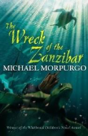  Michael Morpurgo – The Wreck of the Zanzibar  setting description - the wreckage  Non-chronological report – rivers  National Poetry Week unit – haikus | 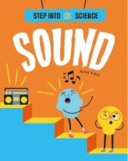  Peter Riley – Step into Science – Sound  Explanation text – How do bats find their way in the dark?  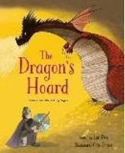  Lari Don – The Dragon’s Hoard  Narrative – alternative ending | 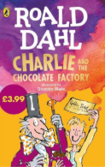  Roald Dahl – Charlie and the Chocolate Factory  Instructional writing – design new chocolate bar.  Write a prequel to the story – How did Willy Wonker become Willy Wonker? | 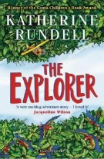  Katherine Rundell – The Explorer  Persuasive leaflet – visit the rainforest  Write an epilogue 12 years later: Have they kept in touch with the explorer? Have they told anyone about the ancient City? What happened after they arrived home? | 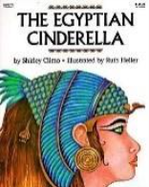  Shirley Climo - The Egyptian Cinderella  Playscripts (Egyptian Cinderella)  Narratives – Historical/ adventure story set in Ancient Egypt.  Write own story – application of skills.
4 | Punctuation and grammar
4 | Narrative  - Introduction  - Figurative language  - Short sentences for effect  - Rhetorical questions  - Conclusion including a cliff hanger  - Expanded noun phrases sights, sounds and smells  - Adverbials of manner including similes  - Participial phrases (-ing and -ed  openers)  - Adverbials of place  - Commas in a list  - Apostrophes for possession  - Commas for fronted adverbials  - Ellipses  Persuasive letter  - Address  - Date  - Salutation  - Brief introduction  - First person  - Past tense  - Facts and opinions  - Rhetorical questions  - Relevant persuasive techniques  - Sign off  - Co-ordinating conjunctions  - Subordinating conjunctions  - Expanded noun phrases  - Adverbs/adverbials of time  - Adverbs/adverbials of place  - Commas for fronted adverbials  - Apostrophes for omission  - Apostrophes for plural possession | Setting description  - Introduction  - Paragraphs pan the setting  - Figurative language  - Short sentences for effect  - Rhetorical questions  - Conclusion including a cliff hanger  - Expanded noun phrases sights, sounds  - and smells  - Adverbials of manner including similes  - Participial phrases (-ing and -ed openers)  - Adverbials of place  - Commas in a list  - Apostrophes for possession  - Commas for fronted adverbials  - Ellipses  Non-chronological report  - Heading  - Brief introduction  - Subheadings  - Technical vocabulary  - Pictures and captions  - Third person – formal  - Statements giving factual information  - Co-ordinating conjunctions  - Subordinating conjunctions  - Expanded noun phrases  - Present perfect tense  - Commas for lists  - Apostrophes for possession  - Commas after fronted adverbials | Explanation text  - Title  - Introductory paragraph  - Paragraphs detailing a process  - Facts  - Present tense  - Formal language  - Technical vocabulary  - Co-ordinating conjunctions  - Subordinating conjunctions  - Expanded noun phrases  - Adverbs/adverbials of time  - Adverbs/adverbials of manner  - Commas for fronted adverbials  - Apostrophes for possession  Narrative  - Introduction  - Figurative language  - Short sentences for effect  - Rhetorical questions  - Conclusion including a cliff hanger  - Expanded noun phrases sights, sounds and smells  - Adverbials of manner including similes  - Participial phrases (-ing and -ed openers)  - Adverbials of place  - Commas in a list  - Apostrophes for possession  - Commas for fronted adverbials  - Ellipses  - Inverted commas  - Characterisation of speech  - Colloquial language (non-Standard  - English)  - Discourse markers | Instructions  - Title statement  - List of equipment or materials  - Sequenced, chronological steps  - Diagrams or illustrations  - Present tense  - Imperative verbs (commands)  - Detailed information  - Co-ordinating conjunctions  - Subordinating conjunctions  - Expanded noun phrases  - Commands, using the imperative  - Statements using the pronoun ‘you’  - Adverbs of manner  - Adverbs of time  - Commas in a list  - Commas for fronted adverbials  - Apostrophes for possession  - Apostrophes for omission  Narrative  - Introduction  - Figurative language  - Short sentences for effect  - Rhetorical questions  - Conclusion including a cliff hanger  - Expanded noun phrases sights, sounds and smells  - Adverbials of manner including similes  - Participial phrases (-ing and -ed openers)  - Adverbials of place  - Commas in a list  - Apostrophes for possession  - Commas for fronted adverbials  - Ellipses  - Inverted commas  - Characterisation of speech  - Colloquial language (non-Standard  - English)  - Discourse markers | Persuasive leaflet  - Heading  - Subheadings  - Introduction  - First person  - Past tense  - Facts and opinions  - Rhetorical questions  - Relevant persuasive techniques  - Co-ordinating conjunctions  - Subordinating conjunctions  - Expanded noun phrases  - Adverbs/adverbials of time  - Adverbs/adverbials of place  - Commas for fronted adverbials  - Apostrophes for omission  - Apostrophes for plural possession  Narrative  - Introduction  - Figurative language  - Short sentences for effect  - Rhetorical questions  - Conclusion including a cliff hanger  - Expanded noun phrases sights, sounds and smells  - Adverbials of manner including similes  - Participial phrases (-ing and -ed openers)  - Adverbials of place  - Commas in a list  - Apostrophes for possession  - Commas for fronted adverbials  - Ellipses  - Inverted commas  - Characterisation of speech  - Colloquial language (non-Standard  - English)  - Discourse markers | Playscript  - Introduction  - Each character shows emotions  - Stage directions  - Short sentences for effect  - Colloquial language (non-Standard  - English)  - Discourse markers  - Expanded noun phrases  - Adverbials of manner  - Participial phrases & clauses (-ing and  -ed openers)  - Adverbials of place  - Apostrophes for omission  Narrative  - Introduction  - Each character shows emotions  - Each character performs actions  - Short sentences for effect  - Colloquial language (non-Standard  - English)  - Discourse markers  - Expanded noun phrases  - Adverbials of manner  - Participial phrases & clauses (-ing and -ed openers)  - Adverbials of place  - Apostrophes for omission  - Commas for fronted adverbials  - Inverted commas  - Ellipses to show a pause or incomplete  - thought  - Hyphens to show stutter
4 | Morphology morphemes, prefixes and suffixes
4 | Baseline assessments GPCs  Vowels and consonants  Compound words  tele  port | -s -es  -y | -s -es  -y  -ous  -ly  -ment  -ion | -ness  -ed -ing  -ion  -ful  -ly | -ed -ing  -er/-or  de- | inter-  ject  struct  spect  -ness  tele  tract  port
4 | -ion  -an | -ous  -ic/-al  -able/-ible | -ive  -ty  aud  phone | kilo  gram  mill(i)  cent  en-  em- | per-  sub-  tract  aut(o)  -fy/-fic/-fice | act  rupt  -en  -ise  -hood  -ship
5 | History  What did the Victorians leave for us? | Geography  What is life like in the Alps? | History  How did the Maya Civilisation compare to the Anglo-Saxons? | Geography  Why do oceans matter? | History  What influence did the Ancient Greeks have on the world? | Geography  Would you live in a desert?
5 | 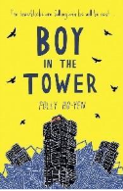  Polly Ho-yen – Boy in the Tower  Informal letter from Ade to Gia.  Newspaper report – Bluchers – building eating plants | Polly Ho-yen – Boy in the Tower  Write own version of story/disaster narrative  Instructions – how to survive the Blutchers take over.  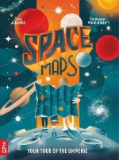  Lara Albanese – Space Maps: Your tour of the Universe  Non-chronological report – planets of the solar system  National Poetry Week unit – Kennings | 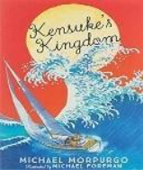  Michael Morpurgo –  Kensuke’s Kingdom  Persuasive argument – Micheal and his family should give up everything and sail around the world?  Alternative ending : Kensukes decides to leave with Michael– narrative writing  Persuasive letter from Michael to Kensuke asking him to change his mind and leave with him. |  | 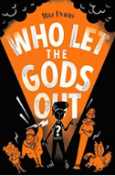  Maz Evans – Who Let the Gods Out?  Greek Myths – use text to read and write own Greek Myth.  Explanation text – The original Olympic Games OR Greek Gods and Godesses. | 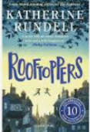  Katherine Rundell – Rooftoppers  Narrative - Written from a different view point  diary entry – Sophie trying to find her mother.  Write own story – application of skills.
5 | Punctuation and Grammar
5 | Informal letter  - Address  - Date  - Salutation  - Brief introduction  - Chronological order  - First person  - Past tense  - Facts and opinions  - Rhetorical questions  - Sign off  - Subordinating conjunctions  - Conjunctive adverbs  - Relative clauses  - Expanded noun phrases  - Adverbs/adverbials of time  - Adverbs/adverbials of place  - Parentheses  - Apostrophes for plural possession  Newspaper report  - Heading  - Brief introduction  - Subheadings  - Technical vocabulary  - Pictures and captions  - Third person – formal  - Statements giving factual information  - Facts and statistics  - Opinion (can be expert opinion)  - Repetition  - Rhetorical questions  - Emotive/exaggerated language  - Triples/the rule of three  - Modal verbs  - Adverbs for possibility/degree  - Subordinating conjunctions  - Relative clauses  - Conjunctive adverbs  - Commas for lists  - Apostrophes for possession  - Parentheses | Narrative  - Introduction  - Each character shows emotions  - Each character performs actions  - The audience reacts to each character  - Short sentences for effect  - Colloquial language (non-Standard  - English)  - Discourse markers  - Expanded noun phrases  - Adverbials of manner  - Participial phrases & clauses (-ing and  -ed openers)  - Relative clauses  - Adverbials of place  - Inverted commas  - Parentheses  - Ellipses to show stammer, pause or  - incomplete thought  - Hyphens to show stutter  Instructions  - Title statement  - List of equipment or materials  - Sequence, chronological steps  - Diagrams or illustrations  - Present tense  - Imperative verbs (commands)  - Detailed information  - Co-ordinating conjunctions  - Subordinating conjunctions  - Expanded noun phrases  - Commands, using the imperative  - Adverbs of manner  - Adverbs of time  - Commas in a list  - Parentheses  - Apostrophes for possession  - Commas  Non-chronological report  - Heading  - Brief introduction  - Subheadings  - Technical vocabulary  - Pictures and captions  - Third person – formal  - Statements giving factual information  - Subordinating conjunctions  - Relative clauses  - Conjunctive adverbs  - Commas for lists  - Apostrophes for possession  - Parentheses | Persuasive argument  - Title – question  - Conclusion  - Present tense  - First person  - Detailed information  - Technical vocabulary  - Alliteration and assonance  - Facts and statistics  - Opinion (can be expert opinion)  - Repetition  - Rhetorical questions  - Emotive/exaggerated language  - Triples/the rule of three  - Subordinating conjunctions  - Modal verbs  - Expanded noun phrases  - Adverbs/adverbials of manner  - Adverbs/adverbials of time  - Conjunctive adverbs  - Relative clauses  - Commas, brackets and dashes for parentheses  Narrative  - Introduction  - Each character shows emotions  - Each character performs actions  - The audience reacts to each character  - Short sentences for effect  - Colloquial language (non-Standard  - English)  - Discourse markers  - Expanded noun phrases  - Adverbials of manner  - Participial phrases & clauses (-ing and  -ed openers)  - Relative clauses  - Adverbials of place  - Inverted commas  - Parentheses  - Ellipses to show stammer, pause or  - incomplete thought  - Hyphens to show stutter | Persuasive letter  - Address  - Date  - Salutation  - Brief introduction  - Direct address (can include flattery)  - Alliteration and assonance  - Facts and statistics  - Opinion (can be expert opinion)  - Repetition  - Rhetorical questions  - Emotive/exaggerated language  - Triples/the rule of three  - Modal verbs  - Adverbs for possibility/degree  - Personal pronouns  - Expanded noun phrases  - Subordinating conjunctions  - Conjunctive adverbs  - Commands  - Commas for lists  - Hyphens | Narrative Myth  - Introduction  - Each character shows emotions  - Each character performs actions  - The audience reacts to each character  - Short sentences for effect  - Colloquial language (non-Standard  - English)  - Discourse markers  - Expanded noun phrases  - Adverbials of manner  - Participial phrases & clauses (-ing and  -ed openers)  - Relative clauses  - Adverbials of place  - Inverted commas  - Parentheses  - Ellipses to show stammer, pause or  - incomplete thought  - Hyphens to show stutter  Explanation text  - Technical vocabulary  - Pictures and captions  - Third person – formal  - Statements giving factual information  - Subordinating conjunctions  - Relative clauses  - Conjunctive adverbs  - Commas for lists  - Apostrophes for possession  - Parentheses | Narrative  - Introduction  - Each character shows emotions  - Each character performs actions  - The audience reacts to each character  - Short sentences for effect  - Colloquial language (non-Standard  - English)  - Discourse markers  - Expanded noun phrases  - Adverbials of manner  - Participial phrases & clauses (-ing and  -ed openers)  - Relative clauses  - Adverbials of place  - Inverted commas  - Parentheses  - Ellipses to show stammer, pause or  - incomplete thought  - Hyphens to show stutter  Diary entry  - Date  - Salutation  - Chronological order  - Past tense  - First person  - Facts and opinions  - Rhetorical questions  - Sign off  - Subordinating conjunctions  - Conjunctive adverbs  - Relative clauses  - Adverbs/adverbials of time  - Adverbs/adverbials of  - place/preposition phrases  - Expanded noun phrases  - Commas for parentheses
5 | Morphology morphemes, prefixes and suffixes
5 | Baseline assessments GPCs  Vowels and consonants  Compound words  -ed -ing  -ness | -s -es  -y  -ous | dis-/dif-/di-  in-/im-/il-/ir-  -able/-ible | -ful, -ly, -er, -or, -al, -ise, -fy/-fic/-fice  -ive/-ty  -ous | inter-  ject | en-/ em-  -hood  -ship
5 | -ate  fact/fect/face/fice | Semi, une, bi, tri, quadr/quart, pent/penta/quint, hexa, hept/hepta/sept/septem, oct/octa, none/nona/novem, dece/deca/decem | -ant  -ance  -ent  -ence  -ably/-ibly | cess/ceed/cede/cease  ab-/a-  ad-/a-  -tude  vert/verse | pro-  form  duct/duce  temp/tempere/tempore  therm | -dom  -ary/-ery
6 | History  What was the impact of World War 2 on the people of Britain? |  | Geography  Why does population change? | Geography  Where does our energy come from? | History  What was life like in the Kingdom of Benin? | Geography  Can I carry out an independent fieldwork inquiry?
6 | 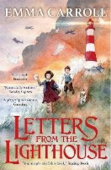  Emma Carroll – Letters from the Lighthouse  Persuasive letter writing – evacuee to new home.  Narrative piece describing a street after a bomb attack during the blitz | Narrative – Adventure story/Historical story  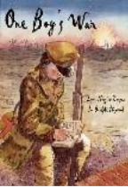  Lynn Huggins-Cooper – One Boy’s War  Non-chronological report – WWII  National Poetry Week unit – free verse | 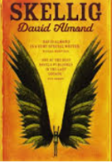  David Almond - Skellig  Narrative – write next chapter/new ending  Diary entry | David Almond – Skellig  Narrative – dialogue focus – characterisation and advancing the action (Francis Literacy Shed video)  Biography – Either David Almond or children choose own celebrity/significant individual | 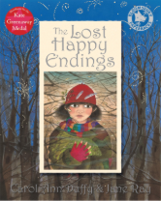  Carol Ann Duffy - The Lost Happy Endings  Twisted fairytales  Literacy Shed Video – Little pigs frame the Pig  Persuasive letter – post SATs visit  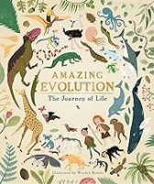  Anna Claybourne – Amazing Evolution  - Explanation text – How have plants adapted to survive in the desert? (completed in science) | 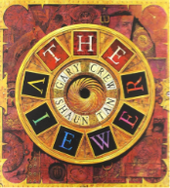  Gary Crew – The Viewer  Plan and write a sequel to The Viewer  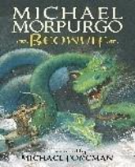  Michael Morpurgo – Beowulf  Narrative poetry – The Raven – Edgar Allen Poe  Suspense narrative
6 | Punctuation and grammar
6 | Persuasive letter  - Address  - Date  - Salutation  - Brief introduction  - Direct address (can include flattery)  - Alliteration and assonance  - Facts and statistics  - Opinion (can be expert opinion)  - Repetition  - Rhetorical questions  - Emotive/exaggerated language  - Triples/the rule of three  - Modal verbs  - Active voice  - Adverbs for possibility/degree  - Personal pronouns  - Expanded noun phrases  - Subordinating conjunctions  - Conjunctive adverbs  - Commands  - Semi-colons  - Colons  Narrative  - Introduction  - Paragraphs pan the setting  - Figurative language  - Short sentences for effect  - Rhetorical questions  - Conclusion including a cliff hanger  - Expanded noun phrases sights, sounds  and smells  - Adverbials of manner including similes  - Participial phrases (-ing and -ed  openers)  - Characterising speech  (emotion, action, thought)  - Relative clauses  - Adverbials of place  - Apostrophes for possession  - Semi-colons  - Colons | Narrative  - Consequence story path  - Past tense  - Characterising speech  (emotion, action, thought)  - Colloquial language  - Idioms  - Contractions  - Rhetorical questions  - Adverbials of time  - Adverbials of place  - Adverbials of manner  - Relative clauses  - Ellipses to show pause  - Semi-colons  - Colons  Non-chronological report  - Heading  - Brief introduction  - Subheadings  - Technical vocabulary  - Pictures and captions  - Third person – formal  - Statements giving factual information  - Passive voice  - Subordinating conjunctions  - Relative clauses  - Subjunctive form  - Conjunctive adverbs  - Semi-colons  - Colons  - Apostrophes for possession  - Parentheses | Narrative  - Past tense  - Characterising speech  (emotion, action, thought)  - Colloquial language  - Idioms  - Contractions  - Rhetorical questions  - Adverbials of time  - Adverbials of place  - Adverbials of manner  - Relative clauses  - Ellipses to show pause  - Semi-colons  Diary entry  - Dates  - Salutation  - Chronological order  - Past tense  - First person  - Facts and opinions  - Rhetorical questions  - Sign off  - Active voice  - Subjunctive mood  - Subordinating conjunctions  - Conjunctive adverbs  - Relative clauses  - Adverbs/adverbials of time  - Adverbs/adverbials of  - place/preposition phrases  - Expanded noun phrases  - Semi-colons | Narrative  - Introduction  - Each character shows emotions  - Each character performs actions  - The audience reacts to each character  - Short sentences for effect  - Colloquial language (non-Standard  - English)  - Discourse markers  - Expanded noun phrases  - Adverbials of manner  - Participial phrases & clauses (-ing and  -ed openers)  - Relative clauses  - Adverbials of place  - Inverted commas  - Colons  - Semi-colons  - Parentheses  - Ellipses to show stammer, pause or  incomplete thought  - Dashes to show change of thought or  interruption  - Hyphens to show stutter  Biography  - Heading  - Brief introduction  - Subheadings  - Technical vocabulary  - Pictures and captions  - Third person – formal  - Statements giving factual information  - Passive voice  - Subordinating conjunctions  - Relative clauses  - Subjunctive form  - Conjunctive adverbs  - Semi-colons  - Colons  - Apostrophes for possession  - Parentheses | Narrative (recap)  - Introduction  - Each character shows emotions  - Each character performs actions  - The audience reacts to each character  - Short sentences for effect  - Colloquial language (non-Standard  - English)  - Discourse markers  - Expanded noun phrases  - Adverbials of manner  - Participial phrases & clauses (-ing and  -ed openers)  - Relative clauses  - Adverbials of place  - Inverted commas  - Colons  - Semi-colons  - Parentheses  - Ellipses to show stammer, pause or  incomplete thought  - Dashes to show change of thought or  interruption  - Hyphens to show stutter  Persuasive letter  - Headings  - Subheadings  - Deals and bargains  - Direct address (can include flattery)  - Alliteration and assonance  - Facts and statistics  - Opinion (can be expert opinion)  - Repetition  - Rhetorical questions  - Emotive/exaggerated language  - Triples/the rule of three  - Modal verbs  - Active voice  - Adverbs for possibility/degree  - Personal pronouns  - Expanded noun phrases  - Subordinating conjunctions  - Conjunctive adverbs  - Commands  - Semi-colons  - Colons  Explanation text (science)  - Technical vocabulary  - Pictures and captions  - Third person – formal  - Statements giving factual information  - Subordinating conjunctions  - Relative clauses  - Conjunctive adverbs  - Commas for lists  - Apostrophes for possession  - Parentheses  - Passive voice  - Subjunctive form | Narrative (recap)  - Introduction  - Each character shows emotions  - Each character performs actions  - The audience reacts to each character  - Short sentences for effect  - Colloquial language (non-Standard  - English)  - Discourse markers  - Expanded noun phrases  - Adverbials of manner  - Participial phrases & clauses (-ing and  -ed openers)  - Relative clauses  - Adverbials of place  - Inverted commas  - Colons  - Semi-colons  - Parentheses  - Ellipses to show stammer, pause or  incomplete thought  - Dashes to show change of thought or  interruption  - Hyphens to show stutter  Narrative poetry  - Similes  - Metaphors  - Personification  - Onomatopoeia  - Alliteration  - Hyperbole  - idioms
6 | Morphology morphemes, prefixes and suffixes
6 | Baseline assessments GPCs  Vowels and consonants  Compound words  -s/-es  -y  -ic  -al  -an | -ness,  -ed, -ing  trans-, port  -ant/-ent, -ance/-ence  -less, -ful, -ly | -ed, -ing, -ly  -er, – or  trans-  -ate  Fact/fect/face/fice | inter-, ject, struct, spect  -ary/-ery | -ing, -ion, dis-/dif-/di-  -ise  -fy/-fic/-fice | Recap previously taught morphemes as needed.
6 | -ism  -ist | -ish  -esque  fer  -age  ceive/cept | Com-/con-/co-/cor-/col- | post  fore  fract/frag/frage | magn

