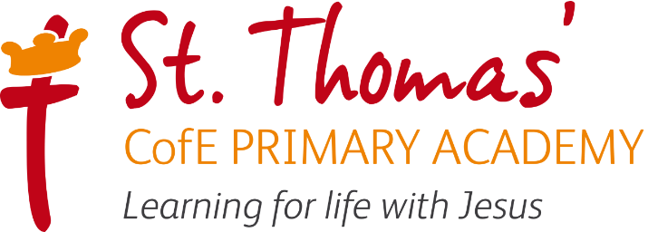



Writing Learning Journey
2026/2027

Intent, Implementation and Impact

Learning for life with Jesus
Inspired by our Christian faith, we guide children on a personalised journey towards achievement. As a learning community, we are committed to ensuring that children are equipped with skills and aspirations to reach their full potential in mind, body, heart and spirit.

Intent
As a Church of England school, our Writing curriculum is underpinned by our gospel values. These values are used and applied throughout the curriculum. Our children will be able to practise and apply writing skills in a variety of different contexts and use these skills to write for a real purpose. They show curiosity, attentiveness and active learning through their independence within lessons, following their own learning journey, taking charge of their own learning by using a variety of resources, and continuously acting on feedback through active marking within each lesson. Our Christian values create a solid moral background for our children and encourage them to become better members of society.
At the heart of our writing curriculum is our core skills. These skills are progressive and are built on year after year, all the way through to Year 6. This ensures that children are given opportunities to practise and apply skills such as composition, grammar and spelling in different contexts. Our approach ensures that the love of writing is not lost, but that children are also given every opportunity for deliberate practice to ultimately become successful writers and communicators, culminating in them being well-equipped in their English education for secondary school.
At St. Thomas’, our children come from a range of backgrounds and starting points. This may mean they are not fully equipped with the English skills and experiences they need to become the best readers and writers that they can be. Our intent is to foster a love for writing among our pupils, ensuring they develop the necessary skills, creativity, and confidence to express themselves effectively across various contexts. We aim to provide a rich and engaging curriculum that:

- Promotes creativity and individuality: We inspire children to experiment with different genres and styles, encouraging them to find their unique voices.
- Develops key skills: Our approach ensures that students acquire fundamental writing skills, including grammar, punctuation, and spelling, as well as higher-order thinking skills such as planning, editing, and evaluating their work.
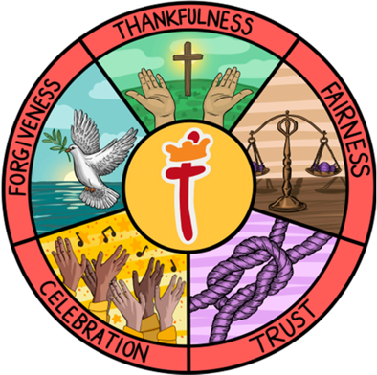
- Encourages critical thinking and self-reflection: Students are taught to assess their writing critically.
- Develops clarity and coherence: Pupils are taught to structure their thoughts logically.
- Fosters a positive attitude towards writing: Provides diverse, engaging, and relevant writing opportunities.

Our English and writing lead in school is Mrs A Tomkins

Implementation

St Thomas’ Writing Learning Journey focuses on a spiral curriculum model where previous skills and knowledge are revisited and built upon. Writing is taught for an hour a day in KS1 and KS2.
As a school, we draw on some principles of 'Talk for Writing' in KS1 so that the children can rehearse and learn exemplary models of writing. They will dissect and evaluate these models, analysing the grammatical rules and tools that make the piece of writing a success. The rules for writing are the non-negotiable year group expectations we expect the children to include in every piece of work, whilst the tools are the specific grammatical features that the children should include.
When the KS1 children write independently, they may be expected to use the 'Talk for Writing' strategies of imitation, where they change some elements of an original piece, or innovation, where they are expected to have planned a new piece of writing from scratch based on the model. By the end of KS2, we expect that the children will be confident in selecting their own writing genres to present their work based on a given stimulus, whilst keeping their audience in mind.
Editing within writing is a key skill taught to all pupils and the children are taught to edit as a part of the writing process. Through explicit modelling and deliberate practice either in stand-alone editing lessons or on-the-go feedback sessions in lessons, children are taught that editing may be clerical e.g. checking for spelling and punctuation, but may also involve making changes to directly impact the intended audience or purpose for writing.
Each classroom's S Plan is an essential element to teaching and learning in Writing: across a unit of work, children work with their teacher to co-construct a range of resources from planning sheets, vocabulary banks, sentence structure activities, tools and rules resources and modelled/shared writing which is made available for children to independently draw on when creating their own pieces. This also drives children's accountability and independence in writing.
We organise intended learning into writing units. We plan these out using an S-Plan. These group the knowledge, skills and understanding that we want children to remember, do and use. The writing units are taught in daily lessons in 2 to 3-weekly sequences. We start with a high quality and inspiring text or other “hook” and identify writing opportunities which link to this and can be crafted, building lessons from this point up. A typical learning sequence includes consideration of:
• GENRE – This is the text type. We consider what we want pupils to write and why (the audience and purpose).
• TEXT / READING ANALYSIS – This requires effective models of the genre to build up pupils’ understanding of texts in this particular style.
• SENTENCE CRAFTING – Plan for sentence composition linked to the genre type. Composition practice should link to the end outcome piece so pupils can draw on this practice to support independent composition.
• VOCABULARY DEVELOPMENT – Consider words that will support pupils to improve their composition, draw attention to any taught spelling patterns. These should be taught within context with opportunities for pupils to apply within the composition of sentence structures.
• PLANNING FOR WRITING – Modelling of effective planning is crucial. Teachers should be careful with the format used so we do not limit ideas to small boxes which are not useful to follow when composing. Tools and approaches should enable pupils to plan ideas for the composition and the vocabulary they will use within the writing.
• MODELLED WRITING – Teachers usually prepare the models to support the compositional and transcriptional skills, and component knowledge being developed in the sequence. As well as using the preprepared model, teachers live model and collaboratively write with pupils so that they understand how to compose. During this step, teachers also model proofreading and editing.
• SHARED WRITING – Using the planning, model how to compose the piece (parts of the piece) with the pupils. Teacher modelling is really important to develop writer’s voice and promote thinking (cognition and metacognition).
• GUIDED WRITING – Working with groups of pupils to specifically guide their writing skills. Assessment is key to delivering guided writing. Lower attaining pupils should not be limited. Higher attaining pupils require teachers to guide writing to understand how to critically shape sentences for effect. Teachers should focus on particular skills that the pupils need to include and group together.
• INDEPENDENT WRITING – Pupils compose their own piece. This can be in parts as they work through paragraphs of the text or as a full piece. Redrafting and editing can be of sections to lead to more focused impact.

EYFS

Writing is taught as part of the Literacy area of the EYFS learning and development. Some aspects of writing also link to the Physical Development area. Children in Reception are taught handwriting through the Supersonic Phonic Friends Handwriting scheme linked to letter families. Children in Reception are taught to hear and write initial and end sounds first, then are taught to hear all sounds in CVC words. This then progresses through the year to writing a sentence. Children in Reception have adult-led book activities which link to their phonic ability. During this, the teacher will support them. Enhanced Provision activities are a variety of scaffolded opportunities linked to their book of the week/theme. Children have the opportunity to practise and apply what has been taught independently through continuous provision. Reception also take part in daily dough disco exercises which promote finger strength. Children will be assessed against the Early Learning Goals (see table below) at the end of the academic year.

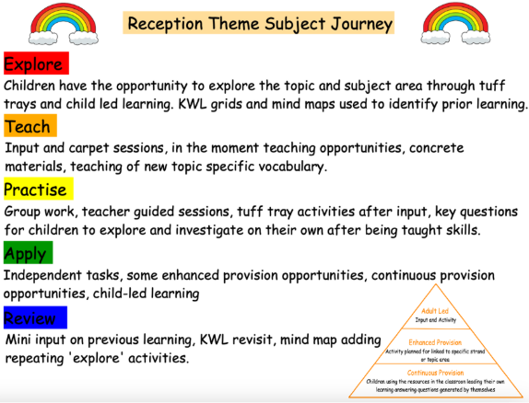

ELG
Transcription: Letter formation, placement and positioning
Physical development |  | Hold a pencil effectively in preparation for fluent writing using the tripod grip in almost all cases
Literacy |  | Write recognisable letters, most of which are correctly formed.
Composition: Planning, writing and editing
Literacy | Writing | Write recognisable letters, most of which are correctly formed.  Spell words by identifying sounds in them and representing the sounds with a letter or letters.  Write simple phrases and sentences that can be read by others.
Expressive Arts  and Design | Being  Imaginative  and Expressive | Invent, adapt and recount narratives and stories with peers  and teachers
Composition: Awareness of audience, purpose and structure
Communication and language | Speaking | Participate in small group, class and one-to-one discussion, offering their own ideas, using recently introduced vocabulary.  Offer explanations for why things might happen, making use of recently introduced  vocabulary from stories, non-fiction, rhymes and poems when appropriate.  Express their ideas and feelings about their experiences using full sentences, including use of past, present and future tenses and making use of conjunctions, with modelling and support from their teacher
Vocabulary, Grammar and Punctuation: sentence structure and tense
Communication and language | Speaking | Offer explanations for why things might happen, making use of recently introduced vocabulary from stories, non-fiction, rhymes and poems when appropriate.  Express their ideas and feelings about their experiences using full sentences, including the use of past, present and future tenses and making use of conjunctions with modelling and  support from the teacher.
Vocabulary, Grammar and Punctuation: use of phrases and clauses
Communication and language | Speaking | Express their ideas and feelings about their experiences using full sentences, including the use of past, present and future tenses and making use of conjunctions with modelling and  support from the teacher.
Composition: Poetry and performance
Literacy | Comprehension | Demonstrate understanding of what has been read to them by retelling stories and narratives using their own words and recently introduced vocabulary.
Expressive Arts  and Design | Creating  with Materials | Make use of props and materials when role playing characters in narratives and stories.
Expressive Arts  and Design | Being  Imaginative  and Expressive | Invent, adapt and recount narratives and stories with their peers and their teacher.  Perform songs, rhymes, poems and stories with others, and  (when appropriate) try to move in time to music.
Composition: Non fiction
Communication and language | Speaking | Offer explanations for why things might happen, making use of recently introduced vocabulary from stories, non-fiction, rhymes and poems when appropriate.
Literacy | Comprehension | Use and understand recently introduced vocabulary during discussions about stories, non-fiction, rhymes and poems and during role play.

Impact

In addition to the outcomes shown on our curriculum tree the specific impact of the St Thomas’ Writing Learning Journey is that children will (as stated in the national curriculum):
- acquire a wide vocabulary, an understanding of grammar and knowledge of linguistic conventions for reading, writing and spoken language
- appreciate our rich and varied literary heritage
- write clearly, accurately and coherently, adapting their language and style in and for a range of contexts, purposes and audiences
- use discussion in order to learn; they should be able to elaborate and explain clearly their understanding and ideas
- are competent in the arts of speaking and listening, making formal presentations, demonstrating to others and participating in debate

Our commitment to teaching writing is reflected in the significant progress and achievements of our pupils. We measure impact through:

- Assessment data: Regular tracking of writing attainment shows that a high percentage of pupils achieve age-related expectations, with an increasing number exceeding these benchmarks.
- Quality of writing produced: An analysis of pupils' written work demonstrates a strong command of vocabulary, grammar, and structure, alongside clear evidence of personal voice and creativity.
- Pupil engagement and attitudes: Feedback from pupils illustrates a positive attitude towards writing; they express enthusiasm for writing activities and a sense of pride in their accomplishments.
- Cultural enrichment: Pupils are able to connect their writing experiences to wider cultural contexts, enhancing their understanding of diverse narratives and perspectives.

In summary, our writing programme is holistic, well-resourced, and continually evolving, ensuring that every pupil leaves us equipped not only with essential writing skills but also with a lifelong enthusiasm for expressing themselves through the written word.

Handwriting

We aim for our children to leave in Year 6 with the ability to write using their own style of fast, fluent, legible and sustainable handwriting, as well as other styles of writing for specific purposes. In addition to teaching handwriting during our regular handwriting lessons, we have high expectations that what is taught and practiced in handwriting lessons will be used in all writing activities, across all subject areas. We believe that handwriting is integral to a child’s personal development and know that children’s engagement and self-esteem can be improved by their satisfaction and pride in good quality presentation.

All of our children have equal access to handwriting lessons and to the resources available. We recognise that some children take longer to develop the necessary skills and we cater for those children by providing additional opportunities for skills development. Children who need specific gross/fine motor or handwriting interventions are identified early and the impact of interventions is carefully monitored. Children with a physical disability are catered for, and progress is monitored, according to their additional support plans.

In Reception and KS1, letter formation is taught alongside daily phonics lessons using Supersonic Phonic Friends.
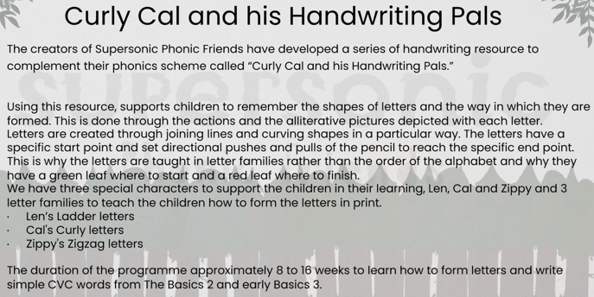

Joined handwriting is taught from the Summer Term in Year 1. All the joins will be taught by the end of Year 3, and from then, on children are encouraged to use joined handwriting for all their writing - notes
and more formal pieces of writing. This way, children build on producing legible handwriting so that they are joining writing automatically, enabling them to focus on the content of their work rather than the process of transcription.

In order to start learning the joins, children first need to be forming individual letters accurately so that each letter ends in the correct place. They need to see the joins being written, before practising themselves. When children are secure in the use of all four joins, short bursts of regular practice will help to build up speed and fluency.

Once joins begin to be taught, handwriting sessions follow the sequence:
- Fine motor skills; hand and finger strength warm up
- Seating position
- Pencil grip (tripod grip)
- Teacher modelling
- Independence

These are the four main joins and order that are taught:
- Diagonal joins to letters without ascenders e.g: ai, ar, un, am, ear, aw, ir, hu, ti, ki, du, up, ag, fe, fu.
- Horizontal joins to letters without ascenders e.g: ou, vi, wi, op, ow, ov, ri, ru, ve, we, re.
- Diagonal joins to letters with ascenders e.g: ab, ul, it, ib, if, ub, th, ck, ch, it, ft, fl.
- Horizontal joins to letters with ascenders e.g: ob, ol, wh, it, of, rt, rk.

Break letters without exit strokes:
b, g, j, p, q, s, x, y, z

Handwriting Progression

Transcription:  Handwriting | Autumn | Spring | Summer
Year 1 | Continue to practise letter formation with exit strokes using Supersonic Phonic Friends to align with phonics.  Introduce all capital letters | Continue to practise letter formation with exit strokes using Supersonic Phonic Friends to align with phonics.  Practise all capital letters and 0-9 | Continue to practise letter formation with exit strokes using Supersonic Phonic Friends to align with phonics.  Week 1: Numbers 10-20  Week 2: Practise ai unjoined  Week 3: Introduce diagonal join to letters no ascender, e.g: ai  Week 4: Practise ch unjoined  Week 5: Introduce diagonal joins to ascenders, e.g: ch  Week 6: Practise ow unjoined  Week 7: Introduce horizontal joins to no ascender, e.g: ow  Week 8: Practise wh unjoined  Week 9: Introduce horizontal joins to ascender, e.g: wh ch  Week 10: Consolidation
Year 2 | Week 1: Practising diagonal join to ascender: th, ch  Week 2: Practising diagonal join, no ascender: ai, ay  Week 3: Practising diagonal join, no ascender: ir, er  Week 4: Practising horizontal join to ascender: wh, oh  Week 5: Practising horizontal join, no ascender: ow, ou  Week 6: Consolidation  Week 7: Introducing diagonal join to e: ie, ue  Week 8: Introducing horizontal join to e: oe, ve  Week 9: Writing numbers 1–100  Week 10: Consolidation | Week 1: Introducing diagonal join to anticlockwise letters: ea  Week 2: Practising diagonal join to anticlockwise  letters: igh  Week 3: Practising diagonal join to anticlockwise  letters: dg, ng  Week 4: Introducing horizontal join to anticlockwise  letters: oo, oa  Week 5: Practising horizontal join to anticlockwise  letters: wa, wo  Week 6: Consolidation  Week 7: Introducing mixed joins for three letters: air, ear  Week 8: Practising mixed joins for three letters: oor, our  Week 9: Practising mixed joins for three letters: ing  Week 10 - Consolidation | Week1: Building on diagonal join, no ascender: ui, ey, aw, ur, an, ip  Week 2: Building on diagonal join to ascender: ck, al, el, at, il, ill  Week 3: Building on horizontal join, no ascender: oi, oy, on, op, ov  Week 4: Building on horizontal join to ascender: ok, ot,  ob, ol  Week 5: Consolidation  Week 6: Building on diagonal join to anticlockwise letters: ad, cc, eg, ic, ad, ug, dd, ag  Week 7: Building on horizontal join to anticlockwise letters: oc, og, od, va, vo  Week 8: Introducing joins to s: as, es, is, os, ws, ns, ds, ls, ts, ks  Week 9: Capital letters  Week 10: Consolidation
LKS2 | Week 1: Practising joining  through a word in stages: no  ascenders or descenders  Week 2: Practising joining through a word in stages: parallel ascenders  Week 3: Introducing joining from r to an ascender: rb, rh, rk, rl,  Week 4: Introducing joining  from r, no ascender: ri, ru, rn, rp  Week 5: Introducing joining from r to an anticlockwise letter: ra, rd, rg, ro  Week 6: Introducing joining from r to e: are, ere, ure, ore, ire  Week 7: Introducing break letters: g, j, y, f, b, p, x, z, y  Week 8: Consolidation | Week 1: Introducing joining to f: if, ef, af, of  Week 2: Introducing joining from f to an ascender: fl, ft  Week 3: Introducing joining from f, no ascender: fe, fi, fu, fr, fy  Week 4: Introducing joining from f to an anticlockwise letter: fo, fa  Week 5: Introducing ff  Week 6: Introducing rr  Week 7: Introducing qu  Week 8: Consolidation | Summer term in Year 3 will focus on consolidation and practise of speed ad fluency.
UKS2 | From Year 4 onwards, handwriting will be practised regularly in the form of copying a short paragraph or presenting a longer piece of work. Children will focus on:  Speed and legibility  Consolidation of joins  Developing their own style  Spacing  Consistency of letter sizes  Relative size of capitals  Handwriting for different purposes.

Spelling Progression

In Reception and Year 1, the children learn to spell as part of their daily phonics (Supersonic Phonic Friends) lessons where they learn to apply the sounds taught.

From Year 2 through to Year 6, our spelling curriculum places a strong emphasis on developing pupils’ understanding of morphology (the meaning and structure of words) and etymology (the origin of words). Using an adapted version of the Grammarsaurus Place Value of Spelling scheme, we have created a bespoke, progressive approach that ensures children build upon their knowledge of morphemes, including bases, prefixes and suffixes, year on year. These spelling patterns and word parts are carefully revisited and reinforced throughout the curriculum. Each half term, the spellings are closely linked to the genre of writing being taught, providing purposeful opportunities for pupils to apply their understanding of spelling within meaningful writing contexts. This approach supports children in becoming confident, accurate and thoughtful spellers who understand the structure and history of the words they use.

Spelling morphology has been matched per year group and linked closely with each genre of writing (where possible). See writing curriculum below with spellings linked in for the progression and structure of spellings teaching.

Word lists and visual prompts are used in classrooms to assist children with their spelling. In all work, spelling is given a high priority. Children are encouraged to use different strategies to help them spell correctly including phonics, use of word lists or mats and dictionaries. When marking work, teachers pick out spellings for children to correct.

Assessment

The best form of assessment in writing is at the point of delivery, while pupils are working. This helps us to understand pupils' development as writers, rather than their ability to produce a prescribed end outcome. By encouraging pupils to articulate their thinking and reflections, we can understand which aspects of writing may require additional teaching and reshape teaching to support this.

The assessment of pupils is formative based on pupil outcomes.
Exemplification materials are available to be used to moderate against in order to ensure that expectations and judgements are secure. Internal moderation will take place in all year groups.

If our curriculum is effective, it will lead to improvements in summative assessments over time. Teacher assessment judgements are against an agreed assessment model (the Teacher Assessment Frameworks "TAF"). We make summative judgements termly.

A range of genres/text types will be completed across the academic year so that an overview of a child's writing can be assessed. It is important to note that judgements against the TAF will be on a 'best fit' model. However, for writing, there are essential skills as well as the working towards statements that need to be met for working at Age Related Expectation to be achieved in each year group.

The Subject Leader undertakes a range of activities to understand what the curriculum looks like across the school and how well pupils know more, remember more and can do more as a result. In addition to the above tools, they use learning walks, planning reviews and book looks. When looking at books, we look at the content and knowledge, teaching sequence and vocabulary. They use their findings to support teachers to improve how they implement our writing curriculum.

Adaptive Teaching Strategies

To ensure all pupils can access our Writing curriculum and lessons, we make the following adjustments where necessary:
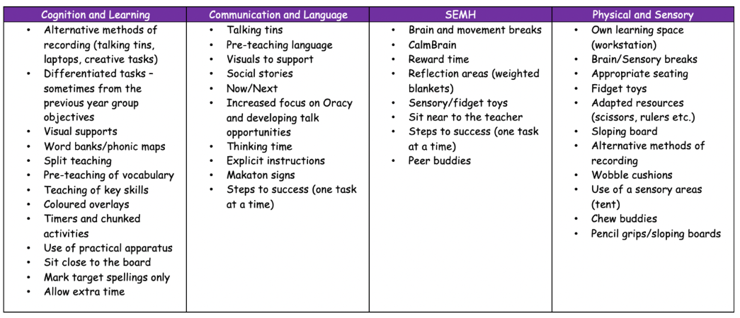
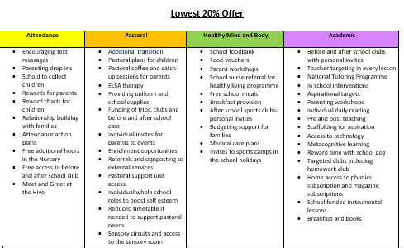
Lowest 20% offer

2026/2027 English Writing and Spelling Overview

Year group | Autumn 1 | Autumn 2 | Spring 1 | Spring 2 | Summer 1 | Summer 2
Rec | UW/P&P  Who am I? Who is in my family? | UW/PC&C  How do we celebrate?  Where is my school? | UW/PC&C  What happens in Winter? What is it like where I live? | UW/P&P – Who is our King? UW/PC&C -  What is it like in London? | UW/PC&C Who helps in our community? UW/P&P How have emergency vehicles changed? | UW/P&P What were seaside holidays like in the past? How have I changed?
Rec | 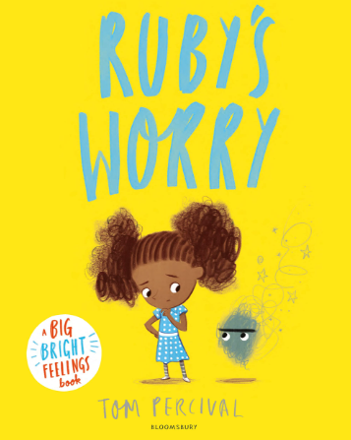  Tom Percival – Ruby’s Worry  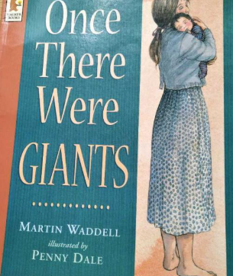 Martin Waddell - Once there were giants  +Space Week – Tim Peake (significant individ  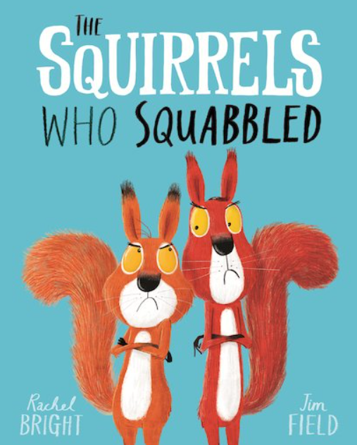 Rachel Bright – The Squirrels Who Squabbled  Black History Month  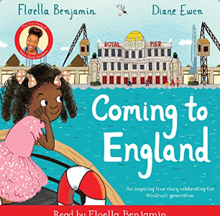  Floella Benjamin – Coming to England | 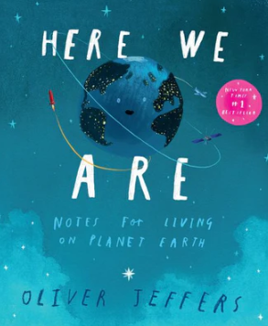  Oliver Jeffers – Here We Are  Nursery Rhyme Week (10-14 Nov):  -Sing a Song of Sixpence  -Humpty Dumpty  -When I was One  -I Hear Thunder  -Two Little Dickie Birds  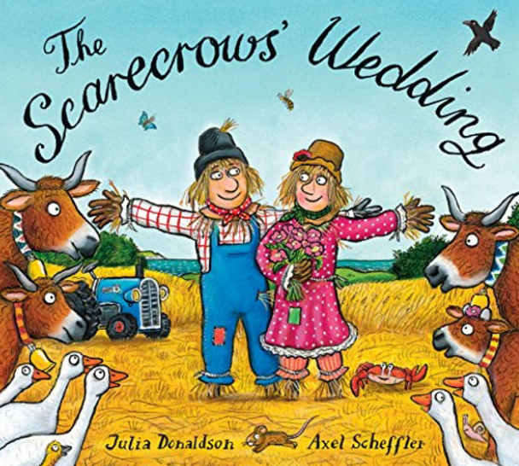  Julia Donaldson – The Scarecrows Wedding  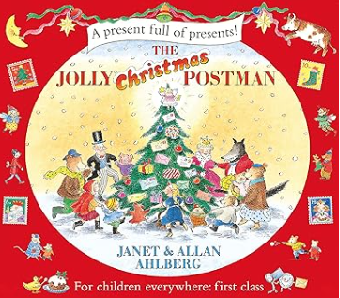  Allan & Janet Ahlberg – The Jolly Christmas Postman | 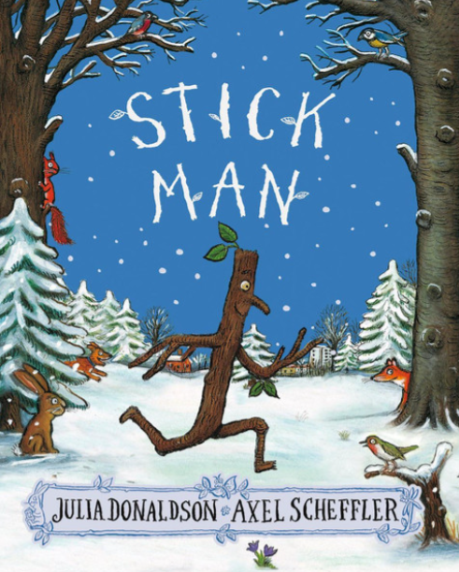  Julia Donaldson – Stick Man  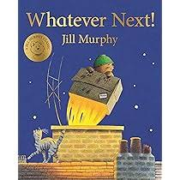  Jill Murphy – Whatever next!  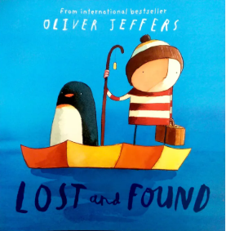  Oliver Jeffers – Lost and Found | 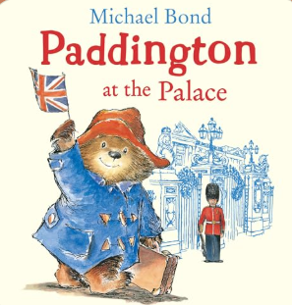  Michael Bond – Paddington at the Palace  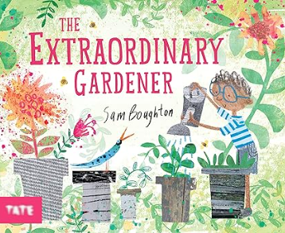  Sam Boughton – The Extraordinary Gardener  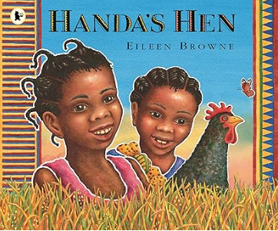  Eileen Browne – Handa’s Hen | Eileen Browne – Handa’s Hen  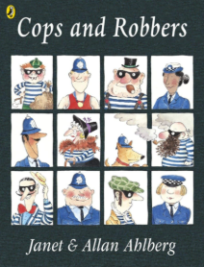  Allan & Janet Ahlberg – Cops and Robbers  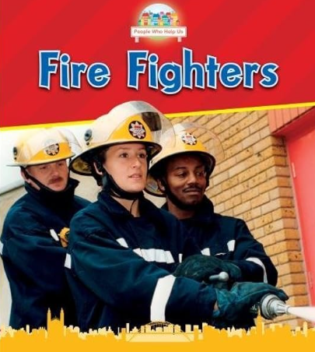  Non-fiction – Fire Fighters / Police Officers | 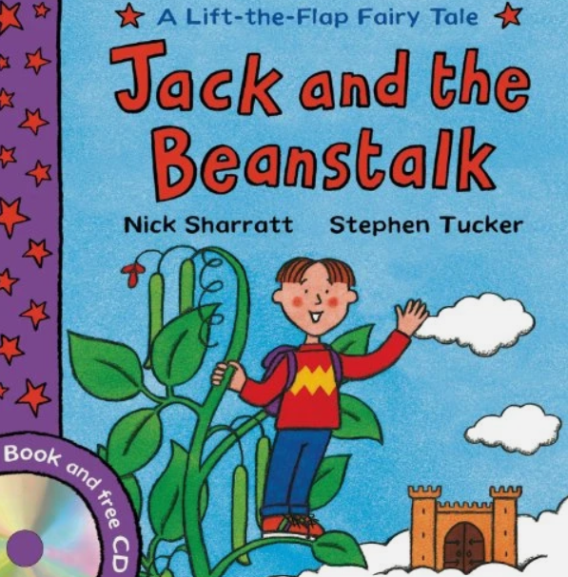  Nick Sharratt - Jack and the Beanstalk  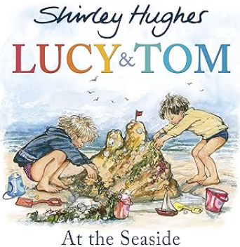  Shirley Hughes - Lucy and Tom at the seaside  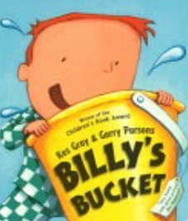  Kes Gray – Billy’s Bucket
1 | History  What was it like here?  What were toys like in the past? | Geography  What is it like here? | History  What is a monarch? | Geography  What is the weather like in the UK? | History  Who are they and where did they go? | Geography  What is it like to live in Shanghai?
1 | 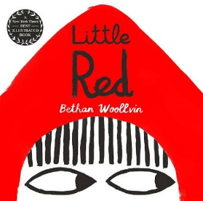  Bethan Woolvin – Little Red  Rehearsal of basic skills (Capital letters, full stops, finger spaces)  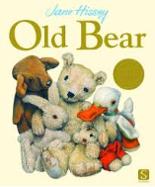  Jane Hissey – Old Bear  Rehearsal of basic skills (Capital letters, full stops, finger spaces)  Captions  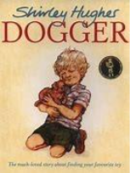  Shirley Hughes – Dogger  - Simple sentences based on character (Dogger) | 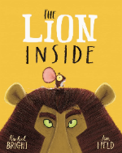  Rachel Bright – The Lion Inside  Simple retell (Lion inside)  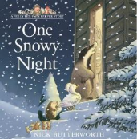  Nick Butterworth – One Snowy Night Simple sentences – setting (One Snowy Night)  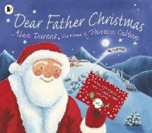  Alan Durant – Dear Father Christmas  Letter to Santa – simple sentences to Santa | 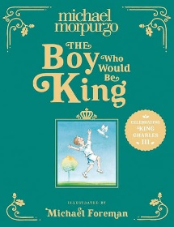  Michael Morpurgo – The Boy who would be King  Fact file about the King – simple sentences using ‘and’ about the King  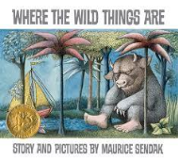  Maurice Bendak– Where the Wild Things are  Character description (wild thing) | 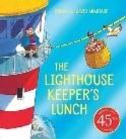  Ronda and David Hermitage – The Lighthouse Keeper’s Lunch  Setting descriptions – seaside setting  Instructions – How to make a sandwich.  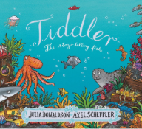  Julia Donaldson – Tiddler  Narrative writing - retell of the story.  . | 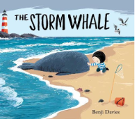  Benji Davies – The Storm Whale  Fact file about a whale (simple sentences).  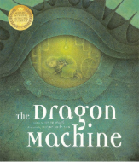  Helen Ward - The Dragon Machine  Narrative writing - adventure story inside the dragon machine. | 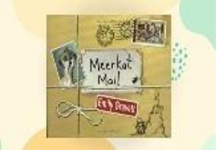  Emily Gravett – Meerkat Mail  Postcards  Letter writing – return response to one of the letters  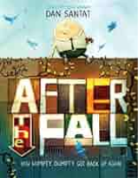  Dan Santat – After The Fall  Twisted tale retell
1 | Punctuation and Grammar
1 | Rehearsal of basic skills from reception  - Capital letters  - Full stops  - Finger spaces  - Application of phonic knowledge | Continued focus on basic skills from Reception  - Capital letters  - Full stops  - Finger spaces  - Application of phonic knowledge  - Begin sequencing sentences to form short texts  National Poetry Week unit – rhyming poems | Fact file  - Headings and subheadings  - Bullet points  - Technical vocabulary  - Pictures and captions  - Coordinating conjunctions (and, but)  - Expanded noun phrases  - Capital letters for proper nouns  - Commas for lists  Character description  - Introduction  - Third person  - Rhetorical question  - Expanded noun phrases  - Coordinating conjunctions  - Capital letters for proper nouns  - Exclamation marks  - Commas for lists | Setting description  - Introduction  - Conclusion  - Third person  - Expanded noun phrases  - Coordinating conjunctions  - Prepositions/adverbials of place  - Capital letters for proper nouns  - Exclamation marks  - Commas for lists  Instructions  - Title statement  - List of equipment or materials  - Sequence, chronological steps  - Diagrams or illustrations  - Present tense  - Commands  - Co-ordinating conjunctions  - Expanded noun phrases  - Adverbs/adverbials of time  - Question marks  Narrative retell  - Third person  - Past tense  - Irregular verbs  - Capital letters for proper nouns  - Adverbs/adverbials of time  - Adverbs/adverbials of place  - Co-ordinating conjunctions (and to join clauses)  - Expanded noun phrases | Fact file  - Headings and subheadings  - Bullet points  - Technical vocabulary  - Pictures and captions  - Coordinating conjunctions (and, but)  - Expanded noun phrases  - Capital letters for proper nouns  - Commas for lists  - Statements and questions  Narrative  - Third person  - Past tense  - Irregular verbs  - Capital letters for proper nouns  - Adverbs/adverbials of time  - Adverbs/adverbials of place  - Co-ordinating conjunctions (and to join clauses)  - Expanded noun phrases  - Exclamation marks and question marks | Postcards/letters  - Features of a letter - address, date, salutation, brief introduction, sign off  - Chronological order  - First person  - Past tense  - Coordinating conjunctions  - Expanded noun phrases  - Commas in a list  - Exclamation marks and question marks  - Capital letter for personal pronoun, I.  - Adverbs/ adverbials of time  - Adverbs/ adverbials of place  Narrative  - Third person  - Past tense  - Irregular verbs  - Capital letters for proper nouns  - Adverbs/adverbials of time  - Adverbs/adverbials of place  - Co-ordinating conjunctions (and to join clauses)  - Expanded noun phrases  - Exclamation marks and question marks
2 | Geography  Why is our natural world wonderful? | History  What happened in London in September 1666? | History  How have explorers changed the world? | Geography  Would you prefer to live in a hot or cold place? | History  Why were the lives of Florence Nightingale and Mary Seacole significant? | Geography  What is it like to live at the coast?
2 | 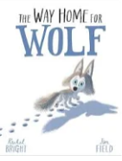  Rachel Bright – The Way Home for Wolf  Diary entry as Wilf when he realises that he is alone.  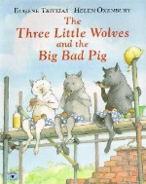  Helen Oxenbury - The Three Little Wolves and the Big Bad Pig  Narrative retell. | 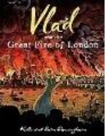  Kate Cunningham – Vlad and the Great Fire of London  Non-chronological report (The Great Fire of London)  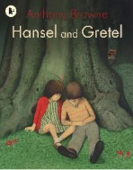  Anthony Browne – Hansel and Gretel  Twisted tale/alternative ending  National Poetry Week unit – list poems |   Simon Bartram – Man on the Moon  Character description (Man on the Moon)  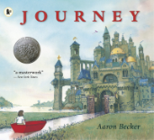  Aaron Becker - Journey  Setting description portal writing – describe a new setting from going through the portal | 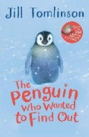  Jill Tomlinson – The Penguin Who Wanted to Find Out  Information text – Facts about real penguins.  Informal letter (recount) to Claudius telling him about one of his adventures. | 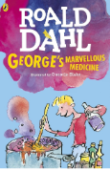  Roald Dahl – George's Marvellous Medicine  Instructional Writing – how to make George’s Marvellous Medicine (also make practical)  Create a new animal reaction story – imagine what happens when a different animal drinks Georges Marvellous Medicine (narrative) | 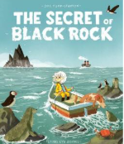  Joe Todd-Stanton – The Secret of Black Rock  Persuasive letter – What Erin might say to convince them not to destroy Black Rock.  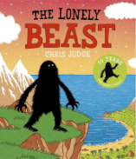.  Chris Judge – The Lonely Beast  Narrative – Create a new adventure for the Beast.
2 | Punctuation and grammar
2 | Diary entry  - Date  - Salutation  - Chronological order  - Past tense  - First person – informal  - Facts and opinions  - Rhetorical questions  - Sign off  - Co-ordinating conjunctions  - Subordinating conjunctions  - Adverbs/adverbials of time  - Adverbs/adverbials of place  - Expanded noun phrases  - Exclamation marks  - Commas for lists  - Apostrophes for omission  - Apostrophes for possession (GDS)  Narrative retell  - Repetitive story path  - Third person  - Past tense  - Pronouns  - Statements, commands and  - exclamation sentences  - Expanded noun phrases  - Adverbials of time  - Adverbials of place  - Adverbials of manner  - Co-ordinating conjunctions  - Subordinating conjunctions  - Exclamation marks  - Commas in a list | Non-chronological report  - Heading and subheadings  - Brief introduction  - Technical vocabulary  - Pictures and captions  - Third person – formal  - Statements giving factual information  - Co-ordinating conjunctions  - Subordinating conjunctions  - Expanded noun phrases  - Present progressive  - Statements  - Questions  - Commands/imperative  - Capital letters for proper nouns  - Commas for lists  - Apostrophes for possession (GDS)  Narrative – twisted tale  - Repetitive story path  - Third person  - Past tense  - Pronouns  - Statements, commands and  exclamation sentences  - Expanded noun phrases  - Adverbials of time  - Adverbials of place  - Adverbials of manner  - Co-ordinating conjunctions  - Sub-ordinating conjunctions  - Exclamation marks  - Commas in a list | Character description  - Introduction  - Third person  - Rhetorical questions  - Expanded noun phrases  - Adverbials of manner including similes  - Adverbials of place  - Commas in a list  - Apostrophes for possession  - Apostrophes for omission  - Capital letters for proper nouns  - Question marks  Setting description  - Introduction  - Paragraphs pan the setting  - Third person  - Rhetorical questions  - Conclusion including a clihanger  - Expanded noun phrases sights, sounds  and smells  - Adverbials of manner including similes  - Adverbials of place  - Commas in a list  - Apostrophes for possession  - Apostrophes for omission  - Capital letters for proper nouns  - Question marks | Information text  - Heading and subheadings  - Brief introduction  - Technical vocabulary  - Pictures and captions  - Third person – formal  - Statements giving factual information  - Co-ordinating conjunctions  - Subordinating conjunctions  - Expanded noun phrases  - Present progressive  - Statements  - Questions  - Commands/imperative  - Capital letters for proper nouns  - Commas for lists  - Apostrophes for possession (GDS)  Letter  - Address  - Date  - Salutation  - Brief introduction  - Chronological order  - First person  - Past tense  - Facts and opinions  - Rhetorical questions  - Sign off  - Co-ordinating conjunctions  - Subordinating conjunctions  - Expanded noun phrases  - Adverbs/adverbials of time  - Adverbs/adverbials of place  - Apostrophes for omission  - Apostrophes for possession (GDS)  - Commas in a list  - Exclamation marks | Instructions  - Title statement  - List of equipment or materials  - Sequence, chronological steps  - Diagrams or illustrations  - Present tense  - Commands  - Detailed information  - Co-ordinating conjunctions  - Subordinating conjunctions  - Expanded noun phrases  - Direct address using ‘you’  - Adverbials of place  - Adverbs/adverbials of time  - Adverbs/adverbials of manner  - Question marks  - Commas for lists  - Apostrophes for possession (GDS)  - Apostrophes for omission  Narrative  - Introduction  - Paragraphs pan the setting  - Third person  - Rhetorical questions  - Conclusion including a clihanger  - Expanded noun phrases sights, sounds  - and smells  - Adverbials of manner including similes  - Adverbials of place  - Commas in a list  - Apostrophes for possession  - Apostrophes for omission  - Capital letters for proper nouns  - Question marks | Persuasive writing  - Deals and bargains  - Direct address (can include flattery)  - Alliteration and assonance  - Facts and statistics  - Opinion (can be expert opinion)  - Repetition  - Rhetorical questions  - Emotive/exaggerated language  - Triples/the rule of three  - Co-ordinating conjunctions  - Subordinating conjunctions  - Expanded noun phrases  - Commands  - Question marks  - Exclamation marks  - Apostrophes for possession (GDS)  Narrative  - Introduction  - Paragraphs pan the setting  - Third person  - Rhetorical questions  - Conclusion including a clihanger  - Expanded noun phrases sights, sounds  - and smells  - Adverbials of manner including similes  - Adverbials of place  - Commas in a list  - Apostrophes for possession  - Apostrophes for omission  - Capital letters for proper nouns  - Question marks
2 | Morphology morphemes, prefixes and suffixes
2 | Baseline assessments GPCs  Vowels and consonants  1Compound words  -s -es  -y | -ed  -ing  un-  re-  -ly | -er  -est  -er/-or  -ly | -less  -ful  Super-/sur-  Under-/over- | -ness  -ed  -ing | -ment  Recap all affixes
3 | History  Would you prefer to live in the Stone Age, Bronze Age or Iron Age? | Geography  Are all the settlements the same? | History  Would you prefer to live in the Stone Age, Bronze Age or Iron Age? | Geography  Why do people live near volcanoes? | History  Why were the Romans so powerful? | Geography  Who lives in Antarctica??
3 | 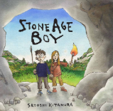  Satoshi Kitamura - Stone Age Boy  Diary entry (1st person)  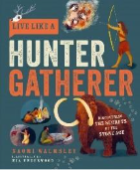  Naomi Walmsley – Live like a Hunter Gatherer  Non-chronological report - How to be a Hunter Gatherer | 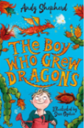  Andy Shepherd – the boy who grew dragons  Instructions – How to grow a dragon  Write a short story as a sequel. Using the three next book titles, children to choose one and write story based on title  National Poetry Week unit – cinquains | 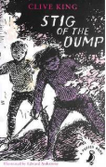  Clive King – Stig of the Dump  Narrative – character description  Biography - Clive King | 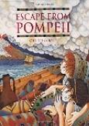  Christina Balit – Escape from Pompeii  Informal letter to family – escaping Pompeii  Persuasive leaflet – ‘come to live near a volcano!’  Informal letter to family – escaping Pompeii | 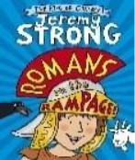  Jeremy Strong – Romans on the Rampage  Historical narrative – write their own short story set in Roman Times.  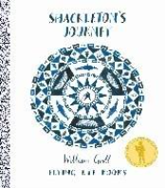#  William Grill – Shackleton’s journey  Job advert – persuasive writing – looking for a new explorer to join the team. | William Grill – Shackleton’s journey  Narrative writing – adventure/ mystery story during an artic exploration.  Write own story – application of skills.
3 | Punctuation and grammar
3 | Diary entry  - Address  - Date  - Brief introduction  - Chronological order  - First person  - Past tense  - Facts and opinions  - Rhetorical questions  - Sign off  - Co-ordinating conjunctions  - Subordinating conjunctions  - Expanded noun phrases  - Adverbs/adverbials of time  - Adverbs/adverbials of place  - Exclamation marks  - Apostrophes for omission  - Apostrophes for plural possession  Non Chronological report  - Heading  - Brief introduction  - Subheadings  - Technical vocabulary  - Pictures and captions  - Third person – formal  - Statements giving factual information  - Co-ordinating conjunctions  - Subordinating conjunctions  - Expanded noun phrases  - Present perfect tense  - Commas for lists  - Apostrophes for possession | Instructions  - Title statement  - List of equipment or materials  - Sequenced, chronological steps  - Diagrams or illustrations  - Present tense  - Imperative verbs (commands)  - Detailed information  - Co-ordinating conjunctions  - Subordinating conjunctions  - Expanded noun phrases  - Commands, using the imperative  - Statements using the pronoun ‘you’  - Adverbs of manner  - Adverbs of time  - Commas for lists  - Apostrophes for possession  - Apostrophes for omission  Narrative  - Third person  - Past tense  - Co-ordinating conjunctions  - Subordinating conjunctions  - Adverbials of time  - Adverbials of place  - Adverbials of manner  - Apostrophes for possession | Character description  - Introduction  - Figurative language  - Short sentences for effect  - Rhetorical questions  - Expanded noun phrases  - Adverbials of manner including similes  - Participial phrases (-ing and -ed openers  - Adverbials of place  - Commas in a list  - Apostrophes for possession  - Apostrophes for omission  Biography  - Heading  - Brief introduction  - Subheadings  - Chronological order  - Technical vocabulary  - Pictures and captions  - Third person – formal  - Statements giving factual information  - Co-ordinating conjunctions  - Subordinating conjunctions  - Expanded noun phrases  - Perfect tense  - Adverbs/adverbials of time  - Commas for lists  - Apostrophes for possession | Informal letter  - Address  - Date  - Salutation  - Brief introduction  - Chronological order  - First person  - Past tense  - Facts and opinions  - Rhetorical questions  - Sign off  - Co-ordinating conjunctions  - Subordinating conjunctions  - Expanded noun phrases  - Adverbs/adverbials of time  - Adverbs/adverbials of place  - Exclamation marks  - Apostrophes for omission  - Apostrophes for plural possession  Persuasive leaflet  - Deals and bargains  - Direct address (can include flattery)  - Alliteration and assonance  - Facts and statistics  - Opinion (can be expert opinion)  - Repetition  - Rhetorical questions  - Emotive/exaggerated language  - Triples/the rule of three  - Adverbs  - Personal pronouns  - Expanded noun phrases  - Co-ordinating conjunctions  - Subordinating conjunctions  - Commands  - Commas for lists  - Apostrophes for possession | Narrative  - Third person  - Past tense  - Co-ordinating conjunctions  - Subordinating conjunctions  - Adverbials of time  - Adverbials of place  - Adverbials of manner  - Apostrophes for possession  - Inverted commas  - Characterisation of speech  - Colloquial language (non-Standard  - English)  - Discourse markers  Persuasive advert  - Deals and bargains  - Direct address (can include flattery)  - Alliteration and assonance  - Facts and statistics  - Opinion (can be expert opinion)  - Repetition  - Rhetorical questions  - Emotive/exaggerated language  - Triples/the rule of three  - Adverbs  - Personal pronouns  - Expanded noun phrases  - Co-ordinating conjunctions  - Subordinating conjunctions  - Commands  - Commas for lists  - Apostrophes for possession (GDS) | Narrative  - Third person  - Past tense  - Co-ordinating conjunctions  - Subordinating conjunctions  - Adverbials of time  - Adverbials of place  - Adverbials of manner  - Apostrophes for possession  - Inverted commas  - Characterisation of speech  - Colloquial language (non-Standard  - English)  - Discourse markers
3 | Morphology morphemes, prefixes and suffixes
3 | Baseline assessments GPCs  Vowels and consonants  Compound words  -s -es  -y  re-  -ly | -ful  -ly  un- | -ness  -ed  -ing  -ment | -ed  -ing  -er/-or | -ful  -less  -y | Super-/sur-  Under-/over-
3 | -ous  -ion  -an | Scribe/script  pre-  vise | inter-  ject  struct  spect | port  de-  trans-  tele | dis-/dif-/di-  mis-  in-/im/-il/-ir  -ure | ex-/e-  anti-/ant  mult(i)  vent/vene
4 | History  What was life like for the Anglo-Saxons? | Geography  What are rivers and how are they used? | History  How did life change when the Vikings arrived? | Geography  Where does our food come from? | Geography  Why are rainforests important to us? | History  What were the significant achievements of the Ancient Egyptians?
4 | 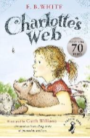  E.B White – Charlotte's Web  Narrative – recount from a different viewpoint  Persuasive letter – stopping the pig going to slaughter | 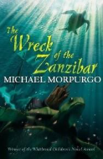  Michael Morpurgo – The Wreck of the Zanzibar  setting description - the wreckage  Non-chronological report – rivers  National Poetry Week unit – haikus | 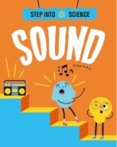  Peter Riley – Step into Science – Sound  Explanation text – How do bats find their way in the dark?  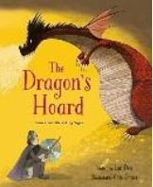  Lari Don – The Dragon’s Hoard  Narrative – alternative ending | 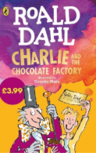  Roald Dahl – Charlie and the Chocolate Factory  Instructional writing – design new chocolate bar.  Write a prequel to the story – How did Willy Wonker become Willy Wonker? | 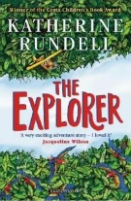  Katherine Rundell – The Explorer  Persuasive leaflet – visit the rainforest  Write an epilogue 12 years later: Have they kept in touch with the explorer? Have they told anyone about the ancient City? What happened after they arrived home? | 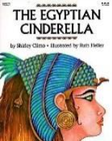  Shirley Climo - The Egyptian Cinderella  Playscripts (Egyptian Cinderella)  Narratives – Historical/ adventure story set in Ancient Egypt.  Write own story – application of skills.
4 | Punctuation and grammar
4 | Narrative  - Introduction  - Figurative language  - Short sentences for effect  - Rhetorical questions  - Conclusion including a cliff hanger  - Expanded noun phrases sights, sounds and smells  - Adverbials of manner including similes  - Participial phrases (-ing and -ed  openers)  - Adverbials of place  - Commas in a list  - Apostrophes for possession  - Commas for fronted adverbials  - Ellipses  Persuasive letter  - Address  - Date  - Salutation  - Brief introduction  - First person  - Past tense  - Facts and opinions  - Rhetorical questions  - Relevant persuasive techniques  - Sign off  - Co-ordinating conjunctions  - Subordinating conjunctions  - Expanded noun phrases  - Adverbs/adverbials of time  - Adverbs/adverbials of place  - Commas for fronted adverbials  - Apostrophes for omission  - Apostrophes for plural possession | Setting description  - Introduction  - Paragraphs pan the setting  - Figurative language  - Short sentences for effect  - Rhetorical questions  - Conclusion including a cliff hanger  - Expanded noun phrases sights, sounds  - and smells  - Adverbials of manner including similes  - Participial phrases (-ing and -ed openers)  - Adverbials of place  - Commas in a list  - Apostrophes for possession  - Commas for fronted adverbials  - Ellipses  Non-chronological report  - Heading  - Brief introduction  - Subheadings  - Technical vocabulary  - Pictures and captions  - Third person – formal  - Statements giving factual information  - Co-ordinating conjunctions  - Subordinating conjunctions  - Expanded noun phrases  - Present perfect tense  - Commas for lists  - Apostrophes for possession  - Commas after fronted adverbials | Explanation text  - Title  - Introductory paragraph  - Paragraphs detailing a process  - Facts  - Present tense  - Formal language  - Technical vocabulary  - Co-ordinating conjunctions  - Subordinating conjunctions  - Expanded noun phrases  - Adverbs/adverbials of time  - Adverbs/adverbials of manner  - Commas for fronted adverbials  - Apostrophes for possession  Narrative  - Introduction  - Figurative language  - Short sentences for effect  - Rhetorical questions  - Conclusion including a cliff hanger  - Expanded noun phrases sights, sounds and smells  - Adverbials of manner including similes  - Participial phrases (-ing and -ed openers)  - Adverbials of place  - Commas in a list  - Apostrophes for possession  - Commas for fronted adverbials  - Ellipses  - Inverted commas  - Characterisation of speech  - Colloquial language (non-Standard  - English)  - Discourse markers | Instructions  - Title statement  - List of equipment or materials  - Sequenced, chronological steps  - Diagrams or illustrations  - Present tense  - Imperative verbs (commands)  - Detailed information  - Co-ordinating conjunctions  - Subordinating conjunctions  - Expanded noun phrases  - Commands, using the imperative  - Statements using the pronoun ‘you’  - Adverbs of manner  - Adverbs of time  - Commas in a list  - Commas for fronted adverbials  - Apostrophes for possession  - Apostrophes for omission  Narrative  - Introduction  - Figurative language  - Short sentences for effect  - Rhetorical questions  - Conclusion including a cliff hanger  - Expanded noun phrases sights, sounds and smells  - Adverbials of manner including similes  - Participial phrases (-ing and -ed openers)  - Adverbials of place  - Commas in a list  - Apostrophes for possession  - Commas for fronted adverbials  - Ellipses  - Inverted commas  - Characterisation of speech  - Colloquial language (non-Standard  - English)  - Discourse markers | Persuasive leaflet  - Heading  - Subheadings  - Introduction  - First person  - Past tense  - Facts and opinions  - Rhetorical questions  - Relevant persuasive techniques  - Co-ordinating conjunctions  - Subordinating conjunctions  - Expanded noun phrases  - Adverbs/adverbials of time  - Adverbs/adverbials of place  - Commas for fronted adverbials  - Apostrophes for omission  - Apostrophes for plural possession  Narrative  - Introduction  - Figurative language  - Short sentences for effect  - Rhetorical questions  - Conclusion including a cliff hanger  - Expanded noun phrases sights, sounds and smells  - Adverbials of manner including similes  - Participial phrases (-ing and -ed openers)  - Adverbials of place  - Commas in a list  - Apostrophes for possession  - Commas for fronted adverbials  - Ellipses  - Inverted commas  - Characterisation of speech  - Colloquial language (non-Standard  - English)  - Discourse markers | Playscript  - Introduction  - Each character shows emotions  - Stage directions  - Short sentences for effect  - Colloquial language (non-Standard  - English)  - Discourse markers  - Expanded noun phrases  - Adverbials of manner  - Participial phrases & clauses (-ing and  -ed openers)  - Adverbials of place  - Apostrophes for omission  Narrative  - Introduction  - Each character shows emotions  - Each character performs actions  - Short sentences for effect  - Colloquial language (non-Standard  - English)  - Discourse markers  - Expanded noun phrases  - Adverbials of manner  - Participial phrases & clauses (-ing and -ed openers)  - Adverbials of place  - Apostrophes for omission  - Commas for fronted adverbials  - Inverted commas  - Ellipses to show a pause or incomplete  - thought  - Hyphens to show stutter
4 | Morphology morphemes, prefixes and suffixes
4 | Baseline assessments GPCs  Vowels and consonants  Compound words  tele  port | -s -es  -y | -s -es  -y  -ous  -ly  -ment  -ion | -ness  -ed -ing  -ion  -ful  -ly | -ed -ing  -er/-or  de- | inter-  ject  struct  spect  -ness  tele  tract  port
4 | -ion  -an | -ous  -ic/-al  -able/-ible | -ive  -ty  aud  phone | kilo  gram  mill(i)  cent  en-  em- | per-  sub-  tract  aut(o)  -fy/-fic/-fice | act  rupt  -en  -ise  -hood  -ship
5 | History  What did the Victorians leave for us? | Geography  What is life like in the Alps? | History  How did the Maya Civilisation compare to the Anglo-Saxons? | Geography  Why do oceans matter? | History  What influence did the Ancient Greeks have on the world? | Geography  Would you live in a desert?
5 | 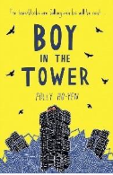  Polly Ho-yen – Boy in the Tower  Informal letter from Ade to Gia.  Newspaper report – Bluchers – building eating plants | Polly Ho-yen – Boy in the Tower  Write own version of story/disaster narrative  Instructions – how to survive the Blutchers take over.  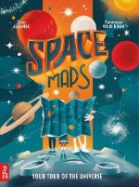  Lara Albanese – Space Maps: Your tour of the Universe  Non-chronological report – planets of the solar system  National Poetry Week unit – Kennings | 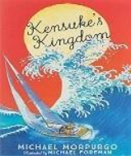  Michael Morpurgo –  Kensuke’s Kingdom  Persuasive argument – Micheal and his family should give up everything and sail around the world?  Alternative ending : Kensukes decides to leave with Michael– narrative writing  Persuasive letter from Michael to Kensuke asking him to change his mind and leave with him. |  | 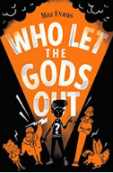  Maz Evans – Who Let the Gods Out?  Greek Myths – use text to read and write own Greek Myth.  Explanation text – The original Olympic Games OR Greek Gods and Godesses. | 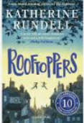  Katherine Rundell – Rooftoppers  Narrative - Written from a different view point  diary entry – Sophie trying to find her mother.  Write own story – application of skills.
5 | Punctuation and Grammar
5 | Informal letter  - Address  - Date  - Salutation  - Brief introduction  - Chronological order  - First person  - Past tense  - Facts and opinions  - Rhetorical questions  - Sign off  - Subordinating conjunctions  - Conjunctive adverbs  - Relative clauses  - Expanded noun phrases  - Adverbs/adverbials of time  - Adverbs/adverbials of place  - Parentheses  - Apostrophes for plural possession  Newspaper report  - Heading  - Brief introduction  - Subheadings  - Technical vocabulary  - Pictures and captions  - Third person – formal  - Statements giving factual information  - Facts and statistics  - Opinion (can be expert opinion)  - Repetition  - Rhetorical questions  - Emotive/exaggerated language  - Triples/the rule of three  - Modal verbs  - Adverbs for possibility/degree  - Subordinating conjunctions  - Relative clauses  - Conjunctive adverbs  - Commas for lists  - Apostrophes for possession  - Parentheses | Narrative  - Introduction  - Each character shows emotions  - Each character performs actions  - The audience reacts to each character  - Short sentences for effect  - Colloquial language (non-Standard  - English)  - Discourse markers  - Expanded noun phrases  - Adverbials of manner  - Participial phrases & clauses (-ing and  -ed openers)  - Relative clauses  - Adverbials of place  - Inverted commas  - Parentheses  - Ellipses to show stammer, pause or  - incomplete thought  - Hyphens to show stutter  Instructions  - Title statement  - List of equipment or materials  - Sequence, chronological steps  - Diagrams or illustrations  - Present tense  - Imperative verbs (commands)  - Detailed information  - Co-ordinating conjunctions  - Subordinating conjunctions  - Expanded noun phrases  - Commands, using the imperative  - Adverbs of manner  - Adverbs of time  - Commas in a list  - Parentheses  - Apostrophes for possession  - Commas  Non-chronological report  - Heading  - Brief introduction  - Subheadings  - Technical vocabulary  - Pictures and captions  - Third person – formal  - Statements giving factual information  - Subordinating conjunctions  - Relative clauses  - Conjunctive adverbs  - Commas for lists  - Apostrophes for possession  - Parentheses | Persuasive argument  - Title – question  - Conclusion  - Present tense  - First person  - Detailed information  - Technical vocabulary  - Alliteration and assonance  - Facts and statistics  - Opinion (can be expert opinion)  - Repetition  - Rhetorical questions  - Emotive/exaggerated language  - Triples/the rule of three  - Subordinating conjunctions  - Modal verbs  - Expanded noun phrases  - Adverbs/adverbials of manner  - Adverbs/adverbials of time  - Conjunctive adverbs  - Relative clauses  - Commas, brackets and dashes for parentheses  Narrative  - Introduction  - Each character shows emotions  - Each character performs actions  - The audience reacts to each character  - Short sentences for effect  - Colloquial language (non-Standard  - English)  - Discourse markers  - Expanded noun phrases  - Adverbials of manner  - Participial phrases & clauses (-ing and  -ed openers)  - Relative clauses  - Adverbials of place  - Inverted commas  - Parentheses  - Ellipses to show stammer, pause or  - incomplete thought  - Hyphens to show stutter | Persuasive letter  - Address  - Date  - Salutation  - Brief introduction  - Direct address (can include flattery)  - Alliteration and assonance  - Facts and statistics  - Opinion (can be expert opinion)  - Repetition  - Rhetorical questions  - Emotive/exaggerated language  - Triples/the rule of three  - Modal verbs  - Adverbs for possibility/degree  - Personal pronouns  - Expanded noun phrases  - Subordinating conjunctions  - Conjunctive adverbs  - Commands  - Commas for lists  - Hyphens | Narrative Myth  - Introduction  - Each character shows emotions  - Each character performs actions  - The audience reacts to each character  - Short sentences for effect  - Colloquial language (non-Standard  - English)  - Discourse markers  - Expanded noun phrases  - Adverbials of manner  - Participial phrases & clauses (-ing and  -ed openers)  - Relative clauses  - Adverbials of place  - Inverted commas  - Parentheses  - Ellipses to show stammer, pause or  - incomplete thought  - Hyphens to show stutter  Explanation text  - Technical vocabulary  - Pictures and captions  - Third person – formal  - Statements giving factual information  - Subordinating conjunctions  - Relative clauses  - Conjunctive adverbs  - Commas for lists  - Apostrophes for possession  - Parentheses | Narrative  - Introduction  - Each character shows emotions  - Each character performs actions  - The audience reacts to each character  - Short sentences for effect  - Colloquial language (non-Standard  - English)  - Discourse markers  - Expanded noun phrases  - Adverbials of manner  - Participial phrases & clauses (-ing and  -ed openers)  - Relative clauses  - Adverbials of place  - Inverted commas  - Parentheses  - Ellipses to show stammer, pause or  - incomplete thought  - Hyphens to show stutter  Diary entry  - Date  - Salutation  - Chronological order  - Past tense  - First person  - Facts and opinions  - Rhetorical questions  - Sign off  - Subordinating conjunctions  - Conjunctive adverbs  - Relative clauses  - Adverbs/adverbials of time  - Adverbs/adverbials of  - place/preposition phrases  - Expanded noun phrases  - Commas for parentheses
5 | Morphology morphemes, prefixes and suffixes
5 | Baseline assessments GPCs  Vowels and consonants  Compound words  -ed -ing  -ness | -s -es  -y  -ous | dis-/dif-/di-  in-/im-/il-/ir-  -able/-ible | -ful, -ly, -er, -or, -al, -ise, -fy/-fic/-fice  -ive/-ty  -ous | inter-  ject | en-/ em-  -hood  -ship
5 | -ate  fact/fect/face/fice | Semi, une, bi, tri, quadr/quart, pent/penta/quint, hexa, hept/hepta/sept/septem, oct/octa, none/nona/novem, dece/deca/decem | -ant  -ance  -ent  -ence  -ably/-ibly | cess/ceed/cede/cease  ab-/a-  ad-/a-  -tude  vert/verse | pro-  form  duct/duce  temp/tempere/tempore  therm | -dom  -ary/-ery
6 | History  What was the impact of World War 2 on the people of Britain? |  | Geography  Why does population change? | Geography  Where does our energy come from? | History  What was life like in the Kingdom of Benin? | Geography  Can I carry out an independent fieldwork inquiry?
6 | 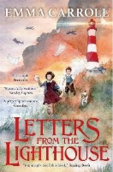  Emma Carroll – Letters from the Lighthouse  Persuasive letter writing – evacuee to new home.  Narrative piece describing a street after a bomb attack during the blitz | Narrative – Adventure story/Historical story  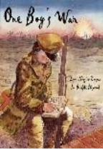  Lynn Huggins-Cooper – One Boy’s War  Non-chronological report – WWII  National Poetry Week unit – free verse | 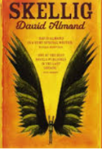  David Almond - Skellig  Narrative – write next chapter/new ending  Diary entry | David Almond – Skellig  Narrative – dialogue focus – characterisation and advancing the action (Francis Literacy Shed video)  Biography – Either David Almond or children choose own celebrity/significant individual | 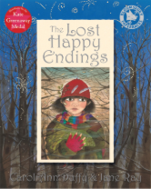  Carol Ann Duffy - The Lost Happy Endings  Twisted fairytales  Literacy Shed Video – Little pigs frame the Pig  Persuasive letter – post SATs visit  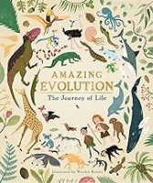  Anna Claybourne – Amazing Evolution  - Explanation text – How have plants adapted to survive in the desert? (completed in science) | 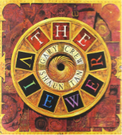  Gary Crew – The Viewer  Plan and write a sequel to The Viewer  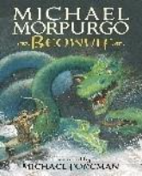  Michael Morpurgo – Beowulf  Narrative poetry – The Raven – Edgar Allen Poe  Suspense narrative
6 | Punctuation and grammar
6 | Persuasive letter  - Address  - Date  - Salutation  - Brief introduction  - Direct address (can include flattery)  - Alliteration and assonance  - Facts and statistics  - Opinion (can be expert opinion)  - Repetition  - Rhetorical questions  - Emotive/exaggerated language  - Triples/the rule of three  - Modal verbs  - Active voice  - Adverbs for possibility/degree  - Personal pronouns  - Expanded noun phrases  - Subordinating conjunctions  - Conjunctive adverbs  - Commands  - Semi-colons  - Colons  Narrative  - Introduction  - Paragraphs pan the setting  - Figurative language  - Short sentences for effect  - Rhetorical questions  - Conclusion including a cliff hanger  - Expanded noun phrases sights, sounds  and smells  - Adverbials of manner including similes  - Participial phrases (-ing and -ed  openers)  - Characterising speech  (emotion, action, thought)  - Relative clauses  - Adverbials of place  - Apostrophes for possession  - Semi-colons  - Colons | Narrative  - Consequence story path  - Past tense  - Characterising speech  (emotion, action, thought)  - Colloquial language  - Idioms  - Contractions  - Rhetorical questions  - Adverbials of time  - Adverbials of place  - Adverbials of manner  - Relative clauses  - Ellipses to show pause  - Semi-colons  - Colons  Non-chronological report  - Heading  - Brief introduction  - Subheadings  - Technical vocabulary  - Pictures and captions  - Third person – formal  - Statements giving factual information  - Passive voice  - Subordinating conjunctions  - Relative clauses  - Subjunctive form  - Conjunctive adverbs  - Semi-colons  - Colons  - Apostrophes for possession  - Parentheses | Narrative  - Past tense  - Characterising speech  (emotion, action, thought)  - Colloquial language  - Idioms  - Contractions  - Rhetorical questions  - Adverbials of time  - Adverbials of place  - Adverbials of manner  - Relative clauses  - Ellipses to show pause  - Semi-colons  Diary entry  - Dates  - Salutation  - Chronological order  - Past tense  - First person  - Facts and opinions  - Rhetorical questions  - Sign off  - Active voice  - Subjunctive mood  - Subordinating conjunctions  - Conjunctive adverbs  - Relative clauses  - Adverbs/adverbials of time  - Adverbs/adverbials of  - place/preposition phrases  - Expanded noun phrases  - Semi-colons | Narrative  - Introduction  - Each character shows emotions  - Each character performs actions  - The audience reacts to each character  - Short sentences for effect  - Colloquial language (non-Standard  - English)  - Discourse markers  - Expanded noun phrases  - Adverbials of manner  - Participial phrases & clauses (-ing and  -ed openers)  - Relative clauses  - Adverbials of place  - Inverted commas  - Colons  - Semi-colons  - Parentheses  - Ellipses to show stammer, pause or  incomplete thought  - Dashes to show change of thought or  interruption  - Hyphens to show stutter  Biography  - Heading  - Brief introduction  - Subheadings  - Technical vocabulary  - Pictures and captions  - Third person – formal  - Statements giving factual information  - Passive voice  - Subordinating conjunctions  - Relative clauses  - Subjunctive form  - Conjunctive adverbs  - Semi-colons  - Colons  - Apostrophes for possession  - Parentheses | Narrative (recap)  - Introduction  - Each character shows emotions  - Each character performs actions  - The audience reacts to each character  - Short sentences for effect  - Colloquial language (non-Standard  - English)  - Discourse markers  - Expanded noun phrases  - Adverbials of manner  - Participial phrases & clauses (-ing and  -ed openers)  - Relative clauses  - Adverbials of place  - Inverted commas  - Colons  - Semi-colons  - Parentheses  - Ellipses to show stammer, pause or  incomplete thought  - Dashes to show change of thought or  interruption  - Hyphens to show stutter  Persuasive letter  - Headings  - Subheadings  - Deals and bargains  - Direct address (can include flattery)  - Alliteration and assonance  - Facts and statistics  - Opinion (can be expert opinion)  - Repetition  - Rhetorical questions  - Emotive/exaggerated language  - Triples/the rule of three  - Modal verbs  - Active voice  - Adverbs for possibility/degree  - Personal pronouns  - Expanded noun phrases  - Subordinating conjunctions  - Conjunctive adverbs  - Commands  - Semi-colons  - Colons  Explanation text (science)  - Technical vocabulary  - Pictures and captions  - Third person – formal  - Statements giving factual information  - Subordinating conjunctions  - Relative clauses  - Conjunctive adverbs  - Commas for lists  - Apostrophes for possession  - Parentheses  - Passive voice  - Subjunctive form | Narrative (recap)  - Introduction  - Each character shows emotions  - Each character performs actions  - The audience reacts to each character  - Short sentences for effect  - Colloquial language (non-Standard  - English)  - Discourse markers  - Expanded noun phrases  - Adverbials of manner  - Participial phrases & clauses (-ing and  -ed openers)  - Relative clauses  - Adverbials of place  - Inverted commas  - Colons  - Semi-colons  - Parentheses  - Ellipses to show stammer, pause or  incomplete thought  - Dashes to show change of thought or  interruption  - Hyphens to show stutter  Narrative poetry  - Similes  - Metaphors  - Personification  - Onomatopoeia  - Alliteration  - Hyperbole  - idioms
6 | Morphology morphemes, prefixes and suffixes
6 | Baseline assessments GPCs  Vowels and consonants  Compound words  -s/-es  -y  -ic  -al  -an | -ness,  -ed, -ing  trans-, port  -ant/-ent, -ance/-ence  -less, -ful, -ly | -ed, -ing, -ly  -er, – or  trans-  -ate  Fact/fect/face/fice | inter-, ject, struct, spect  -ary/-ery | -ing, -ion, dis-/dif-/di-  -ise  -fy/-fic/-fice | Recap previously taught morphemes as needed.
6 | -ism  -ist | -ish  -esque  fer  -age  ceive/cept | Com-/con-/co-/cor-/col- | post  fore  fract/frag/frage | magn

Spelling Progression – taken from the National Curriculum Statements

 | Year 1 | Year 2 | LKS2 | UKS2
Transcription: Spelling (Phonic and whole word) | Spell words containing each of the 40+ phonemes taught  Spell common exception words  Spell the days of the week  Name the letters of the alphabet in order  Use letter names to distinguish between alternative spellings of the same sound  Spell words with simple phoneme/grapheme correspondence accurately e.g. cat, dog, red  Make phonetically plausible attempts at writing longer words using dominant phonemes and common grapheme representations | Segment spoken words into phonemes and represent these by graphemes, spelling many correctly  Learn new ways of spelling phonemes for which 1 or more spellings are already known  Learn to spell common exception words  Distinguish between homophones and near- homophones | Spell further homophones  Spell words that are often misspelt  Use knowledge of morphology and etymology in spelling and understand that the spelling of some words needs to be learnt specifically | Spell some words with ‘silent’ letters  Use knowledge of morphology and etymology in spelling and understand that the spelling of some words needs to be learnt specifically

 | Year 1 | Year 2 | LKS2 | UKS2
Transcription: Spelling (Other word building) | Use the spelling rule for adding –s or –es as the plural marker for nouns and the third person singular marker for verbs  Use the prefix un–  Use –ing, –ed, –er and –est where no change is needed in the spelling of root words | Learning the possessive apostrophe (singular)  Learn to spell more words with contracted forms  Add suffixes to spell longer words, including –ment, –ness, –ful, – less, –ly  Show awareness of silent letters in spelling e.g. knight, write  Use –le ending as the most common spelling for this sound at the end of words | Use further prefixes and suffixes and understand how to add them  Place the possessive apostrophe accurately in words with regular plurals and in words with irregular plurals  Use the first 2 or 3 letters of a word to check its spelling in a dictionary | Use dictionaries to check the spelling and meaning of words

Writing Composition progression – taken from the National Curriculum Statements
Composition Progression – taken from the National Curriculum Statements

 | Year 1 | Year 2 |  |  | LKS2 | UKS2
Composition: Planning | Compose a sentence orally before writing. | Plan what they are going to write about, including writing down ideas and/or key words and new vocabulary eg: mind-maps. |  |  | Use ideas from their own reading and modelled examples to plan their writing.  Discuss and record ideas about writing similar to which they are planning | Plan their writing by identifying the audience for and purpose of the writing, selecting the appropriate form and using other similar writing as models for their own.  Note down and develop initial ideas, drawing on reading and research where necessary.
 | Year 1 |  | Year 2 | LKS2 |  |  | UKS2
Composition: drafting and writing | Encapsulate what they want to say sentence by sentence. |  | Say a sentence out loud before writing it – oral rehearsal.  Sequence sentences to form short narratives. | Compose and rehearse sentences orally (including dialogue) progressively building a varied and rich vocabulary and increasing range of sentence structures  Organise paragraphs around a theme (e.g. beginning, middle and end) |  |  | Select appropriate grammar and vocab to change and enhance meaning  Use a wide range of devices to build cohesion within and across paragraphs.  Use appropriate organisational and presentational devices (e.g. headings, bullet points, underlining).
 | Year 1 |  | Year 2 | LKS2 |  |  | UKS2
Composition: editing and evaluating | Read their writing to check that it makes sense to themselves and to an adult.  Discuss what they have written with the teacher or other pupils.  Begin to independently make a change to their writing so that they make their writing better. |  | Make simple additions, revisions and corrections to their own writing by evaluating their writing with the teacher and other pupils.  Read to check that their writing makes sense and that the correct tense is used throughout with the help of an adult where necessary.  Check for errors in spelling, grammar and punctuation with the help of an adult where necessary. | Assess the effectiveness of their own and others’ writing and suggesting improvements  Propose changes to vocabulary to improve consistency including accurate use of pronouns.  Proofread for spelling and punctuation errors |  |  | Recognise how words are related by meaning as synonyms and antonyms and to use this knowledge to make improvements to their writing  Make changes to vocabulary, grammar and punctuation to enhance effects and clarify meaning.
The following progression should be used to inform sentence crafting

 |  | Year 1 |  |  | Year 2 |  |  | LKS2 |  |  |  |  | UKS2
Composition: Punctuation and grammar  Text structure |  | Sequencing sentences to form short narratives. |  |  | Correct choice and consistent use of the present tense and past tense throughout writing.  Use of the progressive form of verbs in the present and past tense to mark actions in progress |  |  | Headings and subheadings to aid presentations.  Use of the present perfect form of verbs instead of the simple past. (e.g. He has gone out to play contrasted with He went out to play)  Use paragraphs to organise ideas around a theme.  Appropriate choice of pronoun and noun within and across sentences to aid cohesion and avoid repetition |  |  |  |  | Devices to build cohesion within a paragraph (e.g. then, after that, this, firstly).  Linking ideas across paragraphs using a wider range of cohesive devices: repetition of word or phrase, grammatical connections (e.g. the use of adverbials such as on the other hand, in contrast) and ellipsis.  Layout devices, such as headings, sub headings, columns, bullets, tables, to structure text.
 |  | Year 1 |  | Year 2 |  |  |  |  | LKS2 |  |  | UKS2
Composition: Punctuation and grammar  Sentence structure |  | How words can combine to make sentences. Joining words and joining sentences using ‘and’  Write from memory simple sentences dictated by the teacher. |  | Subordination (using when, if, that, because) and coordination (using or, and, or, but).  Expanded noun phrases for description sand specification (e.g. the blue butterfly).  How the grammatical patterns in a sentence indicate its function as a statement, question, exclamation or command. |  |  |  |  | Expressing the time, place and cause using conjunctions (e.g. when, so, before, after, while, because), adverbs (e.g. then, next, soon, therefore), or prepositions (e.g. before, after, during, in, because) use ‘a’ or ‘an’ correctly throughout a piece of writing.  Use subordinate clauses, extending the range of sentences with more than one clause by using a wider range of conjunctions, including when, if, because, and although.  Noun phrases expanded by the addition of modifying adjectives, nouns and preposition phrases (e.g. the teacher expanded to: the strict maths teacher with curly hair).  Fronted adverbials (e.g. Later that day, I heard bad news). |  |  | Relative clauses beginning with who, which, where, why, whose, that *** an omitted pronoun.  Indicating degrees of possibility using adverbs (e.g perhaps, surely) or modal verbs (e.g. might, should, will, must).  Use the passive voice to affect the presentation of information in a sentence.  Know how words are related by meaning as synonyms and antonyms e.g. big, large, little and use these in their writing.  The difference between structures typical of informal speech and structures appropriate for formal speech and writing (such as the use of question tags, e.g. He’s your friend, isn’t he? Or the use of subjunctive forms such as ‘I were’ or ‘Were they to come ‘ in some very formal writing and speech)
 | Year 1 |  | Year 2 |  |  |  | LKS2 |  |  |  | UKS2
Composition: Punctuation and grammar  Sentence types (see resource document for examples and link to National Curriculum) | Short  Simple sentences  Sound! Cause.  All the W’s |  | 2A sentences  List sentences  BOYs sentences  Similes |  |  |  | Alliteration  Ad, same ad  _ing, _ ed  Double ly ending  Personification  Emotion word, (comma)  Verb, person  If, if, if, then |  |  |  | 3 _ed  Noun, which/where/who  The more, the more  3 bad – (dash) question?  Metaphors  De:de  Some; others  Irony  Outside. (Inside.)  Imagine 3  Figurative language
 | Year 1 |  | Year 2 |  |  |  | LKS2 |  |  |  | UKS2
Composition: Punctuation and grammar  Punctuation | Separation of words with finger spaces.  Use capital letters and full stops to demarcate sentences.  Begin to use question marks and exclamation marks to demarcate sentences.  Capital letters for names and the personal pronoun I, places and days of the week. |  | Use of capital letters, full stops, question marks and exclamation marks to demarcate sentences.  Commas to separate items in a list.  Apostrophes to mark where letters are missing in spelling (omission) and to mark singular possession in nouns. |  |  |  | Use of inverted commas and other punctuation to indicate direct speech.  Apostrophes to mark plural possession.  Use of commas after fronted adverbials.  Punctuation of bullet points to list information. |  |  |  | Brackets, dashes or commas to indicate parenthesis.  Use of commas and hyphens to clarify meaning or avoid ambiguity  Use of semi-colon, colon and dash to mark the boundary between independent clauses.  Use of the colon to introduce a list and use of the semi- colon within lists.
Terminology used
 | Letter, capital letter  Word  Singular  Plural  Sentence  Punctuation mark  Full stop  Question mark  Exclamation mark |  | Noun  Noun phrase  Statement  Question  Exclamation  Command  Compound  Suffix  Adjective  Verb |  |  | Adverb  Tense (past, present)  Apostrophe  Comma  Consonant  Vowel | Preposition  Conjunction  Word family  Prefix  Cause  Subordinate clause  Direct speech  Pronoun |  |  | Possessive pronoun  Adverbial  Bullet points  Inverted commas (or speech marks)  Determiner | Modal verb  Relative pronoun  Relative clause  Parenthesis  Bracket  Dash  Cohesion  Ambiguity |  |  | Subject  Object  Active  Passive  Synonym  Antonym  Ellipsis  Hyphen  Colon  Semi-colon

Examples S Plans KS1

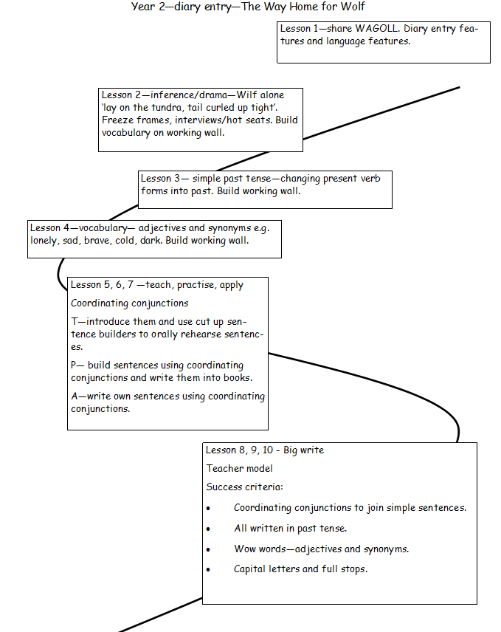

KS2


