What is my child learning in Year 2…


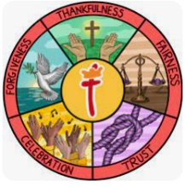  School Values | Our theme this half term is ‘thankfulness’. We will use the story of Joseph as a basis to look at the importance of gratitude and being thankful. We will be discussing what we are thankful for, what we are grateful for and appreciating what we have.
  RE | In RE this half term, we will be exploring Christianity. Our topic is ‘What is the good news Christians believe Jesus brings?’  The children will be learning to;  · Explore the story of Jesus and Matthew the tax collector and understand why Jesus chose him as a disciple.  · Understand that Christians believe the Good News of Jesus includes forgiveness, peace and love.  · Explore how Christians try to follow Jesus’ teachings by forgiving others, showing kindness and welcoming those who may feel excluded.  · Explore how Christians use prayer, including the Lord’s Prayer, to say sorry, ask for forgiveness and find peace.  · Consider how Jesus’ message of forgiveness, peace and love might be good news for everyone.
English    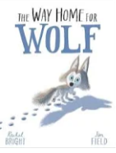  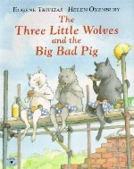 | Focus text  In English, Year 2 will begin by reading ‘The Way Home for Wolf’ by Rachel Bright.  ‘Set in the snowy Arctic, Wilf is a brave wolf cub. He is spirited and independent. When the wolf pack decides to move, Wilf is keen to lead the pack.’  They will then move on to ‘The Three Little Wolves and the Big, Bad Pig’, a funny twisted tale of the classic ‘Three Little Pigs’ that the children will already be familiar with.  In writing, Year 2 will strengthen and build upon grammar learned in Year 1 by learning to join simple sentences together using a range of coordinating conjunctions, recapping writing in the past tense and also learning to use simple expanded noun phrases to describe. Year 2 will be learning to write diary entries and a simple retell of a story.
Phonics  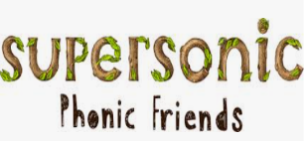  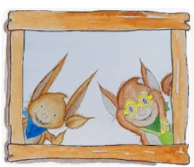 | We will be continuing to have daily phonics lessons using our supersonic phonics scheme and recapping all the Basics 4 and 5 sounds that the children learnt in year 1. We will continue to recap tricky words and build on these to learn the year 2 common exception words. We will slowly come away from phonics as the year goes on and begin learning about morphology and etymology in spelling sessions.
Reading    = | Within reading groups, children in Year 2 will continue to work on their decoding skills, their use of prosody and expression when reading, as well as working on their comprehension by answering questions about what they’ve read and explaining how they know.  As well as reading groups, we will have an additional guided reading session a week wherein we will focus on the following skills:  Vocabulary – Looking at what the word means.  Inference – Use clues in the text to help you.  Predicting – What may happen next?  Retrieval – The answer is somewhere in the text.  Sequencing – Putting events in order  We also have our weekly session in our library where the children will have the chance to enjoy some quiet reading and share some of their favourite stories! The children will have the opportunity to take a library book home on a Friday and change them every week (as long as they bring them back).
Maths   | In maths, Year 2 will be covering the following topics:  - Place value to 100- recognising, partitioning and comparing numbers to 100, we will also look at skip counting in 2s, 5s and 10s.  - Addition and subtraction- finding 10 more and less than any numbers, adding and subtracting up to 100 with some crossing of a tens boundary.
  Science | Our science topic this half term is ‘Animals including Humans’. The children will be learning to;  · Find out about the basic needs of animals and humans for survival, including food, water and air.  · Identify and classify different types of animals, including mammals, birds, fish, amphibians and reptiles.  · Explore the importance of exercise, a healthy diet and good hygiene for humans.  · Investigate how exercise affects heart rate and use observations and data to answer questions.  · Learn about looking after our teeth and the importance of good oral hygiene.
Geography  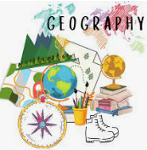 | Our Geography topic this half term is ‘Why is our natural world wonderful?’ The children will be learning to:  - Identify and locate characteristics of the UK on a map.  - Identify human and physical features.  - Locate human and physical features on a world map.  - Explain the difference between oceans and seas.  - Name and locate the five oceans on a world map.  - Use an aerial photograph to draw a simple sketch map.  - Collect data by sketching findings on a map and completing a tally chart.  - Present their findings in a bar chart
  ART | Our art focus for this half term is ‘drawing’. This unit focuses on helping pupils develop their ability to tell a story through drawing. It includes lessons on creating textures, observational drawing, character expression, and storytelling through illustrations, enhancing pupils' mark-making techniques, observational skills, and imagination in art.
Computing   | Our computing topic this half term is ‘Computing Systems and Networks – IT Around Us’. The children will be learning to;  · Understand what information technology (IT) is and identify examples in everyday life.  · Explore how technology is used at home, in school and in places such as shops, hospitals and libraries.  · Identify and describe the main parts of a computer system.  · Explore how IT can help and improve our lives.  · Learn how to use technology safely, responsibly and respectfully.
PE   | Fundamentals  · Explore how their bodies move at different speeds.  · Develop changing direction and dodging skills.  · Improve balance, stability and safe landing.  · Develop jumping, hopping and skipping actions.  · Improve co-ordination and combine different movements.  · Develop jumping and skipping using an individual skipping rope. | Stretch and Smile  · Copy and repeat different stretching and movement poses.  · Develop strength, balance and flexibility through a range of poses.  · Understand how flexibility helps keep our bodies healthy.  · Remember and link movements together to create a flow.  · Create, perform and teach a sequence of movements to a partner.  · Develop confidence, control and focus when performing movements.
 | PE will be on Wednesday and Thursday afternoons this half term for Year 2.
Music   | Our music topic this half term is ‘Call and Response’. The children will be learning to;  · Explore call and response using voices and instruments.  · Copy and create short sound patterns.  · Explore dynamics by making sounds louder and quieter.  · Perform and respond to different rhythms and sound patterns.
PSHE   | Our topic this half term is ‘Being Me in My World’. The Children will be learning about;  - Hopes and fears for the year  - Rights and responsibilities  - Rewards and consequences  - Safe and fair learning environment  - Valuing contributions  - Choices  - Recognising feelings
Key events for the half term | Future dates to be aware of:  - Friday 25th September 2026 – Macmillan coffee morning  - Monday 5th October 2026 – Year 2 SHINE  - Tuesday 6th October 2026 – School photographs  - Thursday 15th October 2026 – Scholastic Book fair in school  - Monday 19th October 2026 – Parents evening  - Tuesday 20th October 2026 – Parents evening  - Thursday 22nd October and Friday 23rd October 2026 – INSET days  - Friday 4th December 2026 – Year 2 coffee morning
Homework | The children are encouraged to play Times Tables Rockstars at home 3 times a week as well as reading 3-5 times a week too. Reading records should be signed by an adult to indicate that their child has read at home. Reading books will be changed weekly as part of the final reading group for that week.  Thank you for your support with completing your child’s homework.

