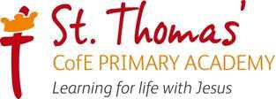

Behaviour Policy

Date policy reviewed: September 2026
Date policy to be reviewed – September 2027

Signed by | Date
Principal:
Trust:

Intent
At St Thomas’ CofE Primary Academy we firmly believe that everyone has the right to feel safe, the right to learn without distraction or disruption and the right to be respected and receive fair treatment. We believe that All children need a well ordered, safe, structures and disciplined environment in which to learn and develop their self-control, respect and appreciation of others. We believe that in order to promote good behaviour, and thus work to the best of their abilities, children need to be offered positive role models who embody Christian Gospel values. They need to be taught how to behave well and appropriately within the context they’re in.
We will endeavour to fully communicate the contents of this policy to all pupils and parents to ensure that the Trust’s and Academy’s expectations are transparent to all pupils, parents and stakeholders. This will help ensure that the expectations of and responses to behaviour are consistent, fair, proportionate and predictable. Staff will do this through classroom routines, clear expectations, class charters, assemblies, PSHE lessons etc.
Our behaviour policy and approach to behaviour is underpinned by our 5 key values that underpin everything we do at Academy.
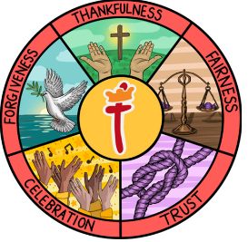
- Thankfulness
- Forgiveness
- Fairness
- Trust
- Celebration
Aims
- To encourage a safe, calm, purposeful and happy atmosphere within Academy. The behaviour policy is a “key system” to support safeguarding.
- To foster positive, caring and respectful attitudes towards everyone, where achievements at all levels are acknowledged and valued.
- To encourage increasing independence and self-discipline so that each child learns to accept responsibility for his/her own behaviour.
- To ensure safety by making boundaries of acceptable/appropriate behaviour clear.
- To create a common sense of direction and feeling of purpose for pupils, staff and parents.
- To identify quickly those children who need additional support and put strategies in place to support them. (This could include a Positive Behaviour Plan)
- To ensure that our children recognise our Academy’s key Christian values as a model for good behaviour.
- To ensure all staff are relational and restorative in their interactions.

Objectives

- Expectations of good behaviour are made clear.

- We encourage all staff and children to embody our Christian Values.

- Children are encouraged to take responsibility for their own actions and behaviour.

- Positive behaviour is recognised and rewarded both publicly and private (stickers, dojo awards, special assembly mentions, praise, class recognition boards).

- A whole Academy restorative approach is used when dealing with inappropriate behaviour.

- Parents are involved in any support programmes.

- Children are encouraged to report examples of positive behaviour.

Roles and Responsibilities

To develop a consistent, positive approach to behaviour, it is important to establish clear responsibilities of children, staff and parents. These are as follows:

Leaders’ responsibilities:
- To be a high visible role model to staff, children and parents embodying the academy’s Christian values in all their interactions.
- To engage with Governors, parents and staff regarding the behaviour within Academy.
- To engage weekly with children regarding the behaviour within Academy. (Celebration Worships and when present around Academy/ visiting classrooms)
- Ensure that all staff receive appropriate induction regarding the behaviour policy and the importance of rigorous modelling, enforcement and behaviour recording (using Arbor).
- Ensure that all staff have the tools and resources to support all children effectively.
- Ensure that all staff receive regular and appropriate training in the management of behaviour.
- To monitor behaviour patterns at Academy level, group level and individual staff and pupil level termly and report to Governors.

Staff responsibilities:

- To offer good role models by embodying the academy’s Christian values in all their interactinteractions.
- To communicate the Academy expectations, routines, and Christian values through explicit te teaching
- To challenge and support pupils who are not meeting behaviour expectations.

- To provide a challenging and relevant curriculum which engages children

- To create a Christian environment that is safe, secure, nurturing and engaging.

- To treat all children fairly and with respect taking into consideration their different needs.
- To identify those children who needs extra support quickly and provide the support require required.

- To follow the policy to implement rules and sanctions clearly and consistently.

- To foster good relationships with parents/carers.
Children’s responsibilities –
- To treat other people how we wish to be treated.
- To think, ‘What would Jesus do?’
- To follow the agreement made between children and their teacher in their class charters.

Classroom Charters
As part of our commitment to being a Rights Respecting School, we design and create our own classroom charters.
After discussing all of the articles, we pick those which were most important to us. Each class then creates their own charter based on the rights of a child and how we, as responsible citizens, can respect those rights. Both staff and children understand their roles in following the charters and have all signed them in agreement.
Our School Charter is an agreement between children and adults in our school. They are shared values and principles based on the CRC. The children chose UNCRC articles which they felt was important to us. We then have agreed actions between all of the children and adults to ensure the rights can be realised and enjoyed by everyone.
Parents’ responsibilities:

- To be aware of the Academy rules and expectations.
- To support staff in the implementation of the policy.
- To foster good relationships with the Academy.
- To make their child aware of appropriate behaviour at all times.
- To show an interest in all that their child does in Academy.
- To encourage independence and self-discipline.
- Monitor and take responsibility for your child’s online behaviour

Academy Systems

Term | Christian Values | Church of England Vision for Education
Autumn 1 | Thankfulness | Educating for community and living well together
Autumn 2 | Fairness | Educating for dignity and respect
Spring 1 | Forgiveness | Educating for wisdom, knowledge and skills
Spring 2 | Forgiveness | Educating for wisdom, knowledge and skills
Summer 1 | Trust | Educating for hope and aspiration
Summer 2 | Celebration | Educating for hope and aspiration
Each half term, the children at St Thomas’ develop their understanding of one of our key Christina values and strive to apply these to their everyday lives.

Class / Academy behaviour management.

It is widely recognised that children have clear and consistent approached to behaviour they are more likely to also behave in a more consistent manner. All classes in our Academy use ‘class dojo’ as a method for rewarding positive behaviour with dojo points. We also operate house points in Academy.

Coming into Academy

How the day starts sets the tone for the rest of the day. At St Thomas’ CofE Academy we firmly believe that all children should receive a warm welcome as they enter Academy. The class teacher will be at the classroom door to welcome them into their class. When that class teacher is unavailable another adult in the class will do this.

For some children an alternative start to the day is required. We offer a ‘meet and greet’ in the HAVEN for children who require additional support to start the day.

Coming in from Breaks and Lunches

As with the start of the day, how children re-enter the Academy has an impact on their next lesson and their readiness to learn. At St Thomas’ C of E Academy we operate the following system.

At the end of the break the whistle is blown – all children stop what they are doing and stand still. On the second blow of the whistle children will walk and enter Academy. (Years 1, 2,5 and6 will enter through tier classroom doors. Year 3 and 4 will enter through the green double doors to walk down to their classrooms). A member of their classroom staff will support them entering Academy to ensure they enter calm, ready to learn and in an orderly manner.

Moving around Academy

All staff and children will walk in the left when moving round the Academy building, children will show respect and hold door for adults when necessary. Adults will too hold doors for children as we operate a Academy of mutual respect.

Encouraging Positive Behaviour

Children’s good behaviour is noticed, encouraged and often rewarded. Strategies include:

● Emphasis on encouraging and motivating pupil e.g. positive feedback, descriptive praise, give attention for success.
- Promoting respect for individuals by:
- including their culture and background
- modelling desired behaviour
- listening to children and communicating that you have heard what they have said.
● Creating safety, both physical and emotional with clear and consistent use of rules and consequences.
● Raising self-esteem by ensuring pupils experience and recognise their own success.

● Maximising opportunities for pupils to take responsibility for themselves in their behaviour by providing choices wherever possible.
- Ensuring that feelings are part of the PSHE curriculum and included in assembly themes.

Incentives/Rewards
Positive behaviour is rewarded in several ways at St Thomas’ C of E Academy.
Examples include:
- Class Dojo points (Class Dojo is a whole Academy, computer-based behaviour system that allows teachers to award positive and negative points. This system also links with parents so they can view behaviours at home.)
- Prizes when a certain number of dojos are achieved
- Class prize when class dojo total reached
- Certificates
- Sending good work to other staff members for reward or praise
- Special responsibilities or jobs
- Class recognition boards
- Star of the week, Values awards and Compliment award.

Above and Beyond Award

The aim of the next level of the reward system is to recognise children who consistently demonstrate exceptional character and go beyond the usual expectations. It is particularly designed to celebrate those children who are often quietly doing the right thing, making positive choices and supporting others, but who may not always receive recognition for this.
Children would not receive stars for simply meeting the usual expectations of school life, such as following instructions, completing normal work or generally behaving well. Stars would be awarded for exceptional moments, achievements or sustained contributions that demonstrate a child going Above & Beyond.

Children could be given a star for demonstrating:
🌟 Exceptional kindness and compassion
For example, consistently including somebody who is lonely or supporting another child who is struggling, without being asked.
🌟 Courage and integrity
For example, making the right choice when it is difficult, unpopular or when nobody is watching.
🌟 Outstanding resilience
For example, continuing to persevere through significant challenges and demonstrating exceptional personal growth.
🌟 Going above and beyond
For example, taking initiative to help others or improve the school community without being asked.
🌟 Exceptional effort and personal growth
For example, showing a significant level of commitment and determination to improve in an area where they have previously struggled.

🌟 Above & Beyond
15 points — Superstar Certificate - From head teacher
30 points — Bronze Superstar – Bronze pin badge
50 points — Silver Superstar – Silver pin badge
75 points — Gold Superstar – Gold pin badge
100 points — Above & Beyond Superstar badge (school colours)
125 points – trophy
150 points – pick and mix treats

Nominations would need to explain what the child did and why it was considered to be genuinely Above & Beyond the usual expectations.

This would help ensure that stars are awarded for specific, meaningful examples rather than simply for being generally well behaved or kind.

How are points be awarded?
Nominations could be made by any member of the school community, including:
Teachers Office staff
Teaching assistants Senior leaders
Lunch time supervisors Other members of the school staff

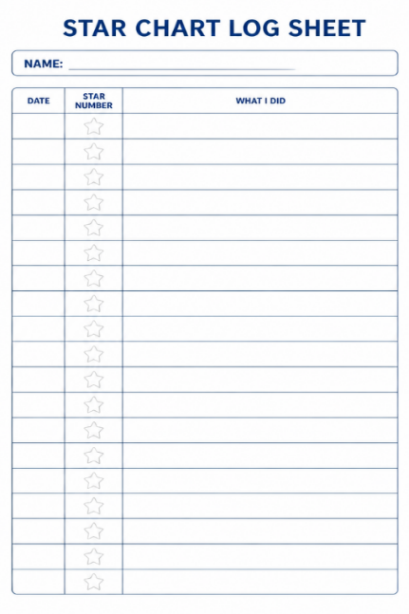
How are the points be recorded?
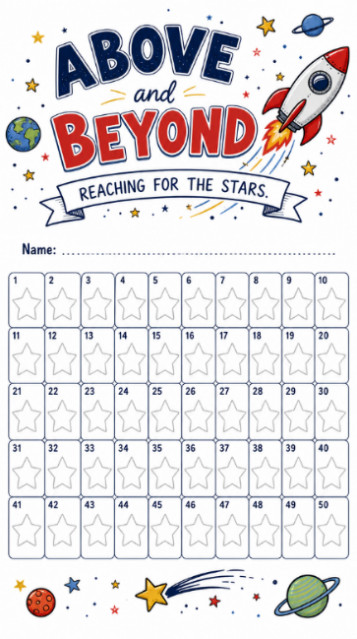
Each class will have a folder that will move up through the school with them. Each child will have an individual chart, and whenever they earn a star, the teacher will add a star sticker to their chart.
There will also be a log sheet recording what the child did to earn each star. Both the chart and the log sheet could then go home with the child at the end of Year 6, providing them with a record of everything they achieved throughout their primary school journey.

Please see Appendix 3 for copies of the record sheets.

Negative Consequences (Sanctions)

It is important to teach children positive behaviours. When children misbehave, staff ask children to stop the behaviour and discuss the incident.

Staff encourage children to try and resolve disputes themselves and take responsibility for their own actions. There is a stepped approach to the agreed system of consequences.

- Verbal warning

- Written warning (name on board)

- Yellow card (teacher to log onto Arbor and complete restorative conversation with child during the next most appropriate moment) A yellow card leads to 5 minutes off next breaktime.

- Red Card (teacher to log onto Arbor and senior leaders to complete restorative conversation with the child). A red card leads to 10 minutes off next breaktime.

- Reflection time with Principal. A phone call home will be made by the class teacher to discuss the reflection and how we can support behaviour moving forward.)

All children who receive a yellow or red card will either have a dojo sent home on the same day or where possible the parents/ carers will be spoken to at the end of the day when the class teacher dismisses the children.

Sanctions are only to be issued by paid members of Academy staff and not by adult Academy volunteers or students. Lunchtime supervisors follow the same behaviour policy as the rest of the Academy.

All staff will ensure that mitigating circumstances are considered before issuing a sanction. Mitigating circumstances may but not exclusively include:
bereavement, abuse, neglect, mental health need, subjected to bullying, SEND, criminal exploitation, significant challenges at home.

Examples of behaviour which results in a warning/ yellow card | Examples of serious Level which may result in a direct red card/ reflection
Consistently shouting out  Fighting  Threatening/ aggressive behaviour  Refusal to co - operate  Harmful/offensive name calling  Affecting other pupil’s learning  Inappropriate remark to other pupils  Minor challenge to authority  Not completing learning within reasonable time  Hurting another child in retaliation | Throwing objects with intent to harm  Continued or more serious challenge to authority  Stealing  Repeated refusal to do set task  Vandalism (damage to Academy property)  Serious physical, verbal threats made to staff/children  Refusal to come into Academy from playground  Violent outbursts  Racial incidents  Online abuse  Persistent verbal abuse to a member of staff  Physical abuse to any member of staff/adult  Malicious physical assault on another pupil

Restorative Practice

As an academy, we embrace Restorative Approaches which aim to build the Academy community and to repair and strengthen relationships within it. These approaches foster an awareness of how others have been affected by inappropriate behaviour. This is done by actively engaging participants in a process allowing participators to make amends for the harm caused. Restorative Approaches acknowledges the intrinsic worth of the person and their potential contribution to the Academy community. As we are a UNICEF Rights Respecting Academy, we also use the language of rights to support our restorative conversations and approaches.

Restorative Approaches aim to:

- improve behaviour and attitudes;
- provide explicit tools within a defined framework to challenge unacceptable behaviour, resolve conflict and repair harm;
- improve relationships; establish rights, accountabilities and responsibilities to the community;
- provide a safe philosophical basis for staff pupils and parents to share ideas and discuss issues.

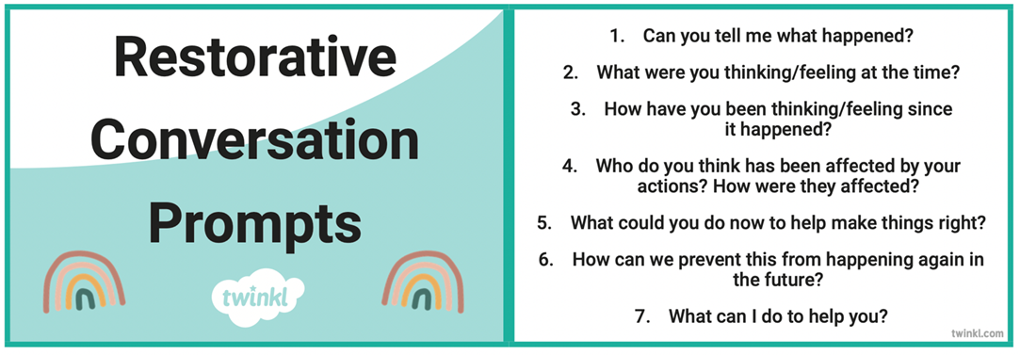

Managing incidents of unacceptable or inappropriate behaviour during break and lunchtime

Lunchtime supervisors should use a positive approach of praise and encouragement for good behaviour, which may involve their participation in playground games as a role model. There will also be occasions when they will need to discourage children from indulging in unacceptable behaviour by anticipating problems and intervening restoratively. Sanctions used by lunchtime supervisors will depend on the problem and may include:

• A reminder to play and speak kindly
• Giving a warning to improve behaviour
• Child to stand with adult for 5 mins, adult to have an Informal restorative chat
• Sending the child to a member of the SLT

In order to maintain a consistent approach in dealing with good and/or unacceptable behaviour, there is regular communication between mid-day supervisors and class teachers. Children need to see that the class teacher and mid-day supervisors work in partnership. At the start of lunchtime, teachers may ask mid-day supervisors to help or monitor specific children’s behaviour and then report back to the teacher at the end of the lunch hour.

Academy staff aim to work in cooperation with parents to understand the reasons behind their child’s behaviour and put in a clear support strategy for modifying and addressing that behaviour, This might include the designated safeguarding lead (DSL) making enquiries into circumstances outside of the academy and / or having a targeted discussion with the pupils, including explaining what they did wrong, the impact of their actions, how they can do better in the future and what will happen if their behaviour fails to improve, The academy recognises the importance of effective home-school communication and will endeavor to communicate with parents, and the virtual school head for looked after children regarding the pupils behaviour, when necessary. When a sanction is imposed, parents will be informed in writing,

Managing incidents of unacceptable or inappropriate behaviour outside of Academy

The DfE state the following in their guidance;

Schools have the power to sanction pupils for misbehaviour outside of the Academy premises to such an extent as is reasonable.
(Page 25 of Behaviour in Schools – Advice for Principals and School staff – February 2024)

Conduct outside the Schools premises, including online conduct, that schools might sanction pupils for include misbehavior:
• when taking part in any school-organised or school-related activity;
• when travelling to or from school;
• when wearing school uniform;
• when in some other way identifiable as a pupil at the school;
• that could have repercussions for the orderly running of the school;
• that poses a threat to another pupil; or that could adversely affect the reputation of the school.

https://www.gov.uk/government/publications/behaviour-in-schools-2 (2024)

All behaviour will be dealt with as if the incident had happened within school and parents will be informed.

EYFS

The Academy’ EYFS classes follow this behaviour policy but amend the Rewards and Sanctions in line with and age and stage of the children in their care. EYFS use a cloud system and thinking spot to mirror the sanctions model in this policy. All EYFS classes embed positive behaviours through the Characteristics of learning in their learning environments and reward positive behaviours immediately with the use of praise and stickers.

Positive Behaviour Plans

Some children might require further support to help them manage their behaviour. Where a child is struggling with support to follow the behaviour policy a conversation will take place with the Academy SENDCO (Mrs Buggy) or Deputy SENDCO (Mrs Cooke) to see what further support can be put in place.
With this a Positive Behaviour Plan will be written in conjunction with the parents/ carers and the child (where age appropriate).

Suspension and or Permanent Exclusions
An accumulation of Red Cards and reflections can lead to a suspension.
Incidents that may lead to suspension or permanent exclusions, are dealt with on an individual basis, taking into account all factors pertaining to children and incident. If an incident has led to a child or staff member being endangered then swift and decisive action to remove threat and reduce likelihood of reoccurrence will be taken. Only the Principal or Deputy are sanction to issue Suspensions or Permanent Exclusions. For any suspensions the Three Spires Trust policy and templates will be used.
Any child who has been subject to a suspension will be offered a reintegration meeting with the Principal/SENCO and their parents.
If criminal behaviour of any type is suspected then Academy will report the matter to the police, When referring to police the Academy will also refer to children’s social care.
The academy will follow the Trust’s exclusions policy and the DfE statutory guidance on suspensions and exclusions when taking a decision to suspend or exclude.
Managed move
A managed move is used to initiate a process which leads to the transfer of a pupil to another mainstream Academy permanently. If a temporary move needs to occur to improve a pupil’s behaviour, then an Alternative Provision provider will be used. Managed moves will only occur when it is in the pupil’s best interests.

Pupil transition and support

St Giles’ and St George’s Academy recognises that the Behaviour policy must meet the needs of all pupils in the Academy, including pupils with SEND, so that everyone can feel they belong in the Academy community and high expectations are maintained for all pupils.

Staff quickly identify pupils who need extra support and will put in place a range of preventative measure which may include.

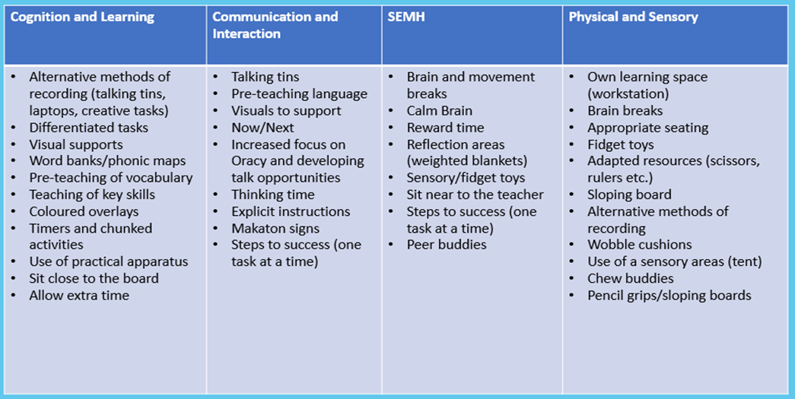

Any child who requires additional support to manage their behaviour will have a Positive Behaviour Plan, this will be uploaded to Edukey and shared with Parents. Individual behavioural targets will be made in conjunction with the SENCO and class teacher. Other outside agencies, such as SEMH team, access to CAMHS, or social care, may be used to support families and children where appropriate.

Any child who arrives at Academy midway during a Academy year is assigned a ‘buddy’ and their class teacher is responsible for ensuring they are aware of expected behaviours, reasonable adjustments are made during the first two weeks to allow the child time to meet the Academy’s behaviour expectations

The Haven

Children may also be allocated time in The Haven. The Haven is our in Academy quite and nurture space. It is an area where interventions and meet and greet take place. The area is open at breaktimes and lunchtimes and is reserved for children who want to play quietly , who need further support and those children who find the hustle and bustle of the playground too much.

The Haven is not used for pupils from other Academy and it is not an area used for wet breaks or because it is cold outside.

Children who have timetabled time in the Haven completed ELSA and social intervention work which encourages children to focus on desired behaviour and how they might accomplish it e.g.:

• Turn taking
• Appropriate participation
• Sustaining interest in a game
• Accepting winning or losing
• Allowing other children their personal space
• Understanding fair play

Pupil Voice

The Principal completes an annual pupil voice which I includes specific questions around behaviour. The Principal and members of SLT actively talk to the children around Academy on a weekly basis and support al staff in having open conversations around behaviour and expectations to ensure consistency

Pupils are encouraged to raise any concerns with trusted adults within the Academy, the ‘My Voice Matters’ suggestion box or worry boxes in their classrooms.

Staff induction, development and support

All staff receive a full induction when they start which includes the Academy behaviour systems. All staff are allocated a mentor to ensure that they have a point of contact for any questions. All staff receive termly training on areas of the behaviour policy. For all ECT’s behaviour forms the core of all initial mentor meetings and action plans,

Behaviour and Safeguarding

The behaviour policy plays a pivotal role in supporting safeguarding at St Thomas’ C of E Academy. Any behaviour that raises a safeguarding concern should be reported to the Designated Safeguarding Lead or one of the Deputy DSLs using My Concern or a blank behaviour incident recording form which are located in the Principals office, the staffroom and on TEAMS.

Our Academy DSL is Mrs Debbie Cooke
Our Academy DDSL’s are Mrs Donna Pierpoint, Mrs Kerryanne Buggy and Miss Stephanie Viggars.

The DSL ensures that all procedures set out in KCSIE 2025 are met.

Anti-Bullying Procedures – Please also see our Anti-Bullying policy for further information

Reporting
We encourage all members of our Academy community to report bulling concerns.

Pupils
Pupils should report concerns to:
- A trusted adult in Academy
- A parent/carer
- A friend
- Childline – 08001111

Parents
Parents should report concerns to:
- A member of Academy staff – class teacher is the first point of contact
- The Academy office

Staff
Staff should follow the procedure below.

Staff will:
  - Investigate reported bullying incidents thoroughly and talk to those involved, witnesses and appropriate staff.
  - Record the incident on Arbor – which may have been reported orally, in writing or in picture form.
  - Respond to the child concerned by:
- Listening actively
- Offering support and strategies to deal with unacceptable behaviour
- Protecting the child and ensuring their safety as and when necessary
- Involving parents, if necessary
- Involving external agencies to support the child as appropriate
• Respond to the child who bullied by:
- Ensuring he/she recognises his/her behaviour and how it affects others
- Applying appropriate sanctions as per our behaviour procedures
- Guiding, supporting, advising and offering strategies to change behaviour
- Encouraging him/her to take responsibility for actions and help them to make amends.
- Involving parents and external agencies to support the child as appropriate
  - Prevent further situations by providing opportunities for children/young people to explore the issues.
  - Review the situation with the child or young person and parents and others, throughout the investigation and afterwards.
  - Review policies and procedures - consider changes that can be made to environment, groupings, rules and codes of conduct etc.
  - Monitor the situation:
  - Contact parents if required.

Monitoring by all staff is an essential element in the effectiveness of good behaviour and low incidences of bullying within our Academy.

Child on Child Sexual Abuse

At St Thomas’ C of E Academy sexual violence and sexual harassment are never acceptable, will not be tolerated and pupils whose behaviour falls below expectations will be sanctioned. Staff will challenge all inappropriate language and behaviour between pupils. Online behaviour will be treated in the same manner as offline behaviours.

If any staff member feels that behaviour falls under the remit of Child on Child abuse they refer the matter to the DSL who will follow general safeguarding principles set out in Keeping children safe in education (KCSIE 2025)

The DSL will complete a Child on Child risk assessment with parents, this will be uploaded to Edukey and shared with relevant staff.

Please refer to the Academies Child on Child Abuse Policy 2025.

Banned items

- Knives and weapons
- Illegal drugs
- Alcohol
- Stolen items
- Any item a member of staff reasonably expects to used to commit an offence or cause personal injury to or damage to property of any person including the child.
- Tobacco or cigarette papers/fireworks/pornographic images.

If the Academy believes that a child is in possession of any of the above items, the child will first be asked if the item exists and to demonstrate to a member of staff that the suspected item is not in their bag or locker. If the staff member reasonably believes that the child still possesses the item and the child has refused to co-operate with a search of their bag or locker then the staff member will refer the matter to the Principal who will ask parent to attend Academy to discuss the matter. No staff member shall undertake a search of any child.

Mobile Phones

Children in Years 5 and 6 will be permitted to bring a mobile phone to Academy, this must be handed to the school office at the beginning of the day and collect at the end of the Academy day. Mobile phones are not permitted to be used at any time during the Academy day. Any child who is found to have a mobile phone during Academy hours will have the phone removed and given to the Principal and a parent will be required to collect it. Mobile phones are only required by children who will be walking home from school alone (In line with our collecting children from school policy)

Use of Force

Key Points Regarding Use of Force

  - School staff have a power to use force and lawful use of the power will provide a defence to any related criminal prosecution or other legal action.
  - Senior school leaders will support their staff when they use this power.
  - Some staff are trained in restrictive physical intervention. On occasions these staff may need to use reasonable and proportionate force to reduce the risk presented by unsafe behaviours. On occasion where use of force is used a Restrictive Physical intervention record is completed and uploaded to My Concern. If a child has needed physical intervention during the day the parents will be notified on the same day.

What is Reasonable Force?

- The term ‘reasonable force’ covers the broad range of actions used by most teachers at some point in their career that involve a degree of physical contact with pupils.
- Force is usually used either to control or restrain. This can range from guiding a pupil to safety by the arm through to more extreme circumstances such as breaking up a fight or where a student needs to be restrained to prevent violence or injury.
- ‘Reasonable in the circumstances’ means using no more force than is needed.
- As mentioned above, schools generally use force to control pupils and to restrain them. Control means either passive physical contact, such as standing between pupils or blocking a pupil’s path, or active physical contact such as leading a pupil by the arm out of a classroom.
- Restraint means to hold back physically or to bring a pupil under control. It is typically used in more extreme circumstances, for example when two pupils are fighting and refuse to separate without physical intervention.
- School staff should always try to avoid acting in a way that might cause injury, but in extreme cases it may not always be possible to avoid injuring the pupil.

Communication

This policy will be made available on the school website and is shared with all stakeholders annually.

Other relevant Guidance and Policies

https://www.gov.uk/government/publications/behaviour-in-schools--2

https://www.gov.uk/government/publications/keeping-children-safe-in-education--2

St Thomas’ Safeguarding Policy 2025
St Thomas’ Child on Child Abuse policy 2025
Equality Act 2010,
Children and Families Act 2014,
Statutory obligation where a child has an EHCP.

APPENDIX 1 – Positive Behaviour Plan Example

Positive Behaviour Plan

Name: | DOB: | Plan Number: | Year group: | Teacher:

ALL ABOUT ME
STRENGTHS:  - Child can work hard in lessons when distractions are kept to a minimum.  - Child understands the rules and why he needs to follow them  - Child is engaged in his learning if it is something that he enjoys/feels he is capable of completing  - He is a friendly boy and has a willingness to cooperate on a day to day basis | RESPONDS WELL TO…  - Positive praise  - iPad time  - Dojos  - Time outside

DESCRIPTION OF BEHAVIOUR:
Child has formed friendships with children across the Y5 and Y6 classes since September. As these relationships have grown more meaningful Child has become more invested in disputes that develop throughout break times and lunch times. This does not mean that Child starts these disputes, however, Child is very supportive of his friends and is confident with his own opinions. As this is a good quality that Child possesses, it sometimes leads Child to struggle with identifying the correct way to deal and communicate his feelings and emotions towards a situation before they become inappropriate. If Child’ emotions become heightened, his positive relationships with the staff begin to depreciate as he becomes sometimes defiant and refusing to follow instructions. Child behaviours begin to bubble showing an increased disrespect for adults and small behaviour issues, previously these behaviours have then settled back down but this time these small behaviours have resulted in an extreme outburst

FREQUENCY:
Recently, Child has been doing really well only showing behaviours occasionally, over the past two weeks the low level behaviours have been constant resulting in the outburst where Child left school.

KNOWN TRIGGERS / SIGNS:
- Feeling there has been an injustice of some sort
- Conflict at break times/lunch times
- People moaning
- Lack of concentration due to distractions from conflicts
- Tiredness

STRATEGIES FOR INTERVENTION AND PREVENTION:
Prevention
- Rewards- as listed above
- Following the behaviour policy (verbal warning, written warning, yellow card, red card)
- If you… Then you… Reward based on the day and his current interests
- Child communicate his emotions as they occur/conflicts in order for them to be dealt with before they become inappropriate/escalate.
- Child to be given a Time Out card to use when he feels he needs to cool off or time to be able to re-enter the classroom appropriately
- Reduced timetable to manage mental wellbeing and reduce stress
- Isolation from other children at lunch to reduce incidents causing anxiety
Intervention
- Instruct Child to leave the room to cool off/ have time out before re-entering the class.
- Remind Child that he is working towards I-Pad time if he comes back and completes his work.
- Remind Child that he could be removed by a member of SLT.
- Child to be sent to the Reflection if behaviours continue after a red card to reflect on his behaviour and emotions

GOALS AND ASPIRATIONAL BEHAVIOUR

- Child will complete lessons with the appropriate breaks in place to aid his handwriting
- Child will avoid situations and tensions with other children at lunch time that don’t concern
- Child will inform a member of staff when he feels his emotions are heightened.
- Child to then opt to leave the room for 5 minutes cool down/time out to reflect and then return to work.

INTERVENTION

CALMING (Engagement Profile)

Child is calmed by having time outside of the classroom in a quiet space/with an iPad. He instigates this by using his time out card. | Pupil Comment  Child prefers the I-pad

REACTION MANAGEMENT (Emergency Plan)

- Follow behaviour policy and warnings.  - If Child is unable to calm down by himself or puts himself in danger, SLT may be called to remove him from the room.  - Child is to be supervised when removed from class to reduce the chance of leaving the school building.  - If Child becomes violent staff are not to intervene but to remove other children  - If Child leaves the building then staff are not to follow but to ring mum and police and inform them | Parent informed:  If Child has to be removed from the classroom

RECOVERY

Child to make an apology to staff if he has not followed instructions. Child to apologise to pupils involved, if appropriate. If he has hurt himself, he will realise and positively move forward to avoid this.  Remind Child that the next day is a fresh day and we start again.  Discuss behaviours with mum so that Child is aware of his behaviour at home. | Significant Adults

PARENT VIEW

Perception: | Home strategies: | Communication:

REVIEW DATE:

DATE
SIGNED Parent
SIGNED School

APPENDIX 2 – How to log behaviour incidents on Arbor

From R – Y6
If any child receives a yellow card, red card or a reflection it is the responsibility of the class teacher or classroom staff to log this on Arbor.

Yellow cards are dealt with fully at class level. A yellow card results in 5 minute loss of the next break time.
Red cards are sent to Mrs Buggy and this will result in a 10-minute loss of the next break/ lunch
Reflection are sent to Mrs Pierpoint and this is then a set amount of time out of class. (The time set is individual to the age of the child, the circumstances and the number of reflections)

Any card (yellow or red) need sending home and either a conversation with parents on the door or a dojo message home.
Reflections need a phone call home from the class teacher at the end of the day.

To log in Arbour:
- Log into Arbor and on the left-hand side menu select – ‘log a behaviour incident’
- Enter date of incident and the time – the time is VERY important.
- Event is year group – please select year group form the drop down menu.
- Add students involved – Start typing the name and it should appear
- Click on the behaviour box – the drop down menu gives you the option of yellow card/ red card/ reflection. (Suspensions are also recorded this way but this can only be done my myself or Kerryanne)
- Assign to member of staff – this is the class teacher for a yellow card, Kerryanne for a red card and Donna for a reflection.
- For incident summer it is really important you put the reason why the card has been given and the behaviour – EG repeatedly shouting out and disturbing the learning of others.
- Staff involved – who issued the card – could be any member of staff
- Location
- Click next (green button) this will take you to a review page, then click LOG INCIDENT at the bottom right hand side.

It is really important that ALL incidents are logged, especially if they escalate form yellow to red, both need to be logged as SEPARATE behaviour incidents.

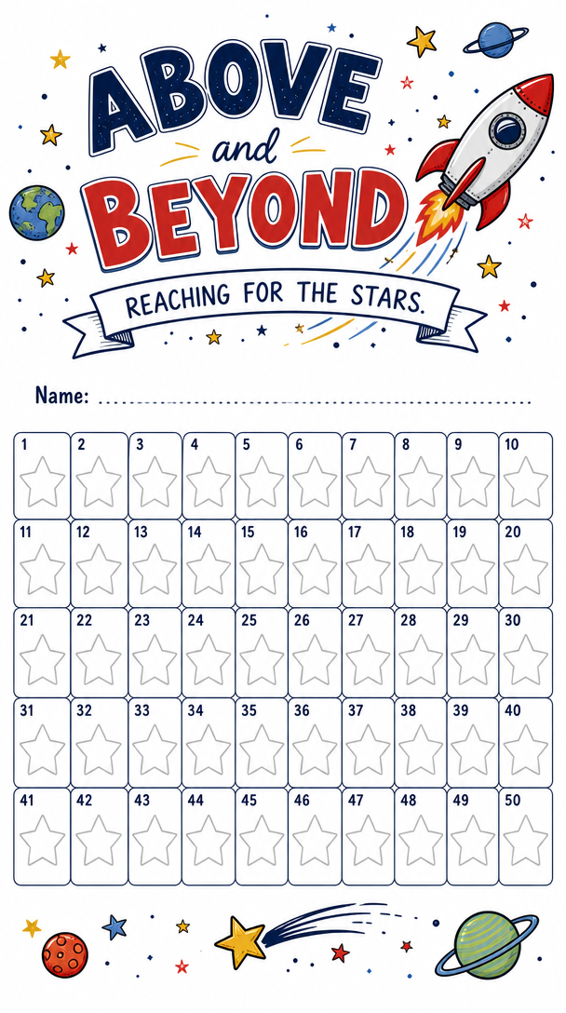
APPENDIX 3 – Above and Beyond Award



