What is my child learning in Nursery:
Autumn 1 – 2026 – What makes me amazing?
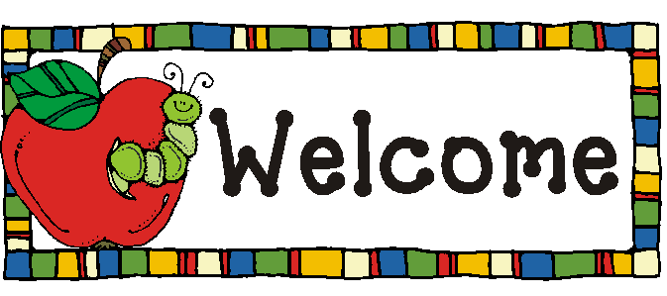
School Values  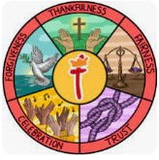 | For Autumn 1 our value is Thankfulness. As we encourage the children to look at themselves and their families, we shall be celebrating the similarities and differences.  As we continue our journey as a Silver UNICEF Rights Respecting School working towards our gold status we are focusing on Article 29 The Right to an Education which celebrates personality and abilities alongside respecting other people’s rights and values and respecting the environment.
RE   | Children will:  - Start to learn our prayers that we share at lunch time and home times.
Communication and Language   | Children will:  - Enjoy listening to longer stories and remember much of what happens.  - Use longer sentences of four to six words.  Some of the books we shall be sharing this half term include:  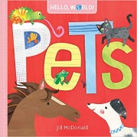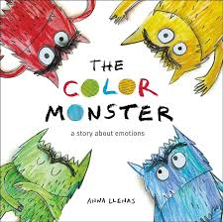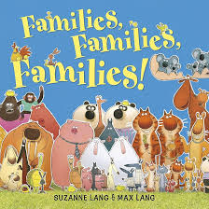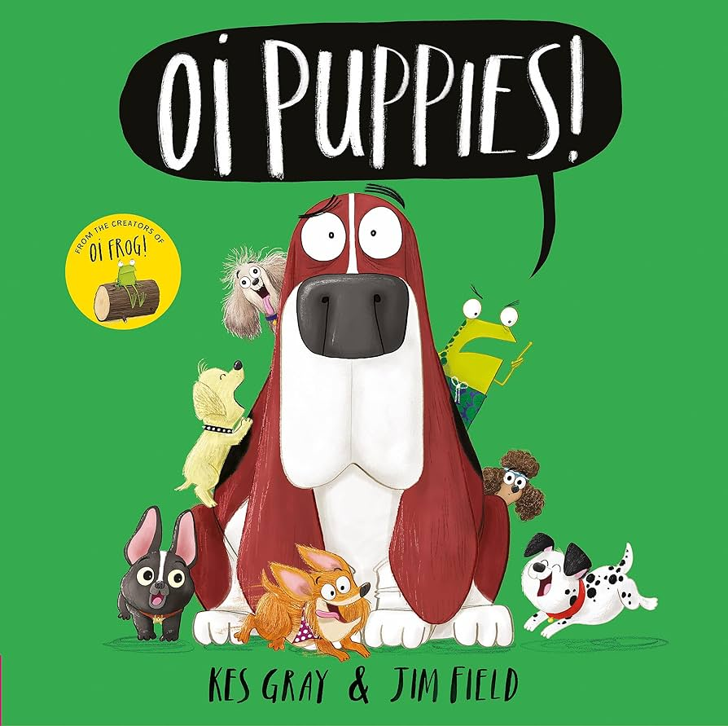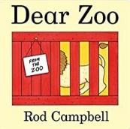
Physical Development   | Children will:  - Continue to develop their fine motor skills through activities such as using tweezers and taking part in daily dough disco routines.  - Continue to develop their dressing skills.  - Use a comfortable grip with good control when holding pens and pencils.  For our nursery children to take full advantage of the physical opportunities the school has to offer nursery children come to school in their PE Kits they do not need to wear anything different. On a rotation throughout the week we have a PE session, a dance session and a parachute play session.
Personal, Social and Emotional Development   | Children will:  - Children will settle into the class and learn how to play with each other.  - They will learn how to separate positively from their main caregivers and follow the routines and rules within the classroom and the wider school environment.
Literacy  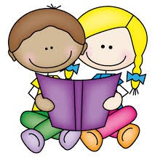 | Children will:  - Be exposed to and given the opportunity to engage in extended conversations around stories.  - Children will hear and learn new vocabulary.  - When mark making children will be encouraged to give a meaning to the marks that they make.
Mathematics  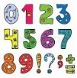 | Children will:  - Recite numbers up to and past five, often using finger rhymes to support this learning.  - Say one number for each item in order 1,2,3,4,5.  - Link numerals and amounts up to 5.  - Begin to use shapes appropriately for construction.
Understanding the World   | Children will:  - During National Space Week (4^{th-}10th October) the children shall explore space and aliens through stories and activities. arm.  - Learn the names of different body parts, Heads Shoulders, Knees and Toes is sure to become a favourite dance.  - Learn and talk about the autumn season.  - Go on a Autumn walk with magnifying glasses up the secret bank.
Expressive Arts and Design   | Children will:  - Produce a self-portrait.  - Later during the half term when exploring Autumn the children will be given the opportunity to independently paint a spider.
Key events for the half term | We use dojo to share key dates with our families, please make sure you use your sign up code to register. for our new families these details will be shared with you shortly.  Nursery Coffee morning – Friday 6th November - 9am  Nursery SHINE afternoon – Monday 21st September – 2pm  Nursery and Reception inspire afternoon – Tuesday 29th June - 2pm
Homework | This half term we are looking at growth and growing we would love for you to share a picture of your child when they were a baby so that we talk about how much we have grown and if we look different.  We shall also be looking at our family pets, if you have any at home or in your wider family we would love to have some pictures to show the class.

