What is my child learning in Year 6…



School Values  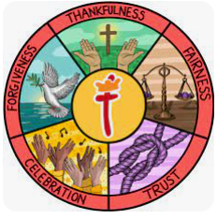 | Our Gospel value in school this half term is Thankfulness.  In Year 6, we will be using our class worship sessions to discover what thankfulness means to Christians. We will use different teachings from the Bible to start our discussions, from Feeding the Five Thousand, to Noah, looking at how and why Christians give thanks. We will also use these sessions to draw parallels to our own lives and discuss how and why we might be thankful.
RE  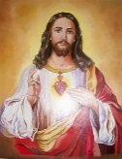 | In Year 6 this half term, we will be exploring the questions 'How do Christians live? What would Jesus do?'  Children will learn about the four gospels, noting some of the similarities and differences between them. They will learn about the context of the gospels and the Christian tradition that Matthew, Mark and Luke wrote using eyewitness accounts to the life and teachings of Jesus whereas John used some different sources and includes long reflections on Jesus’ teaching.
English    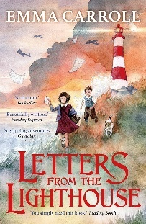 | In English, we will be looking at the text ‘Letters from a Lighthouse’ by Emma Carroll. This is a fabulous story set in World War 2 where a brother and sister (Cliff and Olive) are evacuated from London to the Devon Coast. It tells the story of them joining ‘Mr Ephraim,’ the local lighthouse keeper who clearly doesn’t want to look after evacuees and tells their story.  We will use this text to stimulate our learning and look at how we can develop our own authorial voice and style. We will start to use different devices (such as conjunctions and adverbials) to build cohesion and apply these to our very own informal letters. We will then use a formal tone, concise vocabulary and use of devices to structure, such as; headings, sub-heading and bullet points to create our very own non chronological report focusing on World War Two.
Reading   | In reading, we will continue to use ‘Letters from a lighthouse,’ to stimulate our learning and support our comprehension. The children will be building on skills from previous years and enhancing the skills below.  - Vocabulary – Looking at what the word means.  - Inference – Use clues in the text to help you.  - Predicting – What may happen next?  - Retrieval – Finding facts and key details.  - Sequencing – Putting events in order  - Summarising- Finding the main points.  - Comparing/ Contrasting- commentating on what is happening and discussing the content.  We will also take part in our weekly ‘SQUIRT’ (Silent/ Quiet Uninterrupted Independent Reading Time). This will be a 20 minute, weekly session where we will read in the library.
Maths   | In maths, Year 6 will be covering the following topics:  - Place value (10,000,000)  - Addition and Subtraction (of integers, mental calculations and estimation)  - Multiplication (common factors, multiples, prime numbers, cube numbers and multiplication using a written method)  - Division (including long and short division and using a written method to solve multi-step problems)  We will be also looking at improving our mental maths, through our ‘Fluent in 5’ scheme and also working on our instant recall of number facts.  Our Key Instant Recall Fact for this half term is: ‘I can identify common factors of a pair of numbers.’
  Science | In science this half term, we will be covering the topic, light.  Children will use the idea that light travels in straight lines to explain that objects are seen because they give out or reflect light into the eye.  We will also learn that light travels in straight lines to explain why shadows have the same shape as the objects that cast them.
History  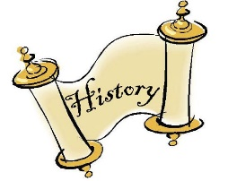 | Our topic for this half term is ‘World War 2.’ For this, we will transform into Historians and start to discover:  - What a primary and secondary source is and whether it is reliable or accurate.  - Some of the causes of World War 2 and identify some of the key phases, such as ‘The Battle of Britain.’  - The effect this time period had on local adults and children and more specifically, how it impacted on the lives of women.  Finally, we will aim to use all of our learning to answer our big History question; ‘What was the impact of World War 2 on British People?’
  Art | World War II – Art in a Time of Conflict  Children will:  Use appropriate vocabulary to describe wartime art.  Develop their ideas through sketching and experimentation.  Apply media techniques effectively to convey tone, emotion or message.
Computing   | In computing, we will be focusing on how to stay safe online. We will be looking at what our online footprint is and how we can protect ourselves and make the right choices when using forms of technology. We will then move onto a unit where we will focus on using data inputting software.
French  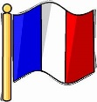 | In French, we will be focussing on the Olympics and Paralympic games in Paris. We will be looking at different sports and experimenting with different tenses to improve our French conversation.
PE   | In PE, Children will be taking part in on-site swimming lessons. Separate information regarding swimming lessons to follow.  During the indoor PE lessons, Year 6 will be learning how to play tennis. They will have opportunities to work co-operatively with others as well as independently. They will develop their tactical awareness, learning how to outwit an opponent when playing together.  Our PE days will usually fall on Monday and Wednesday.
  Music | In Music, we will look at appreciating different genres of Music. We will look to recognise different instruments that are used and how it can make us feel. We will look at the time signatures for pop and Motown music and start to learn how to transcribe to create our own pieces of music.
PSHE   | PSHRE- Being me in my world  This half term we will:  - Identify goals for the year.  - Look at children’s universal rights  - Look at our feelings and choices that we make  - Recognise our roles as ‘agents of change’ and the part we play as a global citizen  - Look at the role of our voice, recognizing how our choices can have an impact.
Key events for the half term | Future Dates to be aware of:  - Thursday 10th September Y6 trip to London  - Friday 18th September David Williams MP visit  - Tuesday 6th October school photographs  - Thursday 15th October Scholastic book fair in school  - Thursday 22nd October INSET day  - Friday 23rd October INSET day
Homework | - Reading- We ask that all children read a minimum of four times per week at home. Reading records should be signed by an adult to indicate that their child has read at home.  - Children in Years 2–6 will also be expected to complete three sessions each week on Times Tables Rock Stars (TT Rock Stars).  - Children in Years 2–6 will be expected to complete three sessions each week on the Morphs Spelling Game.  Thank you for your support with completing your child’s homework.

