What is my child learning in Year 2…


School Values  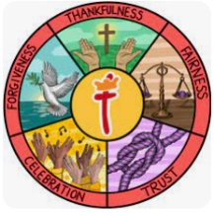 | Our core Christian values underpin the British values and are closely linked. Core British Values of democracy, the rule of law, tolerance, respect and individual liberty are taught in the context of our strong Christian ethos. This half terms value is Celebration. Learning in God’s truth and love, we take pride in success and celebrate what we achieve together academically and creatively. The British value of liberty means we are free to make our own choices and express and celebrate our individuality. We try our best to do what is right and fair.
RE   | In RE this half term, we will be exploring Rites of Passage and good work. What is the best way for a Jew to show commitment to God? (Judaism).  We will continue to look at the Ten Commandments as well as what traditions Jewish families follow. We will be looking at their commitment to God through a Torah scroll and learning all about Bar and Bat Mitzvah ceremonies and why these are important to young Jews and how they show their responsibilities. We will look at good deeds and how these can show responsibility.
English    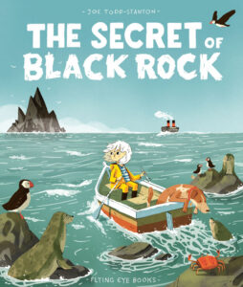  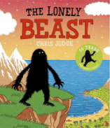 | Focus text  In English, we are focusing on two texts: The Secret of the Black Rock by Joe Todd-Stanton and The Lonely Beast by Chris Judge.  The Secret of Black Rock is about a girl called Erin who is fascinated by the mysterious Black Rock that the local fishermen fear. One day, she discovers that the rock is actually protecting the sea creatures living beneath the water. Erin helps the townspeople understand the truth and learn to care for the ocean.  The Lonely Beast is about a kind but lonely Beast who leaves his home to search for friends in the busy city. Although people are frightened of him at first, the Beast eventually finds friendship and happiness in an unexpected way. The story teaches children about kindness, loneliness and accepting others.  Year 2 will be consolidating their learning from the year and applying their taught language features such as expanded noun phrases, conjunctions, adverbials of place and time into the following genres of writing: persuasive letters from Erin arguing that we should save the Black Rock, an explanation text about living by the coast and an informal letter to a friend from the point of view of the beast.
Reading   | Within reading groups, children in Year 2 will continue to work on their decoding skills, their use of prosody and expression when reading, as well as working on their comprehension by answering questions about what they’ve read and explaining how they know.  As well as reading groups, we will have an additional guided reading session a week wherein we will focus on the following skills:  Vocabulary – Looking at what the word means.  Inference – Use clues in the text to help you.  Predicting – What may happen next?  Retrieval – The answer is somewhere in the text.  Sequencing – Putting events in order  We also have our weekly session in our library where the children will have the chance to enjoy some quiet reading and share some of their favourite stories! We will still be taking library books home on a Wednesday and the children can change them every week (as long as they bring them back).  Some children have not returned their borrowed books. Can these please be returned to school as soon as possible? If you think you may have lost the book they have borrowed from school, please can you let me know by sending a message via Class Dojo.
Maths   | In maths in summer 2, we will be focusing on  - Fractions  - Time  We will be continuing our programme called mastering number. We will be teaching this every afternoon after lunch. This will focus on the children really understanding their number bonds and links within numbers so they can learn facts by heart.  Our KIRF this half term is ‘I can tell the time to the nearest 5 Minutes’.
Science   | Our science topic this half term is ‘Growing Up’  We will be learning about the life cycles of humans, different mammals, amphibians, butterflies and comparing and contrasting to discover patterns in life cycles of different animals.
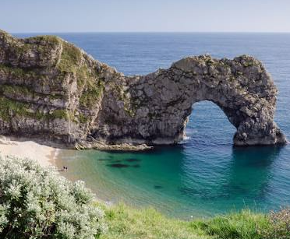 | Our Geography topic for Summer 2 is ‘ What is it like to live at the coast?’  Lesson 1 – Where are the seas and oceans?  Lesson 2 – What is the coast?  Lesson 3 – What are the features of the Jurassic Coast?  Lesson 4- How do people use Weymouth?  Lesson 5 – How do people use the local coast?
  ART | This half term the children will be focusing on DT to construct a windmill using the following lessons  Lesson 1 – Learning about Windmills  Lesson 2 - Making the sails.  Lesson 3 - Attaching the sails.  Lesson 4 - Evaluating windmills
Computing   | Programming quizzes:  Lesson 1 – Scratch Jr recap  Lesson 2 – Outcomes  Lesson 3 – Using a design  Lesson 4 – Changing a design  Lesson 5 – Designing and creating a program  Lesson 6 – Evaluating
PE   | Athletics  Sprinting, jumping further and higher, throwing for a distance and throwing for accuracy. | Striking and fielding  Develop underarm throwing and catching to field a ball, develop hitting for distance, begin to understand how to get a batter out, begin to understand the rules of rounders.
PE days this half term will be on Wednesdays and Thursdays.
Music   | Our topic this half term is Pitch – Musical Me  The children will learn to:  - Move their eyes from left to right to read pitch patterns.  - Sing high and low notes including the notes in between.  - Play a pattern of high and low notes on an instrument.  - Read notation from left to right.  - Draw high and low sounds using dots at the top and bottom of a page, respectively.  - Recognise when notes stay the same.  - Recognise missing notes on a stave.
PSHE   | Our topic this half term is ‘changing me’  Lesson 1 – Life cycles in nature  Lesson 2 – Growng from young to old  Lesson 3 – The changing me  Lesson 4 – Boys and girls bodies  Lesson 5 – Assertiveness  Lesson 6 – Looking ahead
Dates for diary | Future dates to be aware of:  - Friday 5th June – Year 2 coffee morning  - Friday 5th June - PSA Summer Fair  - Friday 19th June – Father's Day breakfast  - Monday 22nd June – Class Photographs  - Friday 25th June – Sports Day  - Monday 29th June – Year 2 SHINE
Homework | Homework will be sent out on a Friday and will be due back the following Wednesday.  The children are also encouraged to continue playing Times Tables Rockstars at home 3 times a week as well as reading 3-5 times a week too. Reading records should be signed by an adult to indicate that their child has read at home. Reading books will be changed weekly. If they have finished their book, please encourage your child to read it again for fluency and to improve comprehension.  Your child will have received a log in for Morphs spelling game. They should aim to play at home 2-3 times a week. I will be giving the children 5 dojos for playing 3 times a week.  Thank you for your support with completing your child’s homework.

