What is my child learning in Nursery.
Summer 2 – 2026 – What is it like at the seaside?


School Values  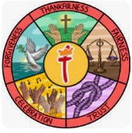 | For Summer 2 our whole school value is Celebration. During this half term we shall be celebrating the achievements the children have made during this academic year. Looking back and reflecting on how much we have achieved during the school year together as a group.
RE  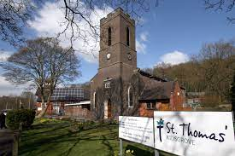 | Children will:  - Learn what makes places special.  - Linking to British values children will learn about mutual respect and tolerance when learning about life in places around the world.
Communication and Language   | Children will:  - Understand and act on longer sentences.  - Be able to express a point of view and to debate when they disagree.  - Start a conversation with an adult or friend and continue it for many turns.  - Use talk to organise themselves and their play.  Some of the books we shall be sharing this half term include:  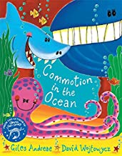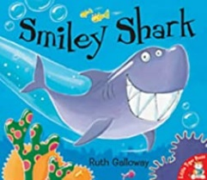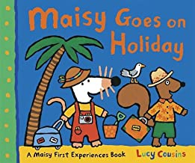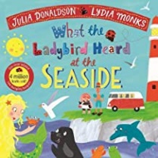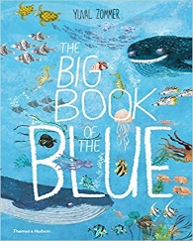  The preschool children will be exploring two stories through the talk through stories scheme, Tiddler and Aliens Love Underpants. Talk through stories allows us to explore the same story for two weeks, week one focuses on the storya and week two focuses on exploring the vocabulary further.
Physical Development   | Children will:  - Start taking part in some group activities which they make up for themselves or in teams.  - Choose the right resources to carry out their own plan.  - Use a comfortable grip with good control when holding pens and pencils.  - Spend time taking part in different races to practice for sports day.  The nursery children wear their PE uniform all week to allow us to take advantage of spontaneous physical activities. On a rotation we have a PE session, a dance session and a parachute play session.
Personal, Social and Emotional Development   | Children will:  - Select and use activities and resources, with help when needed. This helps them to achieve a goal they have chosen, or one which is suggested to them.  - Understand gradually how others may be feeling.
Literacy   | Children will:  - Develop their phonological awareness, so that they can:  - spot and suggest rhymes  - count or clap syllables in a word  - recognise words with the same initial letter sound, such as  money and mother  - Use some of their print and letter knowledge in their early writing.  - Practice mark-making their name on pieces of artwork.
Mathematics  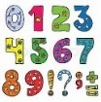 | Children will:  - Subitise up to 3. (Recognise a group has 3 objects without counting them)  - Recite numbers past 5.  - Say one number for each item in order 1,2,3,4,5.  - Know that the last number reached when counting a small set of objects tells you how many there are in total. (The cardinal principle)  The preschool children will continue to access the White Rose Maths Scheme. This will include work on ABAB patterns, showing and representing 5 and matching, sorting and comparing.
Understanding the World   | Children will:  - Look at pictures of the seaside and consider what they could do if they were there.  - Compare seaside holidays to go to other places.  - Look at the ocean and learn about some of the amazing creatures that live in it.  - Consider ways to protect our wonderful world and keep our ocean clean.
Expressive Arts and Design  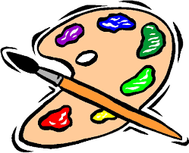 | Children will:  - Explore different materials freely, in order to develop their ideas about how to use them and what to make. (Junk Modelling)  - Develop their own ideas and then decide which materials to express them.  - Look at the work of the artist Monet and recreate work in the same style.
Key events for the half term | - Nursery Shine afternoon – Monday 8th June at 2pm  - Father’s Day breakfast – Friday 19th June  - Sports Day – Thursday 25th June  - Inspire session with Reception Thursday July 7th at 2pm
Homework | This half term we would love to see any photographs, souvenirs or beach finds from holidays or day trips.

