What is my child learning in Year 6…


School Values  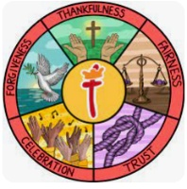 | Here at St Thomas’ we fulfil our mission of ‘Learning for Life with Jesus’ at every opportunity. Underpinning this are our 5 school values of: thankfulness, fairness, trust, celebration and forgiveness.  This half term we will focus on the value of Celebration
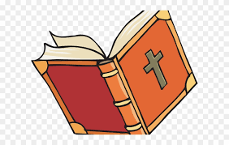  RE | Belief in moral values: Does belief in Akhirah (after life) help Muslims to lead good lives?  In RE, Year 6 will be learning about the 5 pillars of Islam and how Muslims use them to help them lead a good life. We will be discussing ‘just’ wars and ‘holy’ wars and reflecting on each of these, encouraging the children to discuss these themes with maturity.
Writing    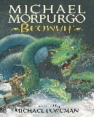 | In writing, the children will continue to work on building a range of language devices in order to develop their writing style. This will include:  - The use of more advanced punctuation (semi-colons, brackets, colons)  - Extending sentences by adding fronted adverbials and relative clauses  - Developing their understanding of the difference between a main clause and a subordinate clause so they can manipulate the order of sentences.  - Exploring language choices and ensuring they are appropriate for the audience of that genre  - Exploring features of explanation texts  - Creating our own narrative poetry  This half term we will explore a text by Michael Morpurgo called ‘Beowulf’.
Reading | This half term we will continue reading ‘Beowulf’. We will be using our inference and retrieval skills to answer questions.  As well as exploring ‘Beowulf’, children will also be exposed to many fiction, non-fiction and poetry texts to build up their stamina and comprehension.
Maths  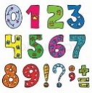 | During this half term, children will complete projects in maths, putting all of their skills into practice completing problem solving activities. Children will also be taught financial literacy, preparing them for real-life situations involving spending, budgeting, and saving.
  Science | This half term children will learn explore the impacts of diet, drugs and lifestyle on overall body health. They will make links to learning in the previous circulatory system block as much as possible to identify how diet can have positive or negative effects on the heart.
Geography | This half term in Geography the focus will be ‘Can I carry out an independent fieldwork inquiry?’  Children will:  Give examples of issues in the local area.  Identify questions to be asked to find the relevant data.  Justify which data collection method is most suitable.  Design an accurate data collection template.  Identify areas along a route that are best for data collection.  Discuss how to mediate potential risks.  Collect data at points located on an OS map.
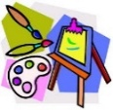  Art | Escher- Illusion, Pattern & Perspective  Children will:  Explore the artwork of M.C. Escher and understand optical illusions  Understand and create tessellations inspired by Escher  Explore perspective and create simple illusion drawings  Create a final artwork inspired by Escher’s style.
Computing   | Sensing movement  Children will learn:  - The Micro:bit  - Go with the flow  - Sensing inputs  - Finding your way  - Designing a step counter  - Making a step counter
French  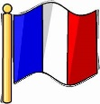 | Visiting a town in France  Children will continue to:  Describe routes to school using pictures and word cards.  Follow simple directions accurately.  Describe the relationship between places using a preposition.  Put modes of transport into a simple sentence.  Role-play buying tickets in French.
  PE | Dance & Athletics  In Athletics, children will learn the following athletic activities: long distance running, sprinting, triple jump, discus and shot put.  In dance, children will focus on developing an idea or theme into dance choreography for their end of year show.
  Music | End of year show  Children will be learning the songs for Oliver with a twist and will practice how to perform to an audience.
PSHE   | Changing Me  In this unit we will be exploring self-image, body image, puberty and feelings and conception to birth.  Children will also explore their own reflections about change.
Key events for the half term | Future dates to be aware of:  Wednesday 3rd June – Year 6 trip to Alton Towers  Friday 5th June - Summer Fair  Monday 15th June – Year 6 leavers photos  Thursday 25th June – Sports day  Thursday 25th June – Sandbach school transition day  Friday 26th June – Sandbach school transition day  Monday 29th June – The Kings transition day & KSS transition  Tuesday 30th June – The Kings transition day & KSS transition  Wednesday 1st July – The Kings transition day & KSS transition & St Margaret Ward transition & Alsager transition  Thursday 2nd July – The Kings transition day & St Margaret Ward transition  Monday 6th July – Year 6 SHINE afternoon  Wednesday 8th July – Year 6 Show 1.30pm  Wednesday 8th July Year 6 Show 6pm  Thursday 9th July Year 6 Show 6pm  Wednesday 15th July – Year 6 Prom  Friday 17th July – Leavers assembly 1.30pm (Children can leave with parents afterwards)
Homework | In year 6, we will continue to send a range of SPAG, reading and maths homework each week to prepare them for their SATs. We ask that the children also read their reading book at least 3 times a week and log on and play Times Table Rockstars 2-3 times a week too!

