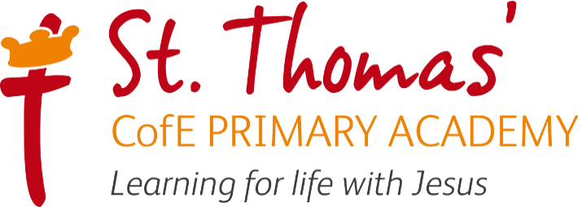

Charges, Consumables and Billing Information
+
Government funding for the 15- or 30- hours entitlements does not cover consumables, so providers are able to ask parents to pay for these things and invoices will be broken down via Arbor for transparency as follows:
- Additional private paid hours
- Food charges
- Non-food consumables charges
- Activities charge
Additional Private Hours:
- Additional Sessions (AM or PM, equivalent to 3 hours) are £16.80.
Included within the free entitlement hours are:
- The Nursery Milk Scheme milk entitlement for all children under 5 of 1/3 pint per day
- The School Fruit and Vegetable Scheme entitlement for a fruit or veg snack, one per day
- Fresh drinking water available all day

Providers may charge for additional payments to cover consumable items.
At St Thomas’, parents are required to supply the following consumable items each day:
- Carrier Bag/Wash Bag (for any wet/soiled clothes)
- Suncream
- Spare clothes (underwear, socks, t-shirt, leggings/trousers, jumper/cardigan)
- Wellies
Where applicable:
- Nappies
- Wipes
- Nappy Sacks
- Additional spare clothes (underwear, socks, t-shirt, leggings/trousers, jumper/cardigan)
- Sleeping blanket

Lunchtime Meals are not included within the free entitlement hours. School meals are available to order at a cost of £2.90 per day, alternatively a healthy balanced packed lunch can be provided from home.

All external activities such as visitors to school and trips are not included within the funded hours entitlement and will be an additional charge.

