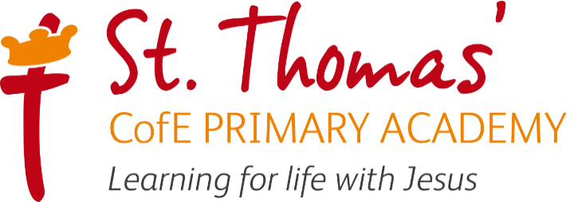

EYFS Funded Hour Entitlement September 2025

At St. Thomas’ CofE Primary Academy, our Early Years setting consists of a Nursery, from 2 years old to Pre-school age, and a Reception class.

Depending on how old your child is and your circumstances, you may be able to access between 15- and 30- hours government funded childcare a week.

From September 2025, working parents of children under the age of five will be entitled to 30 hours of government funded childcare a week. If you are not eligible for free childcare for working parents you may still be eligible for help towards childcare costs.

Check your eligibility and get more information here: https://www.gov.uk/get-childcare
All parents of children aged three to four can still access 15 hours of government funded childcare. It doesn't matter how much you earn or how many hours you work.
Applying is simple and can be done entirely online:
- Check your eligibility
- Sign in or create an account (to create an account you will first need your Government Gateway user ID. If you’re a new user, you will need to register for one)
- Apply online for a childcare code through your childcare account.
- Get your unique code via email and give it to St Thomas’ CofE Academy
- Apply before the deadline – for the autumn term, apply by 31 August 2026.
- Reconfirm every 3 months to keep receiving the funding.

You can apply up to 3 months before your child is eligible.

Children can join our Nursery as soon as they are 2 years old and their funding begins.
Please see overleaf for the Nursery sessions offered.

We offer both 15- hour and 30- hour funded places, as well as full-time places:

15 hours funded | 30 hours funded | Full Time 32.5 hours
5 x 3-hour sessions: | 30 hours within: | Full Time 32.5 hours
Mon – Fri  AM 8:40 – 11:40  PM 12:15-15:15 | Mon – Fri  8:40-15:15 | Mon-Fri  8:40-15:15

Parents of any child allocated 15 hours can pay for additional sessions at a charge of £16.80 per 3-hour morning or afternoon session. These must be pre-booked.

Additional private paid hours must be pre-booked for the term using the booking form. These must be paid in full by the end of each half term and will be invoiced via Arbor weekly.

Government funding for the 15- or 30- hours entitlements does not cover consumables. Providers may charge additional payments to cover consumables.

At St. Thomas’, we ask parents to provide the following consumables:

- Suncream and sunhat
- Wellies and waterproof coat
- Spare clothes (underwear, socks, t-shirt, leggings/trousers, jumper/cardigan)
And, where applicable:
- Carrier Bag/Wash Bag (for any wet/soiled clothes)
- Sleeping blanket
- Additional spare clothes sets (underwear, socks, t-shirt, leggings/trousers, jumper)
- Nappies
- Wipes
- Nappy Sacks

