What is my child learning in Nursery?
Summer 1 – 2026 – What is it like in our community?

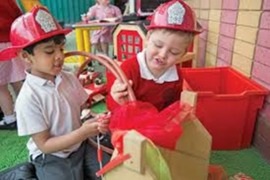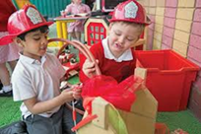
School Values  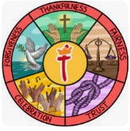 | For Summer 1 the whole school will be looking at trust. In nursery we shall be talking about who we can trust and why this is important. As we learn about our community and the people who help us, we shall be linking this to stranger danger and keeping safe.
RE  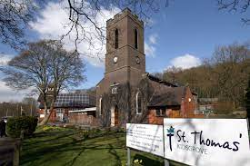 | Children will:  - Learn about what makes places special.  - Invite Reverend Baker in to talk about St Thomas’ Church.
Communication and Language   | Children will:  - Understand and act on longer sentences.  - Be able to express a point of view and to debate when they disagree.  - Start a conversation with an adult or friend and continue it for many turns.  - Use talk to organise themselves and their play.  Some of the books we shall be sharing this half term include:  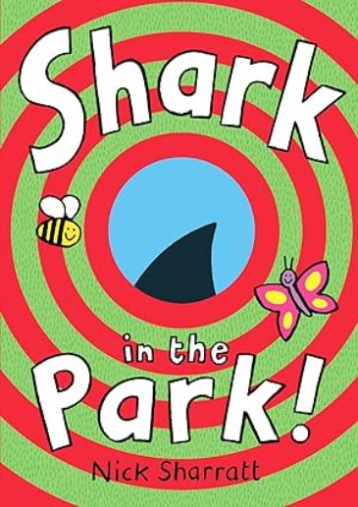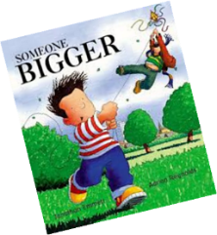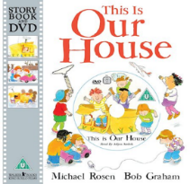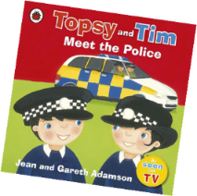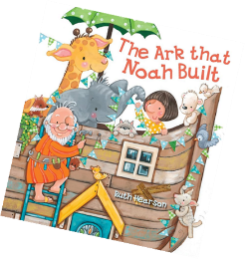
Physical Development   | Children will:  - Start taking part in some group activities which they make up for themselves or in teams.  - Choose the right resources to carry out their own plan.  - Use a comfortable grip with good control when holding pens and pencils.  - Spend time taking part in different races to practice for sports day.  The nursery children wear their PE uniform all week to allow us to take advantage of spontaneous physical activities. On a rotation we have a PE session, a dance session and a parachute play session.
Personal, Social and Emotional Development   | Children will:  - Select and use activities and resources, with help when needed. This helps them to achieve a goal they have chosen, or one which is suggested to them.  - Understand gradually how others may be feeling.
Literacy  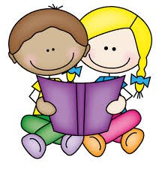 | Children will:  - Develop their phonological awareness, so that they can:  - spot and suggest rhymes  - count or clap syllables in a word  - recognise words with the same initial letter sound, such as  money and mother  - Use some of their print and letter knowledge in their early writing.  - Practice mark-making their name on pieces of artwork.
Mathematics  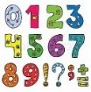 | Children will:  - Understand position through words alone with no pointing,  - Describe a familiar route, for example how do they get to school from their home.  - Discuss routes and locations, using words like ‘in front of’ and ‘behind’.
Understanding the World   | Children will:  - Look at pictures of the local community and talk about their experiences of these places.  - Talk about seaside holidays and day trips they have been on and make comparisons to where they live.  - Talk about different countries and talk about the differences they have experienced or seen in photos.
Expressive Arts and Design   | Children will:  - Explore different materials freely, in order to develop their ideas about how to use them and what to make. (Junk Modelling)  - Develop their own ideas and then decide which materials to express them.  - Children will create models and pictures linked to the local area.  - Bake and decorate cookies and cakes.
Key events for the half term | - Friday 1st May – Nursery coffee morning.  - Monday 8th June – Nursery SHINE afternoon 2:00 – 3:15.  - Tuesday 1st July – INSPIRE session in school joining with Reception led by Reverend Baker from St Thomas’ Church 2:00 – 3:00.
Homework | This half term we would love to see any photographs of your child’s home or places that are familiar to them.

