
What is my child learning in Year 2…

School Values  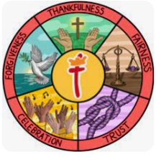 | Everything we do at St Thomas' CofE Primary Academy is built upon our values of thankfulness, fairness, forgiveness, trust and celebration.  Our core Christian values underpin the British values and are closely linked. Core British Values of democracy, the rule of law, tolerance, respect and individual liberty are taught in the context of our strong Christian ethos.  Each half term we focus on one of our values through our class teaching and worship. This half term our key focus is Trust. We aim to trust in God and provide a safe and secure environment in which we can trust one another so that everyone feels valued and is able to share their opinions and grow in confidence.
RE  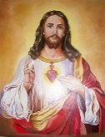 | In RE this half term, we will be exploring The Covenant, and our focus question is ‘How special is the relationship Jews have with God? (Judaism). We will be looking at Kashrut (food laws) and how this helps Jews show God their value and respect for him and how this shows their special relationship. This also links to Passover which we have some knowledge on from a previous topic. We will look at the covenant story of Abraham to support our learning.
English    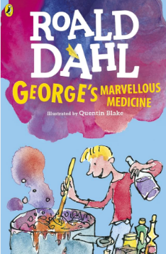  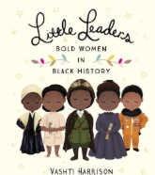 | Focus text  In English, we are focusing on a book called ‘Georges Marvellous Medicine’ by Roald Dahl. This is the laugh-out-loud tale of George Kranky, who plots revenge on his mean and miserable Grandma by concocting a magic medicine for her.  We will also be reading extracts from the non-fiction book, ‘Little Leaders – Bold Women’, particularly focusing on the works of Mary Seacole.  In writing, the children will be writing instructions on how to make their very own Marvellous Medicine, as well as writing stories inspired by the story too. We will also be researching Mary Seacole and writing biographies on her life and her achievements.  We will continue to practise and embed year 2 writing skills such as using conjunctions, expanded noun phrases, questions and exclamations and improving our writing with exciting openers and adverbs too.
Reading   | Within reading groups, children in Year 2 will continue to work on their decoding skills, their use of prosody and expression when reading, as well as working on their comprehension by answering questions about what they’ve read and explaining how they know.  As well as reading groups, we will have an additional guided reading session a week wherein we will focus on the following skills:  - Vocabulary – Looking at what the word means.  - Inference – Use clues in the text to help you.  - Predicting – What may happen next?  - Retrieval – The answer is somewhere in the text.  - Sequencing – Putting events in order  We also have our weekly session in our library where the children will have the chance to enjoy some quiet reading and share some of their favourite stories! We will still be taking library books home on a Wednesday and the children can change them every week (as long as they bring them back).  Some children have not returned their borrowed books. Can these please be returned to school as soon as possible? If you think you may have lost the book they have borrowed from school, please can you let me know by sending a message via Class Dojo.
Maths    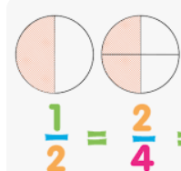 | In maths for the whole summer term, we will be focusing on  - Mass, capacity and temperature  - Fractions  - Time  We will be continuing our programme called mastering number. We will be teaching this every afternoon after lunch. This will focus on the children really understanding their number bonds and links within numbers so they can learn facts by heart.  Our KIRF this half term is to know the 5 times table (× and ÷).
Science   | Our topic in science this half term is ‘Living Things and their Habitats’.  The unit covers the following areas:  • Habitats in my local area  • Polar habitats  • Desert habitats  • Ocean habitats  • Woodland habitats  • Microhabitats  • Habitats and diet  • Food chains  • Living, dead or never alive?  We will be going on a class trip to Hoo Zoo and Dinosaur World on Tuesday 21st April which will link to our Science topic.
History   | Why were the lives of Florence Nightingale and Mary Seacole significant?  - How can we work out why Mary Seacole is famous?  - What were the most important moments in Mary’s life?  - How important was Mary’s work in the Crimean war and how do we know?  - How did life change for Mary after the Crimean war?  - Who was Florence Nightingale?  - What was wrong with hospitals in the 1800s?  - How did Florence Nightingale improve the conditions in hospitals?  - How did Florence Nightingale’s work contribute to hospitals today?  - Who deserves to be commemorated for their significance?
  ART | Our art focus for this half term is ‘craft and design (map it out). This unit focuses on teaching children to explore and create maps through various art forms, including drawing, felt making, printmaking, and designing stained glass  Lesson 1-Creative Journey  Lesson 2-Making felt
Computing   | Creating Media – Digital Music  Lesson 1 -How music makes us feel  Lesson 2 – Rhythms and patterns  Lesson 3 – How music can be used  Lesson 4 – Notes and tempo  Lesson 5 – Creating digital music  Lesson 6 – Reviewing and editing music
PE   | Dance (with Mr Case)  PE will be on Wednesdays and Thursdays this half term. | Net and Wall  - Use ready position to defend space.  - Develop returning a ball with hands.  - Play against a partner.  - Develop racket skills.  - Returning a ball.
Music   | Myths and Legends (Structure)  - Recognise, play and write rhythms with one beats and paired half beats.  - Show a rest beat using a silent movement.  - Read and follow a structure from left to right.  - Add rhythms to a structure to create a beginning, middle and end.  - Work well as part of a group, listening to others and respecting their ideas.  - Maintain a steady beat.  - Use a thinking voice to play rhythms on an instrument.
PSHE   | Our topic this half term is ‘relationships’  Lesson 1 – Families  Lesson 2 – Keeping safe  Lesson 3 – Friends and conflict  Lesson 4 – Secrets  Lesson 5 – Trust and appriciation  Lesson 6 – Celebrating special relationships
Dates for diary | Future dates to be aware of:  - Thursday 16th April – Fire service visiting Year 1 and Year 2.  - Tuesday 21st April – Year 2 visit to HooZoo and Dinosaur World  - Tuesday 28th April – Year 2 INSPIRE at St Thomas’ Church  - Friday 5th June – Year 2 coffee morning  - Friday 5th June - PSA Summer Fair  - Friday 19th June – Father's Day breakfast  - Monday 22nd June – Class Photographs  - Friday 25th June – Sports Day  - Monday 29th June – Year 2 SHINE
Homework | Homework will be sent out on a Friday and will be due back the following Wednesday.  The children are also encouraged to continue playing Times Tables Rockstars at home 3 times a week as well as reading 3-5 times a week too. Reading records should be signed by an adult to indicate that their child has read at home. Reading books will be changed weekly. If they have finished their book, please encourage your child to read it again for fluency and to improve comprehension.  Thank you for your support with completing your child’s homework.

