What is my child learning in Year 5…

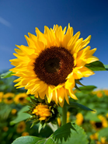
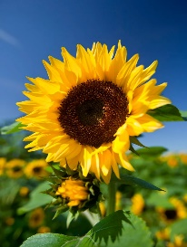

School Values  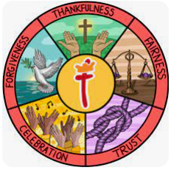 | Our school value this term is Trust. In Year 5 we will be reading stories from the Bible such as Daniel in the Lion’s Den and David and Goliath and learning about how trusting in God and having faith in him can give us true strength. We will be thinking about and reflecting on how we can use our faith in God to find strength in our own lives to overcome our modern-day struggles.
RE     | In RE this half term, Year 5’s topic is ‘What is the best way for a Sikh to show commitment to God?’  Within this unit, Year 5 will consolidate their prior learning on Sikhism throughout this school year and will consider and compare all the ways that Sikhs show their commitment to their faith.
English    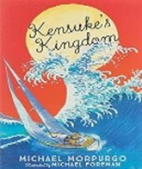 | Book focus:  This half term in Year 5 English, our learning will be centred around the exciting and humorous text Who Let the Gods Out? by Maz Evans. This engaging story will inspire our reading and writing as we explore themes of mythology, adventure, and character development.  Our main writing focus will be on creating a third-person narrative, where pupils will develop their storytelling skills, including characterisation, setting, and plot structure. We will also explore Greek myths, using a range of texts to support understanding, before planning and writing our own original myths.  In addition, we will study poetry, with a focus on Tanka poems. Pupils will learn about the structure and features of this form and create their own imaginative pieces.  Throughout each unit, children will be developing and applying key Year 5 writing skills, including grammar, punctuation, vocabulary choices, and editing techniques to improve their work.  We look forward to an engaging and creative half term in English.
Reading   | In reading, Year 5 will be using a variety of texts to further a number of skills including their knowledge of:  - Vocabulary – Looking at what the word means.  - Inference – Use clues in the text to help you.  - Predicting – What may happen next?  - Retrieval – Finding facts and key details.  - Sequencing – Putting events in order  - Summarising- Finding the main points.  - Comparing/ Contrasting- commentating on what is happening and discussing the content.  We will also be continuing with our SQUIRT (Silent/ Quiet Uninterrupted Independent Reading Time), a 20 minute reading session for each year group which will take place in our new school library. This has already become a cherished and, for many, favourite part of the week.
Maths   | In maths, Year 5 will be covering the following topics:  - Negative numbers  - Compare and calculate area  - Factors and multiples  We will also be completing Fluent in 5 every afternoon for 5 minutes after lunch. Our Key Instant Recall fact topic of the half term is ‘I can recall metric conversion’.
  Science | Year 5’s topic in Science will be Life Cycles.  We will be learning about the life cycles of mammals, amphibians, insects and birds.  We will have the opportunity to go down to the pond in our woodland area to look out for frogs too.
History  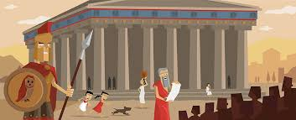 | What Influence did the Ancient Greeks have on our world?  This half term in History, pupils will be learning about the Ancient Greeks and their achievements, spanning from around 3000 BCE to the reign of Alexander the Great (around 330 BCE).  Children will begin by exploring the Minoan civilisation and how life in early Greece developed. They will then investigate how historians learn about the Ancient Greeks through archaeological evidence and historical sources. As the unit progresses, pupils will study key events such as the founding of Athens and Sparta, the Persian invasion, and the impact these had on daily life in the Greek city-states.  Later in the unit, children will learn about the leadership of Alexander the Great and how his influence shaped the ancient world. Throughout the topic, pupils will develop their historical enquiry skills, concluding with a response to the key question: What were the greatest achievements of Ancient Greece?
  Design and Technology | Stuffed Toys  Design a stuffed toy, considering the main component shapes of their toy.  Create an appropriate template for their stuffed toy.  Join two pieces of fabric using a blanket stitch.  Neatly cut out their fabric.  Use appliqué or decorative stitching to decorate the front of their stuffed toy.  Use blanket stitch to assemble their stuffed toy, repairing when needed.  Identify what worked well and areas for improvement.
Computing   | This half term in Computing, children will begin learning how to create vector drawings. They will explore a range of digital drawing tools and learn how to use them effectively to design their own images.  Pupils will develop an understanding that vector images are made up of shapes and lines, with each part known as an object. They will learn how to manipulate these objects by layering, grouping, and duplicating them, enabling them to create more detailed and complex designs.  Throughout the unit, children will build their confidence in using digital tools creatively while developing key computing skills.
French   | Meet my French family!  This term, Year 5 will be learning to explain how many siblings they have, name the members of their family tree and describe the people in their family including what they look like.  They will finish the topic by preparing a presentation to the rest of the class in French about their family.
PE   | Athletics  To develop fluency and coordination when running for speed.  To develop technique in relay changeovers.  To develop throwing with greater control and technique.
  Music | Ballads  Identify the key features of a ballad.  Perform a ballad using actions.  Sing in time and in tune with a song and incorporate actions.  Retell a summary of an animation’s story.  Write a verse with rhyming words which tell part of a story.  Perform their lyrics fluently and with actions.
PSHE   | PSHRE- Relationships  - Recognising me  - Safety with online communities  - Being in an online community  - Online gaming  - My relationship with technology – screen time  Due to our work in the last academic year, we are proud to have obtained the ‘Bronze award’ as a UNICEF Rights Respecting School. We are now aiming to further our understanding of the UN rights of a child by embedding these into our curriculum.
Key events for the half term | Future dates to be aware of:  - Monday 20th April – Year 5 SHINE  - Friday 5th June – PSA Summer Fair  - Wednesday 10th June – Friday 12th June – Dovedale Residential  - Friday 19th June – Father's Day breakfast  - Monday 22nd June – Class Photographs  - Friday 25th June – Sports Day  - Friday 26th June – Year 5 coffee morning
Homework | In year 5, we will be sending weekly homework which will focus on Maths arithmetic practice in order to consolidate their learning at home. It will be handed out on a Friday afternoon and is expected to be completed and returned by Wednesday the following week.  We will also be sending home weekly spellings which we expect the children to practice 3 times a week in preparation for a spelling test the following Friday morning.  The children are also encouraged to continue playing Times Tables Rockstars at home 3 times a week as well as reading 3-5 times a week too. Reading records should be signed by an adult to indicate that their child has read at home. Please make a note if your child has finished their book and needs to change it so that we are able to do so.  Thank you for your support with completing your child’s homework.

