What is my child learning in Year 6…
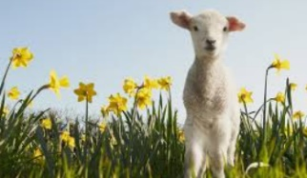
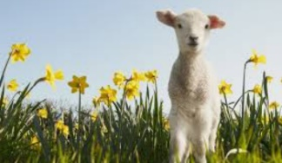


School Values  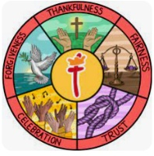 | Here at St Thomas’ we fulfil our mission of ‘Learning for Life with Jesus’ at every opportunity. Underpinning this are our 5 school values of: thankfulness, fairness, trust, celebration and forgiveness.  This half term we will focus on the value of Trust
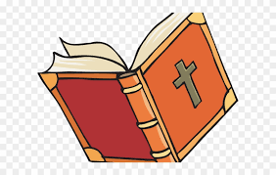  RE | Belief in moral values: Does belief in Akhirah (after life) help Muslims to lead good lives?  In RE, Year 6 will be learning about the 5 pillars of Islam and how Muslims use them to help them lead a good life. We will be discussing ‘just’ wars and ‘holy’ wars and reflecting on each of these, encouraging the children to discuss these themes with maturity.
Writing    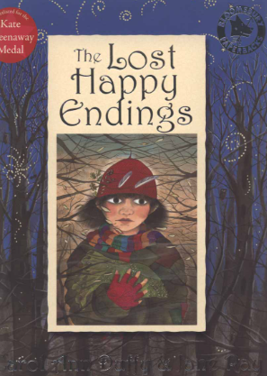 | In writing, the children will be continuing to work on building a range of language devices in order to develop their writing style. This will include:  - The use of more advanced punctuation (semi-colons, brackets, colons)  - Extending sentences by adding fronted adverbials and relative clauses  - Developing their understanding of the difference between and main clause and a subordinate clause so they can manipulate the order of sentences.  - Exploring language choices and ensuring they are appropriate for the audience of that genre  - Looking at the features of persuasive writing and biographies.  Using ‘The Lost happy endings’ as inspiration, we will focus on descriptive writing. Later in the term we will explore features of a biography.
Reading | This half term we will be exploring ‘The Lost happy endings’. We will be using our inference and retrieval skills to answer questions.  As well as exploring our new text, children will also be exposed to many fiction, non-fiction and poetry texts to build up their stamina and comprehension.
Maths  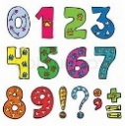 | This half term we will be revising topics taught so for this year. During all the topics, we will continue to focus on both fluency, problem solving and reasoning questions to ensure the children develop a deep understanding of the concepts.
  Science | This half term children will continue to learn about Diet, drugs and lifestyle.  Children will explore how lifestyle choices affect our health. They will also identify ways to reduce their negative impact.
Geography | This half term we will be continuing to learn all about population. We will then move on to learning in depth about where our energy comes from. Children will describe the significance of energy and give examples of sources of energy and their trading routes.
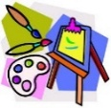  Art | Craft & Design – Benin art  Discovering Benin Art -Children are introduced to the Kingdom of Benin and explore Benin Bronzes, learning that art was used to tell stories and show importance.
Computing   | Creating Media – 3D Modelling  Children will learn all about:  Introduction to 3D modelling  Modifying 3D objects  Make your own name badge  Make a desk tidy  Planning a 3D model  Make your own 3D model
French  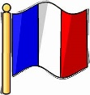 | Visiting a town in France  Children will:  Describe routes to school using pictures and word cards.  Follow simple directions accurately.  Describe the relationship between places using a preposition.  Put modes of transport into a simple sentence.  Role-play buying tickets in French.
  PE | For the first half of this new term, we will continue to develop a skill set that is transferable to OAA (Outdoor adventurous activity). Children will work collaboratively to solve problems and are encouraged to be inclusive of others. They will share ideas to create strategies to produce the best solution to a challenge.
  Music | Baroque  Children will discuss musical eras in context, identifying how they have influenced each other, and discussing the impact of different composers on the development of musical styles.
PSHE   | Dreams and goals  Children will be encouraged to think about their own personal learning goals, in and out of school. We will explore the emotions in success and how to recognise achievements and compliments.
Key events for the half term | Monday 13th April – MHST workshops begin for Year 6  Monday 11th May SATS – Grammar & Punctuation test - 45 minutes & Spelling Test - 20 minutes  Tuesday 12th May SATS - English Reading Test - 60 minutes  Wednesday 13th May SATS - Mathematics Arithmetic (Paper 1) - 30 minutes & Mathematics Reasoning (Paper 2) - 40 minutes  Thursday 14th May SATS - Mathematics Reasoning (Paper 3) - 40 minutes  Friday 15th May – Year 6 Coffee morning  Wednesday 3rd June – Year 6 trip to Alton Towers  Friday 5th June - Summer Fair  Monday 15th June – Year 6 leavers photos  Thursday 25th June – Sports day  Thursday 25th June – Sandbach school transition day  Friday 26th June – Sandbach school transition day  Monday 29th June – The Kings transition day & KSS transition  Tuesday 30th June – The Kings transition day & KSS transition  Wednesday 1st July – The Kings transition day & KSS transition & St Margaret Ward transition & Alsager transition  Thursday 2nd July – The Kings transition day & St Margaret Ward transition  Monday 6th July – Year 6 SHINE afternoon  Wednesday 8th July – Year 6 Show 1.30pm  Wednesday 8th July Year 6 Show 6pm  Thursday 9th July Year 6 Show 6pm  Wednesday 15th July – Year 6 Prom  Friday 17th July – Leavers assembly 1.30pm (Children can leave with parents afterwards)
Homework | In year 6, we will continue to send a range of SPAG, reading and maths homework each week to prepare them for their SATs. We ask that the children also read their reading book at least 3 times a week and log on and play Times Table Rockstars 2-3 times a week too!

