What is my child learning in Nursery.
Spring 2 – 2025 – What is it like in the countryside?

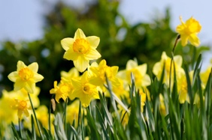

School Values  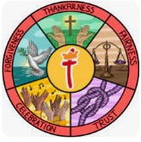 | For Spring 2 the whole school will be looking at forgiveness. In nursery we shall be learning the importance of saying sorry and also being able to forgive our friends.
RE  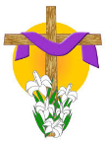 | Children will:  - Look at the story of Easter.  - Talk about Lent and learn that the colour purple is special.  - Learn that the cross is an important symbol.
Communication and Language   | Children will:  - Enjoy listening to longer stories and remember much of what happens.  - Use a wider range of vocabulary.  - Use talk to organise themselves and their play.  - Continue to develop their communication skills with adults and their classmates.  Some of the books we shall be sharing this half term include:
Physical Development  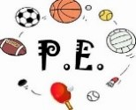 | Children will:  - Continue to develop their fine motor skills through activities such as using tweezers and taking part in daily dough disco routines.  - Continue to develop their dressing skills.  - Use a comfortable grip with good control when holding pens and pencils.  The nursery children wear their uniform all week to allow us to take advantage of spontaneous physical activities. On a rotation we have a PE session, a dance session and a parachute play session.
Personal, Social and Emotional Development   | Children will:  - Continue to increase their independence when using resources and activities in the room.  - Learn about kind choices. They will think about how to resolve conflict and the importance of saying sorry, developing assertiveness, and talking with others.  - Play with one or more other children, extending and elaborating play ideas.
Literacy  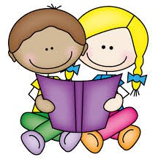 | Children will:  - Develop their phonological awareness, so that they can:  - spot and suggest rhymes  - count or clap syllables in a word  - recognise words with the same initial letter sound, such as  money and mother  - Use some of their print and letter knowledge in their early writing.  - Practice mark-making their name on pieces of artwork.
Mathematics  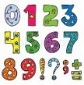 | Children will:  - Talk about and explore shapes using informal and mathematical language: sides, corners, straight, flat and round.  - Combine shapes to make new ones.  - Make comparisons between objects relating to size, weight and capacity.  - Use shapes appropriately for construction.
Understanding the World   | Children will:  - Learn about the occupation of a farmer and the different animals that live on the farm.  - Learn about the life cycle of a butterfly – linking to The Very Hungry Caterpillar story.  - Learn and talk about the signs of the spring season.  - Go on a spring walk with magnifying glasses.
Expressive Arts and Design  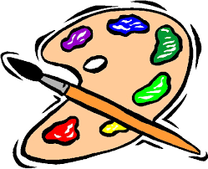 | Children will:  - Learn and remember whole nursery rhymes to sing.  - Sing the melodic shape of familiar songs and make up new songs.  - Use their imagination as they consider what they can do with different materials.
Key events for the half term | Thursday 5th March – World Book Day – the children are invited to dress up as frogs, wear night-time themed outfits (pyjamas, stars, moons, night skies), or be something Magical or Mystical (wizards, fairies, dreamlike character

