What is my child learning in Year 4…


School Values  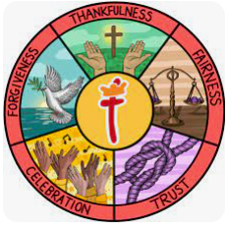 | Our Gospel value this half term is Forgiveness.  In Year 4, we will continue to explore how the value of forgiveness is demonstrated in the world around us and how we can embody it in our daily lives. We will learn about the importance of letting go of anger and resentment, seeking reconciliation, and showing compassion to others. During our class worship sessions, we will read Bible verses that highlight forgiveness and discuss how we can practise it in our actions and words every day. We will also examine our key value of forgiveness in line with our Rights Respecting Schools.
RE     | Easter: Is Forgiveness Always Possible for Christians?  In Year 4, we will explore the meaning of Easter and the importance of forgiveness in Christianity. We will discuss the question, "Is forgiveness always possible for Christians?" by looking at Bible stories which highlight themes of mercy and redemption. Through discussions and activities, we will consider how forgiveness can be challenging and why it is a key value in Christian teachings. We will also reflect on how these beliefs might influence the way Christians treat others and whether religious beliefs always lead to kindness and good actions.
English    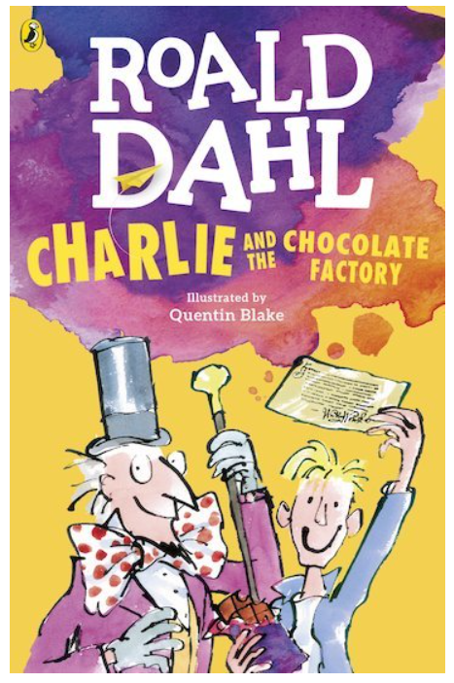 | Book focus:  Book Focus: Charlie and the Chocolate Factory – Roald Dahl  In English this half term, we will focus on a new book, Charlie and the Chocolate Factory by Roald Dahl, which links beautifully to our exploration of imagination, fairness, and perseverance. This much-loved story follows Charlie Bucket on an extraordinary adventure inside Willy Wonka’s magical chocolate factory, bringing themes of creativity and moral choices to life through humour and vivid storytelling. As we read, we will explore character development, descriptive language, and important messages about kindness, honesty, and gratitude, while developing our comprehension and writing skills. Through discussions, creative activities, and engaging writing tasks, the children will be inspired by Charlie’s positive attitude and the exciting world of Willy Wonka.  Writing  This half term in writing, the children will develop their creative and analytical skills through a range of engaging activities linked to Charlie and the Chocolate Factory. They will begin by writing a detailed setting description of Willy Wonka’s chocolate factory, using rich vocabulary and descriptive language to bring the magical environment to life.  Next, the children will explore instructional writing by designing their own chocolate bar. They will learn how to write clear, step-by-step instructions, using precise language and organisational features to explain how their creation is made.  Finally, the children will take part in a film and book comparison of Charlie and the Chocolate Factory, developing their comprehension and critical thinking skills. They will identify similarities and differences between the two versions and learn how to express their opinions clearly in writing.
Reading   | This half term in reading, we will continue to focus on deepening and embedding our reading skills. The children will explore a variety of texts, practising important skills such as understanding word meanings, making predictions, drawing inferences, retrieving information, and summarising key points. Through guided reading sessions, we’ll work on approaching different types of questions with confidence, setting a strong foundation for their continued development as readers.
Maths   | In Maths this half term, Year 4 will cover the following topics:  - Fractions: Exploring fractions, comparing and simplifying them, and learning how to add and subtract fractions to strengthen mathematical skills.  - Decimals: Understanding place value in decimals, comparing and ordering decimals, and learning how to add, subtract, multiply, and divide them. Children will also explore the relationship between fractions and decimals to deepen their mathematical understanding.
  Science | This half term in Science, we will focus on:  - Data Collection: Developing skills to gather, record, and interpret scientific data effectively. The children will apply these skills while conducting experiments related to sound, analysing results, and drawing conclusions.  - Electricity: Exploring electrical circuits, identifying components such as switches, bulbs, and buzzers, and investigating how electricity flows. The children will also learn about conductors and insulators and consider the importance of electrical safety.  - Energy: Understanding different types of energy, including renewable and non-renewable sources, and discussing how energy is transferred and used in everyday life.  The children will take part in hands-on activities to deepen their understanding of sound and practise collecting and analysing data to support their scientific findings.
Geography   | Our geography topic for this half term is “Where Does Our Food Come From?”  The children will explore where different foods are produced and how they travel from farms and factories to our plates. They will learn about local, national, and global food sources, and investigate how climate, environment, and location affect what can be grown in different parts of the world.  Through map work, discussions, and research activities, the children will examine food miles, fair trade, and the journey of food from field to fork. They will also consider the importance of sustainability and making responsible choices as consumers. This topic will help develop their geographical skills while encouraging curiosity about the world around them and the food we eat every day.
  Art | This term, our Art lessons will focus on mechanical engravings as a starting point for exploration. Pupils will develop an awareness of proportion, composition, and pattern in their drawings, learning how to combine different media to create visual effects. They will experiment with techniques to transform their drawings into prints, understanding how to layer and manipulate materials for artistic impact. Through this process, students will enhance their skills in observation, creativity, and technical execution.
Computing   | This term in Computing, children will be learning about how and why data is collected over time. They will explore how humans use their senses to understand the world and how computers use sensors to monitor the environment. Pupils will collect and explore real data, learning about data points, data sets, and how often information is recorded. They will use computers to analyse information, look for patterns, and answer questions. By the end of the unit, children will design their own investigations and use data loggers to automatically collect information to support their findings.
French   | This half term, we will focus on weather and the water cycle in French.  The children will learn how to describe different types of weather using key vocabulary and phrases. They will also explore how to talk about the seasons and temperature in French. Building on this, they will be introduced to the water cycle, learning key terms and how to explain its stages in simple French. Through interactive activities, role-play, and listening exercises, the children will develop their pronunciation and conversational skills while gaining a deeper understanding of weather patterns and the natural water cycle.
PE   | This half term in PE, we will focus on dance and basketball.  In dance, the children will explore movement, rhythm, and expression, developing their ability to create and perform sequences. They will learn how to use body language and timing to convey emotions and themes, working both individually and collaboratively to choreograph routines.  In basketball, the children will develop key skills such as dribbling, passing, and shooting while learning the importance of teamwork and strategy. They will focus on movement, positioning, and defensive play to improve their overall performance on the court.  Through these activities, the children will build confidence, coordination, and teamwork skills while enhancing their enjoyment of physical activity.
  Music | This term in Year 4, we will be exploring Haiku, music, and performance with the theme of the Hanami Festival. Inspired by this traditional Japanese springtime celebration, which honours the fleeting beauty of cherry blossoms, children will use descriptive vocabulary to create their own Haiku poems. They will then put their Haiku to music, experimenting with melody and rhythm to reflect the delicate and transient nature of the blossoms. Finally, they will enhance their compositions with percussion sound effects, bringing all elements together in a group performance. Through this creative and immersive topic, pupils will develop their understanding of poetic structure, musical expression, and performance skills. We look forward to a wonderful celebration of words, music, and nature!
PSHE   | In PSHRE this half term, the children will explore the theme of ‘Healthy Me,’ focusing on both physical and emotional well-being.  They will learn about the importance of healthy friendships and positive group dynamics, understanding how relationships impact their well-being. The topic will also cover the risks associated with smoking and alcohol, helping children to make informed choices about their health. Through discussions and role-play, pupils will develop assertiveness skills, learning how to resist peer pressure and make decisions that align with their values. They will also reflect on their inner strength, recognising their ability to make positive choices and support others in doing the same. By the end of the unit, children will have a deeper understanding of how to maintain a healthy lifestyle, build strong friendships, and confidently navigate social challenges.
Key events for the half term | Future dates to be aware of:  Monday 23rd February – Inset Day  Tuesday 24th and Thursday 26th February – parents evening  Tuesday 3rd March – Year 4 Inspire 2pm  5th March – World book day  Friday 13th March – Bike ability  Friday 20th March – Inset Day
Homework | In year 4, we will send a range of SPAG, reading and maths homework each week.  Homework will always be given out on Fridays and is due back on the following Friday. Children are welcome to bring their homework in earlier and leave it in their trays.  We ask that the children also read their reading book at least 3 times a week and log on and play Times Table Rockstars 2-3 times a week too!

