What is my child learning in Year 6…
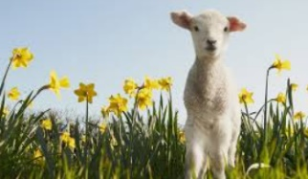
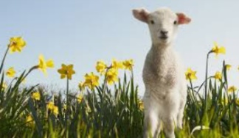


School Values  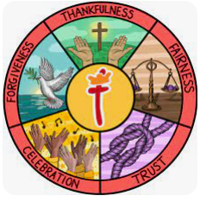 | Here at St Thomas’ we fulfil our mission of ‘Learning for Life with Jesus’ at every opportunity. Underpinning this are our 5 school values of: thankfulness, fairness, trust, celebration and forgiveness.  This half term we continue with the focus on the value of forgiveness
  RE | Salvation: What does the Resurrection mean for Christians?  In RE this half term, we will begin to explore resurrection accounts and compare with the way Christians interpret these texts. We will also look at connections between Luke 24 and the Christian concepts of Sacrifice,  Resurrection, Salvation, Incarnation and Hope using theological terms.
Writing    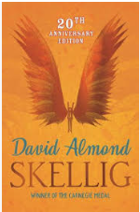 | In writing, the children will be continuing to work on building a range of language devices in order to develop their writing style. This will include:  - The use of more advanced punctuation (semi-colons, brackets, colons)  - Extending sentences by adding fronted adverbials and relative clauses  - Developing their understanding of the difference between and main clause and a subordinate clause so they can manipulate the order of sentences.  - Exploring language choices and ensuring they are appropriate for the audience of that genre  - Looking at the features of different genres  Using ‘Skellig’ as inspiration, we will focus on dialogue – characterisation and advancing the action. We will be writing formal letters and retelling the story from a different point of view.
Reading | This half term, we will continue to read ‘Skellig’  Children will continue to complete comprehension questions and activities, practicing their inference, retrieval, predicting and summarising skills. Later this half term, we will begin to complete reading activities that link to the SATs reading paper.
Maths   | In maths, we will be covering the following topics:  - Area  - Fractions, decimals and percentages  - Perimeter and volume  During all of the topics, we will continue to focus on both fluency and problem solving and reasoning questions to ensure the children develop a deep understanding of the concepts.
  Science | During the first half of this half term children will be learning all about The Circulatory system.  For the second half of Spring 2, children will learn about Diet, drugs and lifestyle.  Children will explore the heart and circulatory system through models and enquiries and considering how lifestyle choices affect our health.
Geography | This half term we will be exploring ‘Where does our energy come from?’  Children will:  Describe the significance of energy.  Give examples of sources of energy and their trading routes.  Define renewable and non-renewable energy.  Discuss the benefits and drawbacks of different energy sources.  Describe the significance of the Prime Meridian.  Identify human features on a digital map.  Discuss how transport links have changed over time.
  Art | Artist study – Painting and mixed media  During art this half term, children will use paint and painting techniques to suit a purpose, explore contrasting and complimentary colours and add collage to a painted, printed or drawn background for effect.
Computing   | Spreadsheets  In computing this half term children will have an introduction to spreadsheets. This will include collecting data, formatting spreadsheets, event planning and presenting data.
French  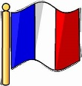 | Planning a French Holiday  Children will:  Remember the countries in the world in French.  Use a writing model to create a complex sentence.  Identify the present and future tenses in reading and listening.  Label images of clothing correctly.
  PE | Volley Ball  Children will learn the techniques required to successfully perform a range of actions in volleyball. Children will also learn lots of different types of skills players need in order to play both attacking and defensive shots in volleyball.
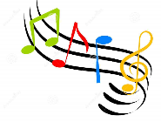  Music | Theme and variations  Children will perform rhythms confidently either on their own or in a group,  identify the sounds of different instruments and discuss what they sound like and will begin to make reasonable suggestions for which instruments can be matched to which art pieces.
PSHE   | Healthy me  Children will explore:  - Taking personal responsibility  - How substances affect the body  - Exploitation, including ‘county lines’ and gang culture  - Emotional and mental health  - Managing stress
Key events for the half term | Future dates to be aware of:  - Tuesday 24th and Thursday 26th February Parents evening  - Thursday 26th February Year 6 visiting The Kings for the careers fair  - Friday 27th Feb Year 6 Coffee morning  - Thursday 5th March World Book Day  - Tuesday 10th March Visit to the Open Centre  - Monday 16th March – Year 6 Shine 2pm  - Wednesday 18th March – School council and RRSA visit Parliament
Homework | In year 6, we will continue to send a range of SPAG, reading and maths homework each week to prepare them for their SATs. We ask that the children also read their reading book at least 3 times a week and log on and play Times Table Rockstars 2-3 times a week too!

