What is my child learning in Nursery?
Spring 1 – 2025 – What is it like in Winter?


School Values  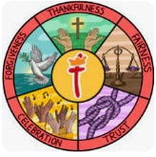 | Underpinning our mission ‘Learning for Life with Jesus we have our 5 school values of: thankfulness, fairness, trust, celebration and forgiveness. This half term we are focusing on forgiveness. In nursery we shall be learning the importance of saying sorry and forgiving our friends.
RE  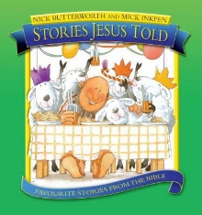 | Using the book ‘Stories Jesus Told’ by Nick Butterworth:  Children will:  - Look at some of the stories that Jesus told together and see what we can learn from these stories.
Communication and Language   | Children will:  - Have opportunities to develop their understanding of ‘why’ questions.  - Continue to develop the skills required to pay attention to more than one thing at a time, which can be difficult.  - Be given daily opportunities to develop their use of a wider range of vocabulary.  Some of the books we shall be sharing this half term include:  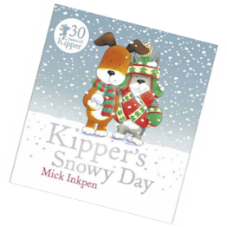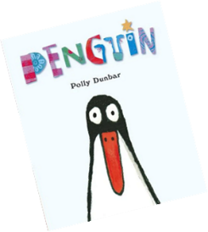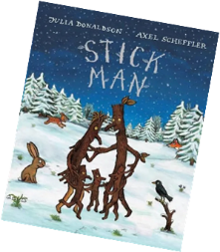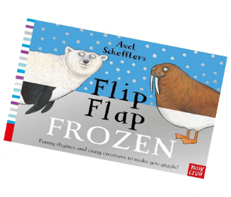
Physical Development   | Children will:  - Given opportunities to match their developing physical skills to tasks and activities both inside and outside.  - Provision will allow children time to practice using a comfortable grip with good control when holding pens and pencils. Children may be showing a preference for a dominant hand  Children in nursery come to school every day in the school PE kit, this allows us to practice our physical skills as much as possible. On a rotation throughout the week, we have a PE session, a dance session and a parachute play session.
Personal, Social and Emotional Development   | Children will:  - Continue to increase their independence when using resources and activities in the room.  - Learn about kind choices. They will think about how to resolve conflict and the importance of saying sorry, developing assertiveness and talking with others.  - Play with one or more other children, extending and elaborating play ideas.
Literacy  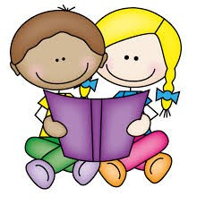 | Children will:  - Develop their phonological awareness, so that they can:  - spot and suggest rhymes  - count or clap syllables in a word  - recognise words with the same initial letter sound, such as  money and mother  - Use some of their print and letter knowledge in their early writing.  - Practice mark-making their name on pieces of artwork.
Mathematics  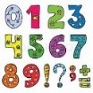 | Children will:  - Talk about and identify the patterns around them and use informal language like ‘pointy’, ‘spotty’, ‘blobs’ etc.  - Have the opportunity to practice ABAB patterns which will then lead them to be able to notice and correct an error in repeating patterns.  Our Preschool children will start to explore the White Rose Maths scheme of learning.
Understanding the World   | Children will:  - Learn about what happens during the different seasons.  - Learn and talk about the places that penguins and polar bears live.  - Go on a winter walk with magnifying glasses up the secret bank.
Expressive Arts and Design   | Children will:  - Make imaginative and complex ‘small worlds’ with blocks and construction toys.  - Be given opportunities to practice their mark making and drawing skills to allow them to develop the ability to draw with increasing complexity and detail, such as drawing a face
Key events for the calendar | - Tuesday 24th February – SHINE afternoon – Eco Council focus  - Friday 23rd January – Family worship and Nursery coffee morning  - Tuesday 7st July – Nursery and Reception Inspire afternoon (2.00 till 3:00pm with St Thomas’ Church in the School Hall)
Homework | When sharing a book with your child it would be helpful to talk about the five key concepts about print:  - We read English from left to Right  - We read from top to bottom  - Print can have different purposes  - The names of the different parts of a book  - Pages are sequential, we read them one after another.

