What is my child learning in Nursery:
Autumn 1 – 2025 – What do we Celebrate?
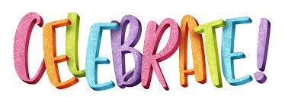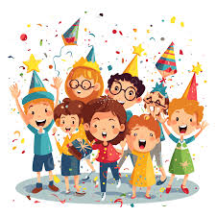
School Values  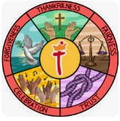 | For Autumn 2 our Value is fairness. We shall be making links to fairness through sharing and taking turns whilst building relationships and continuing to develop the children’s sense of responsibility and membership of the school community. We will encourage the children to think about their actions by asking them if they would like themselves to be treated the same way.
RE  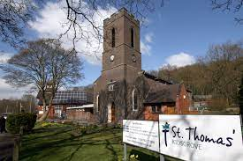 | Children will:  - Learn about the Nativity Story – What is the true meaning of Christmas?  Our EYFS nativity will be Monday 15th December at 2:00pm and Wednesday 17th December at 9:30 am. More information will follow shortly.
Communication and Language   | Children will be learning to  - Sing a large repertoire of songs.  - Sing many rhymes, and be able to talk about familiar books.  - Understand a question or instruction that has two parts.  Some of the books we shall be sharing this half term include:  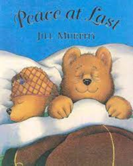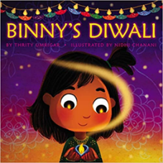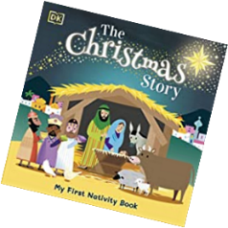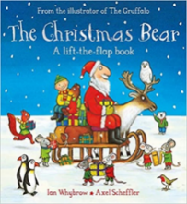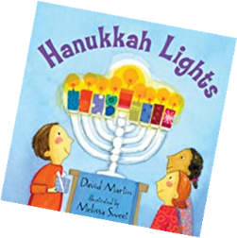
Physical Development  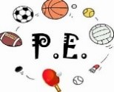 | Children will:  - Continue to develop their fine motor skills through activities such as using tweezers and taking part in daily dough disco routines.  - Have the opportunity to use one handed tools and equipment for example scissors to make snips in paper with. (A supervised activity)  - Continue to develop their dressing skills.  - Use a comfortable grip with good control when holding pens and pencils.  Children will continue to have a weekly P.E lessons on a Monday, Wednesday and a Friday morning as the EYFS children come to school in their PE Kits they do not need to wear anything different. On a rotation we have a PE session, a dance session and a parachute play session.
Personal, Social and Emotional Development   | Children will:  - Begin to understand about feelings.  - Be given opportunities to talk about their feelings using words like happy, sad, angry or worried.  - Be encouraged to understand how others may be feeling.
Literacy  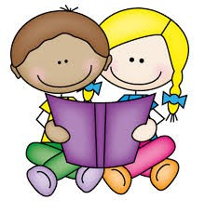 | Children will:  - Be exposed to and given the opportunity to engage in extended conversations around stories.  - Children will hear and learn new vocabulary.  - When mark making children will be encouraged to give a meaning to the marks that they make.
Mathematics  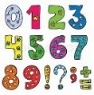 | Children will:  - Be given the opportunity to solve real world mathematical problems with numbers up to 5. For example, counting how many children are at the snack table, how many cups do they need. What if they aren’t given enough cups? How many more do they need.
Understanding the World   | Children will:  - Given lots of opportunities to learn that people have different beliefs and celebrate different times in different ways.  - Look at the different festivals of light celebrated by different communities.  - Use all their senses in hands-on exploration of natural materials.
Expressive Arts and Design  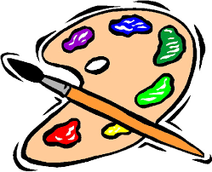 | Children will:  - Use drawing to represent ideas like movement or loud noises (when using different media and materials creating pictures of fireworks).  - Given opportunities to play instruments with increasing control to express their feelings and ideas.
Key events for the half term  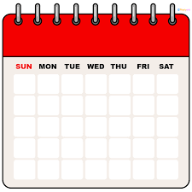 | Friday 7th November – Non uniform day – bring a bottle for the PSA Christmas Fayre  Tuesday 7th November – Non uniform day – bring a chocolate donation for the PSA Christmas Fayre.  w/c 13th Nov -we shall be celebrating World Nursery Rhyme Week  Fri 21st November – Nursery Coffee Morning after family worship.  Fri 21st November – PSA Christmas Fayre – 5:30pm start.  Mon 1st December – Nursery Shine afternoon 2:00pm – 3:00pm  Thu 18th December – Christmas Dinner  Our EYFS nativity will be Monday 15th December at 2:00pm and Wednesday 17th December at 9:30 am. More information will follow shortly.

