



Computing Learning Journey
2025/2026

Intent, Implementation and Impact

Learning for life with Jesus

Intent
All areas of our curriculum are underpinned by our Christian values and we ensure that our curriculum makes links to these values. At the heart of each subject is a set of core skills which form a subject learning journey, this journey is built from EYFS through to year 6 and the skills progressive as you move through the school. Knowledge is communicated to ensure coverage of National curriculum and it is through this knowledge that children apply their skills. Children at St Thomas’ leave with a secure knowledge of both the academic knowledge and skills needed for the next stage of their education. They will have developed a clear set Christian and moral values which they can apply in all areas of their lives and will have taken part in real-life experiences which will have raised their aspirations and given them a thirst for wisdom and knowledge.

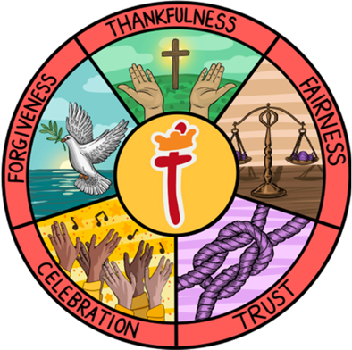
The intention of the St Thomas’ Computing learning journey is first and foremost to provide children with the skills and knowledge they need to embrace new technologies and flourish, both responsibly and safely, in an increasingly digital world. To achieve this, we focus on developing the skills, knowledge and understanding that children need in order to become autonomous, independent users of computing technologies, and gain confidence through active learning and enjoyable activities.

Our History lead in school is Miss E Horwell

Implementation

In line with the National Curriculum, St Thomas’ Computing learning journey identifies five key areas, which stem from the key strands of computing: Computer Science, Information Technology and Digital Literacy. These key areas are woven together to create an engaging and enriching learning experience.

- Computer systems and networks
- Programming
- Creating media
- Data handling
- Online safety

These areas create a cyclical route via a spiral curriculum model, through which pupils can develop their computing knowledge and skills by revisiting and building on previous learning.

The implementation of this curriculum ensures a broad and balanced coverage of National Curriculum requirements, and our curriculum provides pupils with the opportunity to learn and apply transferable skills. Where appropriate, units have been created to link to other subjects, such as art, science and music to enable the development of further transferable skills, and genuine cross-curricular learning.

Computing is taught for 1 hour each week. Each new unit of learning is introduced through an ‘explore’ activity which summarises previous knowledge and skills shared by the children. Children are then introduced to the key vocabulary which will be shared during the unit. During the lesson, activities are scaffolded where appropriate, and assessment and feedback will focus on misconceptions and next steps for learning. At the end of each unit of learning, children will complete an end of unit ‘review’ which will feed into future planning.

Computing Lesson Journey

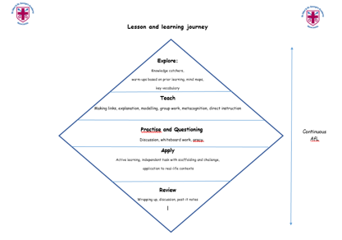
Online Safety is taught throughout each unit and every half term.

In Computing, work is recorded in a class computing journal, with any additional work on the network’s Pupil Share channel in year group folders for monitoring and sharing purposes

EYFS

Computing is taught as part of the Personal, Social and Emotional Development and Expressive Arts and Design area of the EYFS learning and development. Children in Reception will explore a range of computational skills and questions through their theme for the half term. Where appropriate, lessons will take the same form as the rest of the school: explore, teach, practise, apply and review. There will then be an independent activity relating to the input. All classrooms have an investigation station. As part of this, computing based enhanced provision will be planned for. Children also have access to computing-based resources which they are free to use as part of the child-initiated provision. Evidence of these lessons and other learning around computing can be found on Evidence Me linked to the appropriate statements and ELG.
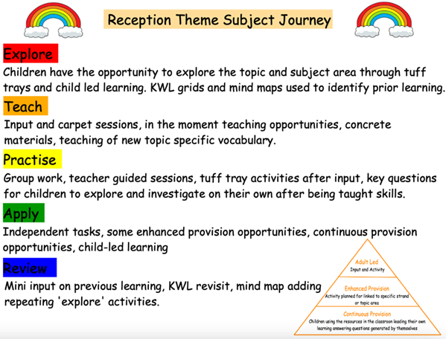
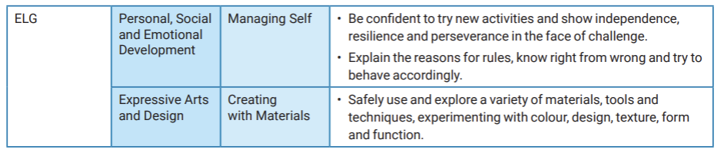
Impact

In addition to the outcomes shown on our curriculum tree, the specific impact of the St Thomas’ Computing Learning Journey is that children will:

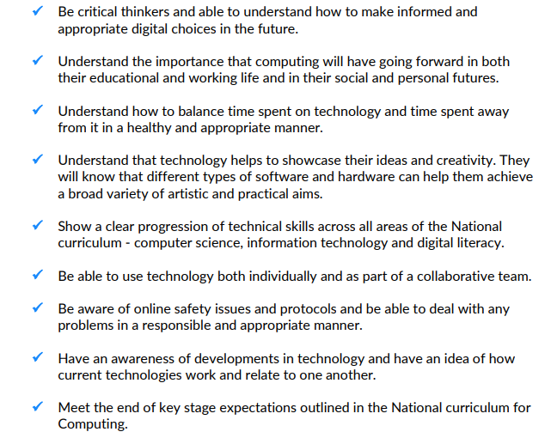

Formative assessment takes part in each lesson and misconception and next steps of the focus for feedback. Summative assessment is completed for each child at the end of each unit of teaching using the assessment overviews at the end of this document. A best fit approach to statements achieved results in an end of year summative grade.

Adaptive Teaching Strategies

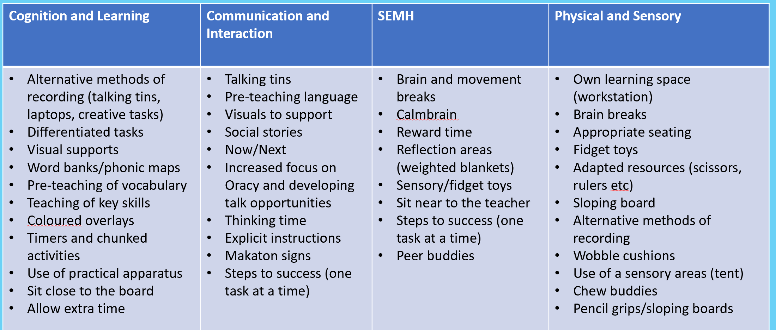

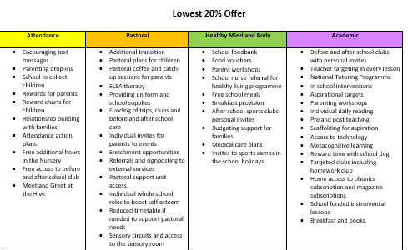
Lowest 20% offer

2025/2026 Computing Overview

 | Autumn 1 | Autumn 2 | Spring 1 | Spring 2 | Summer 1 | Summer 2
Year 1 | Computing systems & networks – Technology around us. | Creating Media - Digital Painting | Programming A – Moving a robot | Data and information – grouping data | Creating Media – Digital writing | Programming B – Programming animations
Year 2 | Computing systems & networks – Technology around us. | Creating Media - Digital photography | Programming A – Robot algorithms | Data and information – pictograms | Creating Media – Digital music | Programming B – Programming quizzes
Year 3 | Computing systems & networks – Connecting Computers | Creating Media - Stop frame animation | Programming A – sequencing sound | Data and information – Branching databases | Creating Media – Desktop publishing | Programming B – Events and actions in programmes
Year 4 | Computing systems & networks – the internet | Creating Media -  Audio production | Programming A – Repetition in shapes | Data and information –  Data logging | Creating Media – Photo editing | Programming B – repetition in games
Year 5 | Computing systems & networks – systems and searching | Creating Media - Video production | Programming A –  Selection in physical computing | Data and information –  Flat file data bases | Creating Media – introduction to Vector Graphics | Programming B – Selection in quizzes
Year 6 | Computing systems & networks – Communication and Collaboration | Creating Media - Web page creation | Programming A –  Variables in games | Data and information – Introduction to spreadsheets | Creating Media – 3D modelling | Programming B – Sensing movement

2025/2026 Computing Curriculum

Computing Curriculum Year 1
Autumn 1 - Computing systems and networks – Technology around us
WK 1 (8.9.25) | WK 2 (15.9.25) |  | WK 3 (22.9.25) |  | WK 4 (29.9.25) |  | WK 5 (6.10.25) |  | WK 6 (13.10.25)
Equipment needed – mouse (track pad) and keyboard
 | Lesson 1 – Technology in our classroom |  | Lesson 2 – Using computer technology |  | Lesson 3 – Developing mouse skills |  | Lesson 4 – Using a computer keyboard |  | Lesson 5 – Developing Keyboard skills
Autumn 2 - Creating Media – Digital painting
WK 1 (3.11.25) | WK 2 (10.11.25) |  | WK 3 (17.11.25) |  | WK 4 (24.11.25) |  | WK 5 (1.12.25) |  | WK 6 (8.12.25)
Resources needed – Paintz.app. alternative Microsoft paint
Lesson 1 – How can we paint using computers? | Lesson 2 – Using shapes and lines. |  | Lesson 3 – Making careful choices |  | Lesson 4 – Why did I choose that? |  | Lesson 5 – Painting all by myself |  | Lesson 6 – Comparing computer art and painting
Spring 1 - Programming A – Moving a robot
WK 1 (5.1.26) | WK 2 (12.1.26) |  | WK 3 (19.1.26) |  | WK 4 (26.1.26) |  | WK 5 (2.2.26) |  | WK 6 (9.2.26)
Resources needed – Bee bot floor robots
Lesson 1 – Buttons | Lesson 2 – Directions |  | Lesson 3 – Forwards and backwards |  | Lesson 4 – Four directions |  | Lesson 5 – Getting there |  | Lesson 6 – Routes
Spring 2 - Data and information – grouping data
WK 1 (23.2.26) |  | WK 2 (2.3.26) |  | WK 3 (9.3.26) |  | WK 4 (16.3.26) |  | WK 5 (23.3.26)
Resources needed – word
Lesson 1 – Label and match and Lesson 2 – Group and count |  | Lesson 3 – Describe an object |  | Lesson 4 – Making different groups |  | Lesson 5 – Comparing groups |  | Lesson 6 – Answering questions
Summer 1 - Creating Media – Digital writing
WK 1 (13.4.26) | WK 2 (20.4.26) |  | WK 3 (27.4.26) |  | WK 4 (4.5.26) |  | WK 5 (11.5.26) |  | WK 6 (18.5.26)
Resources needed - word
Lesson 1 – Exploring the keyboard | Lesson 2 – Adding and removing text |  | Lesson 3 – Exploring the toolbar |  | Lesson 4 – Making changes to the text |  | Lesson 5 – Explaining my choices |  | Lesson 6 – Pencil or keyboard
Summer 2 - Programming B – Programming animations
WK 1 (1.6.26) | WK 2 (8.6.26) |  | WK 3 (15.6.26) |  | WK 4 (22.6.26) |  | WK 5 (29.6.26) |  | WK 6 (6.7.26)
Resources needed – Scratch junior
Lesson 1 – Comparing tools | Lesson 2 – Joining blocks |  | Lesson 3 – Make a change |  | Lesson 4 – Adding sprites |  | Lesson 5 – Project design |  | Lesson 6 – Following my design

Computing Curriculum Year 2
Autumn 1 - Computing systems and networks – IT around us.
WK 2 (15.9.25) | WK 3 (22.9.25) |  | WK 4 (29.9.25) |  | WK 5 (6.10.25) |  | WK 6 (13.10.25) |  | WK 7 (20.10.25)
Resources needed – Microsoft PowerPoint or Google slides
Lesson 1 – What is IT | Lesson 2 – IT in school |  | Lesson 3 – IT in the world |  | Lesson 4 – The benefits of IT |  | Lesson 5 – Using IT safely |  | Lesson 6 – Using IT in different ways.
Autumn 2 - Creating Media – Digital photography
WK 1 (3.11.25) | WK 2 (10.11.25) |  | WK 3 (17.11.25) |  | WK 4 (24.11.25) |  | WK 5 (1.12.25) |  | WK 6 (8.12.25)
Resources needed – Google photos on chrome books
Lesson 1 – Taking photographs | Lesson 2 – Landscape or portrait? |  | Lesson 3 – What makes a good photograph? |  | Lesson 4 – Lighting |  | Lesson 5 – Effects |  | Lesson 6 – Is it real?
Spring 1 - Programming A – Robot algorithms
WK 1 (5.1.26) | WK 2 (12.1.26) |  | WK 3 (19.1.26) |  | WK 4 (26.1.26) |  | WK 5 (2.2.26) |  | WK 6 (9.2.26)
Resources needed – Bee bot floor robots
Lesson 1 – Giving instructions | Lesson 2 – Same but different |  | Lesson 3 – Making predictions |  | Lesson 4 – Mats and routes |  | Lesson 5 – Algorithm design |  | Lesson 6 – debugging
Spring 2 - Data and information – Pictograms
WK 1 (23.2.26) |  | WK 2 (2.3.26) |  | WK 3 (9.3.26) |  | WK 4 (16.3.26) |  | WK 5 (23.3.26)
Resources needed – j2e pictogram and j2e chart
Lesson 1 – Counting and comparing and Lesson 2 – Enter the data |  | Lesson 3 – Creating pictograms |  | Lesson 4 – What is an attribute? |  | Lesson 5 – Comparing people |  | Lesson 6 – Presenting information
Summer 1 - Creating Media – Digital music
WK 1 (13.4.26) | WK 2 (20.4.26) |  | WK 3 (27.4.26) |  | WK 4 (4.5.26) |  | WK 5 (11.5.26) |  | WK 6 (18.5.26)
Resources needed - chrome music lab
Lesson 1 -How music makes us feel | Lesson 2 – Rhythms and patterns |  | Lesson 3 – How music can be used |  | Lesson 4 – Notes and tempo |  | Lesson 5 – Creating digital music |  | Lesson 6 – Reviewing and editing music
Summer 2 - Programming B – Programming quizzes
WK 1 (1.6.26) | WK 2 (8.6.26) |  | WK 3 (15.6.26) |  | WK 4 (22.6.26) |  | WK 5 (29.6.26) |  | WK 6 (6.7.26)
Resources needed – Scratch junior
Lesson 1 – Scratch Jr recap | Lesson 2 – Outcomes |  | Lesson 3 – Using a design |  | Lesson 4 – Changing a design |  | Lesson 5 – Designing and creating a program |  | Lesson 6 – Evaluating
Computing Curriculum Year 3
Autumn 1 - Computing systems and networks – Connecting computers
WK 2 (15.9.25) | WK 3 (22.9.25) |  | WK 4 (29.9.25) |  | WK 5 (6.10.25) |  | WK 6 (13.10.25) |  | WK 7 (20.10.25)
Resources needed - digital devices with a painting application and ‘network tour’, which involves learners identifying key parts of your school network
Lesson 1 – How does a digit device work? | Lesson 2 – What parts make up a digital device. |  | Lesson 3 – How do digital devices help us? |  | Lesson 4 -How am I connected? |  | Lesson 5 – How are computers connected? |  | Lesson 6 -What does our school network look like?
Autumn 2 - Creating Media – Stop frame animation
WK 1 (3.11.25) | WK 2 (10.11.25) |  | WK 3 (17.11.25) |  | WK 4 (24.11.25) |  | WK 5 (1.12.25) |  | WK 6 (8.12.25)
Resources needed – Ideally iPad imotion or stop motion studio
Lesson 1 – Can a picture move | Lesson 2 – Frame by Frame |  | Lesson 3 – What’s the story? |  | Lesson 4 – Picture perfect |  | Lesson 5 – Evaluate and make it great |  | Lesson 6 – Light, camera, action!
Spring 1 - Programming A – Sequencing sound
WK 1 (5.1.26) | WK 2 (12.1.26) |  | WK 3 (19.1.26) |  | WK 4 (26.1.26) |  | WK 5 (2.2.26) |  | WK 6 (9.2.26)
Resources needed – Scratch
Lesson 1 – Introduction to Scratch | Lesson 2 – Programming sprites |  | Lesson 3 – Sequences |  | Lesson 4 – Ordering commands |  | Lesson 5 – Looking good |  | Lesson 6 – Making an instrument
Spring 2 - Data and information – Branching databases
WK 1 (23.2.26) |  | WK 2 (2.3.26) |  | WK 3 (9.3.26) |  | WK 4 (16.3.26) |  | WK 5 (23.3.26)
Resources needed – j2e data
Lesson 1 – Yes or no questions and Lesson 2 – making groups |  | Lesson 3 – Creating a branching database |  | Lesson 4 – Structuring a branching database |  | Lesson 5 – Planning a branching database |  | Lesson 6 – Two ways of presenting information
Summer 1 - Creating Media – Desktop publishing
WK 1 (13.4.26) | WK 2 (20.4.26) |  | WK 3 (27.4.26) |  | WK 4 (4.5.26) |  | WK 5 (11.5.26) |  | WK 6 (18.5.26)
Resources needed – canva (parental consent is required for children under 13 see NCCE for template letter)
Lesson 1 Words and pictures | Lesson 2 – Can you edit it? |  | Lesson 3 – Great template! |  | Lesson 4 – Becoming a designer |  | Lesson 5 – Lay it out |  | Lesson 6 – Why desktop publishing?
Summer 2 - Programming B – Events and actions in programmes
WK 1 (1.6.26) | WK 2 (8.6.26) |  | WK 3 (15.6.26) |  | WK 4 (22.6.26) |  | WK 5 (29.6.26) |  | WK 6 (6.7.26)
Resources needed – Scratch
Lesson 1 – Moving a sprite | Lesson 2 – Maze movement |  | Lesson 3 – Drawing lines |  | Lesson 4 – Adding features |  | Lesson 5 – Debugging movement |  | Lesson 6 – Making a project
Computing Curriculum Year 4
Autumn 1 - Computing systems and networks – The Internet
WK 2 (15.9.25) | WK 3 (22.9.25) |  | WK 4 (29.9.25) |  | WK 5 (6.10.25) |  | WK 6 (13.10.25) |  | WK 7 (20.10.25)
Resources needed - digital devices for learners to interact with access to the internet
Lesson 1 – Connecting Networks. | Lesson 2 – What is the Internet made of? |  | Lesson 3 – Sharing information |  | Lesson 4 – What is a website? |  | Lesson 5 – Who owns the Website? |  | Lesson 6 – Can I believe what I read?
Autumn 2 - Creating Media – Audio Production
WK 1 (3.11.25) | WK 2 (10.11.25) |  | WK 3 (17.11.25) |  | WK 4 (24.11.25) |  | WK 5 (1.12.25) |  | WK 6 (8.12.25)
Resources needed – Audacity alternatives include twisted wave or audio mass for Chromebook and garageband for iPads.
Lesson 1 – Recording sound | Lesson2 – Editing audio |  | Lesson 3 – Planning a podcast |  | Lesson 4 – Creating a podcast |  | Lesson 5 – Behind the scenes |  | Lesson 6 – Evaluating podcasts
Spring 1 - Programming A – Repartition in shapes
WK 1 (5.1.26) | WK 2 (12.1.26) |  | WK 3 (19.1.26) |  | WK 4 (26.1.26) |  | WK 5 (2.2.26) |  | WK 6 (9.2.26)
Resources needed – Turtle Academy alternative – j2logo level3
Lesson 1 – Programming a sea turtle | Lesson 2 – Programming letters |  | Lesson 3 – Patterns and repeats |  | Lesson 4 – Using loops to create shapes |  | Lesson 5 – Breaking things down |  | Lesson 6 – Creating a program.
Spring 2 - Data and information – Data logging
WK 1 (23.2.26) |  | WK 2 (2.3.26) |  | WK 3 (9.3.26) |  | WK 4 (16.3.26) |  | WK 5 (23.3.26)
Resources needed – Data Harvest VU + data loggers and the EasySense2App
Lesson 1 – Answering questions and Lesson 2 – Data collection |  | Lesson 3 – Logging |  | Lesson 4 – Analysing data |  | Lesson 5 – Data for answers |  | Lesson 6 – Answering my questions
Summer 1 - Creating Media – Photo Editing
WK 1 (13.4.26) | WK 2 (20.4.26) |  | WK 3 (27.4.26) |  | WK 4 (4.5.26) |  | WK 5 (11.5.26) |  | WK 6 (18.5.26)
Resources needed – Paint.net or Pixlr or PhotoPea
Lesson 1 – Changing digital images | Lesson 2 – Recolouring |  | Lesson 3 – Cloning |  | Lesson 4 – Combining |  | Lesson 5 – Creating |  | Lesson 6 – Evaluating
Summer 2 - Programming B – repetition in games
WK 1 (1.6.26) | WK 2 (8.6.26) |  | WK 3 (15.6.26) |  | WK 4 (22.6.26) |  | WK 5 (29.6.26) |  | WK 6 (6.7.26)
Resources needed – Scratch
Lesson 1 – Using loops to create shapes | Lesson 2- Different loops |  | Lesson 3 – Animate your name |  | Lesson 4 – Modifying a game |  | Lesson 5 – Designing a game |  | Lesson 6 – Creating our games
Computing Curriculum Year 5
Autumn 1 - Computing systems and networks – Systems and searching
WK 2 (15.9.25) | WK 3 (22.9.25) |  | WK 4 (29.9.25) |  | WK 5 (6.10.25) |  | WK 6 (13.10.25) |  | WK 7 (20.10.25)
Resources needed - digital devices for learners to interact with access to the internet
Lesson 1 – Systems | Lesson 2 – Computer systems and us |  | Lesson 3 – Searching the Web |  | Lesson 4 – Selecting search results. |  | Lesson 5 – How search results are ranked. |  | Lesson 6 – How are searches influenced?
Autumn 2 - Creating Media – Video Production
WK 1 (3.11.25) | WK 2 (10.11.25) |  | WK 3 (17.11.25) |  | WK 4 (24.11.25) |  | WK 5 (1.12.25) |  | WK 6 (8.12.25)
Resources needed – iPad with video capability (iMovie)
Lesson 1 – What is a video | Lesson 2 – Filming Techniques |  | Lesson 3- Using a storyboard |  | Lesson 4 – Planning a video |  | Lesson 5 – Importing and editing video |  | Lesson 6 – Video Evaluation
Spring 1 - Programming A – Selection in physical computing
WK 1 (5.1.26) | WK 2 (12.1.26) |  | WK 3 (19.1.26) |  | WK 4 (26.1.26) |  | WK 5 (2.2.26) |  | WK 6 (9.2.26)
Resources needed – Crumble and sparkles
Lesson 1 – Connecting crumble | Lesson 2 – Combining output components. |  | Lesson 3 – Controlling with conditions |  | Lesson 4 – Starting with selection |  | Lesson 5 – Drawing designs |  | Lesson 6 – Writing and testing algorithms
Spring 2 - Data and information – Flat-file Databases
WK 1 (23.2.26) |  | WK 2 (2.3.26) |  | WK 3 (9.3.26) |  | WK 4 (16.3.26) |  | WK 5 (23.3.26)
Resources needed – j2e data (accessed on Chromebook)
Lesson 1- Creating a paper-based database |  | Lesson 2 – Computer databases and Lesson 3 Using a database |  | Lesson 4 – Using search tools |  | Lesson 5 – Comparing data visually |  | Lesson 6 – Databases in real life
Summer 1 - Creating Media – Introduction to Vector Graphics
WK 1 (13.4.26) | WK 2 (20.4.26) |  | WK 3 (27.4.26) |  | WK 4 (4.5.26) |  | WK 5 (11.5.26) |  | WK 6 (18.5.26)
Resources needed – Chromebook and google drawing app or powerpoint
Lesson 1 – The drawing tools | Lesson 2- Creating images |  | Lesson 3 – Making effective drawings |  | Lesson 4 – Layers and objects |  | Lesson 5 – Manipulating objects |  | Lesson 6 – Becoming a graphic designer
Summer 2 - Programming B – Selection in quizzes
WK 1 (1.6.26) | WK 2 (8.6.26) |  | WK 3 (15.6.26) |  | WK 4 (22.6.26) |  | WK 5 (29.6.26) |  | WK 6 (6.7.26)
Resources needed – Scratch
Lesson 1 – Exploring conditions | Lesson 2 – Selecting outcomes |  | Lesson 3 – Asking questions |  | Lesson 4 – Planning a quiz |  | Lesson 5 – Testing a quiz |  | Lesson 6 – Evaluating a quiz
Computing Curriculum Year 6
Autumn 1 - Computing systems and networks – Communication and collaboration
WK 2 (15.9.25) | WK 3 (22.9.25) |  | WK 4 (29.9.25) |  | WK 5 (6.10.25) |  | WK 6 (13.10.25) |  | WK 7 (20.10.25)
Resources needed – Google slides but alternatives such as PowerPoint or padlet can be used
Lesson 1 – Internet addresses | Lesson 2 – Data Packets |  | Lesson 3 – Working together |  | Lesson 4 – Shared Working |  | Lesson 5 – How we communicate |  | Lesson 6 – Communicating responsibly
Autumn 2 - Creating Media – Web page creation
WK 1 (3.11.25) | WK 2 (10.11.25) |  | WK 3 (17.11.25) |  | WK 4 (24.11.25) |  | WK 5 (1.12.25) |  | WK 6 (8.12.25)
Resources needed – Google sites alternatively PowerPoint
Lesson 1 – What makes a good website? | Lesson 2 – Becoming a web designer |  | Lesson 3 – Copyright or CopyWRONG? |  | Lesson 4 – How does it look? |  | Lesson 5 – Follow the breadcrumbs |  | Lesson 6 – Think before you link!
Spring 1 - Programming A – Variables in games
WK 1 (5.1.26) | WK 2 (12.1.26) |  | WK 3 (19.1.26) |  | WK 4 (26.1.26) |  | WK 5 (2.2.26) |  | WK 6 (9.2.26)
Resources needed – Scratch
Lesson 1 – Introducing variables | Lesson 2 – Variables in programming |  | Lesson 3 – Improving a game |  | Lesson 4 – Becoming a game designer |  | Lesson 5 – Design to code |  | Lesson 6 – Improving and sharing
Spring 2 - Data and information – Introduction to spreadsheets
WK 1 (23.2.26) |  | WK 2 (2.3.26) |  | WK 3 (9.3.26) |  | WK 4 (16.3.26) |  | WK 5 (23.3.26)
Resources needed – excel or Google sheets
Lesson 1 – Collecting Data |  | Lesson 2 – Formatting a spreadsheet and  Lesson 3 – What’s a formula? |  | Lesson 4 – Calculate and duplicate |  | Lesson 5 – Event planning. |  | Lesson 6 – Presenting data
Summer 1 - Creating Media – 3D Modelling
WK 1 (13.4.26) | WK 2 (20.4.26) |  | WK 3 (27.4.26) |  | WK 4 (4.5.26) |  | WK 5 (11.5.26) |  | WK 6 (18.5.26)
Resources needed – TinkerCAD
Lesson 1 – Introduction to 3D modelling | Lesson 2 – Modifying 3D objects |  | Lesson 3 – Make your own name badge |  | Lesson 4 – Make a desk tidy |  | Lesson 5 – Planning a 3D model |  | Lesson 6 – Make your own 3D model
Summer 2 - Programming B – Sensing movement
WK 1 (1.6.26) | WK 2 (8.6.26) |  | WK 3 (15.6.26) |  | WK 4 (22.6.26) |  | WK 5 (29.6.26) |  | WK 6 (6.7.26)
Resources needed – micro:bit alternatively - Makecode.microbit.org
Lesson 1 – The Micro:bit | Lesson 2 – Go with the flow |  | Lesson 3 – Sensing inputs |  | Lesson 4 – Finding your way |  | Lesson 5 – Designing a step counter |  | Lesson 6 – Making a step counter
Computing Progression – Key Stage 1

Autumn 1 – Computer systems and networks

Year 1 | Year 2
Learning Outcomes | Learning Outcomes
Lesson 1 – To identify technology  Lesson 2 – To identify a computer and its main parts  Lesson 3 – To use a mouse in different ways  Lesson 4 – To use a keyboard to type on a computer  Lesson 5 – To use the keyboard to edit text  Lesson 6 – To create rules for using technology responsibly | Lesson 1 – To recognise the uses and features of information technology  Lesson 2 – To identify the uses of information technology in the school  Lesson 3 – To identify information technology beyond school  Lesson 4 – To explain how information technology helps us  Lesson 5 – To explain how to use information technology safely  Lesson 6 – To recognise that choices are made when using information technology
Success Criteria | Success Criteria
Lesson 1:  - They can explain technology as something that helps us  - They can locate examples of technology in the classroom  - They can explain how these technology examples help us  Lesson 2:  - They can name the main parts of a computer  - They can switch on and log into a computer  - They can use a mouse to click and drag  Lesson 3:  - They can use a mouse to open a program  - They can click and drag to make objects on a screen  - They can use a mouse to create a picture  Lesson 4:  - They can say what a keyboard is for  - They can type my name on a computer  - They can save my work to a file  Lesson 5:  - They can open my work from a file  - They can use the arrow keys to move the cursor  - They can delete letters  Lesson 6:  - They can identify rules to keep us safe and healthy when we are using technology in and beyond the home  - They can give examples of some of these rules  - They can discuss how we benefit from these rules | Lesson 1:  - They can identify examples of computers  - They can describe some uses of computers  - They can identify that a computer is a part of IT  Lesson 2:  - They can identify examples of IT  - They can sort school IT by what it’s used for  - They can identify that some IT can be used in more than one way  Lesson 3:  - They can find examples of information technology  - They can sort IT by where it is found  - They can talk about uses of information technology  Lesson 4:  - They can recognise common types of technology  - They can demonstrate how IT devices work together  - They can say why we use IT  Lesson 5:  - They can list different uses of information technology  - They can talk about different rules for using IT  - They can say how rules can help keep me safe  Lesson 6:  - They can identify the choices that I make when using IT  - They can use IT for different types of activities  - They can explain the need to use IT in different ways

Autumn 2 – Creating Media

Year 1 | Year 2
Learning Outcomes | Learning Outcomes
Lesson 1 – To describe what different freehand tools do  Lesson 2 – To use the shape tool and the line tools  Lesson 3 – To make careful choices when painting a digital picture  Lesson 4 – To explain why I chose the tools I used  Lesson 5 – To use a computer on my own to paint a picture  Lesson 6 – To compare painting a picture on a computer and on paper | Lesson 1 – To use a digital device to take a photograph  Lesson 2 – To make choices when taking a photograph  Lesson 3 – To describe what makes a good photograph  Lesson 4 – To decide how photographs can be improved  Lesson 5 – To use tools to change an image  Lesson 6 – To recognise that photos can be changed
Success Criteria | Success Criteria
Lesson 1:  - They can make marks on a screen and explain which tools I used  - They can draw lines on a screen and explain which tools I used  - They can use the paint tools to draw a picture  Lesson 2:  - They can make marks with the square and line tools  - They can use the shape and line tools effectively  - They can use the shape and line tools to recreate the work of an artist  Lesson 3:  - They can choose appropriate shapes  - They can make appropriate colour choices  - They can create a picture in the style of an artist  Lesson 4:  - They can explain that different paint tools do different jobs  - They can choose appropriate paint tools and colours to recreate the work of an artist  - They can say which tools were helpful and why  Lesson 5:  - They can make dots of colour on the page  - They can change the colour and brush sizes  - They can use dots of colour to create a picture in the style of an artist on my own  Lesson 6:  - They can explain that pictures can be made in lots of different ways  - They can spot the differences between painting on a computer and on paper  - They can say whether I prefer painting using a computer or using paper | Lesson 1:  - They can recognise what devices can be used to take photographs  - They can talk about how to take a photograph  - They can explain what I did to capture a digital photo  Lesson 2:  - They can explain the process of taking a good photograph  - They can take photos in both landscape and portrait format  - They can explain why a photo looks better in portrait or landscape format  Lesson 3:  - They can identify what is wrong with a photograph  - They can discuss how to take a good photograph  - They can improve a photograph by retaking it  Lesson 4:  - They can explore the effect that light has on a photo  - They can experiment with different light sources  - They can explain why a picture may be unclear  Lesson 5:  - They can recognise that images can be changed  - They can use a tool to achieve a desired effect  - They can explain my choices  Lesson 6:  - They can apply a range of photography skills to capture a photo  - They can recognise which photos have been changed  - They can identify which photos are real and which have been changed
Spring 1 – Programming A

Year 1 | Year 2
Learning Outcomes | Learning Outcomes
Lesson 1 – To explain what a given command will do  Lesson 2 – To act out a given word  Lesson 3 – To combine ‘forwards’ and ‘backwards’ commands to make a sequence  Lesson 4 – To combine four direction commands to make sequences  Lesson 5 – To plan a simple program  Lesson 6 – To find more than one solution to a problem | Lesson 1 – To describe a series of instructions as a sequence  Lesson 2 – To explain what happens when we change the order of instructions  Lesson 3 – To use logical reasoning to predict the outcome of a program  Lesson 4 – To explain that programming projects can have code and artwork  Lesson 5 – To design an algorithm  Lesson 6 – To create and debug a program that I have written
Success Criteria | Success Criteria
Lesson 1:  - They can predict the outcome of a command on a device  - They can match a command to an outcome  - They can run a command on a device  Lesson 2:  - They can follow an instruction  - They can recall words that can be acted out  - They can give directions  Lesson 3:  - They can compare forward and backward movements  - They can start a sequence from the same place  - They can predict the outcome of a sequence involving ‘forwards’ and ‘backwards’ commands  Lesson 4:  - They can compare left and right turns  - They can experiment with ‘turn’ and ‘move’ commands to move a robot  - They can predict the outcome of a sequence involving up to four commands  Lesson 5:  - They can explain what my program should do  - They can choose the order of commands in a sequence  - They can debug my program  Lesson 6:  - They can identify several possible solutions  - They can plan two programs  - They can use two different programs to get to the same place | Lesson 1:  - They can follow instructions given by someone else  - They can choose a series of words that can be acted out as a sequence  - They can give clear instructions  Lesson 2:  - They can use the same instructions to create different algorithms  - They can use an algorithm to program a sequence on a floor robot  - They can show the difference in outcomes between two sequences that consist of the same instructions  Lesson 3:  - They can follow a sequence  - They can predict the outcome of a sequence  - They can compare my prediction to the program outcome  Lesson 4:  - They can explain the choices that I made for my mat design  - They can identify different routes around my mat  - They can test my mat to make sure that it is usable  Lesson 5:  - They can explain what my algorithm should achieve  - They can create an algorithm to meet my goal  - They can use my algorithm to create a program  Lesson 6:  - They can test and debug each part of the program  - They can plan algorithms for different parts of a task  - They can put together the different parts of my program
Spring 2 – Data and Information

Year 1 | Year 2
Learning Outcomes | Learning Outcomes
Lesson 1 – To label objects  Lesson 2 – To identify that objects can be counted  Lesson 3 – To describe objects in different ways  Lesson 4 – To count objects with the same properties  Lesson 5 – To compare groups of objects  Lesson 6 – To answer questions about groups of objects | Lesson 1 – To recognise that we can count and compare objects using tally charts  Lesson 2 – To recognise that objects can be represented as pictures  Lesson 3 – To create a pictogram  Lesson 4 – To select objects by attribute and make comparisons  Lesson 5 – To recognise that people can be described by attributes  Lesson 6 – To explain that we can present information using a computer
Success Criteria | Success Criteria
Lesson 1:  - They can describe objects using labels  - They can match objects to groups  - They can identify the label for a group of objects  Lesson 2:  - They can count objects  - They can group objects  - They can count a group of objects  Lesson 3:  - They can describe an object  - They can describe a property of an object  - They can find objects with similar properties  Lesson 4:  - They can group similar objects  - They can group objects in more than one way  - They can count how many objects share a property  Lesson 5:  - They can choose how to group objects  - They can describe groups of objects  - They can record how many objects are in a group  Lesson 6:  - They can decide how to group objects to answer a question  - They can compare groups of objects  - They can record and share what I have found | Lesson 1:  - They can record data in a tally chart  - They can represent a tally count as a total  - They can compare totals in a tally chart  Lesson 2:  - They can enter data onto a computer  - They can use a computer to view data in a different format  - They can use pictograms to answer simple questions about objects  Lesson 3:  - They can organise data in a tally chart  - They can use a tally chart to create a pictogram  - They can explain what the pictogram shows  Lesson 4:  - They can tally objects using a common attribute  - They can create a pictogram to arrange objects by an attribute  - They can answer ‘more than’/’less than’ and ’most/least’ questions  Lesson 5:  - They can choose a suitable attribute to compare people  - They can collect the data I need  - They can create a pictogram and draw conclusions from it  Lesson 6:  - They can use a computer program to present information in different ways  - They can share what I have found out using a computer  - They can give simple examples of why information should not be shared
Summer 1 – Creating Media

Year 1 | Year 2
Learning Outcomes | Learning Outcomes
Lesson 1 – To use a computer to write  Lesson 2 – To add and remove text on a computer  Lesson 3 – To identify that the look of text can be changed on a computer  Lesson 4 – To make careful choices when changing text  Lesson 5 – To explain why I used the tools that I chose  Lesson 6 – To compare typing on a computer to writing on paper | Lesson 1 – To say how music can make us feel  Lesson 2 – To identify that there are patterns in music  Lesson 3 – To experiment with sound using a computer  Lesson 4 – To use a computer to create a musical pattern  Lesson 5 – To create music for a purpose  Lesson 6 – To review and refine our computer work
Success Criteria | Success Criteria
Lesson 1:  - They can open a word processor  - They can recognise keys on a keyboard  - They can identify and find keys on a keyboard  Lesson 2:  - They can enter text into a computer  - They can use letter, number, and Space keys  - They can use Backspace to remove text  Lesson 3:  - They can type capital letters  - They can explain what the keys that I have already learnt about do  - They can identify the toolbar and use bold, italic, and underline  Lesson 4:  - They can select a word by double-clicking  - They can select all of the text by clicking and dragging  - They can change the font  Lesson 5:  - They can say what tool I used to change the text  - They can decide if my changes have improved my writing  - They can use ‘Undo’ to remove changes  Lesson 6:  - They can make changes to text on a computer  - They can explain the differences between typing and writing  - They can say why I prefer typing or writing | Lesson 1:  - They can identify simple differences in pieces of music  - They can describe music using adjectives  - They can say what I do and don’t like about a piece of music  Lesson 2:  - They can create a rhythm pattern  - They can play an instrument following a rhythm pattern  - They can explain that music is created and played by humans  Lesson 3:  - They can connect images with sounds  - They can use a computer to experiment with pitch  - They can relate an idea to a piece of music  Lesson 4:  - They can identify that music is a sequence of notes  - They can explain how my music can be played in different ways  - They can refine my musical pattern on a computer  Lesson 5:  - They can create a rhythm which represents an animal I’ve chosen  - They can create my animal’s rhythm on a computer  - They can add a sequence of notes to my rhythm  Lesson 6:  - They can review my work  - They can explain how I changed my work  - They can listen to music and describe how it makes me feel
Summer 2 – Programming B

Year 1 | Year 2
Learning Outcomes | Learning Outcomes
Lesson 1 – To choose a command for a given purpose  Lesson 2 – To show that a series of commands can be joined together  Lesson 3 – To identify the effect of changing a value  Lesson 4 – To explain that each sprite has its own instructions  Lesson 5 – To design the parts of a project  Lesson 6 – To use my algorithm to create a program | Lesson 1 – To explain that a sequence of commands has a start  Lesson 2 – To explain that a sequence of commands has an outcome  Lesson 3 – To create a program using a given design  Lesson 4 – To change a given design  Lesson 5 – To create a program using my own design  Lesson 6 – To decide how my project can be improved
Success Criteria | Success Criteria
Lesson 1:  - They can find the commands to move a sprite  - They can use commands to move a sprite  - They can compare different programming tools  Lesson 2:  - They can use more than one block by joining them together  - They can use a Start block in a program  - They can run my program  Lesson 3:  - They can find blocks that have numbers  - They can change the value  - They can say what happens when I change a value  Lesson 4:  - They can show that a project can include more than one sprite  - They can delete a sprite  - They can add blocks to each of my sprites  Lesson 5:  - They can choose appropriate artwork for my project  - They can decide how each sprite will move  They can create an algorithm for each sprite  Lesson 6:  - They can use sprites that match my design  - They can add programming blocks based on my algorithm  - They can test the programs I have created | Lesson 1:  - They can identify the start of a sequence  - They can identify that a program needs to be started  - They can show how to run my program  Lesson 2:  - They can predict the outcome of a sequence of commands  - They can match two sequences with the same outcome  - They can change the outcome of a sequence of commands  Lesson 3:  - They can work out the actions of a sprite in an algorithm  - They can decide which blocks to use to meet the design  - They can build the sequences of blocks I need  Lesson 4:  - They can choose backgrounds for the design  - They can choose characters for the design  - They can create a program based on the new design  Lesson 5:  - They can choose the images for my own design  - They can create an algorithm  - They can build sequences of blocks to match my design  Lesson 6:  - They can compare my project to my design  - They can improve my project by adding features  - They can debug my program
Computing Progression – Key Stage 2

Autumn 1 – Computer Systems and Networks

Year 3 | Year 4 | Year 5 | Year 6
Learning Outcomes | Learning Outcomes | Learning Outcomes | Learning Outcomes
Lesson 1 - To explain how digital devices function  Lesson 2 - To identify input and output devices  Lesson 3 - To recognise how digital devices can change the way that we work  Lesson 4 - To explain how a computer network can be used to share information  Lesson 5 - To explore how digital devices can be connected  Lesson 6 - To recognise the physical components of a network | Lesson 1 - To describe how networks physically connect to other networks  Lesson 2 – To recognise how networked devices make up the internet  Lesson 3 – To outline how websites can be shared via the World Wide Web (WWW)  Lesson 4 – To describe how content can be added and accessed on the World Wide Web (WWW)  Lesson 5 – To recognise how the content of the WWW is created by people  Lesson 6 – To evaluate the consequences of unreliable content | Lesson 1 – To explain that computers can be connected together to form systems  Lesson 2 – To recognise the role of computer systems in our lives  Lesson 3 – To identify how to use a search engine  Lesson 4 - To describe how search engines select results  Lesson 5 – To explain how search results are ranked  Lesson 6 - To recognise why the order of results is important, and to whom | Lesson 1 – To explain the importance of internet addresses  Lesson 2 – To recognise how data is transferred across the internet  Lesson 3 – To explain how sharing information online can help people to work together  Lesson 4 - To evaluate different ways of working together online  Lesson 5 – To recognise how we communicate using technology  Lesson 6 - To evaluate different methods of online communication
Success Criteria | Success Criteria | Success Criteria | Success Criteria
Lesson 1:  - They can explain that digital devices accept inputs  - They can explain that digital devices produce outputs  - They can follow a process  - They can explain what makes a secure password  Lesson 2:  - They can classify input and output devices  - They can describe a simple process  - They can design a digital device  Lesson 3:  - They can explain how I use digital devices for different activities  - They can recognise similarities between using digital devices and using non-digital tools  - They can suggest differences between using digital devices and using non-digital tools  Lesson 4:  - They can recognise different connections  - They can explain how messages are passed through multiple connections  - They can discuss why we need a network switch  Lesson 5:  - They can recognise that a computer network is made up of a number of devices  - They can demonstrate how information can be passed between devices  - They can explain the role of a switch, server, and wireless access point in a network  Lesson 6:  - They can identify how devices in a network are connected together  - They can identify networked devices around me  - They can identify the benefits of computer networks | Lesson 1 –  - They can describe the internet as a network of networks  - They can demonstrate how information is shared across the internet  - They can discuss why a network needs protecting  Lesson 2 –  - They can describe networked devices and how they connect  - They can explain that the internet is used to provide many services  - They can recognise that the World Wide Web contains websites and web pages  Lesson 3 –  - They can explain the types of media that can be shared on the WWW  - They can describe where websites are stored when uploaded to the WWW  - They can describe how to access websites on the WWW  Lesson 4 –  - They can explain what media can be found on websites  - They can recognise that I can add content to the WWW  - They can explain that internet services can be used to create content online  Lesson 5 –  - They can explain that websites and their content are created by people  - They can suggest who owns the content on websites  - They can explain that there are rules to protect content  Lesson 6 –  - They can explain that not everything on the World Wide Web is true  - They can explain why some information, I find online may not be honest, accurate, or legal  - They can explain why I need to think carefully before I share or reshare content | Lesson 1:  - They can explain that systems are built using a number of parts  - They can describe the input, process, and output of a digital system  - They can explain that computer systems communicate with other devices  Lesson 2:  - They can identify tasks that are managed by computer systems  - They can identify the human elements of a computer system  - They can explain the benefits of a given computer system  - They can explain how to keep my personal information safe online  Lesson 3:  - They can make use of a web search to find specific information  - They can refine my web search  - They can compare results from different search engines  - They can recognise trustworthy websites  Lesson 4:  - They can explain why we need tools to find things online  - They can recognise the role of web crawlers in creating an index  - They can relate a search term to the search engine’s index  Lesson 5:  - They can order a list by rank  - They can explain that a search engine follows rules to rank results  - They can give examples of criteria used by search engines to rank results  Lesson 6:  - They can describe some of the ways that search results can be influenced  - They can recognise some of the limitations of search engines  - They can explain how search engines make money | Lesson 1:  - They can recognise that data is transferred using agreed methods  - They can explain that internet devices have addresses  - They can describe how computers use addresses to access websites  Lesson 2:  - They can identify and explain the main parts of a data packet  - They can explain that data is transferred over networks in packets  - They can explain that all data transferred over the internet is in packets  Lesson 3:  - They can recognise how to access shared files stored online  - They can send information over the internet in different ways  - They can explain that the internet allows different media to be shared  Lesson 4:  - They can identify different ways of working together online  - They can recognise that working together on the internet can be public or private  - They can explain how the internet enables effective collaboration  Lesson 5:  - They can explain the different ways in which people communicate  - They can identify that there are a variety of ways to communicate over the internet  - They can choose methods of communication to suit particular purposes  Lesson 6:  - They can compare different methods of communicating on the internet  - They can decide when I should and should not share information online  - They can explain that communication on the internet may not be private  - They can explain how to report inappropriate content online

Autumn 2 – Creating Media

Year 3 | Year 4 | Year 5 | Year 6
Learning Outcome | Learning Outcome | Learning Outcome | Learning Outcome
Lesson 1 – To explain that animation is a sequence of drawings or photographs  Lesson 2 – To relate animated movement with a sequence of images  Lesson 3 – To plan an animation  Lesson 4 – To identify the need to work consistently and carefully  Lesson 5 – To review and improve an animation  Lesson 6 – To evaluate the impact of adding other media to an animation | Lesson 1 – To identify that sound can be recorded  Lesson 2 – To explain that audio recordings can be edited  Lesson 3 – To recognise the different parts of creating a podcast project  Lesson 4 – To apply audio editing skills independently  Lesson 5 – To combine audio to enhance my podcast project  Lesson 6 – To evaluate the effective use of audio | Lesson 1 – To explain what makes a video effective  Lesson 2 – To use a digital device to record video  Lesson 3 – To capture video using a range of techniques  Lesson 4 – To create a storyboard  Lesson 5 – To identify that video can be improved through reshooting and editing  Lesson 6 – To consider the impact of the choices made when making and sharing a video | Lesson 1 – To review an existing website and consider its structure  Lesson 2 – To plan the features of a web page  Lesson 3 – To consider the ownership and use of images (copyright)  Lesson 4 – To recognise the need to preview pages  Lesson 5 – To outline the need for a navigation path  Lesson 6 – To recognise the implications of linking to content owned by other people
Success Criteria | Success Criteria | Success Criteria | Success Criteria
Lesson 1:  - They can draw a sequence of pictures  - They can create an effective flip book—style animation  - They can explain how an animation/flip book works  Lesson 2:  - They can predict what an animation will look like  - They can explain why little changes are needed for each frame  - They can create an effective stop-frame animation  Lesson 3:  - They can break down a story into settings, characters and events  - They can describe an animation that is achievable on screen  - They can create a storyboard  Lesson 4:  - They can explain ways to make my animation better  - They can evaluate another learner’s animation  - They can improve my animation based on feedback  - They can use onion skinning to help me make small changes between frames  - They can review a sequence of frames to check my work  - They can evaluate the quality of my animation  Lesson 5:  - They can explain ways to make my animation better  - They can evaluate another learner’s animation  - They can improve my animation based on feedback  Lesson 6:  - They can add other media to my animation  - They can explain why I added other media to my animation  - They can evaluate my final film | Lesson 1:  - They can identify the input and output devices used to record and play sound  - They can use a computer to record audio  - They can explain that the person who records the sound can say who is allowed to use it  Lesson 2:  - They can re-record my voice to improve my recording  - They can inspect the soundwave view to know where to trim my recording  - They can discuss what sounds can be added to a podcast  Lesson 3:  - They can explain how sounds can be combined to make a podcast more engaging  - They can save my project so the different parts remain editable  - They can plan appropriate content for a podcast  Lesson 4:  - They can record content following my plan  - They can review the quality of my recordings  - They can improve my voice recordings  Lesson 5:  - They can open a project to continue working on it  - They can arrange multiple sounds to create the effect I want  - They can explain the difference between saving a project and exporting an audio file  Lesson 6:  - They can listen to an audio recording to identify its strengths  - They can suggest improvements to an audio recording  - They can choose appropriate edits to improve my podcast | Lesson 1:  - They can explain that video is a visual media format  - They can identify features of videos  - They can compare features in different videos  - They can know what to do if they see any content online that makes me feel uncomfortable  Lesson 2:  - They can identify and find features on a digital video recording device  - They can experiment with different camera angles  - They can make use of a microphone  Lesson 3:  - They can suggest filming techniques for a given purpose  - They can capture video using a range of filming techniques  - They can review how effective my video is  Lesson 4:  - They can outline the scenes of my video  - They can decide which filming techniques, they will use  - They can create and save video content  Lesson 5:  - They can store, retrieve, and export my recording to a computer  - They can explain how to improve a video by reshooting and editing  - They can select the correct tools to make edits to my video  Lesson 6:  - They can make edits to my video and improve the final outcome  - They can recognise that my choices when making a video will impact the quality of the final outcome  - They can evaluate my video and share my opinions | Lesson 1:  - They can explore a website  - They can discuss the different types of media used on websites  - They can know that websites are written in HTML  Lesson 2:  - They can recognise the common features of a web page  - They can suggest media to include on my page  - They can draw a web page layout that suits my purpose  Lesson 3:  - They can say why they should use copyright-free images  - They can find copyright-free images  - They can describe what is meant by the term ‘fair use’  - They know how to use technology respectfully and responsibly when online- - They can say why they should use copyright-free images  Lesson 4:  - They can add content to my own web page  - They can preview what my web page looks like  - They can evaluate what a web page looks like on different devices and suggest/make edits.  Lesson 5:  - They can explain what a navigation path is  - They can describe why navigation paths are useful  - They can make multiple web pages and link them using hyperlinks  Lesson 6:  - They can explain the implication of linking to content owned by others  - They can create hyperlinks to link to other people's work  - They can evaluate the user experience of a website

Spring 1 – Programming A

Year 3 | Year 4 | Year 5 | Year 6
Learning Outcomes | Learning Outcomes | Learning Outcomes | Learning Outcomes
Lesson 1 – To explore a new programming environment  Lesson 2 – To identify that commands have an outcome  Lesson 3 – To explain that a program has a start  Lesson 4 – To recognise that a sequence of commands can have an order  Lesson 5 – To change the appearance of my project  Lesson 6 - To create a project from a task description | Lesson 1 – To identify that accuracy in programming is important  Lesson 2 – To create a program in a text-based language  Lesson 3 – To explain what ‘repeat’ means  Lesson 4 – To modify a count-controlled loop to produce a given outcome  Lesson 5 – To decompose a task into small steps  Lesson 6 - To create a program that uses count-controlled loops to produce a given outcome | Lesson 1 – To control a simple circuit connected to a computer  Lesson 2 – To write a program that includes count-controlled loops  Lesson 3 – To explain that a loop can stop when a condition is met  Lesson 4 – To explain that a loop can be used to repeatedly check whether a condition has been met  Lesson 5 – To design a physical project that includes selection  Lesson 6 - To create a program that controls a physical computing project | Lesson 1 – To define a ‘variable’ as something that is changeable  Lesson 2 – To explain why a variable is used in a program  Lesson 3 – To choose how to improve a game by using variables  Lesson 4 – To design a project that builds on a given example  Lesson 5 – To use my design to create a project  Lesson 6 - To evaluate my project
Success Criteria | Success Criteria | Success Criteria | Success Criteria
Lesson 1:  - They can identify the objects in a Scratch project (sprites, backdrops)  - They can explain that objects in Scratch have attributes (linked to)  - They can recognise that commands in Scratch are represented as blocks  Lesson 2:  - They can create a program following a design and understand that each sprite is controlled by the commands they choose  - They can predict the coding blocks used to move a sprite  - They can match coding blocks to their actions  Lesson 3:  - They can start a program in different ways  - They can create a sequence of connected commands  - They can explain that the objects in my project will respond exactly to the code  Lesson 4:  - They can explain what a sequence is  - They can combine sound commands  - They can order notes into a sequence  Lesson 5:  - They can build a sequence of commands  - They can decide the actions for each sprite in a program  -They can make design choices for my artwork  Lesson 6:  - They can identify and name the objects I will need for a project  -They can relate a task description to a design  - They can implement my algorithm as code | Lesson 1:  - They can program a computer by typing commands  - They can explain the effect of changing a value of a command  - They can create a code snippet for a given purpose  Lesson 2:  - They can use a template to draw what I want my program to do  - They can write an algorithm to produce a given outcome  - They can test my algorithm in a text-based language  Lesson 3:  - They can identify repetition in everyday tasks  - They can identify patterns in a sequence  - They can use a count-controlled loop to produce a given outcome  Lesson 4:  - They can identify the effect of changing the number of times a task is repeated  - They can predict the outcome of a program containing a count-controlled loop  - They can choose which values to change in a loop  Lesson 5:  - They can identify ‘chunks’ of actions in the real world  - They can use a procedure in a program  - They can explain that a computer can repeatedly call a procedure  Lesson 6:  - They can design a program that includes count-controlled loops  - They can make use of a design to write a program  - They can develop a program by debugging it | Lesson 1:  - They can create a simple circuit and connect it to a microcontroller  - They can program a microcontroller to make an LED switch on  - They can explain what an infinite loop does  Lesson 2:  - They can connect more than one output component to a microcontroller  - They can use a count-controlled loop to control outputs  - They can design sequences that use count-controlled loops  Lesson 3:  - They can explain that a condition is either true or false  - They can design a conditional loop  - They can program a microcontroller to respond to an input  Lesson 4:  - They can explain that a condition being met can start an action  - They can identify a condition and an action in my project  - They can use selection (an ‘if…then…’ statement) to direct the flow of a program  Lesson 5:  - They can identify a real-world example of a condition starting an action  - They can describe what a project will do  - They can create a detailed drawing of a project  Lesson 6:  - They can write an algorithm that describes what a model will do  - They can use selection to produce an intended outcome  - They can test and debug a project | Lesson 1:  - They can identify examples of information that is variable  - They can explain that the way a variable changes can be defined  - They can identify that variables can hold numbers or letters  Lesson 2:  - They can identify a program variable as a placeholder in memory for a single value  - They can explain that a variable has a name and a value  - They can recognise that the value of a variable can be changed  Lesson 3:  - They can decide where in a program to change a variable  - They can make use of an event in a program to set a variable  - They can recognise that the value of a variable can be used by a program  Lesson 4:  - They can choose the artwork for their project  - They can create algorithms for their project  - They can explain their design choices  Lesson 5:  - They can create the artwork for their project  - They can choose a name that identifies the role of a variable  - They can test the code that they have written  Lesson 6:  - They can identify ways that their game could be improved  - They can use variables to extend their game  - They can share their game with others

Spring 2 – Data and Information

Year 3 | Year 4 | Year 5 | Year 6
Learning outcome | Learning outcome | Learning outcome | Learning outcome
Lesson 1 – To create questions with yes/no answers  Lesson 2 – To identify the attributes needed to collect data about an object  Lesson 3 – To create a branching database  Lesson 4 – To explain why it is helpful for a database to be well structured  Lesson 5 – To plan the structure of a branching database  Lesson 6 – To independently create an identification tool | Lesson 1 – To explain that data gathered over time can be used to answer questions  Lesson 2 – To use a digital device to collect data automatically  Lesson 3 – To explain that a data logger collects ‘data points’ from sensors over time  Lesson 4 – To recognise how a computer can help us analyse data  Lesson 5 – To identify the data needed to answer questions  Lesson 6 – To use data from sensors to answer questions | Lesson 1 – To use a form to record information  Lesson 2 – To compare paper and computer-based databases  Lesson 3 – To outline how you can answer questions by grouping and then sorting data  Lesson 4 – To explain that tools can be used to select specific data  Lesson 5 – To explain that computer programs can be used to compare data visually  Lesson 6 – To use a real-world database to answer questions | Lesson 1 – To create a data set in a spreadsheet  Lesson 2 – To build a data set in a spreadsheet  Lesson 3 – To explain that formulas can be used to produce calculated data  Lesson 4 – To apply formulas to data  Lesson 5 – To create a spreadsheet to plan an event  Lesson 6 – To choose suitable ways to present data
Success Criteria | Success Criteria | Success Criteria | Success Criteria
Lesson 1:  - They can investigate questions with yes/no answers  - They can make up a yes/no question about a collection of objects  - They can create two groups of objects separated by one attribute  Lesson 2:  - They can select an attribute to separate objects into groups  - They can create a group of objects within an existing group  - They can arrange objects into a tree structure  Lesson 3:  - They can select objects to arrange in a branching database  -They can group objects using my own yes/no questions  - They can test my branching database to see if it works  Lesson 4:  - They can create yes/no questions using given attributes  - They can compare two branching database structures  - They can explain that questions need to be ordered carefully to split objects into similarly sized groups  Lesson 5:  - They can independently create questions to use in a branching database  - They can create questions that will enable objects to be uniquely identified  - They can create a physical version of a branching database  Lesson 6:  - They can create a branching database that reflects my plan  - They can work with a partner to test my identification tool  - They can suggest real-world uses for branching databases | Lesson 1:  - They can choose a data set to answer a given question  - They can suggest questions that can be answered using a given data set  - They can identify data that can be gathered over time  Lesson 2:  - They can explain what data can be collected using sensors  - They can use data from a sensor to answer a given question  - They can identify that data from sensors can be recorded  Lesson 3:  - They can recognise that a data logger collects data at given points  - They can identify the intervals used to collect data  - They can talk about the data that I have captured  Lesson 4:  -They can view data at different levels of detail  - They can sort data to find information  - They can explain that there are different ways to view data  Lesson 5:  - They can propose a question that can be answered using logged data  - They can plan how to collect data using a data logger  - They can use a data logger to collect data  Lesson 6:  - They can interpret data that has been collected using a data logger  - They can draw conclusions from the data that I have collected  - They can explain the benefits of using a data logger | Lesson 1:  - They can create a database using cards  - They can explain how information can be recorded  - They can order, sort, and group their data cards  Lesson 2:  - They can explain what a field and a record is in a database  - They can navigate a flat-file database to compare different views of information  - They can choose which field to sort data by to answer a given question  Lesson 3:  - They can explain that data can be grouped using chosen values  - They can group information using a database  - They can combine grouping and sorting to answer specific questions  Lesson 4:  - They can choose which field and value are required to answer a given question  - They can outline how ‘AND’ and ‘OR’ can be used to refine data selection  -They can choose multiple criteria to answer a given question  Lesson 5:  - They can select an appropriate chart to visually compare data  - They can refine a chart by selecting a particular filter  - They can explain the benefits of using a computer to create charts  Lesson 6:  - They can ask questions that will need more than one field to answer  - They can refine a search in a real-world context  - They can present their findings to a group | Lesson 1:  - They can collect data  - They can suggest how to structure my data  - They can enter data into a spreadsheet  Lesson 2:  - They can explain what an item of data is  - They can choose an appropriate format for a cell  - They can apply an appropriate format to a cell  Lesson 3:  - They can explain which data types can be used in calculations  - They can construct a formula in a spreadsheet  - They can identify that changing inputs changes outputs  Lesson 4:  - They can calculate data using different operations  - They can create a formula which includes a range of cells  - They can apply a formula to multiple cells by duplicating it  Lesson 5:  - They can use a spreadsheet to answer questions  - They can explain why data should be organised  - They can apply a formula to calculate the data I need to answer questions  Lesson 6:  - They can produce a chart  - They can use a chart to show the answer to a question  - They can suggest when to use a table or chart

Summer 1 – Creating Media

Year 3 | Year 4 | Year 5 | Year 6
Learning Outcome | Learning Outcome | Learning Outcome | Learning Outcome
Lesson 1 – To recognise how text and images convey information  Lesson 2 – To recognise that text and layout can be edited  Lesson 3 – To choose appropriate page setting  Lesson 4 – To add content to a desktop publishing publication  Lesson 5 – To consider how different layouts can suit different purposes  Lesson 6 – To consider the benefits of desktop publishing | Lesson 1 – To explain that the composition of digital images can be changed  Lesson 2 – To explain that colours can be changed in digital images  Lesson 3 – To explain how cloning can be used in photo editing  Lesson 4 – To explain that images can be combined  Lesson 5 – To combine images for a purpose  Lesson 6 – To evaluate how changes can improve an image | Lesson 1 – To identify that drawing tools can be used to produce different outcomes  Lesson 2 – To create a vector drawing by combining shapes  Lesson 3 – To use tools to achieve a desired effect  Lesson 4 – To recognise that vector drawings consist of layers  Lesson 5 – To group objects to make them easier to work with  Lesson 6 – To apply what I have learned about vector drawings | Lesson 1 – To recognise that you can work in three dimensions on a computer  Lesson 2 – To identify that digital 3D objects can be modified  Lesson 3 – To recognise that objects can be combined in a 3D model  Lesson 4 – To create a 3D model for a given purpose  Lesson 5 – To plan my own 3D model  Lesson 6 – To create my own digital 3D model
Success Criteria | Success Criteria | Success Criteria | Success Criteria
Lesson 1:  - They can explain the difference between text and images  - They can recognise that text and images can communicate messages clearly  - They can identify the advantages and disadvantages of using text and images  - They can understand how to use emojis respectfully online  Lesson 2:  - They can change font style, size, and colours for a given purpose  - They can edit text  - They can explain that text can be changed to communicate more clearly  Lesson 3:  - They can explain what ‘page orientation’ means  - They can recognise placeholders and say why they are important  - They can create a template for a particular purpose  Lesson 4:  - They can choose the best locations for my content  - They can paste text and images to create a magazine cover  - They can make changes to content after I’ve added it  Lesson 5:  - They can identify different layouts  - They can match a layout to a purpose  - They can choose a suitable layout for a given purpose  Lesson 6:  - They can identify the uses of desktop publishing in the real world  - They can say why desktop publishing might be helpful  - They can compare work made on desktop publishing to work created by hand | Lesson 1:  - They can improve an image by rotating it  - They can explain why I might crop an image  - They can use photo editing software to crop an image  - They understand that editing images can be unethical  Lesson 2:  - They can explain that different colour effects make you think and feel different things  - They can experiment with different colour effects  - They can explain why I chose certain colour effects  Lesson 3:  - They can add to the composition of an image by cloning  - They can identify how a photo edit can be improved  - They can remove parts of an image using cloning  Lesson 4:  - They can experiment with tools to select and copy part of an image  - They can use a range of tools to copy between images  - They can explain why photos might be edited  Lesson 5:  - They can describe the image I want to create  - They can choose suitable images for my project  - They can create a project that is a combination of other images  Lesson 6:  - They can review images against a given criteria  - They can use feedback to guide making changes  - They can combine text and my image to complete the project | Lesson 1:  - They can recognise that vector drawings are made using shapes  - They can experiment with the shape and line tools  - They can discuss how vector drawings are different from paper-based drawings  Lesson 2:  - They can identify the shapes used to make a vector drawing  - They can explain that each element added to a vector drawing is an object  - They can move, resize, and rotate objects I have duplicated  Lesson 3:  - They can use the zoom tool to help me add detail to my drawings  -They can explain how alignment grids and resize handles can be used to improve consistency  - They can modify objects to create a new image  Lesson 4:  - They can identify that each added object creates a new layer in the drawing  - They can change the order of layers in a vector drawing  - They can use layering to create an image  Lesson 5:  - They can copy part of a drawing by duplicating several objects  - They can recognise when I need to group and ungroup objects  - They can reuse a group of objects to further develop my vector drawing  Lesson 6:  - They can create a vector drawing for a specific purpose  - They can reflect on the skills I have used and why I have used them  - They can compare vector drawings to freehand paint drawings | Lesson 1:  - They can add 3D shapes to a project  - They can view 3D shapes from different perspectives  - They can move 3D shapes relative to one another  Lesson 2:  - They can resize an object in three dimensions  - They can lift/lower 3D objects  - They can recolour a 3D object  Lesson 3:  - They can rotate objects in three dimensions  - They can duplicate 3D objects  - They can group 3D objects  Lesson 4:  - They can accurately size 3D objects  - They can show that placeholders can create holes in 3D objects  -They can combine a number of 3D objects  Lesson 5:  - They can analyse a 3D model  - They can choose objects to use in a 3D model  - They can combine objects in a design  Lesson 6:  - They can construct a 3D model based on a design  - They can explain how my 3D model could be improved  - They can modify my 3D model to improve it

Summer 2 – Programming B

Year 3 | Year 4 | Year 5 | Year 6
Learning Outcome | Learning Outcome | Learning Outcome | Learning Outcome
Lesson 1 – To explain how a sprite moves in an existing project  Lesson 2 – To create a program to move a sprite in four directions  Lesson 3 – To adapt a program to a new context  Lesson 4 – To develop my program by adding features  Lesson 5 – To identify and fix bugs in a program  Lesson 6 – To design and create a maze-based challenge | Lesson 1 – To develop the use of count-controlled loops in a different programming environment  Lesson 2 – To explain that in programming there are infinite loops and count-controlled loops  Lesson 3 – To develop a design that includes two or more loops which run at the same time  Lesson 4 – To modify an infinite loop in a given program  Lesson 5 – To design a project that includes repetition  Lesson 6 – To create a project that includes repetition | Lesson 1 – To explain how selection is used in computer programs  Lesson 2 – To relate that a conditional statement connects a condition to an outcome  Lesson 3 – To explain how selection directs the flow of a program  Lesson 4 – To design a program that uses selection  Lesson 5 – To create a program that uses selection  Lesson 6 – To evaluate my program | Lesson 1 – To create a program to run on a controllable device  Lesson 2 – To explain that selection can control the flow of a program  Lesson 3 – To update a variable with a user input  Lesson 4 – To use an conditional statement to compare a variable to a value  Lesson 5 – To design a project that uses inputs and outputs on a controllable device  Lesson 6 – To develop a program to use inputs and outputs on a controllable device
Success Criteria | Success Criteria | Success Criteria | Success Criteria
Lesson 1:  - They can explain the relationship between an event and an action  - They can choose which keys to use for actions and explain my choices  - They can identify a way to improve a program  Lesson 2:  - They can choose a character for my project  - They can choose a suitable size for a character in a maze  - They can program movement  Lesson 3:  - They can use a programming extension  - They can consider the real world when making design choices  - They can choose blocks to set up my program.  Lesson 4:  - They can identify additional features (from a given set of blocks)  - They can choose suitable keys to turn on additional features  - They can build more sequences of commands to make my design work  Lesson 5:  - They can test a program against a given design  - They can match a piece of code to an outcome  - They can modify a program using a design  Lesson 6:  - They can make design choices and justify them  - They can implement my design  - They can evaluate my project | Lesson 1:  - They can list an everyday task as a set of instructions including repetition  - They can predict the outcome of a snippet of code  - They can modify a snippet of code to create a given outcome  Lesson 2:  - They can modify loops to produce a given outcome  - They can choose when to use a count-controlled and an infinite loop  - They can recognise that some programming languages enable more than one process to be run at once  Lesson 3:  - They can choose which action will be repeated for each object  - They can explain what the outcome of the repeated action should be  - They can evaluate the effectiveness of the repeated sequences used in my program  Lesson 4:  - They can identify which parts of a loop can be changed  - They can explain the effect of my changes  - They can re-use existing code snippets on new sprites  Lesson 5:  - They can evaluate the use of repetition in a project  - They can select key parts of a given project to use in my own design  - They can develop my own design explaining what my project will do  Lesson 6:  - They can refine the algorithm in my design  - They can build a program that follows my design  - They can evaluate the steps I followed when building my project | Lesson 1:  - They can recall how conditions are used in selection  - They can identify conditions in a program  - They can modify a condition in a program  Lesson 2:  - They can use selection in an infinite loop to check a condition  - They can identify the condition and outcomes in an ‘if… then… else…’ statement  - They can create a program that uses selection to produce different outcomes  Lesson 3:  - They can explain that program flow can branch according to a condition  - They can design the flow of a program that contains ‘if… then… else…’  -They can show that a condition can direct program flow in one of two ways  Lesson 4:  - They can outline a given task  - They can use a design format to outline my project  - They can identify the outcome of user input in an algorithm  Lesson 5:  - They can implement my algorithm to create the first section of my program  - They can test my program  - They can share my program with others  Lesson 6:  - They can identify ways the program could be improved  - They can identify the setup code I need in my program  - They can extend my program further | Lesson 1:  -They can apply my knowledge of programming to a new environment  - They can test my program on an emulator  - They can transfer my program to a controllable device  Lesson 2:  - They can identify examples of conditions in the real world  - They can use a variable in an if, then, else statement to select the flow of a program  - They can determine the flow of a program using selection  Lesson 3:  - They can use a condition to change a variable  - They can experiment with different physical inputs  - They can explain that checking a variable doesn’t change its value  Lesson 4:  - They can use an operand (e.g. <>=) in an if, then statement  - They can explain the importance of the order of conditions in else, if statements  - They can modify a program to achieve a different outcome  Lesson 5:  - They can decide what variables to include in a project  - They can design the algorithm for my project  - They can design the program flow for my project  Lesson 6:  - They can create a program based on my design  - They can test my program against my design  - They can use a range of approaches to find and fix bugs

Computing National Curriculum Coverage
Years 1-6

Area of curriculum | KS1 | LKS2 | UKS2
Computing systems and networks | Recognise common uses of information technology beyond school. | Understand computer networks including the internet. How they can provide multiple services, such as the world wide web and the opportunities they offer for communication and collaboration.  Select, use and combine a variety of software (including internet services) on a range of digital devices to design and create a range of programmes, systems and content that accomplish given goals, including collecting, analysing evaluating and presenting data and information. | Understand computer networks including the internet. How they can provide multiple services, such as the world wide web and the opportunities they offer for communication and collaboration.  Select, use and combine a variety of software (including internet services) on a range of digital devices to design and create a range of programmes, systems and content that accomplish given goals, including collecting, analysing evaluating and presenting data and information.
Programming | Understand what algorithms are, how they are implemented as programmes on digital devices and that programmes execute by following precise and unambiguous instructions.  Create and debug simple programmes.  Ise logical reasoning to predict the behaviour of simple programmes. | Use logical reasoning to explain how some simple algorithms work and to detect and correct errors in algorithms and programmes.  Use sequence, selection and repetition in programmes. Work with variables and various forms of input and output. | Design, write and debug programmes that accomplish specific goals, including controlling or simulating physical systems, solve problems by decomposing them into smaller parts.  Use logical reasoning to explain how some simple algorithms work to detect and correct errors in algorithms and programmes.
Creating Media | Use technology purposefully to create, organise, store, manipulate and retrieve digital content. | Design, write and debug programmes that accomplish specific goals, including controlling or simulating physical systems, solve problems by decompressing then into smaller parts. | Use sequence, selection and repetition in programmes, work with variables and various forms of input and output.
Data Handling | Use technology purposefully to create, organise, store, manipulate and retrieve digital content. | Use search technologies effectively, appreciate how results ae selected and ranked and be discerning in evaluating digital content. | Use search technologies effectively, appreciate how results are selected and ranked, ad be discerning in evaluating digital content.
Online Safety | Use technology safely and respectfully, keeping personal information private. Identify where to go for help and support when they have concerns about content or contact on the internet or other online technologies. | Use technology safely and respectfully, keeping personal information private. Identify where to go for help and support when they have concerns about content or contact on the internet or other online technologies. | Use technology safely and respectfully, keeping personal information private. Identify where to go for help and support when they have concerns about content or contact on the internet or other online technologies.

Computing Skills and Knowledge
Y1 – Y6

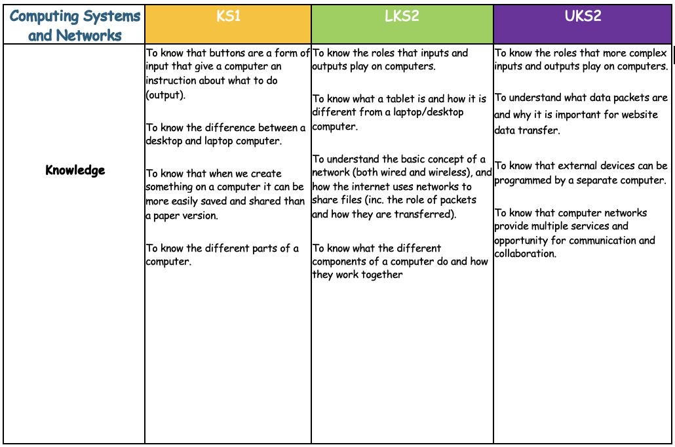
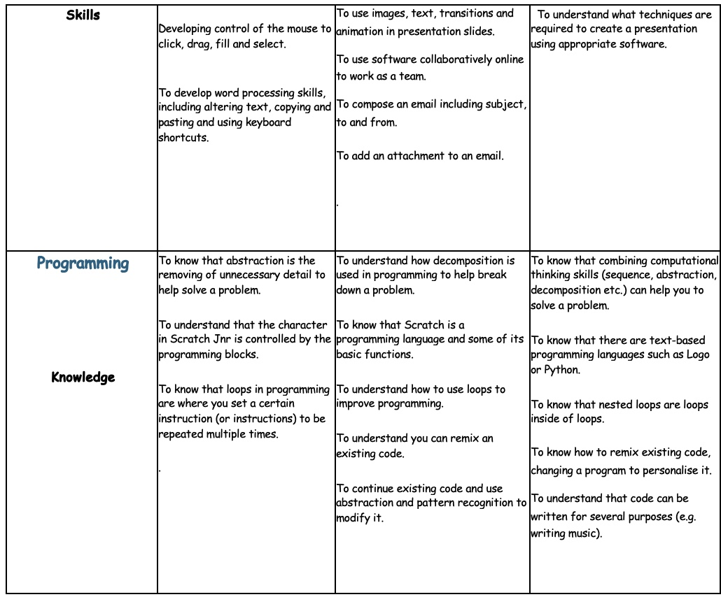
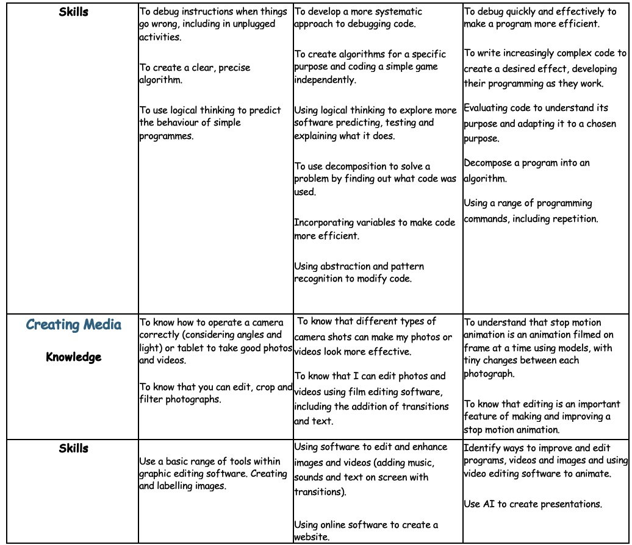
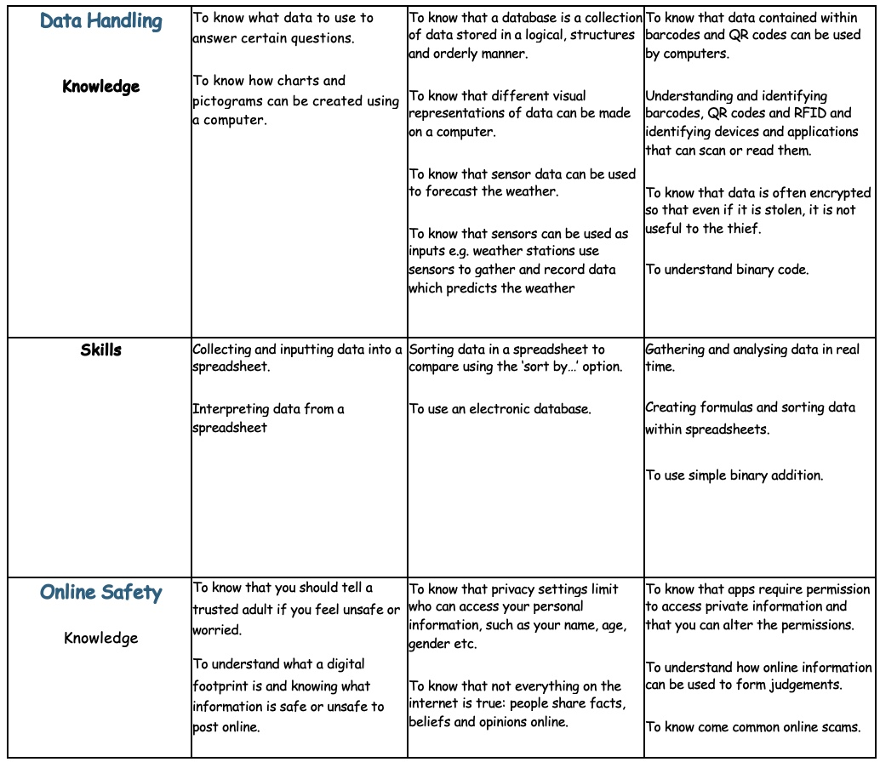
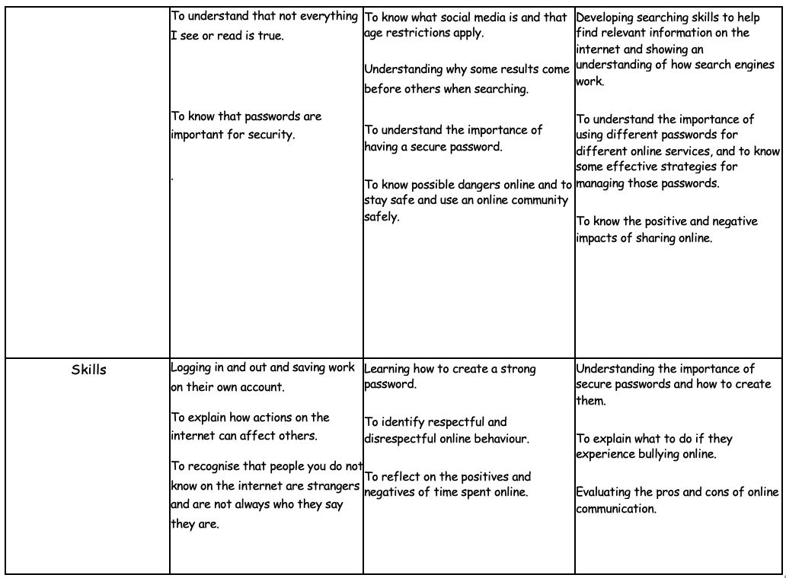

Assessment in History

