What is my child learning in Year 4…


School Values  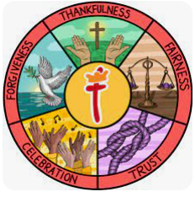 | Our Gospel value this half term is Forgiveness.  In Year 4, we will explore how the value of forgiveness is demonstrated in the world around us and how we can embody it in our daily lives. We will learn about the importance of letting go of anger and resentment, seeking reconciliation, and showing compassion to others. During our class worship sessions, we will read Bible verses that highlight forgiveness and discuss how we can practise it in our actions and words every day. We will also examine our key value of forgiveness in line with our Rights Respecting Schools.
RE     | The 8-fold Path: Can the Buddha's teachings make the world a better place?  In Year 4, we will learn about the teachings of Buddhism and explore the question, "Can the Buddha's teachings make the world a better place?" We will discuss how the 8-fold Path offers guidance on living a balanced and ethical life, emphasising values such as right speech, right action, and right mindfulness. Through stories and activities, we will reflect on how these teachings encourage kindness, wisdom, and harmony and consider how they could inspire positive change in the world today.
English    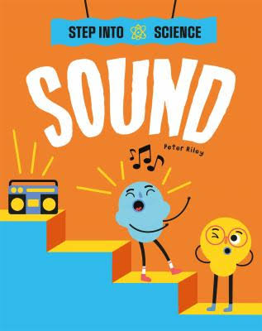 | Book focus:  In English this half term, we will focus on a new book, Step into Science: Sound by Peter Riley, which ties perfectly into our science topic on sound. This engaging text will guide the children through the fascinating world of sound—how it is made, how it travels, and how we experience it. Through rich explanations and practical activities, the book will inspire the children to think deeply about the sounds in their everyday lives and in the natural world. The clear and interactive style of the book ensures they will enjoy discovering the science behind sound while strengthening their literacy skills.  We will also be reading The Dragon’s Hoard – a collection of Viking myths retold by Lari Don. These exciting tales introduce us to legendary gods, daring heroes, and magical creatures from Norse mythology. As we read, we will explore themes such as bravery, trickery, and fate, linking to our wider learning about ancient cultures and storytelling traditions.  Writing  This half term in writing, the children will focus on creating an engaging explanation text titled "How does sound travel?” They will learn to use fronted adverbials and commas to add detail and clarity to their writing. Additionally, they will practise using coordinating (FANBOYS) and subordinating conjunctions to connect their ideas cohesively. Following this, the children will write a formal letter, with an emphasis on using pronouns to avoid repetition and improve the flow of their writing. They will also learn to use fronted adverbials effectively and apply apostrophes for possession, both singular and plural, including regular and irregular forms. This will help them develop a strong understanding of how to write clearly and formally in different contexts. I’m really looking forward to reading their work and seeing their creativity in action!
Reading   | This half term in reading, we will continue to focus on deepening and embedding our reading skills. The children will explore a variety of texts, practising important skills such as understanding word meanings, making predictions, drawing inferences, retrieving information, and summarising key points. Through guided reading sessions, we’ll work on approaching different types of questions with confidence, setting a strong foundation for their continued development as readers.
Maths   | In Maths this half term, Year 4 will cover the following topics:  - Multiplication and Division: Building strategies to solve multiplication and division problems and developing confidence and fluency in these operations.  - Length and Perimeter: Learning to measure and calculate the length of different objects and the perimeter of various shapes, and understanding their practical uses.  - Fractions: Exploring fractions, comparing and simplifying them, and learning how to add and subtract fractions to strengthen mathematical skills.
  Science | This half term in Science, we will focus on:  - Sound: Exploring how sound is produced, how it travels, and how we hear it. The children will investigate the properties of sound through engaging experiments and activities.  - Data Collection: Developing skills to gather, record, and interpret scientific data effectively. The children will apply these skills while conducting experiments related to sound, analysing results, and drawing conclusions.  The children will take part in hands-on activities to deepen their understanding of sound and practise collecting and analysing data to support their scientific findings.
History  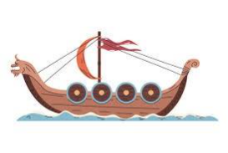 | History  Our history topic for this half term is "Were the Vikings raiders or settlers?"  The children will explore who the Vikings were, where they came from, and why they travelled to other lands. They will investigate whether the Vikings should be remembered mainly as fearsome raiders or as settlers who brought lasting change. Through studying historical sources, maps, artefacts, and stories, the children will gain a deeper understanding of Viking life, including their homes, beliefs, and interactions with Anglo-Saxon England. They will also consider how different perspectives can influence how we interpret the past and reflect on the legacy the Vikings left behind.
  Art | Art, Craft, and Design  This term, our Art, Craft, and Design lessons will centre around a dragon-themed art unit, where pupils will explore a range of art techniques while incorporating different cultural perspectives on dragons. They will practise colour blending, texture creation, and drawing skills to bring their dragon designs to life. Children will begin by drawing simple dragon specifications, developing their ability to plan and visualise ideas.  As part of the unit, pupils will explore how different materials have different properties, experimenting with media such as paint, collage, and pastels to achieve varied effects. They will also learn to communicate their ideas clearly, thinking carefully about how to express mood, movement, and character through their artwork.
Computing   | In computing this half term, we will focus on programming.  - In this unit, Year 4 pupils learn how to create shapes and patterns using Logo, a simple text-based programming language. They will plan, write, test, and improve their code, with a focus on using repetition and loops to make programs more efficient. This unit helps children develop logical thinking, problem-solving skills, and a basic understanding of how computer programs work.
French  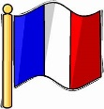 | This half term, we will focus on numbers, calendars, and birthdays in French. The children will learn how to count in French, understand the months of the year, and talk about dates. They will also explore vocabulary and phrases related to birthdays, including how to wish someone a happy birthday and discuss celebrations. Through engaging activities, the children will practise using numbers, learn how to read and create simple calendars, and build their  conversational skills to talk about birthdays in French.
PE    PE days  Tuesday and Friday | This half term in PE, we will focus on gymnastics and tennis. In gymnastics, the children will develop skills such as balance, coordination, and control through a range of movements, including rolls, jumps, and sequences. They will learn how to link actions smoothly and safely to create simple routines.  In tennis, the children will practise key techniques such as serving, rallying, and volleying, while also developing their agility and hand-eye coordination. Through both activities, they will build confidence, improve physical skills, and develop a positive enjoyment of sport.
  Music | This term in Music, children will be developing their singing techniques through a Vikings-themed unit. Pupils will learn to sing together as a group, following lyrics on the screen and keeping in time. Children will practise performing rhythms accurately from notation and will layer different rhythms to create simple compositions. They will also add suitable sound effects using untuned percussion to enhance their performances. Throughout the unit, pupils will be encouraged to perform confidently, stay in tune, and suggest ways to improve their work, helping them to develop both musical skills and teamwork.
PSHE   | In PSHRE this half term, the children will explore the theme of dreams and goals. They will discuss their hopes and dreams, learning to set realistic goals and understanding how to overcome disappointment when things don’t go as planned. Pupils will also explore how to create new, achievable dreams and develop resilience to keep striving for success. Activities will include working in groups to support each other’s goals, celebrating contributions, and understanding the importance of a positive attitude in achieving personal and group objectives. Through these discussions and activities, the children will learn how to stay motivated, face challenges, and build a sense of accomplishment.
Key events for the half term | Future dates to be aware of:  - Friday 9th January –Year 4 coffee morning  - 27th January – Viking day workshop (all day and Viking clothes)  - Monday 9th February – SHINE start at 2:00pm in school  - Friday 13th February – SEND/MHST coffee morning  - Tuesday 3rd March – Year 4 Inspire at the church 2pm-3pm  - Wednesday 11th February – Walking to Kidsgrove library  - Monday 23rd Feb – INSET day – School closed for children  - Friday 20th March – INSET day – School closed for children
Homework | In year 4, we will send a range of maths homework each week.  Homework will always be given out on Fridays and is due back on the following Friday. Children are welcome to bring their homework in earlier and leave it in their trays.  We ask that the children also read their reading book at least 3 times a week and log on and play Times Table Rockstars 2-3 times a week too!

