What is my child learning in Year 6…
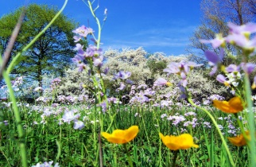
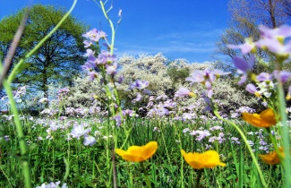


School Values  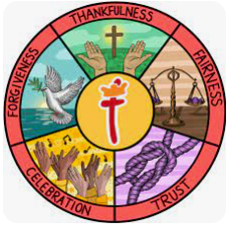 | Here at St Thomas’ we fulfil our mission of ‘Learning for Life with Jesus’ at every opportunity. Underpinning this are our 5 school values of: thankfulness, fairness, trust, celebration and forgiveness. Each half term we focus on a different value through our worship and class lessons.  This half term our value of focus is forgiveness
  RE | Creation – Creation and science: Conflicting or complementary?  Year 6 will explore what Genesis 1 might mean and will compare ideas with ways in which Christians interpret it.  Children will also learn why Christians find science and faith go together and will think about how far the creation narrative is in conflict or is complementary science.
Writing    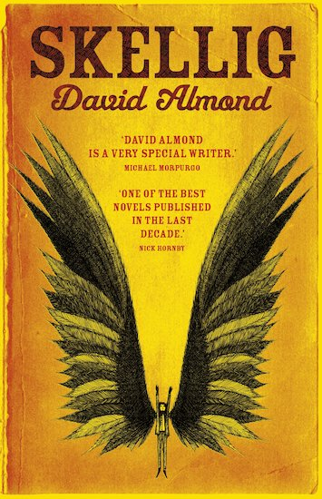 | In writing, the children will be continuing to work on building a range of language devices in order to develop their writing style. We focus particularly on:  - The use of more advanced punctuation (semi-colons, brackets, colons)  - Extending sentences by adding fronted adverbials and relative clauses  - Developing their understanding of the difference between and main clause and a subordinate clause so they can manipulate the order of sentences.  - Exploring language choices and ensuring they are appropriate for the audience of that genre  - Looking at the features of different genres  Using ‘Skellig’ as inspiration, we will be writing formal letters, writing new endings and character descriptions of Skellig.
Reading | This half term we are reading ‘Skellig’ by David Almond.  Michael’s baby sister is sick, maybe dying. As his parents spend their days at the hospital, his life seems suddenly lonely and uncertain. But one day he stumbles into the ramshackle garage of their new home and finds something magical: a strange creature, part owl, part angel. Is it good? Or maybe evil? What is Skellig’s miraculous secret? Can it help him to breathe life back into his sister and stick his broken world together again?  Children will be completing comprehension questions and activities, practicing their inference, retrieval, predicting and summarising skills.
Maths   | In maths, we will be covering the following topics:  - Fractions  - Decimals  - Percentages  During all of the topics, we will focus on both fluency and problem solving and reasoning questions to ensure the children develop a deep understanding of the concepts.
  Science | In science this half term, we will be covering a new topic, living things and their habitats  Children will be grouping organisms, classifying plants and animals and exploring microorganisms. Children will also learn about the work of Carl Linnaeus and his system of classifying organisms.
Geography   | This half term we will be focussing on Why does population change?  Children will explore the most densely and sparsely populated areas, describe the increase in global population over time and begin to describe what might influence the environments people live in.
  Art | Artist study – Salvador Dali  This half term children will focus on understanding narratives and descriptive language in art, exploring meanings behind paintings, and developing personal interpretations.
Computing   | Programming – Variables in games  Year 6 will define a ‘variable’ as something that is changeable, explain why a variable is used in a program and choose how to improve a game by using variables. Children will then go on to design a project that builds on a given example.
French  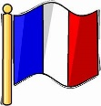 | In my French house  Year 6 will understand the French words for different types of houses and their rooms. They will ask and answer questions using vocabulary about houses and rooms, whilst remembering and understanding the elements of a house and family.
PE   | Gymnastics and hockey  In PE, Year 6 will complete their gymnastics topic, developing their gymnastics skills with a focus on different body shapes and levels and moving with control.  Children will then commence their hockey topic and will learn to perform and combine skills, at speed, with confidence and control.
  Music | Dynamics, pitch and texture  Children will engage in discussion about the sounds of an orchestral piece. Children will also take the role of conductor and follow the conductor to show changes in pitch dynamics and texture.
PSHE   | Relationships  This topic will involve exploring and discussing:  - mental health worries and sources of support  - Managing feelings  - Technology safety  - Taking responsibility with technology
Key events for the half term | Future dates to be aware of:  - Monday 12th Jan – Tween safety workshop begins in Year 6 – See letter for information.  - Wednesday 14th Jan – Young voices – choir  - Tuesday 27th Jan – Year 6 INSPIRE at St Thomas’ Church  - Monday 9th Feb – Year 6 Bikeability begins  - Thursday 12th Feb – Library visit  - Monday 23rd Feb – INSET day – School closed for children  - Thursday 26th Feb – Careers fair at The Kings  - Friday 20th March – INSET day – School closed for children
Homework | In year 6, we will continue to send a range of SPAG, reading and maths homework each week to prepare them for their SATs. We ask that the children also read their reading book at least 3 times a week and log on and play Times Table Rockstars 2-3 times a week too!

