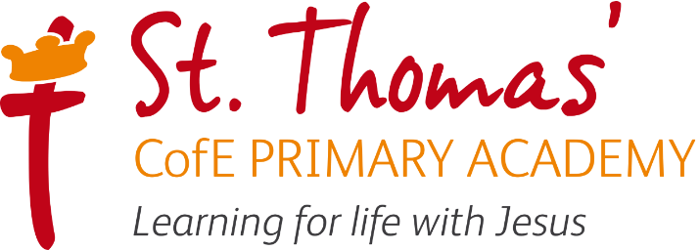

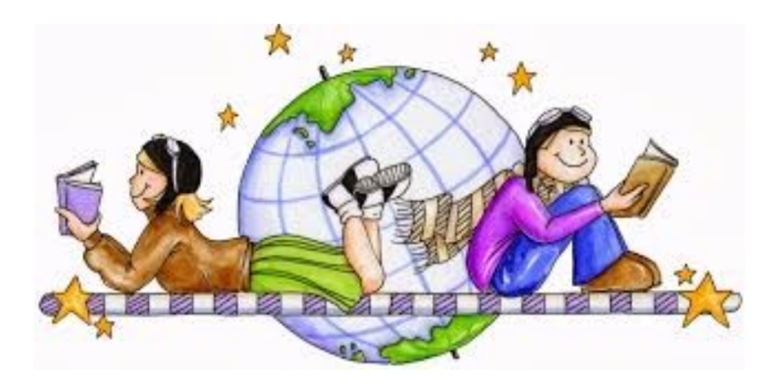

Geography Curriculum
 | Autumn 1 | Autumn 2 | Spring 1 | Spring 2 | Summer 1 | Summer 2
Nursery | Nursery Rhymes | Bedtime Stories | People who help us | Out of this world | Super Safari | Seaside and Holidays
Reception | Different focus | Where is my school? | What happens in winter? What is it like where I live? | What is it like in London? | Different focus | What were seaside holidays like in the past?
Year 1, | History | What is it like here? | History | What is the weather like in the UK? | History | What is it like to live in Shanghai?
Year2 | Why is our natural world wonderful? | History | History | Would you prefer to live in a hot place or a cold place? | History | What is it like to live by the coat?
Year 3 | History | Are all settlements the same? | History | Why do people live near volcanos? | History | Who lives in Antarctica?
Year 4 | History | What are rivers and how are they used? | History | Where does our food come from? | Why are rainforests important to us? | History
Year 5 | History | What is life like in the Alps? | History | Why do Oceans matter? | History | Would you live in a desert?
Year 6 | History | History | Why does population change? | Where does our energy come from? | History | Can I carry out an independent fieldwork inquiry?

Intent, Implementation and Impact

Inspired by our Christian faith, we guide children on a personalised journey towards achievement. As a learning community, we are committed to ensuring that children are equipped with, skills and aspirations to reach their full potential in mind, body, heart and spirit.

Intent
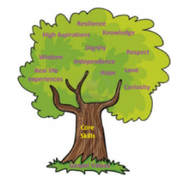
All areas of our curriculum are underpinned by our Gospel values and we ensure that our curriculum makes links to these values. At the heart of each subject is a set of core skills which form a subject learning journey, the skills progress as you move through the school. Knowledge is communicated to ensure coverage of National curriculum and it is through this knowledge that children apply their skills. Children at St Thomas’ leave with a secure knowledge of both the academic knowledge and skills needed for the next stage of their education. They will have developed a clear set Christian and moral values which they can apply in all areas of their lives and will have taken part in real-life experiences which will have raised their aspirations and given them a thirst for wisdom and knowledge.

The intention of the St Thomas’ Geography learning journey is to inspire all pupils develop their knowledge of the world, an understanding where they live and their impact on our lives today and as a result understand how they can make a positive impact on the world. We focus on developing the skills, knowledge and understanding that children need in order find out about the world so they have the skills to continually develop their skills and knowledge throughout their lives.

Implementation
St Thomas’ Geography Learning Journey focuses on a spiral curriculum model where previous skills and knowledge are revisited and built upon. Over the course of the journey children will focus on both declarative and procedural knowledge. Declarative knowledge in Geography is the factual knowledge surrounding the world we live in. This knowledge is not a list of disconnected facts; it is explicitly linked to the content being taught. Procedural knowledge can be viewed as the
know-how to apply declarative facts. This might include applying their historical research skills in another context.

Geography is taught on alternate terms, or adjoining terms depending where it links to other topics, books and subjects in the curriculum and for an hour a week. At the start of each unit of work, children answer the key question using the knowledge that they already have in the form of a mind map and then children are introduced to the key knowledge and vocabulary which will be shared during the unit. During the lesson activities are differentiated where appropriate and assessment and feedback will focus on misconceptions and next steps for learning. At the end of the topic the children answer the key question and any skills that they have used and the teacher highlights WTS, WW or GD on an end of unit assessment sheet.

In Geography, work is recorded in an exercise book and marked in line with the marking policy.

EYFS
As part of Development Matters (2021), Geography is taught in relation to the strand ‘Understanding the world’. Children have a key question which is planned for each half term. Lessons take the form of adult-led inputs. The amount varies dependent on the theme. There will then be an independent activity relating to the input.

All classrooms have an investigation station. As part of this, Humanities based enhanced provision will be planned for each half term. Humanities based enhanced and child-initiated provision may also be found in the Construction area, for instance building a farm or a city. Humanities may also be found in the outside provision, either enhanced or child-initiated, such as treasure hunts, map drawing.
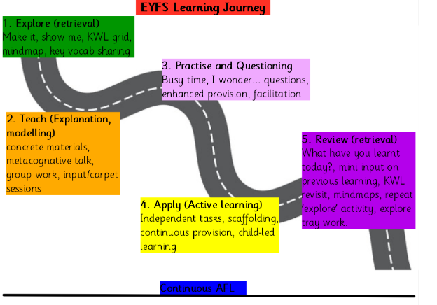

Impact
In addition to the outcomes shown on our curriculum the specific impact of the St Thomas’ Geography Learning Journey is that children will (as stated in the national curriculum):
- develop contextual knowledge of the location of globally significant places – both terrestrial and marine – including their defining physical and human characteristics and how these provide a geographical context for understanding the actions of processes.
- understand the processes that give rise to key physical and human geographical features of the world, how these are interdependent and how they bring about spatial variation and change over time
- collect, analyse and communicate with a range of data gathered through experiences of fieldwork that deepen their understanding of geographical processes.
- interpret a range of sources of geographical information, including maps, diagrams, globes, aerial photographs and Geographical Information Systems (GIS)
- communicate geographical information in a variety of ways, including through maps, numerical and quantitative skills and writing at length.
Formative assessment takes part in each lesson and misconception and next steps of the focus for feedback. Summative assessment is completed for each child at the end of each unit of teaching using the assessment framework at the end of this document. A best fit approach to statements achieved results in an end of year summative grade.
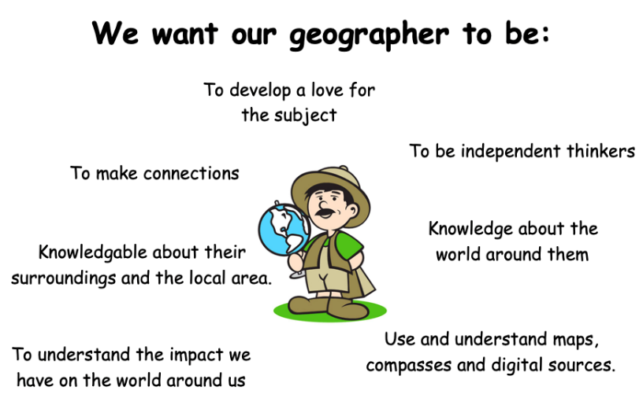

SEN Adjustments
In our history lessons we adjust our lessons using the following strategies:

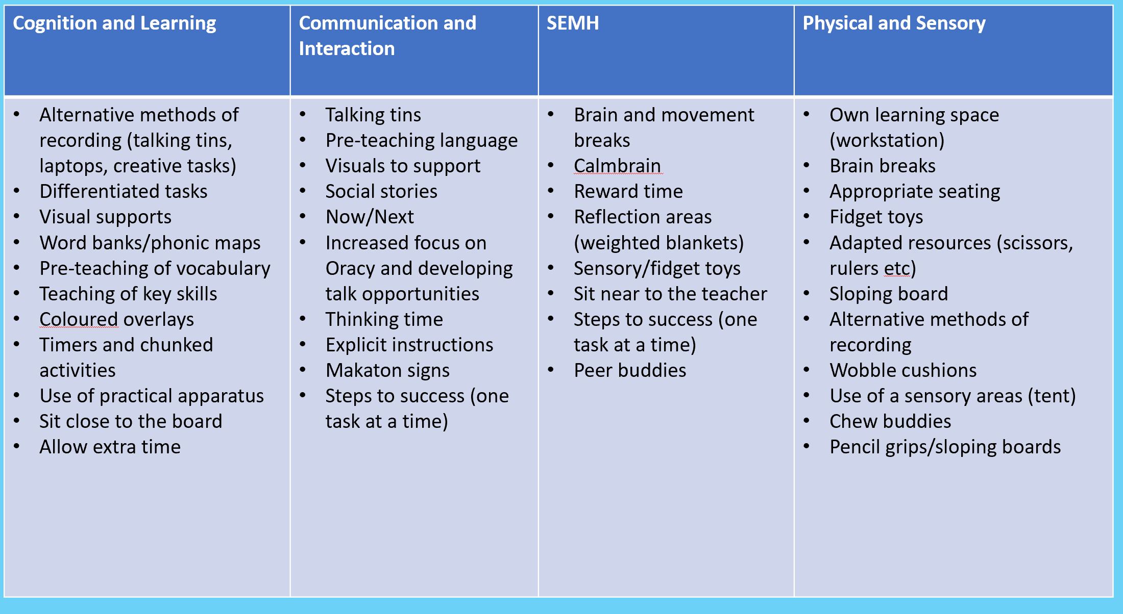

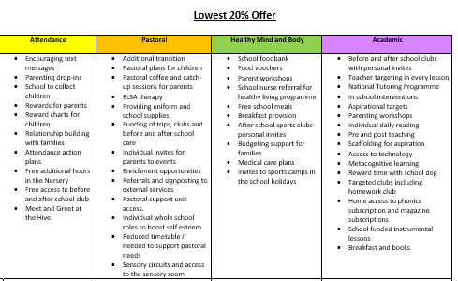
Year 1 | Year 2 | Year 3 | Year 4 | Year 5 | Year 6
Autumn 2-  What is it like here?  - aerial photograph  - aerial view  - atlas  - city  - country  - directional language  - distance  - features  - globe  - improve  - key  - land  - locate  - location  - map  - north  - place  - questionnaire  - sea  - survey  - symbol  - town  - village | Autumn 1 – Why is out natural world wonderful?  - aerial photograph  - capital city  - continent  - country  - data collection  - fieldwork  - human feature  - key  - lake  - land  - landmark  - locate  - location  - map  - north  - physical feature  - ocean  - OS map  - river  - sample  - sea  - scale  - symbol  - tally chart  - vegetation | Autumn 2 – Are all settlements the same?  - agricultural land  - capital city  - commercial land  - compare  - country border  - county  - dispersed  - facilities  - land use  - legend  - linear  - local  - memorial  - metro  - monument  - nucleated  - place of worship  - recreational land  - region  - residential land  - settlement  - transportation | Autumn 2 – What are rivers and how are they used?  - condensation  - delta  - estuary  - evaporation  - flooding  - floodplain  - groundwater  - irrigation  - leisure  - meander  - oxbow lake  - percolation  - precipitation  - river mouth  - source  - transpiration  - tributary  - valley  - water cycle  - waterfall | Autumn 2 – What is life like in the Alps?  - atlas  - climate  - climate change  - coniferous trees  - data  - deciduous trees  - enquiry  - fold mountain  - glacier  - hemisphere  - human feature  - land height  - latitude  - leisure  - longitude  - method  - mountain climate  - mountain range  - OS map  - physical feature  - population  - questionnaire  - sea level  - recreational land use  - risk  - route  - scale  - temperate  - temperate forest  - tourism  - tourist  - vegetation | Autumn – History focus
Spring 2 – What is the weather like in the UK?  - atlas  - autumn  - direction  - east  - England  - Europe  - map  - north  - Northern Ireland  - place  - Scotland  - season  - south  - spring  - summer  - United Kingdom  - Wales  - weather  - west  - winter | Spring 2 – Would you refer to live in a hot place or a cold place?  - arid  - climate  - compass  - continent  - country  - desert  - Equator  - globe  - grasslands  - human feature  - ice sheet  - land  - locate  - map  - mild  - ocean  - pack ice  - physical feature  - polar  - rain gauge  - rainforest | Spring 2 – Why do people live near volcanoes?  - active volcano  - climate change  - composite volcano  - crust  - dormant volcano  - earthquake  - epicentre  - extinct volcano  - fault line  - fault-block mountain  - fertile soil  - fold mountain  - geothermal energy  - igneous rock  - index  - inner core  - outer core  - magma  - magma chamber  - man-made rock  - mantle  - metamorphic rock  - minerals  - natural rock  - negative effects  - plate boundary  - positive effects  - pyroclastic flow  - sedimentary rock  - seismic waves  - shield volcano  - tectonic plate  - tsunami  - vent  - volcanic mountain  - volcanic springs | Spring 2 – Where does our food come from?  - air freight  - carbon footprint  - consume  - distribution  - export  - fertiliser  - food bank  - food miles  - grant  - import  - pesticides  - produce  - qualitative  - quantitative  - reliability  - responsible trade  - sample size  - scale bar  - seasonal food  - source  - sustainability  - trade  - trend | Spring 2 – Why do oceans matter?  - atmosphere  - biodegradable  - buffer  - coral bleaching  - coral reef  - decompose  - digital map  - disposable  - ecology  - ecosystem  - erosion  - geology  - habitat  - human footprint  - marine  - microplastics  - natural disaster  - ocean current  - policy  - renewable energy  - single use plastic  - species  - water cycle | Spring 1 - Why does population change?  - air pollution  - birth rate  - cartogram  - climate  - climate change  - conclusions  - death rate  - deforestation  - densely populated  - digital technologies  - fossil fuels  - greenhouse gases  - impact  - improvements  - involuntary  - Likert scale  - migrants  - migration  - natural increase  - noise pollution  - population  - population density  - population distribution  - pull factors  - push factors  - qualitative  - quantitative  - refugee  - region  - sparsely populated  - voluntary  Spring 2 -Where does our energy come from?  - Biofuel  - coal  - consumption  - contour line  - crude oil  - dam  - emissions  - energy source  - hydropower  - natural gas  - non-renewable  - nuclear power  - Prime Meridian  - producer  - regenerate  - renewable  - replenish  - sea level  - solar power  - time zone  - urban planner  - wind power  - six-figure grid reference
Summer 2 – What is it like to live in Shanghai?  - continent  - country  - different  - directional language e.g. near, far, next to, behind, etc.  - key  - human feature  - map  - physical feature  - similar  - symbol | - Summer 2 - What is it like by the coast?  arch  - aquarium  - bay  - capital city  - city  - cliff  - coast  - coastline  - country  - data collection  - fieldwork  - island  - harbour  - human feature  - location  - locate  - mudflat  - ocean  - physical feature  - pictogram  - pier  - sand dunes  - sea  - stack  - tally chart  - tourist  - town  - village | Summer 2 – Who lives in Antarctica?  - climate  - climate zone  - compass points  - direction  - drifting ice  - hemisphere  - ice sheet  - ice shelf  - iceberg  - lines of latitude  - lines of longitude  - treaty | Summer 1 - Why are rainforests important to us?  - analyse  - biome  - buttress roots  - canopy layer  - community  - data  - deforestation  - drought  - emergent layer  - enquiry  - equator  - forest floor  - global warming  - greenhouse gas  - indigenous peoples  - interpret  - lianas  - lines of latitude  - logging  - method  - mining  - present  - questionnaire  - quote  - risk  - route  - summarise  - Tropic of Capricorn  - Tropic of Cancer  - understorey layer  - vegetation  - vegetation belts | Summer 1 – Would you live in a desert?  - agriculture  - airstrip  - arid  - barren  - biome  - climate  - desert  - desertification  - drought  - flash flood  - mesa  - mining  - mushroom rock  - national park  - natural arch  - nature reserve  - rainfall  - ranching  - renewable energy  - salt flat  - sand dune  - sparse  - time zone  - tourist attraction  - vegetation  - weather | Summer 2 - Can I carry out an independent fieldwork inquiry?  - analyse  - audience  - city  - data  - data collection methods  - enquiry  - evidence  - impact  - improvement  - issue  - justify  - plot  - presenting  - process  - recommendation  - region  - risk  - route  - subjective  - viewpoint
Geographical Knowledge

Year 1 | Year 2 | Year 3 | Year 4 |  | Year 5 | Year 6
Autumn 2  What is it like here?  To know that the UK is short for ‘United Kingdom’.  To know that a country is a land or nation with its own government.  To know the name of the country they live in.  To know that an aerial photograph is a photograph taken from the air above.  To know that atlases give information about the world and that a map tells us information about a place.  To know that a map is a picture of a place, usually drawn from above.  To know that symbols are often used on maps to represent features.  To know simple directional language (e.g. near, far, up, down, left, right, forwards, backwards). | Autumn 1 – Would you prefer to live in a hot place or a cold place?  To know some similarities and differences between their local area and a contrasting non-European country.  To know that the Equator is an imaginary line around the middle of the Earth.  To know that, because it is the widest part of the Earth, the Equator is much closer to the sun than the North and South poles.  To know that the North Pole is the northernmost point of the Earth and the South Pole is the southernmost point of the Earth.  To know that different parts of the world experience different weather conditions and that these are often caused by the location of the place.  To be able to name the seven continents of the world.  To know that a globe is a spherical model of the Earth.  To begin to recognise world maps as a flattened globe. | Autumn 2 – Are all settlements the same?  To know the names of some of the world’s most significant rivers.  To know the name of some counties in the UK (local to your school).  To know the name of some cities in the UK (local to your school).  To know the name of the county that they live in and their closest city.  To begin to name the twelve geographical regions of the UK.  To know the main types of land use.  To know some types of settlement.  To know water is used by humans in a variety of ways.  To know an urban place is somewhere near a town or city.  To know a rural place is somewhere near the countryside.  To know that a natural resource is something that people can use which comes from the natural environment.  To know the UK grows food locally and imports food from other countries.  To understand that a scale shows how much smaller a map is compared to real life.  To know that an OS (Ordnance survey) map is used for personal use and organisations use it for housing projects, planning the natural environment and public transport and for security purposes.  To know that an OS map shows human and physical features as symbols.  To know the main types of land use (agricultural, residential, recreational, commercial, industrial and transportation).  To know an enquiry-based question has an open-ended answer found by research.  To know what a bar chart, pictogram and table are and when to use which one best to represent data. | Autumn 2 – What are rivers and how are they used?  To know where North and South America are on a world map.  To know the names of some of the world’s most significant mountain ranges.  To know the names of some of the world’s most significant rivers.  To know the name of some counties in the UK (local to your school).  To know the name of some cities in the UK (local to your school).  To know the name of the county that they live in and their closest city.  To begin to name the twelve geographical regions of the UK.  To know the main types of land use.  To know some types of settlement.  To know that the water cycle is the processes and stores which move water around our Earth and to be able to name these.  To know the courses and key features of a river.  To know the different types of mountains and volcanoes and how they are formed.  To know water is used by humans in a variety of ways.  To know an urban place is somewhere near a town or city.  To know a rural place is somewhere near the countryside.  To know that a natural resource is something that people can use which comes from the natural environment.  To know the UK grows food locally and imports food from other countries.  To understand that a scale shows how much smaller a map is compared to real life.  To recognise world maps as a flattened globe.  To know that an OS (Ordnance survey) map is used for personal use and organisations use it for housing projects, planning the natural environment and public transport and for security purposes.  To know that an OS map shows human and physical features as symbols.  To know that grid references help us locate a particular square on a map.  To know the eight points of a compass are north, south, east, west, north-east, south-east, north-west, south-west.  To know the main types of land use (agricultural, residential, recreational, commercial, industrial and transportation).  To know an enquiry-based question has an open-ended answer found by research.  To know that an annotated drawing or sketch map is hand drawn and gives a rough idea of features of an area without having to be completely accurate.  To know a Likert scale is used to record people’s feelings and attitudes.  To know what a bar chart, pictogram and table are and when to use which one best to represent data. |  | Autumn 2 – What is life like in the Alps?  To know the name of many countries and major cities in Europe and North and South America.  To know some similarities and differences between the UK and a European mountain region.  To know the location of key physical features in countries studied.  To know why tourists, visit mountain regions.  To know vegetation belts are areas of the world that are home to similar plant species.  To name and describe some of the world’s vegetation belts.  To be aware of some issues in the local area.  To know what a range of data collection methods look like.  To know how to use a range of data collection methods. | Autumn – History focus
Spring 2 -  What is the weather like in the UK?  The name of two continents (Europe and Asia).  That a continent is a group of countries.  That they live in the continent of Europe.  That the UK is short for ‘United Kingdom’.  That a country is a land or nation with its own government.  That the United Kingdom is made up of four countries and their names.  The name of the country they live in.  The four seasons of the UK.  That ‘weather’ refers to the conditions outside at a particular time.  That different parts of the UK often experience different weather.  That a weather forecast is when someone tries to predict what the weather will be like in the near future.  That weather conditions can be measured and recorded.  Simple directional language (e.g. near, far, up, down, left, right, forwards, backwards).  That a compass is an instrument we can use to find which direction is north.  Which direction is N, S, E, W on a map. | Spring 2 – Why is our world wonderful?  To be able to name the seven continents of the world.  To be able to name the five oceans of the world.  To name some characteristics of the four capital cities of the UK.  To know the four capital cities of the UK.  To know that a capital city is the city where a country’s government is located.  To know some key physical features of the UK.  To know some key human features of the UK.  To begin to recognise world maps as a flattened globe.  To know that maps need a title and purpose.  To know that maps need a key to explain what the symbols and colours represent.  To know that a tally chart is a way of collecting data quickly. | Spring 2 – Why do people live near volcanoes?  To know the names of some countries and major cities in Europe and North and South America.  To know the names of some of the world’s most significant mountain ranges.  To know that mountains, volcanoes and earthquakes largely occur at plate boundaries.  To know the main types of land use.  To know some types of settlement.  To know the negative effects of living near a volcano.  To know the positive effects of living near a volcano.  To know the negative effects an earthquake can have on a community.  To know ways in which communities respond to earthquakes.  To know the different types of mountains and volcanoes and how they are formed.  To know that an earthquake is the intense shaking of the ground.  To know the different types of settlement.  To know that a natural resource is something that people can use which comes from the natural environment.  To recognise world maps as a flattened globe.  To know how to use various simple sampling techniques.  To know that an annotated drawing or sketch map is hand drawn and gives a rough idea of features of an area without having to be completely accurate. | Spring 2 – Where does your food come from?  To know where North and South America are on a world map.  To know that climate zones are areas of the world with similar climates.  To know the world’s different climate zones.  To know that biomes are areas of the world with similar climates, vegetation and animals.  To know the world’s biomes.  To know vegetation belts are areas of the world which are home to similar plant species.  To know the main types of land use.  To know that countries near the Equator have less seasonal change than those near the poles.  To know that the Equator is a line of latitude indicating the hottest places on Earth and splitting our globe into the Northern and Southern Hemispheres.  To know lines of longitude are invisible lines on the globe that determine how far east or west a location is from the Prime Meridian.  To know lines of latitude are invisible lines on the globe that determine how far north or south a location is from the Equator.  To know the Tropics of Cancer and Capricorn are lines of latitude and mark the equatorial region; the countries with the hottest climates.  To know the Northern and Southern hemisphere are ‘halves’ of the Earth, above and below our Equator and have alternate seasons to each other.  To know that the hottest biomes are found between the Tropics of Cancer and Capricorn.  To know that climates can influence the foods able to grow.  To know that a natural resource is something that people can use which comes from the natural environment.  To know that fair trading is the process of ensuring workers are paid a fair price, have safe working conditions and are treated with respect and equality.  To know the UK grows food locally and imports food from other countries.  To know that grid references help us locate a particular square on a map.  To know an enquiry-based question has an open-ended answer found by research.  To know what a questionnaire and an interview are.  To know that quantitative data involves numerical facts and figures and is often objective.  To know that qualitative data involves opinions, thoughts and feelings and is often subjective. | Spring 2 – Why do oceans matter?  To know the location of key physical features in countries studied.  To know why the ocean is important.  To know some positive impacts of humans on the environment.  To know some negative impacts of humans on the environment.  To know that GIS is a digital system that creates and manages maps, used to support analysis for enquiries.  To know that a pie chart can represent a fraction or percentage of a whole set of data.  To be aware of some issues in the local area.  To know what a range of data collection methods look like.  To know how to use a range of data collection methods. |  |  | Spring 1 – Why does the population change?  To know that the global population has grown significantly since the 1950s.  To know which factors are considered before people build settlements.  To know migration is the movement of people from one country to another.  To know the name of many countries and major cities in Europe and North and South America.  To know the name of many counties in the UK.  To know the name of many cities in the UK.  To confidently name the twelve geographical regions of the UK.  To know that London and the South East regions have the largest population in the UK.  To know the global population has grown significantly since the 1950s.  To know which factors are considered before people build settlements.  To know migration is the movement of people from one country to another.  To know some negative impacts of humans on the environment.  To know that qualitative data involves qualities, characteristics and is largely opinion based and subjective.  To know that GIS is a digital system that creates and manages maps, used to support analysis for enquiries.  To know that a pie chart can represent a fraction or percentage of a whole set of data.  To be aware of some issues in the local area.  To know what a range of data collection methods look like.  To know how to use a range of data collection methods.  Spring 2 – Where does our energy come from?  To know the name of many countries and major cities in Europe and North and South America.  To know the name of many cities in the UK.  To know the Prime/Greenwich Meridian is a line of longitude which goes through 0°and determines the start of the world’s time zones.  To know that natural resources can be used to make energy.  To know some positive impacts of humans on the environment.  To know some negative impacts of humans on the environment.  To know that contours on a map show height and slope.  To know that qualitative data involves qualities, characteristics and is largely opinion based and subjective.  To know what a range of data collection methods look like.  To know how to use a range of data collection methods.
Summer 2 – What is it like in Shanghai?  To know the name of the two continents (Europe and Asia).  To know that a continent is a group of countries.  To know that they live in the continent of Europe.  To know that life elsewhere in the world is often different to ours.  To know that life elsewhere in the world often has similarities to ours.  To know that physical features means any feature of an area that is on the Earth naturally.  To know that human features mean any feature of an area that was made or built by humans. | Summer 2 – What is it like to live by the coast?  To know that a sea is a body of water that is smaller than an ocean.  To know that there are four bodies of water surrounding the UK and to be able to name them.  To know that coasts (and other physical features) change over time.  To know some key physical features of the UK.  To know that a sea is a body of water that is smaller than an ocean.  To know some key human features of the UK.  To know that maps need a title and purpose.  To know that maps need a key to explain what the symbols and colours represent.  To know that a tally chart is a way of collecting data quickly.  To know that a pictogram is a chart that uses pictures to show data. | Summer 2 – Who lives in Antarctica?  To know where North and South America are on a world map.  To know the names of some countries and major cities in Europe and North and South America.  To know that climate zones are areas of the world with similar climates.  To know the world’s different climate zones (equatorial, tropical, hot desert, temperate and polar).  To know the world’s biomes.  To know the main types of land use.  To know that countries near the Equator have less seasonal change than those near the poles.  To know that the Equator is a line of latitude indicating the hottest places on Earth and splitting our globe into the Northern and Southern Hemispheres.  To know lines of longitude are invisible lines on the globe that determine how far east or west a location is from the Prime Meridian.  To know lines of latitude are invisible lines on the globe that determine how far north or south a location is from the Equator.  To know the Tropics of Cancer and Capricorn are lines of latitude and mark the equatorial region; the countries with the hottest climates.  To know the Northern and Southern hemisphere are ‘halves’ of the Earth, above and below our Equator and have alternate seasons to each other.  To know the boundaries of the polar regions are marked by the invisible lines the Arctic and Antarctic circle.  To know the patterns of daylight in the Arctic and Antarctic circle and the Equatorial regions.  To know that the water cycle is the processes and stores which move water around our Earth and to be able to name these.  To know that a biome is a region of the globe sharing a similar climate, landscape, vegetation and wildlife.  To know that the hottest biomes are found between the Tropics of Cancer and Capricorn.  To know the world’s different climate zones.  To know water is used by humans in a variety of ways.  To know that a natural resource is something that people can use which comes from the natural environment.  To understand that a scale shows how much smaller a map is compared to real life.  To recognise world maps as a flattened globe.  To know the eight points of a compass are north, south, east, west, north-east, south-east, north-west, south-west.  To know that an annotated drawing or sketch map is hand drawn and gives a rough idea of features of an area without having to be completely accurate. | Summer 1 – Why are rainforests important?  To know where North and South America are on a world map.  To know the names of some countries and major cities in Europe and North and South America.  To know the names of some of the world’s most significant rivers.  To know that climate zones are areas of the world with similar climates.  To know the world’s biomes.  To know vegetation belts are areas of the world which are home to similar plant species.  To know the name of some counties in the UK (local to your school).  To know that countries near the Equator have less seasonal change than those near the poles.  To know that the Equator is a line of latitude indicating the hottest places on Earth and splitting our globe into the Northern and Southern Hemispheres.  To know lines of latitude are invisible lines on the globe that determine how far north or south a location is from the Equator.  To know the Tropics of Cancer and Capricorn are lines of latitude and mark the equatorial region; the countries with the hottest climates.  To know that the water cycle is the processes and stores which move water around our Earth and to be able to name these.  To know that a biome is a region of the globe sharing a similar climate, landscape, vegetation and wildlife.  To know that the hottest biomes are found between the Tropics of Cancer and Capricorn.  To know the world’s different climate zones.  To know that climates can influence the foods able to grow.  To know the main types of land use.  To know that a natural resource is something that people can use which comes from the natural environment.  To know the threats to the rainforest both on a local and global scale.  To recognise world maps as a flattened globe.  To know that an OS (Ordnance survey) map is used for personal use and organisations use it for housing projects, planning the natural environment and public transport and for security purposes.  To know that an OS map shows human and physical features as symbols.  To know an enquiry-based question has an open-ended answer found by research.  To know what a questionnaire and an interview are.  To know that quantitative data involves numerical facts and figures and is often objective.  To know that an annotated drawing or sketch map is hand drawn and gives a rough idea of features of an area without having to be completely accurate.  To know that qualitative data involves opinions, thoughts and feelings and is often subjective.  To know what a bar chart, pictogram and table are and when to use which one best to represent data. |  | Summer 2 – Would you live in a desert?  To know the name of many countries and major cities in Europe and North and South America.  To know the location of key physical features in countries studied.  To name and describe some of the world’s vegetation belts.  To know the Prime/Greenwich Meridian is a line of longitude which goes through 0°and determines the start of the world’s time zones.  To know vegetation belts are areas of the world that are home to similar plant species.  To name and describe some of the world’s vegetation belts.  To know which factors are considered before people build settlements.  To know a line graph can represent variables over time.  To know that natural resources can be used to make energy.  To know some negative impacts of humans on the environment.  To know that contours on a map show height and slope.  To know that qualitative data involves qualities, characteristics and is largely opinion based and subjective.  To know that GIS is a digital system that creates and manages maps, used to support analysis for enquiries.  To know that a pie chart can represent a fraction or percentage of a whole set of data. |  | Summer 2 – Can I carry out an independent fieldwork enquiry?  To know the name of many countries and major cities in Europe and North and South America.  To know the name of many cities in the UK.  To confidently name the twelve geographical regions of the UK.  To know some positive impacts of humans on the environment.  To know some negative impacts of humans on the environment.  To know that contours on a map show height and slope.  To know that qualitative data involves qualities, characteristics and is largely opinion based and subjective.  To know that GIS is a digital system that creates and manages maps, used to support analysis for enquiries.  To be aware of some issues in the local area.  To know what a range of data collection methods look like.  To know how to use a range of data collection methods.

Geographical Skills

Year 1 | Year 2 | Year 3 | Year 4 | Year 5 | Year 6
Autumn 2 – What is it like here?  Recognising some physical features in their locality.  Recognising some human features in their locality.  Using an atlas to locate the UK.  |  Using directional language to describe the location of objects in the classroom and playground.  Using directional language to describe features on a map in relation to other features (real or imaginary).  Responding to instructions using directional language to follow routes.  Recognising local landmarks on aerial photographs.  Recognising basic human features on aerial photographs.  Recognising basic physical features on aerial photographs.  Drawing freehand maps (of real or imaginary places) using simple pictures or symbols.  Drawing a simple sketch map of the school and local area using simple pictures, colours or symbols to represent features.  Using simple picture maps and plans to move around the school.  Asking questions about the world around them.  Commenting on the features they see in their school and school grounds on a walk around the respective places.  Asking and answering simple questions about the features of their school and school grounds.  |  Drawing some of the features they notice in their school and school grounds in correct relation to each other on a sketch map.  Using a simple recording technique to express their feelings about a specific place and explaining why they like/dislike some of its features. | Autumn 1 – Would you prefer to live in a hot or cold place?  Locating all the world’s seven continents on a world map.  Describing and beginning to explain some key similarities between their local area and a small area of a contrasting non-European country.  Describing and beginning to explain some key differences between their local area and a small area of a contrasting non-European country.  Describing what physical features may occur in a hot place in comparison to a cold place.  Locating some hot and cold areas of the world on a world map.  Locating the Equator and North and South Poles on a world map.|  Locating hot and cold areas of the world in relation to the Equator and the North and South poles.  Using a world map, globe and atlas to locate all the world’s seven continents on a world map.  Using locational language and the compass points (N, S, E, W) to describe the location of features on a map.  Recognising human features on aerial photographs and plan perspectives.  Recognising physical features on aerial photographs and plan perspectives.  Recognising there are different ways to answer a question.  Asking and answering simple questions about human and physical features of the area surrounding their school grounds. | Autumn 2 – Are all settlements the same?  Locating some major cities of the countries studied.  Locating key physical features in countries studied including significant environmental regions.  Locating some key human features in countries studied.  Locating some counties in the UK (local to your school).  Locating some cities in the UK (local to your school).  Beginning to locate the twelve geographical regions of the UK.  Identifying key physical and human characteristics of counties, cities and/or geographical regions in the UK.  Describing how a locality has changed over time, giving examples of both physical and human features.  Describing and beginning to explain similarities between two regions studied.  Describing and beginning to explain differences between two regions studied.  Describing how and why humans have responded in different ways to their local environments.  Describing and explaining how people who live in a contrasting physical area may have different lives to people in the UK.  Describing and explaining how physical features such as rivers, mountains, volcanoes and earthquakes have had an impact upon the surrounding landscape and communities.  Describing and understanding types of settlement and land use.  Explaining why a settlement and community has grown in a particular location.  Explaining why different locations have different human features.  Explaining why people might prefer to live in an urban or rural place.  Beginning to use maps at more than one scale.  Using atlases, maps, globes, satellite images and beginning to use digital mapping to locate countries studied.  Using atlases, maps, globes and beginning to use digital mapping to recognise and describe physical and human features in countries studied.  Using the scale bar on a map to estimate distances.  Finding countries and features of countries in an atlas using contents and index.  Zooming in and out of a digital map.  Beginning to use the key on an OS map to name and recognise key physical and human features in regions studied.  Using a simple key on their own map to show an example of both physical and human features.  Following a route on a map with some accuracy.  Saying which directions are N, S, E, W on an OS map.  Making and using a simple route on a map.  Labelling some features on an aerial photograph and then locating these on an OS map of the same locality and scale in regions studied.  Beginning to choose the best approach to answer an enquiry question.  Mapping land use in a small local area using maps and plans.  Asking and answering one-step and two-step geographical questions.  Observing, recording, and naming geographical features in their local environments.  Taking digital photos and labelling or captioning them.  Finding answers to geographical questions through data collection. | Autumn 2 – What are rivers and how are they used?  Locating some countries in Europe and North and South America using maps.  Locating some major cities of the countries studied.  Locating key physical features in countries studied including significant environmental regions.  Locating the world’s most significant mountain ranges on a map and identifying any patterns.  Locating some of the world’s most significant rivers and identifying any patterns.  Locating some cities in the UK (local to your school).  Beginning to locate the twelve geographical regions of the UK.  Identifying key physical and human characteristics of counties, cities and/or geographical regions in the UK.  Describing how and why humans have responded in different ways to their local environments.  Describing how physical features, such as mountains and rivers are formed, and why volcanoes and earthquakes occur.  Describing where volcanoes, earthquakes and mountains are located globally.  Describing and explaining how physical features such as rivers, mountains, volcanoes and earthquakes have had an impact upon the surrounding landscape and communities.  Describing how humans use water in a variety of ways.  Describing and understanding types of settlement and land use.  Explaining why a settlement and community has grown in a particular location.  Explaining why different locations have different human features.  Beginning to use maps at more than one scale.  Using atlases, maps, globes, satellite images and beginning to use digital mapping to locate countries studied.  Using atlases, maps, globes and beginning to use digital mapping to recognise and describe physical and human features in countries studied.  Finding countries and features of countries in an atlas using contents and index.  Zooming in and out of a digital map.  Beginning to use the key on an OS map to name and recognise key physical and human features in regions studied.  Accurately using 4-figure grid references to locate features on a map in regions studied.  Beginning to locate features using the 8 points of a compass.  Using a simple key on their own map to show an example of both physical and human features.  Following a route on a map with some accuracy.  Saying which directions are N, S, E, W on an OS map.  Labelling some features on an aerial photograph and then locating these on an OS map of the same locality and scale in regions studied.  Beginning to choose the best approach to answer an enquiry question.  Mapping land use in a small local area using maps and plans.  Asking and answering one-step and two-step geographical questions.  Observing, recording, and naming geographical features in their local environments.  Taking digital photos and labelling or captioning them.  Making annotated sketches, field drawings and freehand maps to record observations during fieldwork.  Beginning to use a simplified Likert Scale to record their judgements of environmental quality.  Presenting data using plans, freehand sketch maps, annotated drawings, graphs, presentations, writing and digital technologies (photos with labels/captions) when communicating geographical information.  Suggesting different ways that a locality could be changed and improved.  Finding answers to geographical questions through data collection. | Autumn 2 – What is life like in the Alps?  Locating more countries in Europe and North and South America using maps.  Locating major cities of the countries studied.  Locating some key physical features in countries studied on a map.  Locating key human features in countries studied.  Identifying significant environmental regions on a map.  Using maps to show the distribution of the world’s climate zones, biomes and vegetation belts and identifying any patterns.  Explaining why a locality has changed over time, giving examples of both physical and human features.  Using longitude and latitude when referencing location in an atlas or on a globe.  Describing and explaining similarities between two environmental regions studied.  Describing and explaining differences between two environmental regions studied.  Understanding how climates impact on trade, land use and settlement.  Describing and understanding the key aspects of the six biomes.  Describing and understanding the key aspects of the six climate zones.  Understanding some of the impacts and causes of climate change.  Describing and understanding the key aspects and distribution of the vegetation belts in relation to the six biomes, climate and weather.  Recognising geographical issues affecting people in different places and environments.  Describing and explaining how humans can impact the environment both positively and negatively, using examples.  Confidently using and understanding maps at more than one scale.  Using atlases, maps, globes and digital mapping to locate countries studied.  Using atlases, maps, globes and digital mapping to describe and explain physical and human features in countries studied.  Using the scale bar on a map to calculate distances.  Confidently using the key on an OS map to name and recognise key physical and human features in regions studied.  Following a short pre-prepared route on an OS map.  Choosing the best approach to answering an enquiry question.  Making sketch maps of areas studied including labels and keys where necessary.  Selecting appropriate methods for data collection.  Designing interviews/questionnaires to collect qualitative data.  Conducting interviews/questionnaires to collect qualitative data.  Deciding how to present data using plans, freehand sketch maps, annotated drawings, graphs, presentations, writing at length and digital technologies (photos with labels/captions) when communicating geographical information.  Drawing conclusions about an enquiry using findings from fieldwork to support your reasonings. | Autumn – History focus
Spring 2 – What is the weather like in the UK?  Showing on a map which continent they live in.  Locating the four countries of the United Kingdom (UK) on a map of this area.  Beginning to locate the capital cities of the four countries of the UK on a map of this area.  Showing on a map which country they live in and locating its capital city.  Describing how the weather changes with each season in the UK.  Describing the daily weather patterns in their locality.  Confidently using the vocabulary ‘season’ and ‘weather’.  Recognising some physical features in their locality.  Using an atlas to locate the UK.  Using an atlas to locate the four countries in the UK.  Using directional language to describe the location of objects in the classroom and playground.  Using directional language to describe features on a map in relation to other features (real or imaginary).  Responding to instructions using directional language to follow routes.  Beginning to use the compass points (N, S, E, W) to describe the location of features on a map.  Using simple picture maps and plans to move around the school.  Commenting on the features they see in their school and school grounds on a walk around the respective places.  Asking and answering simple questions about the features of their school and school grounds.  Drawing some of the features they notice in their school and school grounds in correct relation to each other on a sketch map.  Responding to instructions using directional language to follow routes.  Recognising local landmarks on aerial photographs.  Asking questions about the world around them. | Spring 2 – Why is our world wonderful?  Locating all the world’s seven continents on a world map.  Locating the world’s five oceans on a world map.  Showing on a map the oceans nearest the continent they live in.  Confidently locating the capital cities of the four countries of the UK on a map of this area.  Identifying characteristics (both human and physical) of the four capital cities of the UK.  Showing on a map the city, town or village where they live in relation to their capital city.  Describing the key physical features in a local river area using basic geographical vocabulary.  Recognising why maps need a title.  Using an atlas to locate the four capital cities of the UK.  Using a world map, globe and atlas to locate all the world’s seven continents on a world map.  Using a world map, globe and atlas to locate the world’s five oceans.  Using locational language and the compass points (N, S, E, W) to describe the location of features on a map.  Using locational language and the compass points (N, S, E, W) to describe the route on a map.  Recognising landmarks of a city studied on aerial photographs and plan perspectives.  Recognising human features on aerial photographs and plan perspectives.  Recognising physical features on aerial photographs and plan perspectives.  Drawing a map and using class agreed symbols to make a simple key.  Drawing a simple sketch map of the playground or school grounds using symbols to represent human and physical features.  Finding a given OS symbol on a map with support.  Beginning to draw objects to scale (e.g show the school playground is smaller than the school or school field).  Using an aerial photograph to draw a simple sketch map using basic symbols for a key.  Discussing the features that they see in the area surrounding their school when on a walk.  Asking and answering simple questions about human and physical features of the area surrounding their school grounds.  Classifying the features, they notice into human and physical with teacher support.  Presenting data in simple tally charts or pictograms and commenting on what the data shows.  Asking and answering simple questions about data. | Spring 2 – Who do people live near volcanoes?  Locating some countries in Europe and North and South America using maps.  Locating key physical features in countries studied including significant environmental regions.  Locating the world’s most significant mountain ranges on a map and identifying any patterns.  Locating where the world’s volcanoes are on a map and identifying the ‘Ring of Fire’.  Identifying how topographical features studied have changed over time using examples.  Describing how a locality has changed over time, giving examples of both physical and human features.  Describing how and why humans have responded in different ways to their local environments.  Understanding some of the causes of climate change.  Describing how physical features, such as mountains and rivers are formed, and why volcanoes and earthquakes occur.  Describing where volcanoes, earthquakes and mountains are located globally.  Describing and explaining how physical features such as rivers, mountains, volcanoes and earthquakes have had an impact upon the surrounding landscape and communities.  Beginning to use maps at more than one scale.  Finding countries and features of countries in an atlas using contents and index.  Asking and answering one-step and two-step geographical questions.  Observing, recording, and naming geographical features in their local environments.  Using simple sampling techniques appropriately.  Taking digital photos and labelling or captioning them.  Presenting data using plans, freehand sketch maps, annotated drawings, graphs, presentations, writing and digital technologies (photos with labels/captions) when communicating geographical information.  Finding answers to geographical questions through data collection. | Spring 2 – Where does your food come from?  Locating some major cities of the countries studied.  Locating key physical features in countries studied including significant environmental regions.  Locating some key human features in countries studied.  Finding the position of the Equator and describing how this impacts our environmental regions.  Identifying the position of the Tropics of Cancer and Capricorn and their significance.  Identifying the position and significance of both the Arctic and Antarctic Circle.  Describing and beginning to explain similarities between two regions studied.  Describing and beginning to explain differences between two regions studied.  Describing how and why humans have responded in different ways to their local environments.  Discussing climates and their impact on trade, land use and settlement.  Describing and explaining how people who live in a contrasting physical area may have different lives to people in the UK.  Mapping and labelling the six biomes on a world map.  Understanding some of the causes of climate change.  Describing and understanding types of settlement and land use.  Explaining why a settlement and community has grown in a particular location.  Explaining why different locations have different human features.  Explaining why people might prefer to live in an urban or rural place.  Describing how humans can impact the environment both positively and negatively, using examples.  Beginning to use maps at more than one scale.  Using atlases, maps, globes, satellite images and beginning to use digital mapping to locate countries studied.  Using atlases, maps, globes and beginning to use digital mapping to recognise and describe physical and human features in countries studied.  Using the scale bar on a map to estimate distances.  Finding countries and features of countries in an atlas using contents and index.  Beginning to choose the best approach to answer an enquiry question.  Making a plan for how they wish to collect data to answer an enquiry-based question, with the support of a teacher.  Asking and answering one-step and two-step geographical questions.  Making digital audio recordings for a specific purpose.  Designing a questionnaire/interview to collect qualitative fieldwork data.  Using a questionnaire/interview to collect quantitative fieldwork data.  Presenting data using plans, freehand sketch maps, annotated drawings, graphs, presentations, writing and digital technologies (photos with labels/captions) when communicating geographical information.  Finding answers to geographical questions through data collection. | Spring 2 – Why do oceans matter?  Locating major cities of the countries studied.  Locating some key physical features in countries studied on a map.  Locating key human features in countries studied.  Identifying significant environmental regions on a map.  Identifying key physical and human characteristics of the geographical regions in the UK.  Explaining why a locality has changed over time, giving examples of both physical and human features.  Explaining how and why humans have responded in different ways to their local environments in two contrasting regions.  Understanding how climates impact on trade, land use and settlement.  Using maps to explore wider global trading routes.  Describing and understanding the key aspects of the six climate zones.  Understanding some of the impacts and causes of climate change.  Giving examples of alternative viewpoints and solutions used in regards to an environmental issue and explaining how this links to climate change.  Describing and understanding economic activity, including trade links.  Recognising geographical issues affecting people in different places and environments.  Describing and explaining how humans can impact the environment both positively and negatively, using examples.  Confidently using and understanding maps at more than one scale.  Using atlases, maps, globes and digital mapping to locate countries studied.  Using atlases, maps, globes and digital mapping to describe and explain physical and human features in countries studied.  Using the scale bar on a map to calculate distances.  Beginning to use thematic maps to recognise and describe human and physical features studied.  Selecting a map for a specific purpose.  Choosing the best approach to answering an enquiry question.  Making sketch maps of areas studied including labels and keys where necessary.  Making an independent or collaborative plan of how they wish to collect data to answer an enquiry-based question.  Selecting appropriate methods for data collection.  Beginning to use standard field sampling techniques appropriately.  Using GIS (Geographical Information Systems) to plot data sets.  Deciding how to present data using plans, freehand sketch maps, annotated drawings, graphs, presentations, writing at length and digital technologies (photos with labels/captions) when communicating geographical information.  Drawing conclusions about an enquiry using findings from fieldwork to support your reasonings.  Evaluating evidence collected and suggesting ways to improve this.  Analysing quantitative data in pie charts, line graphs and graphs with two variables. | Spring 1 – Why does the population change?  Locating more countries in Europe and North and South America using maps.  Locating key human features in countries studied.  Locating many counties in the UK.  Confidently locating the twelve geographical regions of the UK.  Identifying key physical and human characteristics of the geographical regions in the UK.  Explaining why a locality has changed over time, giving examples of both physical and human features.  Explaining how and why humans have responded in different ways to their local environments in two contrasting regions.  Understanding how climates impact on trade, land use and settlement.  Understanding some of the impacts and causes of climate change.  Giving examples of alternative viewpoints and solutions used in regards to an environmental issue and explaining how this links to climate change.  Describing and understanding economic activity, including trade links.  Suggesting reasons why the global population has grown significantly in the last 70 years.  Describing the ‘push’ and ‘pull’ factors that people may consider when migrating.  Recognising geographical issues affecting people in different places and environments.  Describing and explaining how humans can impact the environment both positively and negatively, using examples.  Confidently using and understanding maps at more than one scale.  Using atlases, maps, globes and digital mapping to locate countries studied.  Using atlases, maps, globes and digital mapping to describe and explain physical and human features in countries studied.  Recognising an increasing range of Ordnance Survey symbols on maps and locating features using six-figure grid references.  Beginning to use thematic maps to recognise and describe human and physical features studied.  Confidently using the key on an OS map to name and recognise key physical and human features in regions studied.  Accurately using four and six-figure grid references to locate features on a map in regions studied.  Confidently locating features using the 8 points of a compass.  Following a short pre-prepared route on an OS map.  Planning a journey to another part of the world using six-figure grid references and the eight points of a compass.  Developing their own enquiry questions.  Making an independent or collaborative plan of how they wish to collect data to answer an enquiry-based question.  Beginning to use standard field sampling techniques appropriately.  Using GIS (Geographical Information Systems) to plot data sets.  Using a simplified Likert Scale to record their judgements of environmental quality.  Conducting interviews/questionnaires to collect qualitative data.  Deciding how to present data using plans, freehand sketch maps, annotated drawings, graphs, presentations, writing at length and digital technologies (photos with labels/captions) when communicating geographical information.  Drawing conclusions about an enquiry using findings from fieldwork to support your reasonings.  Evaluating evidence collected and suggesting ways to improve this.  Analysing quantitative data in pie charts, line graphs and graphs with two variables.  Spring 2 – Where does our energy come from?  Locating more countries in Europe and North and South America using maps.  Locating major cities of the countries studied.  Locating some key physical features in countries studied on a map.  Locating key human features in countries studied.  Locating many cities in the UK.  Identifying key physical and human characteristics of the geographical regions in the UK.  Understanding how land use has changed over time using examples.  Explaining why a locality has changed over time, giving examples of both physical and human features.  Identifying the location of the Prime/Greenwich Meridian and time zones, (including day and night) and explaining its significance.  Using longitude and latitude when referencing location in an atlas or on a globe.  Describing and explaining similarities between two environmental regions studied.  Describing and explaining differences between two environmental regions studied.  Understanding how climates impact on trade, land use and settlement.  Using maps to explore wider global trading routes.  Understanding some of the impacts and causes of climate change.  Giving examples of alternative viewpoints and solutions used in regards to an environmental issue and explaining how this links to climate change.  Describing and understanding economic activity, including trade links.  Suggesting reasons why the global population has grown significantly in the last 70 years.  Understanding the distribution of natural resources both globally and within a specific region or country studied.  Recognising geographical issues affecting people in different places and environments.  Describing and explaining how humans can impact the environment both positively and negatively, using examples.  Confidently using and understanding maps at more than one scale.  Using atlases, maps, globes and digital mapping to locate countries studied.  Using atlases, maps, globes and digital mapping to describe and explain physical and human features in countries studied.  Identifying, analysing and asking questions about distributions and relationships between features using maps (e.g settlement distribution).  Recognising an increasing range of Ordnance Survey symbols on maps and locating features using six-figure grid references.  Recognising the difference between Ordnance Survey and other maps and when it is most appropriate to use each.  Using models and maps to talk about contours and slopes.  Selecting a map for a specific purpose.  Confidently using the key on an OS map to name and recognise key physical and human features in regions studied.  Accurately using four and six-figure grid references to locate features on a map in regions studied.  Making sketch maps of areas studied including labels and keys where necessary.  Making an independent or collaborative plan of how they wish to collect data to answer an enquiry-based question.  Selecting appropriate methods for data collection.  Designing interviews/questionnaires to collect qualitative data.  Conducting interviews/questionnaires to collect qualitative data.  Deciding how to present data using plans, freehand sketch maps, annotated drawings, graphs, presentations, writing at length and digital technologies (photos with labels/captions) when communicating geographical information.  Drawing conclusions about an enquiry using findings from fieldwork to support your reasonings.
Summer 2 – What is it like to live in Shanghai?  Locating two of the world’s seven continents on a world map.  Showing on a map which continent they live in.  Naming some key similarities between their local area and a small area of a contrasting non-European country.  Naming some key differences between their local area and a small area of a contrasting non-European country.  Recognising some physical features in their locality.  Recognising some human features in their locality.  Using an atlas to locate the UK.  Using a world map and globe to locate four of the world’s seven continents (Europe and Asia).  Using a world map and globe to locate the Atlantic Ocean and Pacific Ocean.  Using directional language to describe features on a map in relation to other features (real or imaginary).  Beginning to use the compass points (N, S, E, W) to describe the location of features on a map.  Recognising local landmarks on aerial photographs.  Recognising basic human features on aerial photographs.  Recognising basic physical features on aerial photographs.  Drawing freehand maps (of real or imaginary places) using simple pictures or symbols.  Drawing a simple sketch map of the school and local area using simple pictures, colours or symbols to represent features.  Adding labels to sketch maps.  Commenting on the features they see in their school and school grounds on a walk around the respective places.  Asking and answering simple questions about the features of their school and school grounds.  Drawing some of the features they notice in their school and school grounds in correct relation to each other on a sketch map. | Summer 2 – What is it like to live by the coast?  Showing on a map the oceans nearest the continent they live in.  Locating the surrounding seas of the UK on a map of this area.  Confidently locating the capital cities of the four countries of the UK on a map of this area.  Describing the key physical features of a coast and how it changes over time using subject-specific vocabulary.  Describing and understanding the differences between a city, town and village.  Describing the key human features of a coast and how it changes over time using subject-specific vocabulary.  Recognising why maps need a title.  Using an atlas to locate the four capital cities of the UK.  Using locational language and the compass points (N, S, E, W) to describe the location of features on a map.  Using locational language and the compass points (N, S, E, W) to describe the route on a map.  Using a map to follow a prepared route.  Recognising human features on aerial photographs and plan perspectives.  Recognising physical features on aerial photographs and plan perspectives.  Asking and answering simple questions about human and physical features of the area surrounding their school grounds.  Collecting quantitative data through a small survey of the local area/school to answer an enquiry question  Presenting data in simple tally charts or pictograms and commenting on what the data shows.  Asking and answering simple questions about data. | Summer 2 – Who lives in Antarctica?  Locating some countries in Europe and North and South America using maps.  Locating key physical features in countries studied including significant environmental regions.  Locating some key human features in countries studied.  Finding the position of the Equator and describing how this impacts our environmental regions.  Finding lines of latitude and longitude on a globe and explaining why these are important.  Identifying the position of the Tropics of Cancer and Capricorn and their significance.  Identifying the position of the Northern and Southern hemispheres and explaining how they shape our seasons.  Identifying the position and significance of both the Arctic and Antarctic Circle.  Describing and beginning to explain similarities between two regions studied.  Describing and beginning to explain differences between two regions studied.  Describing how and why humans have responded in different ways to their local environments.  Discussing climates and their impact on trade, land use and settlement.  Explaining what measures humans have taken in order to adapt to survive in cold places.  Describing and explaining how people who live in a contrasting physical area may have different lives to people in the UK.  Describing where volcanoes, earthquakes and mountains are located globally.  Describing how humans use water in a variety of ways.  Describing and understanding types of settlement and land use.  Explaining why different locations have different human features.  Explaining why people might prefer to live in an urban or rural place.  Beginning to use maps at more than one scale.  Using atlases, maps, globes, satellite images and beginning to use digital mapping to locate countries studied.  Using atlases, maps, globes and beginning to use digital mapping to recognise and describe physical and human features in countries studied.  Using the scale bar on a map to estimate distances.  Finding countries and features of countries in an atlas using contents and index.  Zooming in and out of a digital map.  Accurately using 4-figure grid references to locate features on a map in regions studied.  Beginning to locate features using the 8 points of a compass  .  Making and using a simple route on a map.  Observing, recording, and naming geographical features in their local environments. | Summer 1 – Why are rainforests important to us?  Locating some countries in Europe and North and South America using maps.  Locating key physical features in countries studied including significant environmental regions.  Locating some key human features in countries studied.  Locating some of the world’s most significant rivers and identifying any patterns.  Identifying key physical and human characteristics of counties, cities and/or geographical regions in the UK.  Identifying how topographical features studied have changed over time using examples.  Describing how a locality has changed over time, giving examples of both physical and human features.  Finding the position of the Equator and describing how this impacts our environmental regions.  Finding lines of latitude and longitude on a globe and explaining why these are important.  Identifying the position of the Tropics of Cancer and Capricorn and their significance.  Describing and beginning to explain similarities between two regions studied.  Describing and beginning to explain differences between two regions studied.  Describing how and why humans have responded in different ways to their local environments.  Discussing climates and their impact on trade, land use and settlement.  Describing and explaining how people who live in a contrasting physical area may have different lives to people in the UK.  Mapping and labelling the six biomes on a world map.  Understanding some of the causes of climate change.  Describing and explaining how physical features such as rivers, mountains, volcanoes and earthquakes have had an impact upon the surrounding landscape and communities.  Describing how humans use water in a variety of ways.  Describing and understanding types of settlement and land use.  Explaining why a settlement and community has grown in a particular location.  Describing how humans can impact the environment both positively and negatively, using examples.  Beginning to use maps at more than one scale.  Using atlases, maps, globes, satellite images and beginning to use digital mapping to locate countries studied.  Finding countries and features of countries in an atlas using contents and index.  Making and using a simple route on a map.  Beginning to choose the best approach to answer an enquiry question.  Mapping land use in a small local area using maps and plans.  Making a plan for how they wish to collect data to answer an enquiry-based question, with the support of a teacher.  Asking and answering one-step and two-step geographical questions.  Observing, recording, and naming geographical features in their local environments.  Making annotated sketches, field drawings and freehand maps to record observations during fieldwork.  Collecting quantitative data in charts and graphs.  Using a questionnaire/interview to collect quantitative fieldwork data.  Presenting data using plans, freehand sketch maps, annotated drawings, graphs, presentations, writing and digital technologies (photos with labels/captions) when communicating geographical information.  Suggesting different ways that a locality could be changed and improved.  Finding answers to geographical questions through data collection. | Summer 2 – Would you live in a desert?  Locating more countries in Europe and North and South America using maps.  Locating major cities of the countries studied.  Locating some key physical features in countries studied on a map.  Locating key human features in countries studied.  Identifying significant environmental regions on a map.  Using maps to show the distribution of the world’s climate zones, biomes and vegetation belts and identifying any patterns.  Confidently locating the twelve geographical regions of the UK.  Understanding how land use has changed over time using examples.  Explaining why a locality has changed over time, giving examples of both physical and human features.  Identifying the location of the Prime/Greenwich Meridian and time zones, (including day and night) and explaining its significance.  Using longitude and latitude when referencing location in an atlas or on a globe.  Describing and explaining similarities between two environmental regions studied.  Describing and explaining differences between two environmental regions studied.  Explaining how and why humans have responded in different ways to their local environments in two contrasting regions.  Understanding how climates impact on trade, land use and settlement.  Explaining how humans have used desert environments.  Describing and understanding the key aspects of the six biomes.  Describing and understanding the key aspects of the six climate zones.  Understanding some of the impacts and causes of climate change.  Describing and understanding the key aspects and distribution of the vegetation belts in relation to the six biomes, climate and weather.  Describing and understanding economic activity, including trade links.  Describing the ‘push’ and ‘pull’ factors that people may consider when migrating.  Understanding the distribution of natural resources both globally and within a specific region or country studied.  Recognising geographical issues affecting people in different places and environments.  Describing and explaining how humans can impact the environment both positively and negatively, using examples.  Confidently using and understanding maps at more than one scale.  Using atlases, maps, globes and digital mapping to locate countries studied.  Using atlases, maps, globes and digital mapping to describe and explain physical and human features in countries studied.  Identifying, analysing and asking questions about distributions and relationships between features using maps (e.g settlement distribution).  Using models and maps to talk about contours and slopes.  Interpreting and using real-time/live data.  Drawing conclusions about an enquiry using findings from fieldwork to support your reasonings.  Analysing quantitative data in pie charts, line graphs and graphs with two variables. | Summer 2 – Can I carry out an independent fieldwork enquiry?  Locating major cities of the countries studied.  Locating some key physical features in countries studied on a map.  Locating key human features in countries studied.  Locating many cities in the UK.  Confidently locating the twelve geographical regions of the UK.  Identifying key physical and human characteristics of the geographical regions in the UK.  Giving examples of alternative viewpoints and solutions used in regards to an environmental issue and explaining how this links to climate change.  Recognising geographical issues affecting people in different places and environments.  Describing and explaining how humans can impact the environment both positively and negatively, using examples.  Confidently using and understanding maps at more than one scale.  Using atlases, maps, globes and digital mapping to locate countries studied.  Using atlases, maps, globes and digital mapping to describe and explain physical and human features in countries studied.  Identifying, analysing and asking questions about distributions and relationships between features using maps (e.g settlement distribution).  Recognising an increasing range of Ordnance Survey symbols on maps and locating features using six-figure grid references.  Recognising the difference between Ordnance Survey and other maps and when it is most appropriate to use each.  Selecting a map for a specific purpose.  Confidently using the key on an OS map to name and recognise key physical and human features in regions studied.  Accurately using four and six-figure grid references to locate features on a map in regions studied.  Confidently locating features using the 8 points of a compass.  Following a short pre-prepared route on an OS map.  Identifying the eight compass points on an OS map.  Developing their own enquiry questions.  Choosing the best approach to answering an enquiry question.  Making sketch maps of areas studied including labels and keys where necessary.  Making an independent or collaborative plan of how they wish to collect data to answer an enquiry-based question.  Selecting appropriate methods for data collection.  Designing interviews/questionnaires to collect qualitative data.  Beginning to use standard field sampling techniques appropriately.  Using GIS (Geographical Information Systems) to plot data sets.  Using a simplified Likert Scale to record their judgements of environmental quality.  Conducting interviews/questionnaires to collect qualitative data.  Interpreting and using real-time/live data.  Deciding how to present data using plans, freehand sketch maps, annotated drawings, graphs, presentations, writing at length and digital technologies (photos with labels/captions) when communicating geographical information.  Drawing conclusions about an enquiry using findings from fieldwork to support your reasonings.  Evaluating evidence collected and suggesting ways to improve this.

Assessment

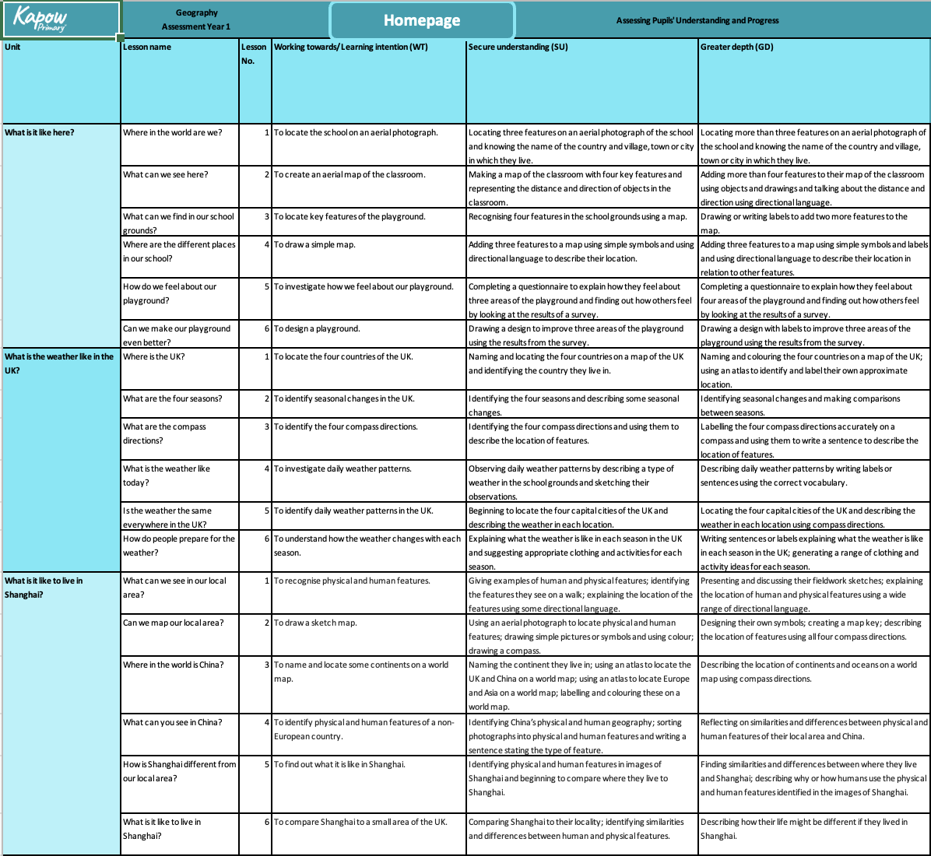
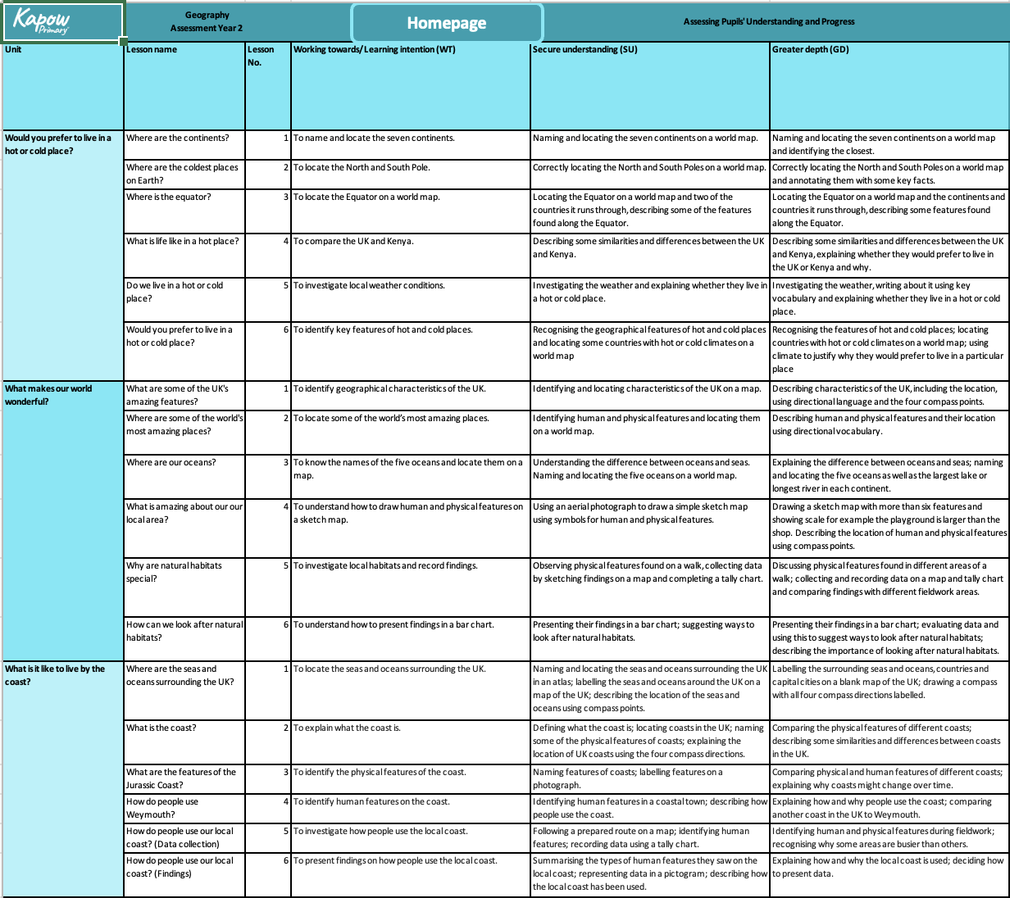
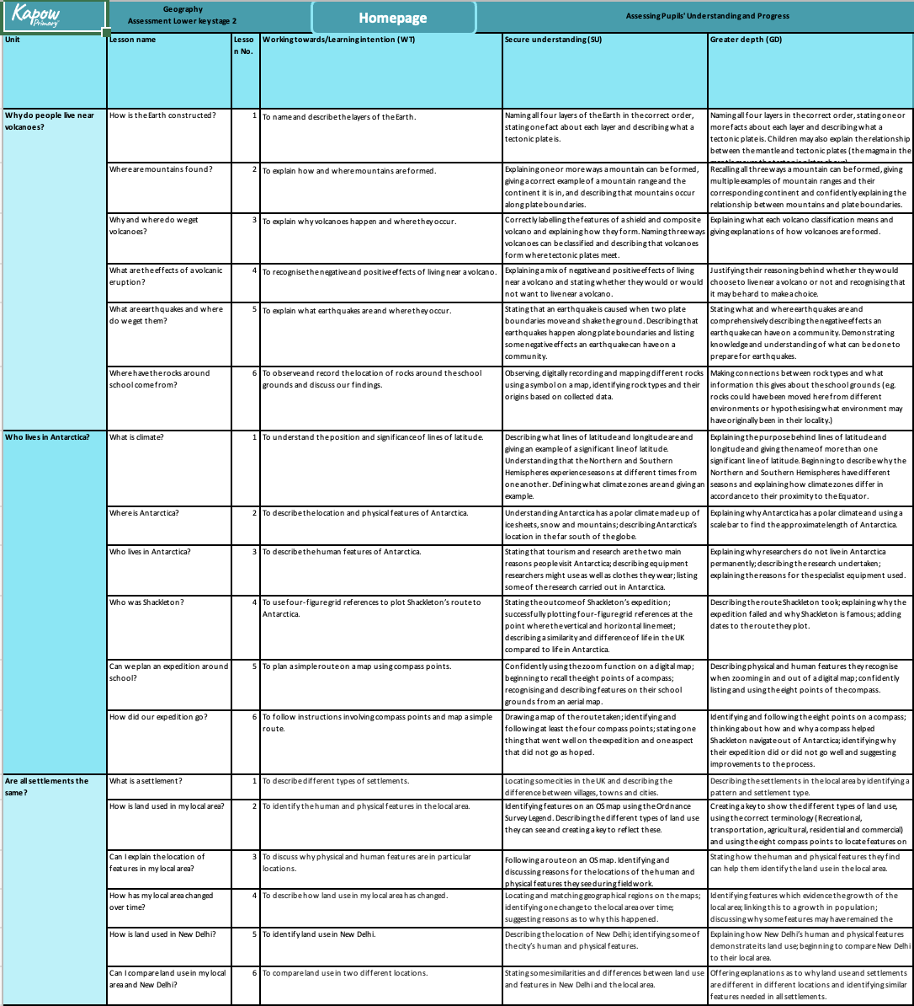
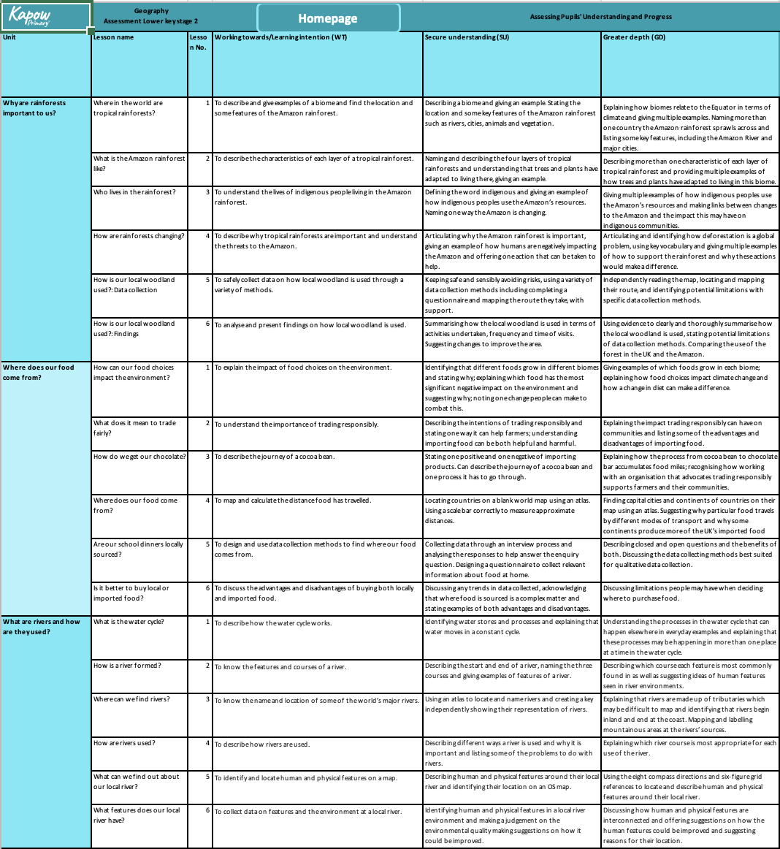
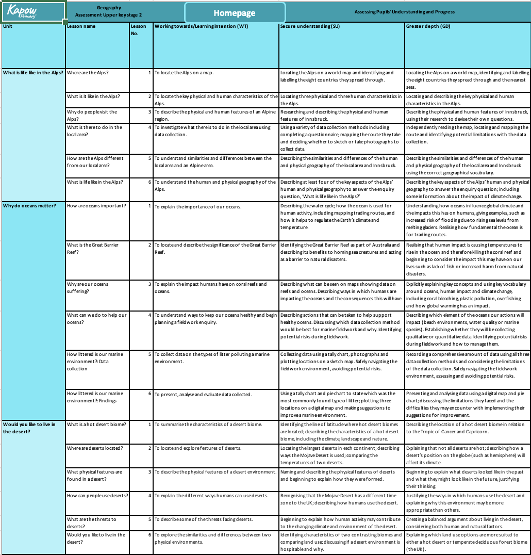
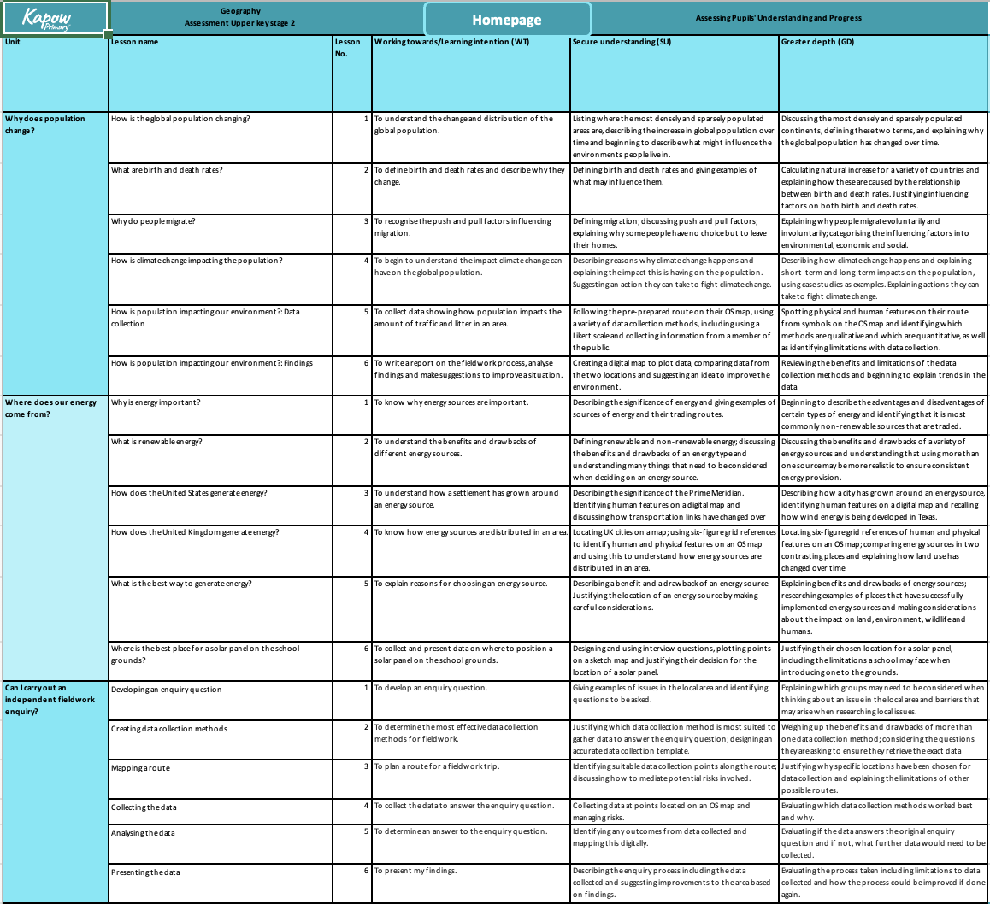
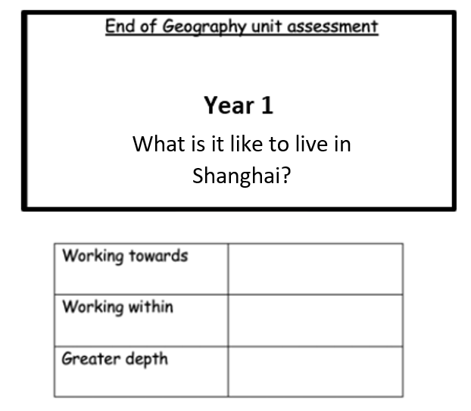
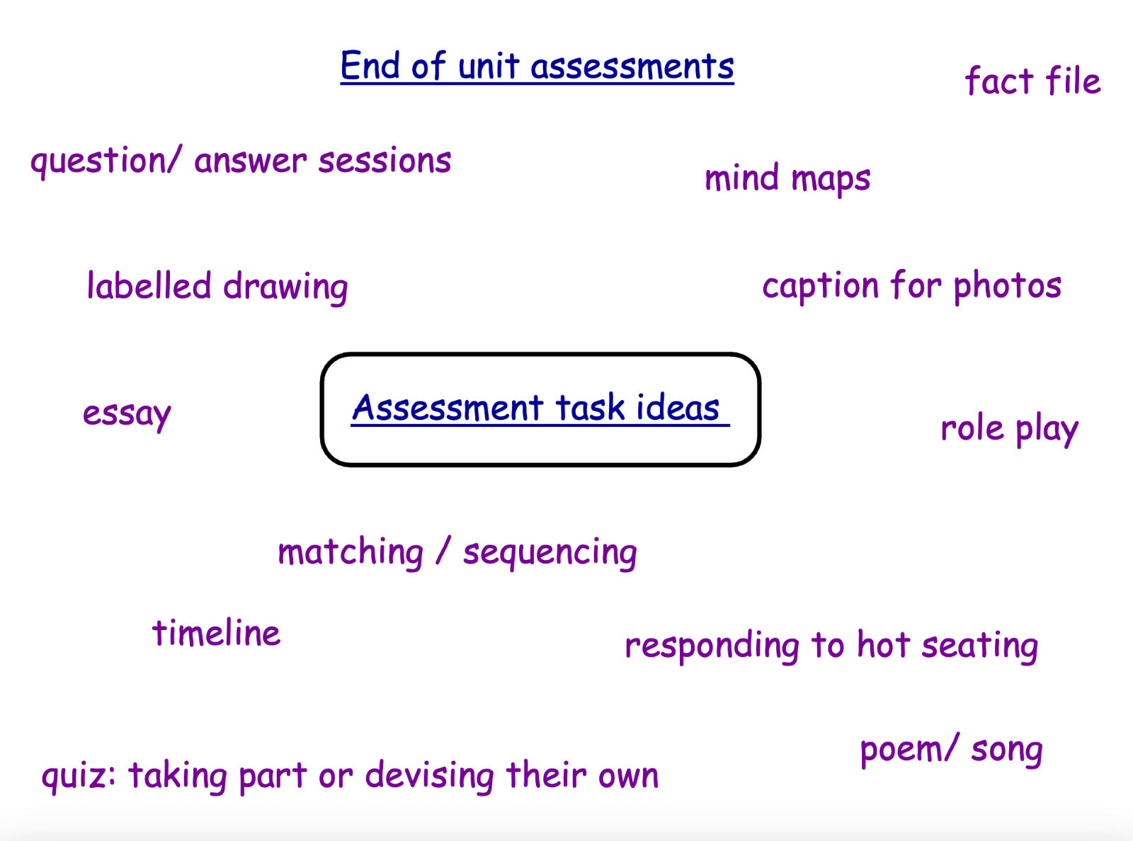

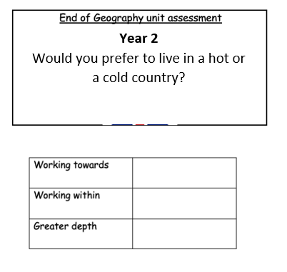

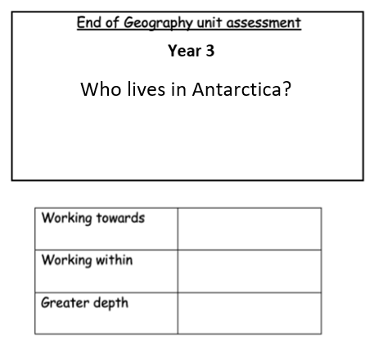

Lesson/Topic layout

A lesson and topic layout must have: 
- Before first lesson
-Mind map with key question in middle, what do children already know? (Stuck in books)
- Key question/Learning intention for that lesson
- Start of each lesson to include key vocab and meanings
- Starter question – can be on previous topic to retain information
- Mixture of lessons (if relevant) including
- Use atlases/maps
- Fieldwork
- Group work
- End of unit assessment

