
What is my child learning in Year 2…
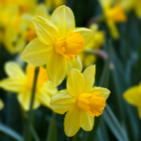
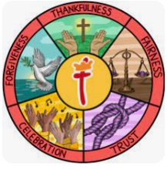  School Values | Everything we do at St Thomas' CofE Primary Academy is built upon our values of thankfulness, fairness, forgiveness, trust and celebration.  Our core Christian values underpin the British values and are closely linked. Core British Values of democracy, the rule of law, tolerance, respect and individual liberty are taught in the context of our strong Christian ethos.  Each half term we focus on one of our values through our class teaching and worship. This half term our key focus is forgiveness. Building the foundations for the British value of Rule of Law is about learning to manage our own feelings and behaviours as well as about learning right from wrong, and understanding there are consequences for certain choices and behaviours.
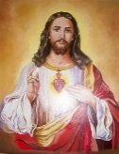  RE | In RE this half term, we will be exploring Passover and how important is it to Jewish people to do what God is asking (Judaism). We will be learning to understand the special relationship between Jews and God and the promises they make to each other.  We will be exploring the questions:  Is God important to everyone?  Should people follow religious leaders and teachings?
English    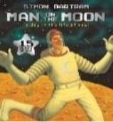  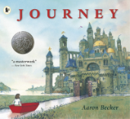 | Book focus:  In English, Year 2 will begin by reading ‘Man on the Moon’ by Simon Bartram.  This beautifully illustrated picture book tells the story of Bob, a man who lives and works on the moon. While people on Earth believe the moon is a quiet and empty place, Bob knows it is full of activity as he goes about his important job of looking after it. The story encourages children to think about perspective, imagination and feelings, as well as how illustrations can tell a story alongside the text.  We will then move on to our next class text, ‘Journey’ by Aaron Becker.  This wordless picture book follows a young girl who escapes into a magical world using a red crayon. Through detailed illustrations, children explore a range of fantastical settings and encounter mysterious characters as the girl travels through castles, cities and skies. The absence of words allows pupils to interpret the story themselves, supporting discussion, inference and creative thinking.  In writing, Year 2 will focus on developing character and setting descriptions, inspired by the rich illustrations and imaginative worlds in both texts. Children will build on their use of expanded noun phrases, adjectives and conjunctions to create clear and engaging descriptions. They will also learn to organise ideas and explain events by writing an explanation text about the first moon landing, linking their literacy learning with their understanding of real historical events.
Reading   | Our shared reading sessions are a chance for the children to learn important skills to help support their comprehension, which is a big focus for us. The children will be reading some of our focus book and then answering questions based on the skills below.  - Vocabulary – Looking at what the word means.  - Inference – Use clues in the text to help you.  - Predicting – What may happen next?  - Retrieval – The answer is somewhere in the text.  - Sequencing – Putting events in order  We also have our weekly session in our library where the children will have the chance to enjoy some quiet reading and share some of their favourite stories! We will still be taking library books home on a Wednesday and the children can change them every week (as long as they bring them back).
Maths   | In maths, Year 2 will be covering the following topics:  - Shape  - Money  - Multiplication and division  We will be continuing our programme called mastering number. We will be teaching this every morning after lunch. This will focus on the children really understanding their number bonds and links within numbers so they can learn facts by heart.  Our KIRF this half term is to focus the 2 times table (× and ÷)
  Science | Our science topic this half term will be ‘Plants: Light and Dark’.  The children will begin by making some observations of plants and comparing them. They will learn about the parts of plants and what plants need to grow.  The children will conduct their own experiment to investigate the effects of light and dark on plants.
History  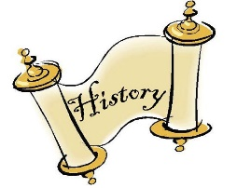 | Our History topic this half term will be ‘How Have Explorers Changed the World?’  Year 2 will be learning about explorers and what it means to travel to new and unknown places. Children will explore the lives of significant individuals including Ibn Battuta, Captain Scott and Neil Armstrong, learning about their journeys, the challenges they faced and the reasons they chose to explore. Through comparing different explorers, pupils will develop their understanding of significance, how we know about the past using sources such as diaries, and how important achievements are remembered and commemorated, including the first moon landing.
  ART | Our Art focus for this half term is drawing: Make your mark. The children will be exploring mark making and lines to create observational drawings. They will will be using various different media while responding to music
Computing   | In Computing this half term, Year 2 will be learning about programming through robot algorithms. Using Bee-Bot floor robots, children will practise giving clear instructions, exploring how different commands can lead to the same outcome, and making predictions about movements. They will progress to designing simple algorithms, following routes on mats and debugging their programs when things go wrong, developing key problem-solving and logical thinking skills.
PE   | The focus for PE this half term will be;  - Dance (with Mr Case)  - Sending and recieving
Music   | In Music this term, Year 2 will develop their singing and performance skills through a musical storytelling unit. Children will learn and perform songs linked to different environments such as the seaside, countryside and city, focusing on singing from memory, using pitch accurately and breathing at the correct points. They will work collaboratively to create soundscapes, use symbols to represent sounds and apply pitch and dynamics to enhance their own compositions, finishing the unit by performing a structured piece of music.
PSHE   | Our topic this half term is ‘Dreams and goals’. We will be looking at achieving realistic goals, perseverance, learning strengths, learning with others, group co-operations, and contributing to and sharing success.
Dates for diary | Future dates to be aware of:  - Friday 16th January – Year 2 topic launch day (Explorers)  - Monday 26th January – Geography/Sustainability SHINE – 2-3:15pm  - Tuesday 10th February – KS1 Kidsgrove Library visit IN school.  - Monday 24th February INSET day
Homework | Homework will be sent out on a Friday and will be due back the following Wednesday.  The children are also encouraged to continue playing Times Tables Rockstars at home 3 times a week as well as reading 3-5 times a week too. Reading records should be signed by an adult to indicate that their child has read at home. Reading books will be changed weekly. If they have finished their book, please encourage your child to read it again for fluency and to improve comprehension.  Thank you for your support with completing your child’s homework.

