What is my child learning in Year 3
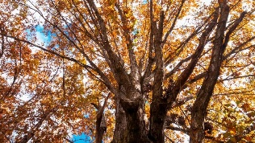


School Values  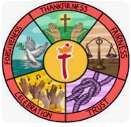 | Thankfulness  Our school Value this term is ‘Thankfulness’. Expressing gratitude is a form of worship and acknowledgment of God's provision in our lives. When we offer thanks for the blessings we've received, we acknowledge that all good things come from God. In Psalm 136:26, the psalmist writes, “Give thanks to the God of heaven. His love endures forever”.
RE  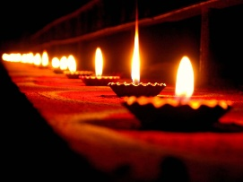 | Diwali Would celebrating Diwali bring a sense of belonging to a child? (Hinduism)  As we journey through this half term, the children will be learning about Diwali, the Hindu festival of light, which takes place every Autumn. Diwali means ‘row of lights’ and celebrates the story of Rama and Sita’s return home from 14 years of exile. It also marks the beginning of the Hindu New Year. We will look closely at how they make artistic rangoli patterns and place them outside their front door to welcome Lakshmi, the goddess of wealth. As well as decorating their houses and streets with lights and attend firework displays and dance shows with their parents and friends.
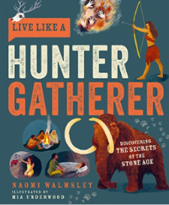    Engl ish | Book focus: Stone Age Boy  This tells the story of a modern boy who falls through a hole in the woods and travels 20,000 years back in time to the Stone Age, where he meets a prehistoric girl named Om and learns how her tribe makes tools, hunts, cooks, and creates art, only to be jolted awake back to his own time after a frightening encounter with a cave bear.  Book focus: Live like a Hunter Gatherer  Live Like a Hunter Gatherer is an informative and immersive guide to the Stone Age, written by a real-life hunter gatherer! If you imagined that all Stone Age people lived in caves, were not very clever, not very clean and said "Ugg" a lot, then think again…  We will use both our class text as inspiration for our own writing. We will be building on the skills the children learnt in Year 2 to write diary entries, narrative retells and non-chronological reports!  Ongoing throughout this term we will be focussing in on spelling, punctuation and handwriting. Please help your child to practise these skills at home. There will be weekly homework to help with these too!
Reading     | We will be exploring our key reading skills. These skills include:  - Vocabulary – Looking at what the word means.  - Inference – Use clues in the text to help you.  - Predicting – What may happen next?  - Retrieval – Finding facts and key details.  - Sequencing – Putting events in order  - Summarising- Finding the main points.  - Comparing/ Contrasting- commentating on what is happening and discussing the content.  At St Thomas’ this year, we are introducing SQUIRT (Silent/ Quiet Uninterrupted Independent Reading Time), a 20-minute reading session for each year group which will take place in our school library. The children will also have another session where they can share books with their friends and choose a book to bring home.
Maths   | Over the whole Autumn term, the children will be building on their prior knowledge on these subjects  - Place value  - Addition and subtraction  - Multiplication and division
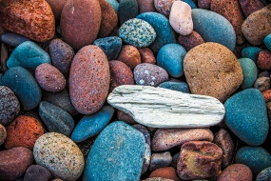  Science | Rocks and fossils  In Years 1 and 2, children looked at rocks as a type of material. They used the terms ‘rock’, ‘stone’ and ‘pebble’ and they will recap the differences between these different forms of rock. In Year 3, the children will:  - Begin to identify granite, pumice, sandstone, chalk, marble and gneiss. We will be identifying.  - Group and classify rocks based on their simple properties.  - Explore fossils.  The idea of a fossil will be a big part of our learning this half term. They will discover that a fossil is described as the remains or trace of a living thing that lived a long time ago. Fossils have led scientists to discover important information about living things from the past, such as dinosaurs.
History   | Would you prefer to live in the Stone Age, Bronze Age or Iron Age?  In our history unit we will be looking at the chronology of mankind, children are introduced to Britain’s story. They use archaeological evidence to find out about the Stone Age, Bronze and Iron Age. Using their research and evidence children will then answer the key topic question.
  Art | Painting and mixed media- prehistoric painting.  In this new and exciting topic. Children will begin to discover how and why our ancient ancestors made art, experimenting with natural materials to make homemade paints and playing with scale to paint on a range of surfaces.
Computing   | Online Safety  In computing our first topic for the Autumn term will be online safety. This is a very important topic that will help guide the children as we journey on through the year. The content will include:  . ‘Fake news’  . Privacy settings  . Ways to deal with upsetting online content  . Protecting our personal information on social media.
French  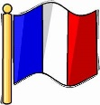 | French greetings with puppets.  In our new French topic children will use puppets to practise a variety of French greetings and learning how to introduce themselves. We will choose the correct greeting based on the time of day and by asking someone how they are.
PE   | Year 3’s PE lessons will take place on a Tuesday and Wednesday afternoons 2.15-3.15. Please ensure your child comes into school in their PE kit, hair tied back and jewelry removed on these days.  We will be covering the following lessons over the whole Autumn term  - Tennis  - Ball skills  - Swimming (details to follow soon)
Music   | Let your spirit fly  In this new and exciting unit, children will be introduced to the genres, R&B, Western, musical, motown and soul. Using these genres, children will begin to tell stories through music. Listening to music and considering the narrative it could represent. Paying close attention to the dynamics, pitch and tempo and how they change.
PSHE   | Being Me in My World  Setting personal goals Self-identity and worth Positivity in challenges Rules, rights and responsibilities Rewards and consequences Responsible choices Seeing things from others’ perspectives
Key events for the half term | Future dates to be aware of:  Friday 12th September – Everyone welcome coffee morning  Friday 19th September – Year 3 coffee morning  Friday 26th September – Pupil leaders Macmillan coffee morning  Tuesday 4th November – Year 3 INSPIRE (At church) 2pm-3pm  Tuesday 11th November – Year 3 SHINE (In school) 2pm-3pm  Friday 12th December – Eco and school council coffee morning  Friday 19th December – End of term, everyone welcome coffee morning
Homework | - Homework will be handed out on Fridays and due in on Thursdays.  - Spellings that are sent home will be tested in school on a Friday  - All homework is to be completed in one book. This will make it easier to keep track.  - Please ensure children bring in their reading journal and reading book every day to school.  Please ensure you listen to your child read at home as much as possible and record this in their reading journal.  If you have any questions about your child’s homework then please let me know.

