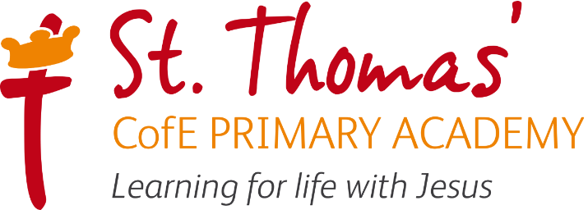

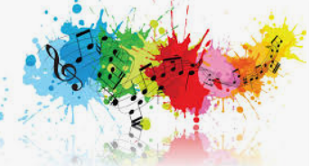
\

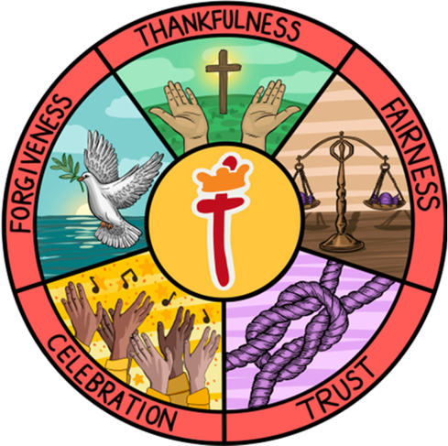

Music Learning Journey
2025/ 2026

Music Intent Implementation and Impact

Learning for life with Jesus

Intent
All areas of our curriculum are underpinned by our Gospel values and we ensure that our curriculum makes links to these values. At the heart of each subject is a set of core skills which form a subject learning journey, this journey is built from EYFS through to year 6 and the skills progressive as you move through the school. Knowledge is communicated to ensure coverage of National curriculum and it is through this knowledge that children apply their skills.
Children at St Thomas’ leave with a secure knowledge of both the academic knowledge and skills needed for the next stage of their education. They will have developed a clear set Christian and moral values which they can apply in all areas of their lives and will have taken part in real-life experiences which will have raised their aspirations and given them a thirst for wisdom and knowledge. The intention of the St Thomas’ Music learning journey is first and foremost to help children to feel that they are musical and develop a life-long love of music.

We focus on developing the skills, knowledge and understanding that children need in order to become confident performers, composers and listeners. Our learning journey introduces children to real life musical experiences from around the world and across the generations.

Our Music Lead in school is Mrs M Salt.

Implementation

St Thomas’ Music Learning Journey takes an holistic approach to music, the individual strands below are woven together to create an engaging and enriching learning experience.
- Performing
- Listening
- Composing
- History of music
- Knowledge of music

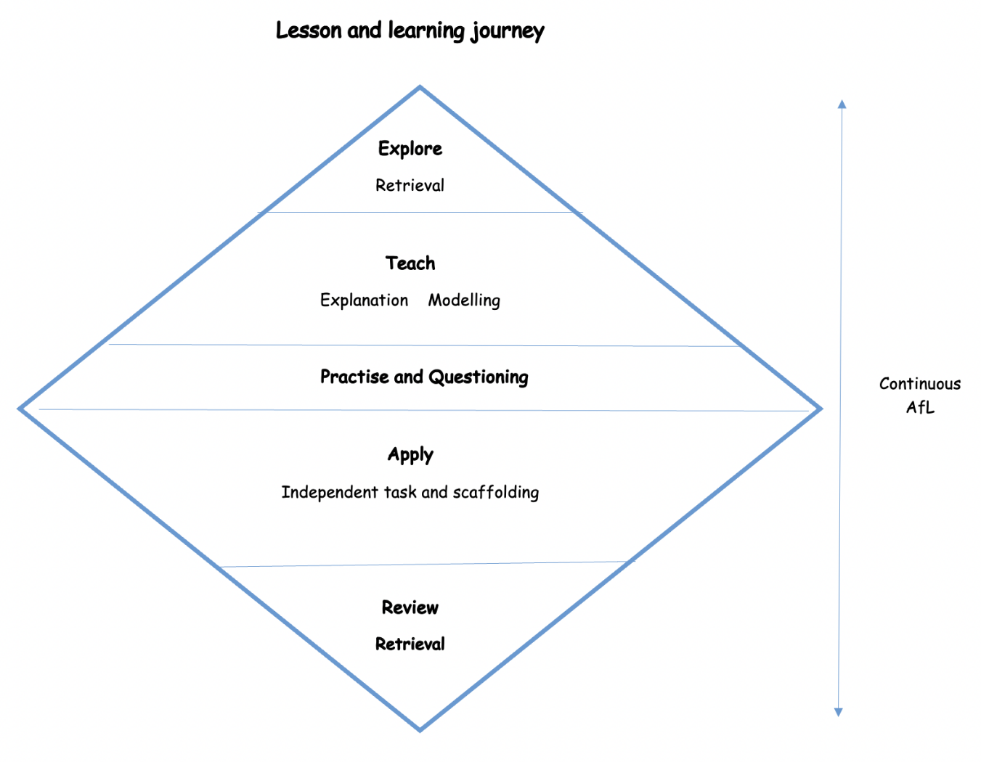

Over the course of the journey children will be taught to sing fluently and expressively, play tuned and untuned instruments accurately and with
control. They will learn to recognise and name pitch, duration, tempo, timbre, structure, texture and dynamics whilst using them in their own improvisations and compositions. A spiral curriculum model is followed where previous skills and knowledge are revisited and built upon.

Music is taught for 45 mins each week or 1hr 30 mins every two weeks depending on the unit and year group being taught. Each new unit of learning
Is introduced through a knowledge catcher which summarises previous knowledge and skills shared by the children. Children are then introduced to the key knowledge which will be shared during the unit in the form of a knowledge organiser. The knowledge organiser will be shared at the start and end of each lesson with key knowledge for each lesson highlighted. During the lesson activities are differentiated where appropriate and assessment
And feedback will focus on misconceptions and next steps for learning. At the end of each unit of learning children will complete an end of unit
assessment which will fed into future planning.

In music work is recorded and saved onto the Music TEAMS channel in year group folders for monitoring and sharing purposes

Following the Model Music Curriculum guidance (DfE 2021) St Thomas’ Music learning journey has an instrumental scheme of work which is taught in Year 4, this allows whole-class instrumental teaching and supports staff to deliver this using tuned percussion.

The school also raises the profile of music across the school through opportunities to join the school choir, school recorder group and
peripatetic music lessons.
EYFS
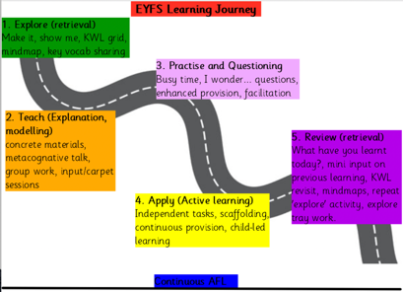

Impact

The specific musical impact of the St Thomas’ Music Learning Journey is that children will be

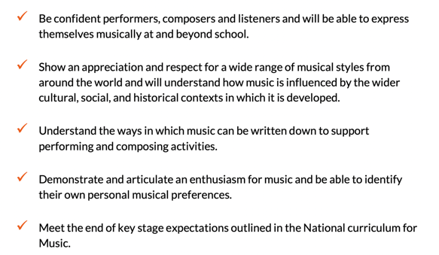

Assessment

Formative assessment takes part in each lesson and misconception and next steps of the focus for feedback. Summative assessment is completed for each child at the end of each unit of teaching using the assessment framework at the end of this documents. A best fit approach to statements
achieved results in an end of year summative grade.

Music Curriculum

 | Autumn 1 | Autumn 2 | Spring 1 | Spring 2 | Summer 1 | Summer 2
Nur | Nursery Rhymes | Bedtime Stories | Our Community  (People Who Help us) | Out of this World  (space, monsters, aliens, superheroes) | Safari  (Animals) | We’re all going on a summer holiday.  (seaside, holidays, travel)
Rec | Exploring Sound  Linked to firm foundation phonics | Celebration Music | Musical stories | Music and movement | Transport | Big Band
Year 1 | Keeping the pulse (Theme: My favourite things) | Tempo (Theme: Snail and mouse | Dynamics (Theme: Seaside) | Sound patterns (Theme: Fairytales) | Pitch (Theme: Superheroes) | Musical symbols (Theme: Under the sea)
Year 2 | Call and response (animals) | Instruments (musical storytelling) | Singing (on this island) | Contrasting dtnamics (space) | Structure (myths and legends) | Pitch: (musical me)
Year 3 | Adapting and transposing motifs  (Romans)  From 2026/2027  India | Ballads / Christmas practise | Creating compostions  (mountains) | Pentatonic melodies and composition  (Chinese new year) | India  From 2026/2027  Adapting and transposing motifs  (Romans) | Jazz  Singing
Year 4 | Body and tuned percussion  (rainforests)  Violins  From 2026/2027  Samba and carnival sounds and instruments | Changes in pitch, tempo and dynamics.  (Rivers)  Violin | Developing singing technique  (Vikings)  Violins | Haiku, music and performance.  Violins | Samba and carnival sounds and instruments  Violins  From 2026/2027  Body and tuned percussion  (rainforests) | Rock and roll  Violins
Year 5 | Blues music  From 2026/2027  Composition notation | Blues music | Musical Theatre | Composition to represent the festival of colour (Holi festival) | Looping and remixing | South and West Africa
Year 6 | Songs of WW2 | Film Music | Dynamics, pitch and tempo (Coast) | Theme and Variations  (Pop Art) | Advanced Rhythms  Whole class instrumental  Ukulele  (borrow from STGG or the Kings) | Composing and performing a leavers song

Red indicates the whole class instrumental programme as recommended by the DfE Model music curriculum 2021

Music Skills and Knowledge Progression

EYFS | Year 1 | Year 2 | Year 3 | Year 4 | Year 5 | Year 6
Explore lyrics by suggesting appropriate actions.  Listen to and follow a beat using body percussion and instruments.  Listen to sounds and match them to the object or instrument.  Listen to sounds and identify high and low pitch.  Listen to and repeating a simple rhythm and lyrics.  Understand that different instruments make different sounds and grouping them accordingly. | Recognise and understand the difference between pulse and rhythm.  Listening to and repeating short, simple rhythmic patterns. | Recognise timbre changes in music they listen to.  Recognise structural features in music they *listen to.  Listen to and recognise instrumentation.  Listen to and repeat a short, simple melody by ear.  Suggest improvements to their own and others’ work. | Recognise timbre changes in music they listen to.  Recognise structural features in music they listen to.  Listen to and recognise instrumentation.  Identify melodies that move in steps.  Listen to and repeat a short, simple melody by ear.  Suggest improvements to their own and others’ work. | Recognise the use and development of motifs in music.  Identify gradual dynamic and tempo changes within a piece of music.  Recognise and discuss the stylistic features of different genres, styles and traditions of music using musical vocabulary (Samba, Rock and Roll).  Identify common features between different genres, styles and traditions of music.  Recognise, naming and explaining the effect of the interrelated dimensions of music.  Identify scaled dynamics (crescendo/decrescendo) within a piece of music. | Recognise and confidently discuss the stylistic features of different genres, styles and traditions of music using musical vocabulary. (South African, West African, Musical, Theatre, Blues, Dance Remix.).  Represent the features of a piece of music using graphic notation, and colours, justifying their choices with reference to musical vocabulary. | Represent changes in pitch, dynamics and texture using graphic notation, justifying their choices with reference to musical vocabulary.  Identify the way that features of a song can complement one another to create a coherent overall effect.

EYFS | Year 1 | Year 2 | Year 3 | Year 4 | Year 5 | Year 6
Exploring the story behind the lyrics or music.  Respond to music through movement, altering movement to reflect the tempo, dynamics, or pitch of the music.  Consider whether a piece of music has a fast, moderate or slow tempo. | Describe the character, mood, or ‘story’ of music they listen to, both verbally and through movement.  Describe differences between two pieces of music.  Express a basic opinion about music (like/dislike). | Begin to use musical vocabulary to describe music. Identifying melodies that move in steps. | Begin to use musical vocabulary to describe music. | Use musical vocabulary to discuss the purpose of a piece of music.  Use musical vocabulary (related to the inter-related dimensions of music) when discussing improvements to their own and others’ work. | Compare, discuss and evaluate music using detailed musical vocabulary.  Develop confidence in using detailed musical vocabulary (related to the inter-related dimensions of music) to discuss and evaluate their own and others’ work. | Discuss musical eras in context, identifying how they have influenced each other, and discussing the impact of different composers on the development of musical styles.  Recognise and confidently discuss the stylistic features of music and relating it to other aspects of the Arts (Pop art, Film music).  Use musical vocabulary correctly when describing and evaluating the features of a piece of music.  Evaluate how the venue, occasion and purpose affects the way a piece of music sounds.  Confidently use detailed musical vocabulary (related to the inter-related dimensions of music) to discuss and evaluate their own and others work.

EYFS | Year 1 | Year 2 | Year 3 | Year 4 | Year 5 | Year 6
Using their voices to join in with well-known songs from memory.  Remembering and maintaining their role within a group performance.  Moving to music with instruction to perform actions.  Participating in performances to a small audience.  Stopping and starting playing at the right time. | Use voices expressively to speak and chant.  Sing short songs from memory, maintaining the overall shape of the melody and keeping in time.  Maintain the pulse (play on the beat) using hands, and tuned and untuned instruments.  Copy back short rhythmic and melodic phrases on percussion instruments.  Respond to simple musical instructions such as tempo and dynamic changes as part of a class performance.  Perform from graphic notation. | Use voices expressively when singing, including the use of basic dynamics (loud and quiet).  Sing short songs from memory, with melodic and rhythmic accuracy.  Copy longer rhythmic patterns on untuned percussion instruments, keeping a steady pulse.  Perform expressively using dynamics and timbre to alter sounds as appropriate.  Sing back short melodic patterns by ear and playing short melodic patterns from letter notation. | Sing songs in a variety of musical styles with accuracy and control, demonstrating developing vocal technique.  Sing and play in time with peers, with some degree of accuracy and awareness of their part in the group performance.  Perform from basic staff notation, incorporating rhythm and pitch and being able to identify these symbols using musical terminology. | Sing longer songs in a variety of musical styles from memory, with accuracy, control, fluency, and a developing sense of expression including control of subtle dynamic changes.  Sing and play in time with peers with accuracy and awareness of their part in the group performance.  Play melody parts on tuned instruments with accuracy and control and developing instrumental technique.  Play syncopated rhythms with accuracy, control and fluency. | Sing songs in two or more parts, in a variety of musical styles from memory, with accuracy, fluency, control and expression.  Work as a group to perform a piece of music, adjusting dynamics and pitch according to a graphic score, keeping in time with others and communicating with the group.  Perform with accuracy and fluency from graphic and simple staff notation.  Play a simple chord progression with accuracy and fluency. | Sing songs in two or more secure parts from memory, with accuracy, fluency, control and expression.  Work as a group to perform a piece of music, adjusting the interrelated dimensions of music as required, keeping in time with others and communicating with the group.  Perform a solo or taking a leadership role within a performance.  Perform with accuracy and fluency from graphic and staff notation and from their own notation.  Perform by following a conductor’s cues and directions.

Playing untuned percussion ‘in time’ with a piece of music.  Selecting classroom objects to use as instruments.  Experimenting with body percussion and vocal sounds to respond to music.  Selecting appropriate instruments to represent action and mood.  Experimenting with playing instruments in different ways. | Select and create short sequences of sound with voices or instruments to represent a given idea or character.  Combine instrumental and vocal sounds within a given structure.  Create simple melodies using a few notes.  Choose dynamics, tempo and timbre for a piece of music.  Create a simple graphic score to represent a composition.  Begin to make improvements to their work as suggested by the teacher. | Select and create longer sequences of appropriate sounds with voices or instruments to represent a given idea or character.  Combine and layer several instrumental and vocal patterns within a given structure.  Create simple melodies from five or more notes.  Choose appropriate dynamics, tempo and timbre for a piece of music.  Use letter name and graphic notation to represent the details of their composition.  Begin to suggest improvements to their own work. | Compose a piece of music in a given style with voices and instruments (Battle Song, Indian Classical, Jazz, Swing).  Combine melodies and rhythms to compose a multi-layered composition in a given style (pentatonic).  Use letter name and rhythmic notation (graphic or staff), and key musical vocabulary to label and record their compositions.  Suggest and implementing improvements to their own work, using musical vocabulary. | Compose a coherent piece of music in a given style with voices, bodies and instruments.  Begin to improvise musically within a given style.  Develop melodies using rhythmic variation, transposition, inversion, and looping.  Create a piece of music with at least four different layers and a clear structure.  Use letter name, graphic and rhythmic notation and key musical vocabulary to label and record their compositions.  Suggest improvements to others’ work, using musical vocabulary. | Compose a detailed piece of music from a given stimulus with voices, bodies and instruments (Remix, Colours, Stories, Drama).  Improvise coherently within a given style.  Combine rhythmic patterns (ostinato) into a multi-layered composition using all the inter-related dimensions of music to add musical interest.  Use staff notation to record rhythms and melodies.  Select, discuss and refine musical choices both alone and with others, using musical vocabulary with confidence.  Suggest and demonstrating improvements to own and others’ work. | Improvise coherently and creatively within a given style, incorporating given features.  Compose a multi-layered piece of music from a given stimulus with voices, bodies and Instruments.  Compose an original song, incorporating lyric writing, melody writing and the composition of accompanying features, within a given structure.  Develop melodies using rhythmic variation, transposition and changes in dynamics, pitch and texture.  Record your own composition using appropriate forms of notation and/or technology and incorporating.  Constructively critique their own and others’ work, using musical vocabulary.

EYFS | Year 1 | Year 2 | Year 3 | Year 4 | Year 5 | Year 6

EYFS | Year 1 | Year 2 | Year 3 | Year 4 | Year 5 | Year 6

 |  |  | Understand that music from different times has different features. | Recognise and discuss the stylistic features of different genres, styles and traditions of music using musical vocabulary. | Confidently discuss the stylistic features of different genres, styles and traditions of music and explaining how these have developed over time. | Discuss musical eras in context, identifying how they have influenced each other, and discussing the impact of different composers on the development of musical styles.

EYFS | Year 1 | Year 2 | Year 3 | Year 4 | Year 5 | Year 6

Pitch | To understand that what ‘high’ and ‘ low’ notes are. | To understand that pitch means how high or low a note sounds.  To understand that 'tuned' instruments play more than one pitch of notes. | To know that some tuned instruments have a lower range of pitches and some have a higher range of pitches.  To understand that a melody is made up from high and low pitched notes played one after the other, making a tune. | To know that the group of pitches in a song is called its 'key' and that a key decides whether a song sounds happy or sad.  To know that some traditional music around the world is based on five-notes called a 'pentatonic' scale.  To understand that a pentatonic melody uses only the five notes C D E G A | To know that a bass line is the lowest pitch line of notes in a piece of music, and a walking bassline (where patterns of notes go up then down again) is common in rock and roll.  To know that a glissando in music means a sliding effect played on instruments or made by your voice.  To know that 'transposing' a melody means changing its key, making it higher or lower pitched | To understand that a minor key (pitch) can be used to make music sound sad.  To understand that major chords create a bright, happy sound.  To know that a 'bent note' is a note that varies in its pitch, eg the pitch may slide up or down.  To understand that varying effects can be created using only your voice, for example by changing the pitch, dynamic or tempo of the sounds made. | To know that the Solfa syllables represent the pitches in an octave.  To understand that 'major' key signatures use note pitches that sound cheerful and upbeat.  To understand that 'minor' key signatures use note pitches that can suggest sadness and tension.  To know that a melody can be adapted by changing its pitch.

EYFS | Year 1 | Year 2 | Year 3 | Year 4 | Year 5 | Year 6
Duration | To recognise that different sounds can be long or short. | To know that rhythm means a pattern of long and short notes. | To know that 'duration' means how long a note, phrase or whole piece of music lasts.  To know that the long and short sounds of a spoken phrase can be represented by a rhythm. | To know that different notes have different durations, and that crotchets are worth one whole beat.  To know that written music tells you how long to play a note for. | To know that combining different instruments playing different rhythms creates layers of sound called ‘texture’.  To know that playing ‘in time’ requires playing the notes for the correct duration as well as at the correct speed.  To know that a motif in music can be a repeated rhythm. | To know that ‘poly-rhythms’ means many different rhythms played at once.  To know that the duration of a note or phrase in music can be shown using a repeated symbol or the size of a symbol on a graphic score. | To understand that all types of music notation show note duration, including the Kodaly method which uses syllables to indicate rhythms.  To understand that representing beats of silence or ‘rests’ in written music is important as it helps us play rhythms correctly.  To know that a quaver is worth half a beat.
Dynamics | To understand that instruments can be played loudly or softly. | To know that dynamics means how loud or soft a sound is.  To understand that sounds can be adapted to change their mood, eg through dynamics. | To know that dynamics can change the effect a sound has on the audience. | To know that the word 'crescendo' means a sound getting gradually louder. | To know that changing the dynamics of a musical phrase or motif can change the texture of a piece of music. | To understand that varying effects can be created using only your voice, for example by changing the pitch, dynamic or tempo of the sounds made. | To know that a melody can be adapted by changing its dynamics.
Tempo | To recognise music that is ‘fast’ or ‘slow’.  To understand that we can match our body movements to the speed (tempo) or pulse (beat) of music. | To know that the ‘pulse’ is the steady beat that goes through music.  To know that tempo is the speed of the music. | To understand that the tempo of a musical phrase can be changed to achieve a different effect. |  | To know that playing in time means all performers playing together at the same speed | To understand that a slow tempo can be used to make music sound sad.  To understand that varying effects can be created using only your voice, for example by changing the pitch, dynamic or tempo of the sounds made. | To know that a melody can be adapted by changing its dynamics, pitch or tempo.

EYFS | Year 1 | Year 2 | Year 3 | Year 4 | Year 5 | Year 6
Timbre | To know that different instruments can sound like a particular character. | To know that 'timbre' means the quality of a sound; eg that different instruments would sound different playing a note of the same pitch.  To know that my voice can create different timbres to help tell a story. | To know that musical instruments can be used to create 'real life' sound effects.  To understand an instrument can be matched to an animal noise based on its timbre. | To understand that the timbre of instruments played affect the mood and style of a piece of music. | To know that grouping instruments according to their timbre can create contrasting ‘textures’ in music.  To understand that both instruments and voices can create audio effects that describe something you can see. | To understand that human voices have their own individual timbre, and that this can be adapted by using the voice in different ways. | To know that timbre can also be thought of as 'tone colour' and can be described in many ways eg warm or cold, rich or bright
Texture | To know that music often has more than one instrument being played at a time. | To know that music has layers called 'texture'. | To know that a graphic score can show a picture of the layers, or 'texture', of a piece of music. | To know that many types of music from around the world consist of more than one layer of sound; for example a ‘tala’ and ‘rag’ in traditional Indian music. | To know that combining different instruments and different rhythms when we compose can create layers of sound we call 'texture'.  To understand that harmony means playing two notes at the same time, which usually sound good together. | To understand that a chord is the layering of several pitches at the same time.  To know that poly-rhythms means many rhythms played at once. | To understand that texture can be created by adding or removing instruments in a piece and can create the effect of dynamic change.  To know that a counter-melody is different to harmony because it used a differ rhythm as well as complementary notes.

\

EYFS | Year 1 | Year 2 | Year 3 | Year 4 | Year 5 | Year 6
Structure | To recognise the chorus in a familiar song. | To know that a piece of music can have more than one section, eg a versed and a chorus. | To understand that structure means the organisation of sounds within music, eg a chorus and verse pattern in a song. | To know that in a ballad, a 'stanza' means a verse.  To know that music from different places often has different structural features, eg traditional Chinese music is based on the five-note pentatonic scale. | To know that deciding the structure of music when composing can help us create interesting music with contrasting sections.  An ostinato is a musical pattern that is repeated over and over; a vocal ostinato is a pattern created with your voice.  To understand that musical motifs (repeating patterns) are used as a building block in many well-known pieces of music | To know that a loop is a repeated rhythm or melody and is another words for ostinato.  To know that 12-bar Blues is a sequence of 12 bars of music, made up of three different chords. | To know that a chord progression is a sequence of chords that repeats throughout a song.  To know that a ‘theme’ in music is the main melody and that ‘variations’ are when this melody has been changed in some way.
Notation | To know that signals can tell us when to start or stop playing. | To understand that music can be represented by pictures or symbols. | To know that 'notation' means writing music down so that someone else can play it  I know that a graphic score can show a picture of the structure and / or texture of music. | To understand that 'reading' music means using how the written note symbols look and their position to know what notes to play. | To know that ‘performance directions’ are words added to music notation to tell the performers how to play. | To know that simple pictures can be used to represent the structure (organization of music).  To understand that in written staff notation, notes can go on or between lines, and that the lines show the pitch of the note. | To know that ‘graphic notation’ means writing down using your choice of pictures or symbols but ‘staff notation’ means written more formally on the special lines called ‘staves.’  To know that chord progressions are represented in music by Roman numerals.

SEN Adjustments
In our Music Lessons we cater for our SEN children using the following strategies

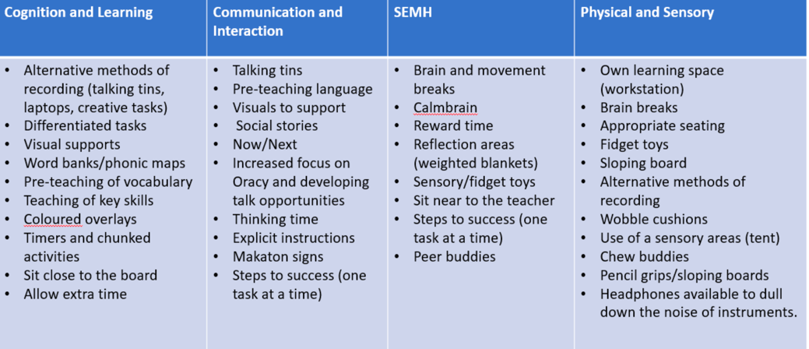

Assessments

Staff to use the assessment documents on Kapow

