What is my child learning in Year 1…



School Values  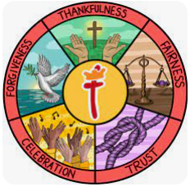 | Our Gospel value this half term is Fairness. In Year 1, we will explore what it means to be fair through stories and activities. We’ll talk about how we can show fairness in our classroom, during playtimes, and at home. This value will help us understand the importance of treating others equally and making sure everyone has a fair chance.
RE     | This term in RE, we are focusing on Incarnation.  We will explore the significance of Jesus' birth and the question, "Why does Christmas matter to Christians?" By the end of the unit, we should be able to:  • Recognise and retell the key figures and events in the Nativity story.  • Say why Jesus' birth is important to Christians and what it tells them about God's love.  • Give examples of how Christians celebrate Christmas and the themes of giving and love.  • Talk and ask questions about why Christmas is a time of joy and celebration for Christians.
English    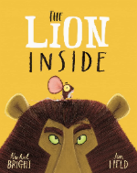  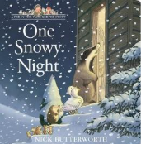  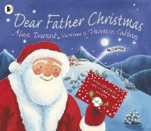 | Book focus:  This term, our writing will be inspired by a range of engaging texts. We’ll begin with The Lion Inside by Rachel Bright, where children will explore character and story by creating a simple retell. Next, we'll move on to One Snowy Night by Nick Butterworth, using the story’s cosy setting to support writing simple sentences. Later in the term, Dear Father Christmas by Alan Durant will help us learn how to write letters, as children have the chance to write their own letters to Santa.  Throughout these activities, we’ll continue to emphasize the importance of using phonics, capital letters, full stops, using and, punctuation and complete sentences in their writing.
Reading   | Our Guided Reading sessions will be a chance for the children to learn and apply many key reading skills. We will use our class text to work on the key skills of reading.  - Vocabulary – Looking at what the word means.  - Inference – Use clues in the text to help you.  - Predicting – What may happen next?  - Retrieval – The answer is somewhere in the text.  - Sequencing – Putting events in order
Maths   | In Maths, we are laying the foundation for essential number skills.  We’ll focus on:  - Place Value within 10, helping the children understand how numbers are made, recognition and their order.  - Addition and Subtraction within 10 with the use of symbols.  - Shapes and their properties.  We will also be continuing the NCTEM program ‘Mastering Number.’ This is a program designed to support our children with their mental maths in a fun and engaging way. This half term, they will be exploring the composition of numbers within 10 and addition and subtraction structures.  Our Key Instant Recall Facts will be based on number bonds to 10
  Science | This term in Science, we will focus on:  Everyday Materials, where the children will learn the names of different materials and explore their physical properties through hands-on investigations.  We’ll also observe the transition to Winter, discussing how the environment and weather change with the seasons and learning to recognise the signs of winter.
Geography  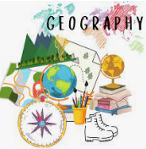 | Our Geography topic is "What is it like here?".  The Children will:  - Locate three features on an aerial photograph of the school  - Know the name of the country and village, town or city in which they live.  - Make a map of the classroom with key features.  - Explain how they feel about three areas of the playground and find out how others feel by looking at the results of a survey.  - Draw a design to improve the playground.  You can help us by talking about where you live.
Computing   | In Computing, we’ll continue with Online Safety as the children learn how to use the internet safely. We’ll explore Purple Mash, where the children will engage in fun activities to build their digital skills. We’ll mainly be learning about grouping and sorting information and how to create and interpret pictograms to represent data.
PE   | This term in PE, the children will be developing their coordination and control through yoga and ball skills. Yoga will help improve balance, flexibility, and focus in a fun and calming way. Through ball skills, we’ll be practising throwing, catching, rolling, and aiming – all while working on teamwork and spatial awareness.
  Music | In Music this term, we’ll be exploring the concept of tempo – the speed of music – through the Snail and Mouse unit. Children will learn to listen carefully and move to music that is fast and slow, just like a speedy mouse or a slow snail! They’ll use instruments, songs, and movement to explore how music can change and how it makes us feel.
PSHE   | This term, our PSHRE theme is "Celebrating Differences".  The children will learn to:  - Appreciate the similarities and differences between themselves and others, creating a sense of inclusion and respect.  - Understand bullying and how to respond to it.  - Making new friends  - Celebrating the uniqueness in everyone.  We will continue to embed the UNICEF Rights Respecting Schools into the PSHE lessons.
  Art | This term, our Art focus is on using storybook illustrations as a stimulus for creative exploration. The children will develop their mark-making skills by experimenting with a variety of tools and techniques. They will learn to use different materials to create textures and add intricate details to their drawings.  Inspired by the rich and imaginative illustrations found in storybooks, students will explore how to convey textures and details through their artwork. They will experiment with tools like brushes, pens, and sponges to enhance their mark-making techniques, creating visually engaging and textured illustrations that bring their own stories to life.
Key events for the half term | Future dates to be aware of:  - Friday 7th November: Coffee morning  - Friday 7th November – PSA Non-uniform day – Bring a bottle.  - Monday 17th November: SHINE  - Tuesday 18th November – PSA Non-uniform day – Bring in chocolate.  - Friday 21st November – PSA Christmas fair – 5pm  - Wednesday 10th December - KS1 Nativity day show – 1:30pm  - Thursday 11th December – KS1 Nativity evening show – 5:30pm  - Thursday 18th December – Christmas dinner and Christmas Jumper Day.  - Friday 19th December – PSA Panto – Jack and the Beanstalk
Homework | . Homework to be given out every Friday and should be completed by the following Friday.  . We ask that reading is completed 3-5 times a week at home too. Reading records should be signed by an adult to indicate that their child has read at home. Please make a note if your child has finished their book and needs to change it so that we are able to do so.  Thank you for your support with completing your child’s homework.

