What is my child learning in Year 6…



School Values  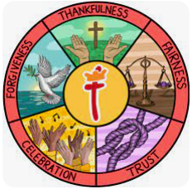 | Here at St Thomas’ we fulfil our mission of ‘Learning for Life with Jesus’ at every opportunity. Underpinning this are our 5 school values of: thankfulness, fairness, trust, celebration and forgiveness. Each half term we focus on a different value through our worship and class lessons.  This half term our value of focus is fairness. In Year 6, we will be exploring how the value of fairness is demonstrated in the world around us and how we can embody fairness in our daily lives. We will learn about the importance of treating others with equality and justice, ensuring that everyone is respected and valued. During our class Worships, we will read Bible verses that highlight fairness and discuss how we can practise fairness in our actions and words every day. We will also look at our key value of Fairness in line with our Rights Respecting Schools to look at our value of fairness on a global scale.
  RE | People of God: What would Jesus do?  Year 6 discuss how good news is not just about setting an example for good behaviour and challenging bad behaviour: it is that Jesus offers a way to heal the damage done by human sin. They will explore Jesus’ teachings through a number of Bible stories, including the Sermon on the Mount, and think about how this will influence their lives.
Writing    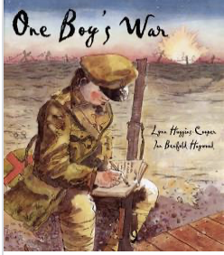 | In writing, the children will be continuing to work on building a range of language devices in order to develop their writing style. We focus particularly on:  - The use of more advanced punctuation (semi-colons, brackets, colons)  - Extending sentences by adding fronted adverbials and relative clauses  - Developing their understanding of the difference between and main clause and a subordinate clause so they can manipulate the order of sentences.  - Exploring language choices and ensuring they are appropriate for the audience of that genre  - Looking at the features of different genres  Using ‘One Boy’s War’ as inspiration, we will be writing diary entries and informal letters in role as characters and then building up to writing a newspaper article.
Reading  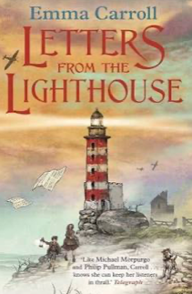 | In Reading, we are continuing with our current book for the next half term, ‘Letters from a Lighthouse’ by Emma Carroll, a fiction text based in World War 2 that the children are already enjoying reading. We will be using this text to practice a range of different comprehension questions types including retrieval, inference and discussions around vocabulary.
Maths   | In maths, we will be covering the following topics:  - The four operations (addition, subtraction, multiplication and division)  - Fractions (including ordering and comparing, finding equivalent fractions and solving problems  - Converting units (including units of time, weight and capacity)  During all of the topics, we will focus on both fluency and problem solving and reasoning questions to ensure the children develop a deep understanding of the concepts
  Science | In science this half term, we will be covering a new topic, electricity.  The children will be exploring signs and symbols used in electrical circuit diagrams, investigating the impact of adding extra bulbs, switches and other components into a circuit and how to stay safe around electrical items.
History   | Next half term we will be continuing with our topic on World War 2  Within this topic, we will be focusing on what life would have been like during this time, key events from the time including the Battle of Britain and their impact on today. We will also be learning about Reginald Mitchell and his impact on the war.
  D&T | Structures- Shelters -To build a model version of an Anderson Shelter  In this unit, we will be focusing on exploring the design of an Anderson Shelter and the advantages and disadvantages of these. We will then be designing and creating a sturdy 3D model of an Anderson Shelter from the knowledge we have gained.
Computing   | Unit 6.3 Spreadsheets  Year 6 will be using the 2Calculate programme on Purple Mash to create spreadsheets and learn about their practical use as a tool for computational modelling and problem solving in the ‘real world’.
French   | French Football Champions  Year 6 will be developing their understanding of masculine and feminine, and become familiar with football-related vocabulary around the positions of players and events in the game. They will explore different footballers and where they have come from.
PE   | Dance and Handball  In PE, Year 6 will be taking part in dance lessons with Mr Case every Thursday. They will learn a range of different dance styles.  In addition to dance, Year 6 will also be learning how to play handball and how to transition quickly between attack and defence to help gain or maintain possession.
  Music | Film Music  Year 6 will learn to appraise musical features in a variety of film contexts, identify and understand some composing techniques in film music, use graphic scores to portray different emotions, create and notate musical ideas and relate them to film music and play a sequence of musical ideas to convey emotion
PSHE   | Celebrating differences  This topic with involve exploring and discussing:  - Perceptions of normality and an understanding disability  - Understanding bullying  - Differences as conflict  - Difference as celebration  - Empathy
Key events for the half term | Future dates to be aware of:  Friday 7th November non uniform day in exchange for bottles  Monday 10th November Anti bullying week begins  Tuesday 11th November Year 6 outdoor learning day  Tuesday 11th November Non uniform day in exchange for chocolate  Friday 14th November school closed for INSET day.  Wednesday 19th November flu immunisations  Friday 21st November Christmas Fayre 5:30pm-7:30pm  Wednesday 17th December KS2 Christmas carol service 6pm at St Thomas’ church  Thursday 18th December Christmas dinner day
Homework | In year 6, we will continue to send a range of SPAG, reading and maths homework each week to prepare them for their SATs. We ask that the children also read their reading book at least 3 times a week and log on and play Times Table Rockstars 2-3 times a week too!

