What is my child learning in Year 2…


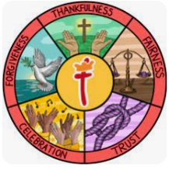  School Values | Our theme this half term is ‘fairness’. We will be exploring parables from the bible that show fairness and justice and we will be embedding this into our school life. We will also be exploring the value of fairness through our Rights Respecting Schools.
  RE | In RE this half term, we will be exploring Christianity. We will look at the teachings of Jesus to answer our big question; ‘What is the Good News that Jesus brings?’  The children will continue to learn from parables told by Jesus, questioning why he told these stories and what the morals of these are too.
English    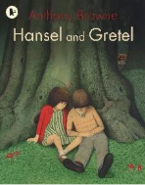  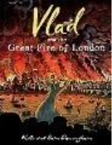 | Focus text  In English, Year 2 will begin by reading ‘Hansel and Gretel’ by Anthony Browne.  A poor woodcutter's children, Hansel and Gretel, are abandoned in the forest, where they stumble upon a house made of gingerbread and cake, only to be ensnared by a wicked witch who plans to eat them. The story follows their journey as they must use their wits to escape the witch's clutches and find their way home.  Then we will move on to our next class text, ‘Vlad and The Great Fire Of London’ by ‘Kate Cunningham’.  Vlad and the Great Fire of London is a picture book that supports the Key Stage 1 history curriculum. Through Vlad’s story and full-colour illustrations it shows how the fire is believed to have started, how it spread and what Londoners did to fight it and escape it. This illustrated story of the Great Fire of 1666 also includes a fact file about the fire.  In writing, Year 2 will be continuing to learn to join simple sentences together using a range of coordinating conjunctions and beginning to understand and use subordinating conjunctions. We will be working on tense, particularly past tense. They will be writing a range of genres including a non-chronological report on the Great Fire of London, a diary entry inspired by the historical diaries by Samuel Pepys, and a ‘twisted tale’/alternative ending to the classic Hansel and Gretel.
Phonics  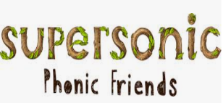  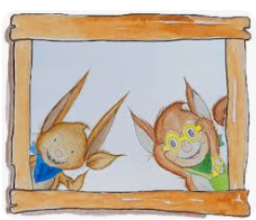 | We will be continuing to have daily phonics lessons using our supersonic phonics scheme. There are different groups for phonics depending on what the children need support with. Below are the different groups:  - Phase 2/3 sounds  - Phase 3/4 sounds  - Phase 4/5 sounds  - Year 2 Spelling rules – the main group in year 2 will be working on ‘switch it spelling’ wherein they look at words with spellings that ‘look the same, but sound different’.
Reading    = | Our shared reading sessions are a chance for the children to learn important skills to help support their comprehension. The children will be reading some of our focus book and then answering questions based on the skills below.  - Vocabulary – Looking at what the word means.  - Inference – Use clues in the text to help you.  - Predicting – What may happen next?  - Retrieval – The answer is somewhere in the text.  - Sequencing – Putting events in order  We will also be continuing with our SQUIRT (Silent/ Quiet Uninterrupted Independent Reading Time), a 20 minute reading session for each year group which will take place in our school library.
Maths   | In maths, Year 2 will be covering the following topics:  Addition and subtraction - finding 10 more and less than any numbers, adding and subtracting up to 100 with some crossing of a ten’s boundary and using different methods such as drawing dienes and column method.  Shape – exploring 2D and 3D shapes, looking at their features and properties and sorting them into categories.  We will be continuing with our fluency programme for maths called mastering number. We will be teaching this every day after lunch for 15 minutes. This will focus on the children really understanding their number bonds and links within numbers so they can learn facts by heart.
  Science | Our science topic this half term is ‘Materials’.  The children will explore and learn the properties of a range of common materials including plastic, glass, wood, metal etc. and will conduct simple tests and experiments. They will learn about the uses of different materials and compare the effectiveness of materials for different jobs through investigations too.
History  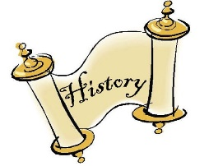 | Our History topic this half term is ‘What happened in London in 1666?  - What was London like?  - What happened on 6th September 1666?  - How did the fire spread?  - What was left of London?  - How was London rebuilt?  - How did the fire impact the future?  We will also be visiting Ford Green Hall, a local Tudor/Stuart era house, for a Great Fire of London experience day on Friday 21st November 2025. If you would like a replacement letter for this visit, please let me know on Class Dojo and I can print you a new one.
  Design and Technology | ‘Making a Moving Storybook’  - Identify whether a mechanism is a side-to-side slider or an up-and-down slider and determine what movement the mechanism will make.  - Clearly label drawings to show which parts of their design will move and in which direction.  - Make a picture that meets the design criteria, with parts that move purposefully as planned.  - Evaluate the main strengths and weaknesses of their design and suggest alterations.
Computing   | This half term we will be focusing on;  - Coding  - Spreadsheets
PE   | In PE this half term, Year 2 will focus on Fitness and Fundamentals.  In Fitness lessons, the children will take part in a range of activties to develop components of fitness. They will begin to explore and develop agility, balance, coordination, speed and stamina.  In Fundamentals, the children will develop the fundamental skills of balancing, running, changing direction, jumping, hopping and skipping.
Music   | This half term, our topic is ‘instruments – musical storytelling’. The children will learn how events, actions and feelings within stories can be represented by pitch, dynamics and tempo.
PSHE   | Our topic this half term is ‘Celebrating differences’.  We will be discussing:  - Assumptions and stereotypes about gender  - Talking about and understanding bullying and standing up for one’s self and others  - Making new friends  - Gender diversity  - celebrating difference
Key events for the half term | Future dates to be aware of:  - Friday 7th November – PSA Non-uniform day – Bring a bottle.  - Tuesday 11th November – PSA Non-uniform day – Bring in chocolate.  - Friday 21st November – Year 2 visit to Ford Green Hall.  - Friday 21st November – PSA Christmas fair – 5:30pm  - Friday 28th November – Year 2 coffee morning.  - Wednesday 10th December - KS1 Nativity day show – 1:30pm  - Thursday 11th December – KS1 Nativity evenin show – 5:30pm  - Thursday 18th December – Christmas dinner and Christmas Jumper day.  - Friday 19th December – PSA Panto – Jack and the Beanstalk
Homework | Homework will be sent out on a Friday and will be due back the following Wednesday.  The children are also encouraged to continue playing Times Tables Rockstars at home 3 times a week as well as reading 3-5 times a week too. Reading records should be signed by an adult to indicate that their child has read at home. Reading books will be changed weekly. If they have finished their book, please encourage your child to read it again for fluency and to improve comprehension.  Thank you for your support with completing your child’s homework.

