What is my child learning in Year 4…



School Values  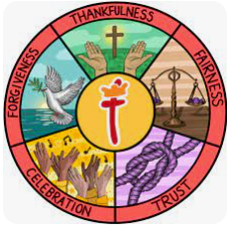 | Our Gospel value this half term is Fairness.  In Year 4, we will be exploring how the value of fairness is demonstrated in the world around us and how we can embody fairness in our daily lives. We will learn about the importance of treating others with equality and justice, ensuring that everyone is respected and valued. During our class Worships, we will read Bible verses that highlight fairness and discuss how we can practise fairness in our actions and words every day. We will also look at our key value of Fairness in line with our Rights Respecting Schools.
RE  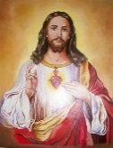   | What is it like for Christians to follow God? (Christianity)  In Year 4, we will be learning about the teachings of Christianity and exploring the question, "What is it like for Christians to follow God?" We will discuss how Christians believe that following God involves living according to His teachings and embracing love, compassion, and forgiveness. Through stories and activities, we will reflect on how these teachings can guide Christians in their daily lives and help them build a strong community rooted in faith.
English    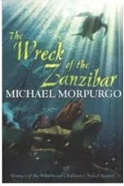 | Book focus:  In English this half term, we will be focusing on a new book, The Wreck of the Zanzibar by Michael Morpurgo. This gripping tale follows the adventures of a young boy who embarks on a journey filled with bravery, friendship, and the challenges of life at sea. The children will be captivated by the vivid storytelling and engaging characters, and I am confident they will enjoy delving into this exciting narrative!  This half term in writing, the children will begin by creating a non-chronological report about rivers. They will learn how to organise their ideas using headings, subheadings, bullet points, and paragraphs, and use a range of conjunctions to link their information clearly and effectively. Following this, the children will imagine that Laura could row in the gig and rewrite the rescue of the General Lee, focusing on developing atmosphere and action through precise vocabulary and sentence variety. Finally, they will explore poetry linked to storms and the sea, studying pieces such as A Smuggler’s Song, Grim and Gloomy, The Sea’s Treasures, and The Ancient Mariner. Through this, they will experiment with rhythm, imagery, and figurative language to create their own sea-inspired poems.  I’m really looking forward to seeing how their imagination and descriptive skills shine through in their writing this term!
Reading   | This half term in reading, we will continue to focus on deepening and embedding our reading skills. The children will explore a variety of texts, practising important skills such as understanding word meaning, making predictions, drawing inferences, retrieving information, and summarising key points. Through guided reading sessions, we’ll work on approaching different types of questions with confidence, setting a strong foundation for their continued development as readers.
Maths   | In Maths this half term, Year 4 will cover the following topics:  - Area: Learning to calculate the area of different shapes and understanding its practical applications.  - Multiplication and Division: Developing strategies for multiplying and dividing numbers to build confidence and fluency in these operations.
  Science | This half term in Science, we will focus on:  - Data Collection: Developing skills to gather, record, and interpret scientific data.  - States of Matter: Exploring the properties of solids, liquids, and gases, and understanding how they change from one state to another.  The children will engage in hands-on activities to conduct experiments, collect and analyse data, and explore different states of matter through practical investigations.
Geography  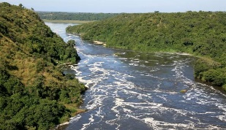 | Our topic for this half term is "What are rivers and how are they used?" We will explore the ways in which water is stored and moves, helping pupils develop an understanding of the water cycle. Children will name and map major rivers both in the UK and globally. They will learn about the features and courses of a river, as well as how rivers are used by humans. Later in the term, pupils will study a local river to identify these features.

D&T
Computing   | In computing this half term, we will continue to focus on:  - Online Safety: Learning how to stay safe online, including understanding privacy, responsible behaviour, and how to protect personal information.  - Coding: Developing basic coding skills by creating simple programs and games using block-based coding languages.  - Hardware Investigators: Exploring the different parts of a computer and understanding how hardware components work together.  The children will engage in activities that teach them about online safety, give them hands-on experience with coding, and allow them to investigate and understand computer hardware.
French  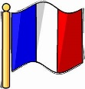 | This half term, we will focus on clothes and getting dressed in French. The children will learn vocabulary to describe different items of clothing, along with the various forms of the indefinite article. They will practise expressing opinions about outfits, enabling them to discuss their preferences in French. Through these activities, the children will enhance their ability to talk about clothing and develop their conversational skills in the language.
PE   | This half term in PE, the children will be developing their skills in hockey and gymnastics.  In hockey, they will focus on improving their control, passing, dribbling, and shooting techniques, as well as learning how to work effectively as part of a team during small-sided games.  In gymnastics, the children will explore balance, movement, and sequencing, creating and performing routines that combine jumps, rolls, and transitions with control and creativity.
  Music | This term in Year 4, we will be exploring changes in pitch, tempo, and dynamics with a focus on rivers, linking closely to our geography topic. Pupils will listen to and create music that reflects the movement and mood of rivers, experimenting with how musical elements can represent flowing water, gentle streams, and powerful rapids. They will have the opportunity to compose and perform their own river-inspired pieces, using instruments and voices to express different sounds and textures. We look forward to hearing their creative interpretations of this exciting theme!
PSHE   | In PSHRE this half term, the children will explore the theme of celebrating differences. They will learn to challenge assumptions and understand the importance of not judging by appearance while also accepting themselves and others. The children will discuss various influences on their lives, including understanding bullying and developing problem-solving skills. They will engage in activities that help them identify how special and unique everyone is, as well as reflect on first impressions and their impact on relationships.
Key events for the half term | Future dates to be aware of:  - Friday 7th November – PSA non uniform day, bring a bottle  - Tuesday 11th November – PSA non uniform day, bring chocolate  - Friday 14th November – Inset day  - Friday 5th December – Year 4 coffee morning  - Friday 12th December – Eco council and school council coffee morning  - Friday 19th December – Everyone welcome – End of term, coffee and mince pies
Homework | In year 4, we will send a range of SPAG, reading and maths homework each week.  Homework will always be given out on Fridays and is due back on the following Friday. Children are welcome to bring their homework in earlier and leave it in their trays.  We ask that the children also read their reading book at least 3 times a week and log on and play Times Table Rockstars 2-3 times a week too!

