What is my child learning in Year 2…


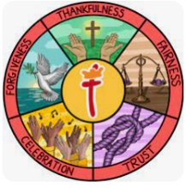  School Values | Our theme this half term is ‘thankfulness’. We will use the story of Joseph as a basis to look at the importance of gratitude and being thankful. We will be discussing what we are thankful for, what we are grateful for and appreciating what we have.
  RE | In RE this half term, we will be exploring Christianity. We will look at the teachings of Jesus to answer our big question; ‘Is it possible to be kind to people all the time?’  We will learn what parables and gospels are and learn why Christians see Jesus as important. We will look at how we can show kindness and how we can look for the message behind a parable.
English    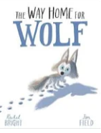  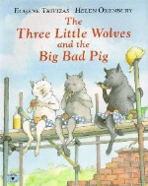 | Focus text  In English, Year 2 will begin by reading ‘The Way Home for Wolf’ by Rachel Bright.  ‘Set in the snowy Arctic, Wilf is a brave wolf cub. He is spirited and independent. When the wolf pack decides to move, Wilf is keen to lead the pack.’  They will then move on to ‘The Three Little Wolves and the Big, Bad Pig’, a funny twisted tale of the classic ‘Three Little Pigs’ that the children will already be familiar with.  In writing, Year 2 will strengthen and build upon grammar learned in Year 1 by learning to join simple sentences together using a range of coordinating conjunctions and beginning to understand and use subordinating conjunctions. They will be writing a range of genres including diary entries, narrative retells and instructions.
Phonics  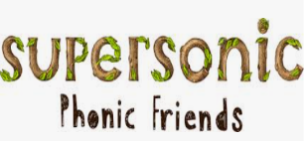  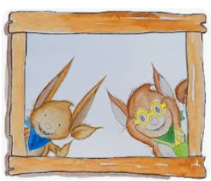 | We will be continuing to have daily phonics lessons using our supersonic phonics scheme and recapping all the phase 4 and 5 sounds that the children learnt in year 1. We will continue to recap tricky words and build on these to learn the year 2 common exception words. We will slowly come away from phonics as the year goes on to learn specific spelling rules.
Reading    = | Our shared reading sessions are a chance for the children to learn important skills to help support their comprehension. The children will be reading some of our focus book and then answering questions based on the skills below.  - Vocabulary – Looking at what the word means.  - Inference – Use clues in the text to help you.  - Predicting – What may happen next?  - Retrieval – The answer is somewhere in the text.  - Sequencing – Putting events in order  We will also be continuing with our SQUIRT (Silent/ Quiet Uninterrupted Independent Reading Time), a 20 minute reading session for each year group which will take place in our school library.
Maths   | In maths, Year 2 will be covering the following topics:  - Place value to 100- recognising, partitioning and comparing numbers to 100, we will also look at skip counting in 2s, 5s and 10s.  - Addition and subtraction- finding 10 more and less than any numbers, adding and subtracting up to 100 with some crossing of a tens boundary.  We will be continuing with our fluency programme for maths called mastering number. We will be teaching this every day after lunch for 15 minutes. This will focus on the children really understanding their number bonds and links within numbers so they can learn facts by heart.
  Science | Our science topic this half term is ‘Living things and their habitats’. The children will be learning to;  - Explore and compare things that are living, dead and things that have never been alive.  - Identifying that most living things live in habitats to which they are suited.  - Describe how different habitats provide basic needs and how they depend on each other.  - Identify and name a variety of plants and animals in their habitats, including microhabitats.  - Describe how animals get their food using a food chain.
Geography  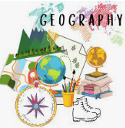 | Our Geography topic this half term is ‘Why is our natural world wonderful?’ The children will be learning to:  - Identify and locate characteristics of the UK on a map.  - Identify human and physical features.  - Locate human and physical features on a world map.  - Explain the difference between oceans and seas.  - Name and locate the five oceans on a world map.  - Use an aerial photograph to draw a simple sketch map.  - Collect data by sketching findings on a map and completing a tally chart.  - Present their findings in a bar chart
  ART | Our art focus for this half term is ‘drawing’. This unit focuses on helping pupils develop their ability to tell a story through drawing. It includes lessons on creating textures, observational drawing, character expression, and storytelling through illustrations, enhancing pupils' mark-making techniques, observational skills, and imagination in art.
Computing   | This half term we will be focusing on;  - Online Safety  - Coding  - Spreadsheets
PE   | In PE this half term, Year 2 will focus on yoga and ball skills.  In yoga, Year 2 will be working on their balance, flexibility, strength and coordination through breathing exercises and yoga poses.  In ball skills, the children will learn to roll, track, dribble, kick, throw and catch balls.  Year 2 PE days will be Mondays and Fridays this half term.
Music  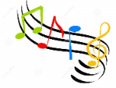 | This half term, the children will use instruments to represent animals, copying rhythms and creating call and response rhythms.  They will play in time, explore dynamics, demonstrate call and response and perform a composition.
PSHE   | Our topic this half term is ‘Being Me in My World’. The Children will be learning about;  - Hopes and fears for the year  - Rights and responsibilities  - Rewards and consequences  - Safe and fair learning environment  - Valuing contributions  - Choices  - Recognising feelings
Key events for the half term | Future dates to be aware of:  - Thursday 2nd October – National Poetry Day  - Monday 6th October – Parent SHINE workshop (2pm-3.15pm)  - Tuesday 7th October – Individual school photographs  - Week beginning 13th October – Time4Sport swimming pool in school (more information on this to follow)
Homework | Homework will be sent out on a Friday and will be due back the following Wednesday.  The children are also encouraged to continue playing Times Tables Rockstars at home 3 times a week as well as reading 3-5 times a week too. Reading records should be signed by an adult to indicate that their child has read at home. Please make a note if your child has finished their book and needs to change it so that we are able to do so. We ask that all other messages please be communicated via Class Dojo.  Thank you for your support with completing your child’s homework.

