What is my child learning in Year 1…
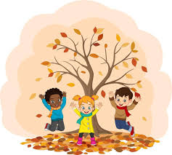


School Values  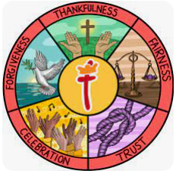 | Our Gospel value this half term is Thankfulness. In Year 1, we will be exploring what it means to be thankful through different stories from the Bible. We will start by linking our value to our RE lessons and look at how Christians believe God created the world and what we are thankful for in our own world. We will also reflect on how we can show thankfulness in our daily lives, both at school and at home.
RE   | This term in RE, we are focusing on the Christian view on creation. We will look at the creation story (Genesis 1:1-2.3) and by the end of the unit we should be able to:  - Recognise and retell the ‘big story’ of the Bible.  - Say what the story tells Christians about God.  - Give an example of how Christians do to say thank you to God for the creation.  - Talk and ask questions about living in an amazing world.
English    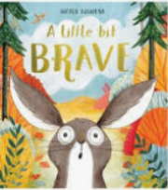  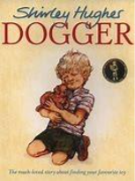  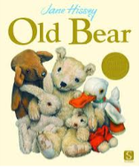 | Book focus:  A Little Bit Brave by Nicola Kinnear  We begin the term with this beautifully illustrated story about courage and friendship. Children will enjoy discussing the characters and making simple predictions. In writing, we’ll focus on rehearsing key early writing skills such as using capital letters, full stops, and finger spaces. These skills form the foundation for confident sentence writing.  Old Bear by Jane Hissey  This classic tale about forgotten toys comes to life in our second book. Children will continue practising their basic sentence skills and begin writing short captions to describe characters, settings and key events. The detailed illustrations in Old Bear provide rich opportunities for talk and vocabulary development.  Dogger by Shirley Hughes  Our final book is the much-loved story of a lost and found toy, which ties beautifully into our themes of emotions and kindness. Building on the caption work from Old Bear, children will begin to write simple sentences about the characters and story events. This supports their growing confidence in independently communicating their ideas in writing.
Reading   | Our Guided Reading sessions will be a chance for the children to learn and apply many key reading skills. We will use our class text to work on the key skills of reading.  - Vocabulary – Looking at what the word means.  - Inference – Use clues in the text to help you.  - Predicting – What may happen next?  - Retrieval – The answer is somewhere in the text.  - Sequencing – Putting events in order  This year, the children will continue to have SQUIRT (Silent/ Quiet Uninterrupted Independent Reading Time), a 20-minute reading session for each year group which will take place in our school library. We can’t wait to share our love of reading with the children.
Maths   | In Maths, we are laying the foundation for essential number skills.  We’ll begin by focusing on:  - Place value to 10 (recognising numbers with in 10, their order and how each number is made)  - Addition and subtraction with in 10 (recognising how to add and subtract with in 10)  We will also be starting the NCTEM program ‘Mastering Number.’ This is a program designed to support our children with their mental maths in a fun and engaging way. This half term, they will be strengthening our subitising to 5 and applying our knowledge of this to help us with our numbers to 10.  Our Key Instant Recall Facts will be based on number bonds to 5
  Science | This half term, our science topic is Animals including Humans. During this topic we will:  - Identify, draw and label parts of the human body.  - Recognise and explore the five senses; sight, sound, taste, touch and smell.  As Scientists, we will conduct our very own investigation into the seasonal changes around us. We will collect and record data to come up with our very own conclusions to what is changing in the world around us.
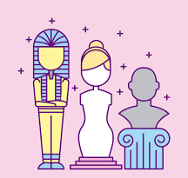  History | This term in history, we will be encouraging children to ask questions about the past and make simple comparisons with their own lives. Through discussion, observation and hands-on experiences, they will begin to develop a sense of chronology and understand how life has changed over time.  What was it like here?  We begin by helping children explore their local area, thinking about how places and daily life might have looked in the past compared to now. Children will use simple historical sources such as photographs, maps and stories to make comparisons and observations about how things have changed over time.  What were toys like in the past?  This exciting topic allows children to compare the toys they play with today to those children used in the past. They will explore a range of old and new toys, ask questions and handle objects where possible. Through activities and discussion, children will begin to understand the concepts of “past” and “present” and think about how materials, design, and technology have changed the way we play.
Computing   | In Computing, we’ll start with Online Safety as the children learn how to use the internet safely. We’ll explore Purple Mash, where the children will engage in fun activities to build their digital skills. We’ll also be learning about grouping and sorting information, and later, we’ll create and interpret pictograms to represent data.
PE   | Year 1’s PE lessons will take place on Tuesday and Friday afternoons.  In PE, we are focusing on developing agility through multi skill games. These will focus on how to move quickly and change direction with increasing control. We’ll also be introducing dance, where the children will explore how to express themselves through movement, understanding the basics of what dance is and how we can use our movements to create a sequence and tell a story.
  Music | In this music topic, children explore how to keep the beat, or “pulse” through music and movement, connecting the learning to things they love.  - Clap the rhythm of their name in time to the pulse  - Sway or tap along to the beat  - Sing a rhythm aligned with the pulse  - Copy rhythmic patterns using instruments  - Keep the pulse while playing rhythms on instruments  - Follow instructions during a musical performance
PSHE   | In PSHE, our theme is "Being Me in My World". We’ll be discussing what makes us unique and how amazing it is to just be yourself. We will also cover:  - What makes us feel safe.  - Our amazing class.  - Our rights and responsibilities.  - Rewards and feeling proud  We will then use all of our knowledge to create a class learning charter.  Due to our work in the last academic year, we are proud to have obtained the ‘Bronze award’ as a UNICEF Rights Respecting School. We are now aiming to further our understanding of the UN rights of a child by embedding these into our curriculum. We will be starting by ensuring our PSHE lessons mirror these and allow for our children to understand what their rights are. We will be starting with ‘Article 28’ with all of our children understanding that they have the right to an education.
  Art | This term, we will dive into "Colour Splash," focusing on exploring colour mixing through paint play. The children will experiment with various painting tools and techniques, applying their paint to different surfaces to discover new textures and effects. They will be inspired by the vibrant, geometric patterns of Clarice Cliff and the bold, abstract works of Jasper Johns.  Through this exploration, students will create their own paintings, experimenting with colour combinations and different mediums to develop their artistic skills and personal style.
Key events for the half term | Future dates to be aware of:  Friday 7th November: Coffee morning  Monday 17th November: SHINE workshop
Homework | . Homework to be given out every Friday and should be completed by the following Friday.  . We ask that reading is completed 3-5 times a week at home too. Reading records should be signed by an adult to indicate that their child has read at home. Please make a note if your child has finished their book and needs to change it so that we are able to do so.  Thank you for your support with completing your child’s homework.

